SIMATS ENGINEERING
DEPARTMENT OF COMPUTER SCIENCE & ENGINEERING
COURSE NAME: Computer Vision with OpenCV COURSE CODE: DSA02
COURSE OUTCOME COVERED: CO2: Apply image processing and feature extraction techniques, including edge detection, motion estimation, and optical flow, for analyzing images.. (BL3)
ASSESSMENT TOOL 2 (SCENARIO-BASED) | Weightage: 30% | Total Marks: 30
Code of Conduct:
I Gadwal Mohammad Muzammil - 192424279 (Name / Reg No) certify that this submission is my original work and that I have adhered to the guidelines specified for this assessment. I understand that any violation of academic integrity rules will result in disciplinary action.
Signature of the student: G. M. Muzammil

RUBRICS FOR CALCULATION
Criteria | Weightage | Level 4 (Exemplary) | Level 3 (Proficient) | Level 2 (Developing) | Level 1 (Beginning) | Marks
Understanding of Scenario | 20% | Demonstrates clear and complete understanding of the scenario and context | Shows good understanding with minor gaps | Partial understanding; misses key aspects | Misinterprets or fails to understand scenario
Identification of Key Issues | 20% | Accurately identifies all relevant issues and factors involved | Identifies most key issues with minor omissions | Identifies limited issues; some irrelevant points | Unable to identify key issues
Application of Concepts | 25% | Applies appropriate concepts effectively to address the scenario | Applies concepts with minor errors | Limited or partially correct application | Unable to apply relevant concepts
Decision Making | 20% | Makes well-reasoned, logical decisions with strong rationale | Makes reasonable decisions with some justification | Makes weak decisions with limited justification | No clear decisions made or rationale provided
Clarity of Response | 15% | Response is clear, structured, and logically presented | Generally clear with minor issues | Somewhat unclear or poorly structured | Disorganized and difficult to understand

Question 1: Crack Detection on Concrete Surfaces Using Drone Images
SCENARIO: Drone Aerial Infrastructure Inspection
A civil inspection team is developing a computer vision system to detect thin cracks on concrete bridges and building surfaces. Images are captured using a drone under outdoor conditions. Due to changing sunlight, shadows, and camera vibration, the raw images contain uneven illumination, low contrast, and Gaussian noise.

A. Preprocessing Pipeline Proposal
- 1. Illumination Correction (Top-Hat Filter / Background Division): Subtracts low-pass filtered background to eliminate non-uniform outdoor sunlight gradients and drone shadows, ensuring uniform background thresholding.
- 2. Noise Reduction (Bilateral Filter): Combines spatial domain Gaussian weighting with intensity range Gaussian weighting to suppress drone camera Gaussian noise in flat concrete regions while preserving sharp crack edges.
- 3. Contrast Enhancement (CLAHE): Contrast Limited Adaptive Histogram Equalization computed over local 8x8 contextual tiles boosts local contrast of faint crack boundaries without amplifying background noise.
- 4. Image Normalization (Min-Max Scaling): Linearly maps pixel intensities to standard range [0, 255] for consistent dynamic range across varying flight lighting.
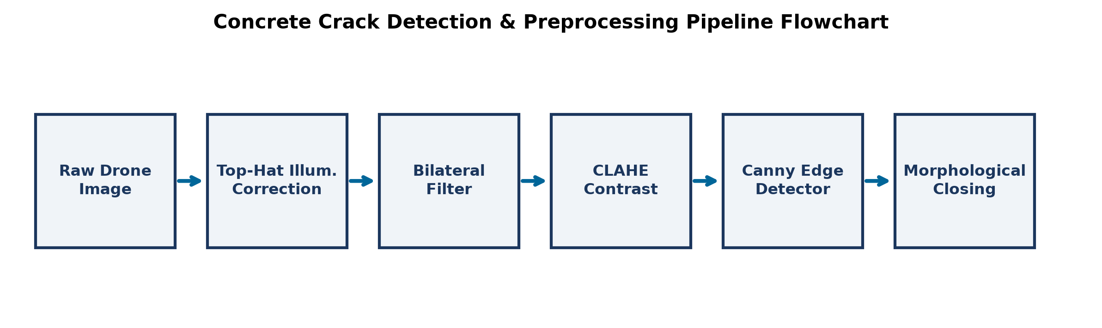
Figure 6: Flowchart of Concrete Crack Detection & Preprocessing Pipeline.
B. Edge Detection Selection and Comparison
- Selected Method: Canny Edge Detector.
- Comparison with Sobel Operator: Sobel uses simple first-order derivatives without edge thinning, producing thick, noisy, double-edged responses around single crack lines. Canny uses Non-Maximum Suppression (NMS) to thin candidate edges down to accurate 1-pixel-wide lines, and Hysteresis Dual Thresholding (T_high, T_low) to track continuous weak crack segments connected to strong edge pixels.
C. Post-Processing for Broken Crack Segments
Answer: Apply Directional Morphological Closing using oriented line structuring elements (or Hessian-based Frangi Vesselness Filtering followed by Connected Component Graph Linking) to bridge broken crack gaps along dominant crack directions.
Question 2: Human Motion Tracking in a Security Camera Video
SCENARIO: Hallway Human Surveillance Tracking
A security camera is installed in a hallway to monitor people moving in different directions. The system must estimate the motion of each person across video frames for tracking and activity analysis. The hallway contains plain walls, smooth floors, and occasional shadows.

A. Lucas-Kanade Optical Flow Working Principle
- Brightness Constancy Assumption: Assumes pixel intensity I(x,y,t) remains constant along motion trajectory: I(x,y,t) = I(x+dx, y+dy, t+dt) => I_x*u + I_y*v + I_t = 0.
- Spatial Coherence: Assumes all pixels within a local N x N window move with identical velocity vector v = [u, v]^T.
- Least Squares Optimization: Solves over-constrained linear system A v = b via v = (A^T A)^-1 A^T b, where A^T A is the 2x2 spatial gradient structure tensor.
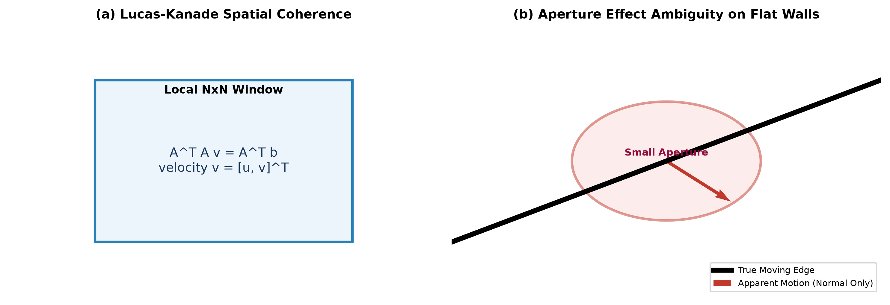
Figure 7: (a) Lucas-Kanade Spatial Coherence and (b) Aperture Effect Ambiguity on Flat Walls.
B. Aperture Effect and Uniform Region Errors
- Aperture Effect & Flat Regions: On plain walls, smooth floors, or uniform clothing, spatial gradients are nearly zero (I_x ≈ 0, I_y ≈ 0).
- Singularity of Structure Tensor: Matrix A^T A becomes rank-deficient (singular), rendering Lucas-Kanade unable to compute motion vectors. Along 1D straight edges, only normal velocity component can be determined, causing parallel motion errors.
C. Handling Sudden Speed/Direction Changes
- Effect: Sudden velocity changes violate small motion assumptions of 1st-order Taylor expansion, causing tracking loss or spurious vector spikes.
- Improvement Method: Use Pyramidal Lucas-Kanade (Coarse-to-Fine Multi-Scale Optical Flow) combined with Kalman Filtering / DeepSORT motion state prediction.
Question 3: Vehicle Tracking at a Traffic Junction Using Video Frames
SCENARIO: Smart Traffic Junction Surveillance
A smart traffic monitoring system uses CCTV footage to track vehicles at a busy road junction. Vehicles move at different speeds, stop suddenly, turn, and experience shadows, reflections, and partial occlusion when vehicles overlap.

A. Speed and Direction Estimation via Optical Flow
Dense optical flow (Farnebäck algorithm) calculates motion vectors [u, v] for all vehicle pixels:
- Instantaneous Speed: Speed = sqrt(u^2 + v^2) * Scale Factor * FPS
- Motion Direction: theta = arctan2(v, u)
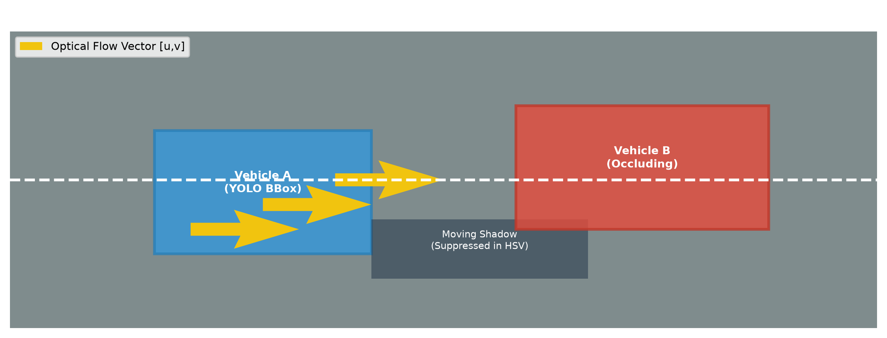
Figure 8: Traffic Junction Optical Flow Tracking & Shadow/Occlusion Handling.
B. Two Key Motion Estimation Challenges
- 1. Partial Occlusion: When one vehicle overlaps another, brightness constancy and spatial coherence are violated, causing optical flow vectors to merge or fail.
- 2. Moving Shadows & Reflections: Moving vehicle shadows change road pixel intensities, generating false optical flow vectors on stationary asphalt.
C. Improvement Method for Reliable Tracking
Answer: Implement a Hybrid Deep Learning & Multi-Object Tracking Pipeline: Combine YOLOv8 Object Detection (bounding boxes) with ByteTRACK / DeepSORT (Kalman Filter + Deep Re-ID embeddings) and HSV Shadow Suppression.

