SIMATS ENGINEERING
DEPARTMENT OF COMPUTER SCIENCE & ENGINEERING
COURSE NAME: Computer Vision with OpenCV COURSE CODE: DSA02
COURSE OUTCOME COVERED: CO2: Apply image processing and feature extraction techniques, including edge detection, motion estimation, and optical flow, for analyzing images.. (BL3)
ASSESSMENT TOOL 3 (CLASS TEST) | Weightage: 20% | Total Marks: 20
Code of Conduct:
I Gadwal Mohammad Muzammil - 192424279 (Name / Reg No) certify that this submission is my original work and that I have adhered to the guidelines specified for this assessment. I understand that any violation of academic integrity rules will result in disciplinary action.
Signature of the student: G. M. Muzammil

RUBRICS FOR CALCULATION
Criteria | Weightage | Level 4 (Exemplary) | Level 3 (Proficient) | Level 2 (Developing) | Level 1 (Beginning) | Marks
Understanding of Concepts | 25% | Demonstrates thorough, accurate understanding of concepts | Good understanding with minor gaps | Basic understanding with some misconceptions | Poor understanding; major misconceptions
Explanation | 25% | Detailed, well-explained answers with relevant examples | Clear explanation with adequate details | Limited explanation; lacks depth | Poor or unclear explanation
Application | 20% | Effectively applies concepts with strong analytical ability | Applies concepts with minor errors | Limited application with weak analysis | No application or incorrect analysis
Organization | 15% | Well-structured answers with logical flow and coherence | Organized with minor issues in flow | Basic structure, lacks clarity | Poor organization, incoherent answers
Accuracy | 10% | Completely accurate and covers all required points | Mostly accurate with minor omissions | Partially correct with missing points | Incorrect answers with major gaps
Clarity | 5% | Clear, neat, professional presentation | Understandable with minor issues | Limited clarity, readability issues | Poorly written, difficult to understand

Question 1: Image Preprocessing and Feature Extraction
SCENARIO: Farmland Pest Damage Identification
A drone is used to capture aerial images of a farmland to identify pest-affected crop regions. Due to sensor limitations, wind movement, and changing sunlight, the captured images contain noise, shadows, and uneven illumination. Pest-affected areas usually show visible texture and color variations compared to healthy crop regions.

a) Preprocessing Pipeline (4 Marks)
- 1. Noise Reduction: Apply Gaussian Smoothing Filter to remove sensor/atmospheric noise while preserving general spatial structure.
- 2. Illumination Correction: Apply Homomorphic Filtering / Background Division to eliminate non-uniform sunlight gradients and cloud shadows.
- 3. Contrast Enhancement: Apply CLAHE in LAB color space (L* channel) to enhance subtle boundary contrast between healthy and damaged leaves.
- 4. Normalization: Perform Min-Max Scaling to map pixel intensities linearly into standard dynamic range [0, 255].
b) Feature Extraction Selection (3 Marks)
- Texture & Color Analysis: Select Local Binary Patterns (LBP) combined with ExG (Excess Green Vegetation Index). LBP captures fine micro-texture variations caused by pest nibbling, while ExG highlights leaf discoloration.
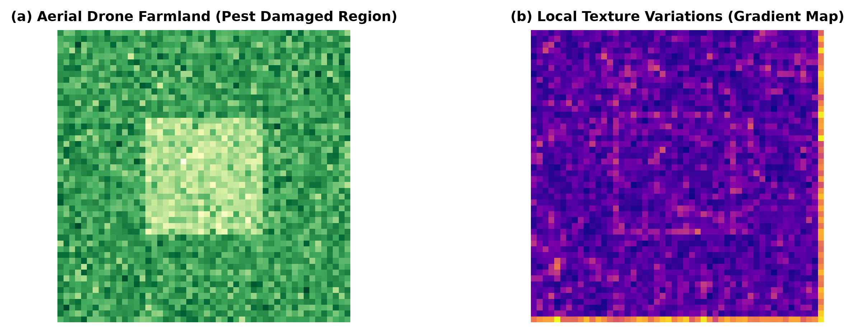
Figure 9: (a) Drone Aerial Farmland Crop Damage and (b) Local Texture Variation Gradient Map.
c) Rotation and Scale Variations (3 Marks)
- Robustness Methods: Drone flight height changes alter crop scale, while camera angle shifts alter rotation. Use SIFT or Rotation-Invariant Uniform LBP (LBP_P,R^riu2) constructed over multi-scale image pyramids to maintain invariant feature detection.
Question 2: Stereo Vision and Motion Estimation
SCENARIO: Self-Driving Car Stereo Navigation
A self-driving car is equipped with stereo cameras to navigate through a busy street. The system must estimate the distance of nearby vehicles and pedestrians in real time. It should also track moving objects accurately to avoid collisions, especially when pedestrians or vehicles change speed suddenly.

a) Stereo Disparity and Depth Estimation (4 Marks)
Stereo vision uses triangulation from left and right camera views separated by baseline distance B:
Depth Z = (f * B) / d, where f is focal length and d = x_l - x_r is disparity.
- Nearby Objects: Produce large disparity d (easy to resolve accurately).
- Distant Objects: Produce small disparity d (higher depth error sensitivity).
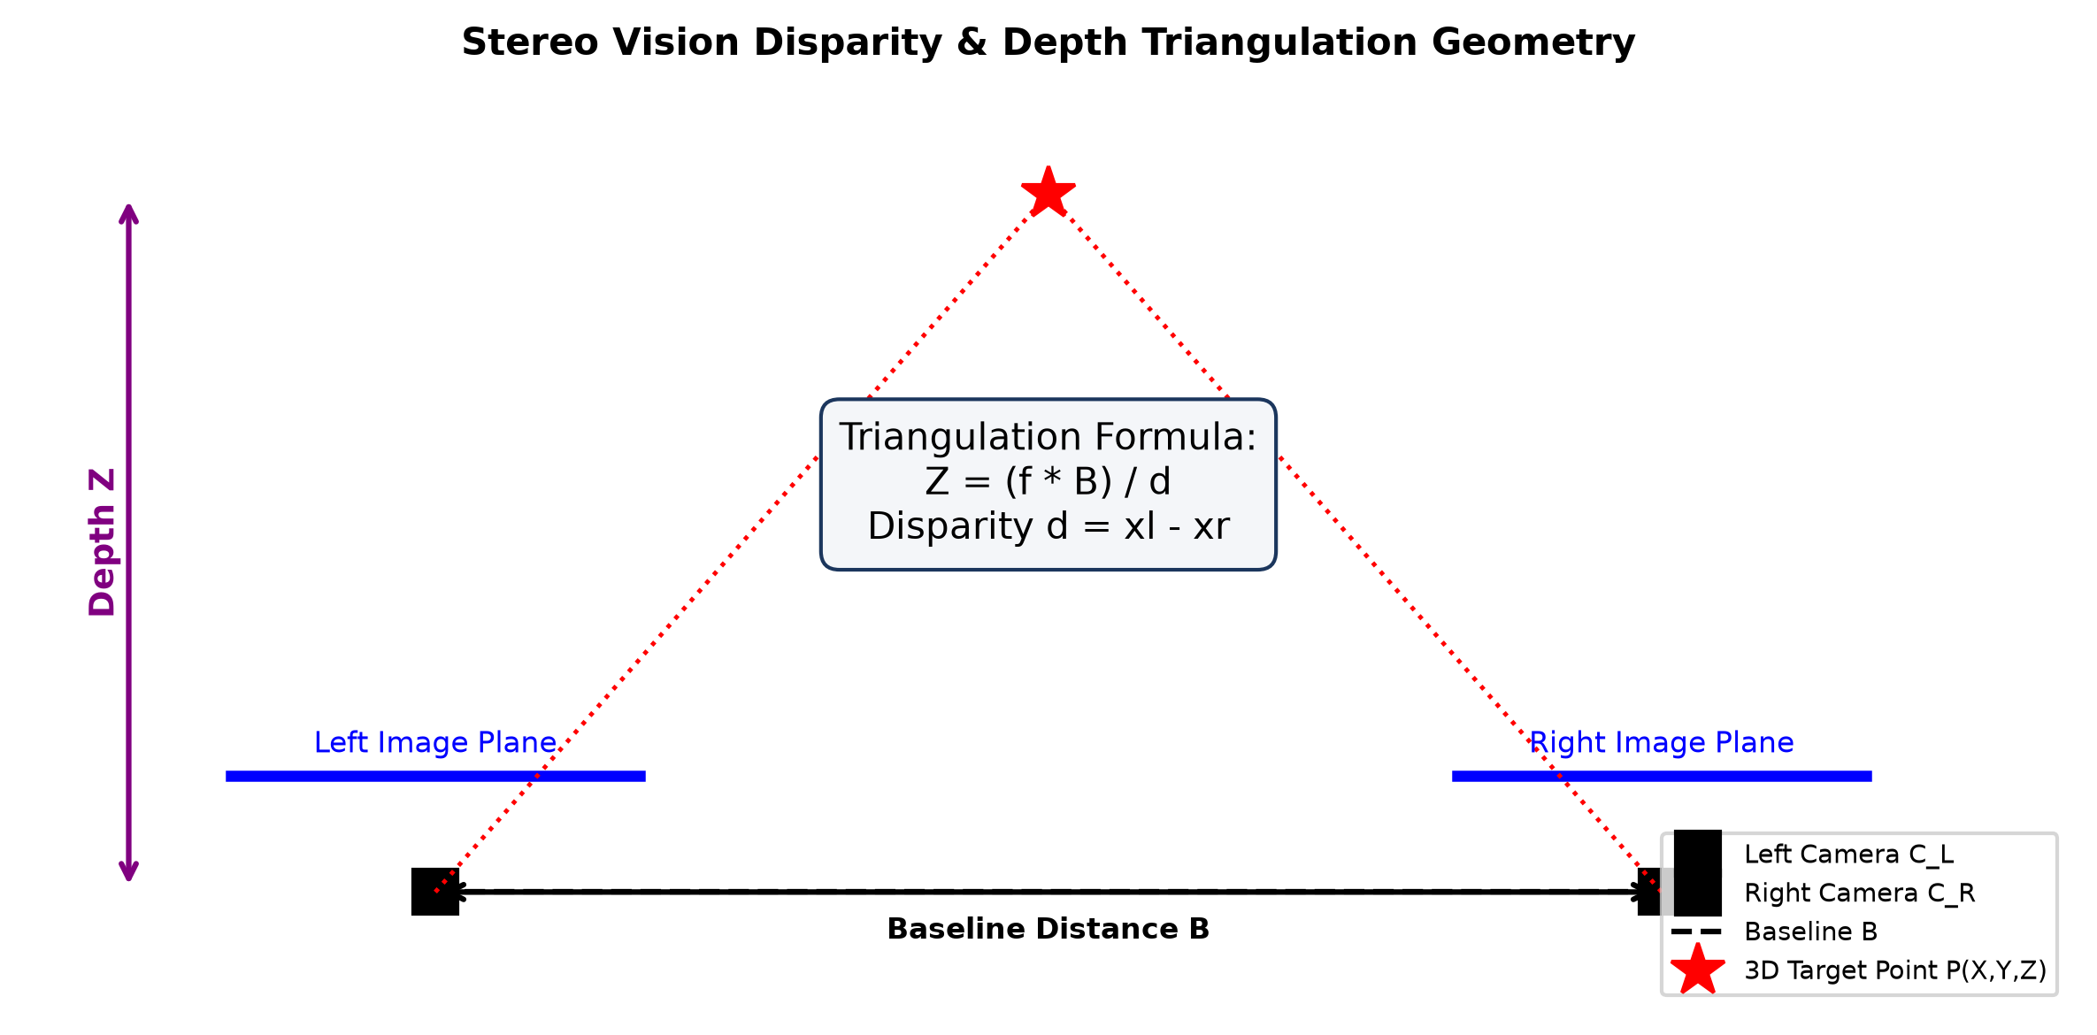
Figure 10: Stereo Vision Disparity & Depth Triangulation Geometry.
b) Optical Flow for Motion Tracking (3 Marks)
Answer: Optical flow calculates motion field [u, v] between consecutive video frames for each pedestrian pixel. Vector trajectories provide real-time velocity magnitude and direction, enabling forward path forecasting and collision avoidance.
c) Errors and Mitigation Techniques (3 Marks)
- Error Sources: Camera miscalibration, textureless surfaces (road asphalt), sudden movement, and lighting changes.
- Mitigation Techniques: Epipolar Image Rectification, Pyramidal Lucas-Kanade optical flow, and Sensor Fusion (Stereo Camera + LiDAR).

