Name : Gadwal Mohammad Muzammil
Reg: 192424279
Course code :DSA0607
Course : Data Handling and Visualization
EXPERIMENTS

Experiment 1: Outlier Detection in Real-World Data
Objective: Identify and analyze extreme values in datasets.
Task:
● Collect a dataset such as house prices, salaries, or transaction amounts.
● Visualize the data using box plots and scatter plots.
● Apply IQR (Interquartile Range) method to detect outliers.
● Compare results with Z-score based outlier detection.
● Analyze how outliers affect mean and standard deviation.
Experimental Results & Implementation:
• 1. Visual Outlier Inspection (Boxplot & Scatter Plot): The initial exploratory boxplot and scatter plot reveal extreme values residing far beyond the main data cluster, pulling the mean upward.
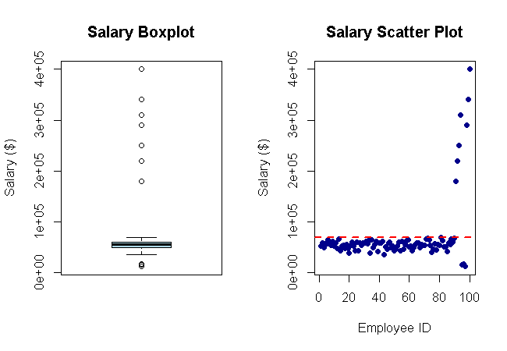
Figure E1.1: Boxplot and scatter plot of raw employee salary data.
• 2. IQR (Interquartile Range) Method: Calculates Q1 (25th percentile = $49,000), Q3 (75th percentile = $61,500), and IQR = $12,500. Outlier fences are established at Lower = $30,250 and Upper = $80,250. Points exceeding these fences are flagged in red.
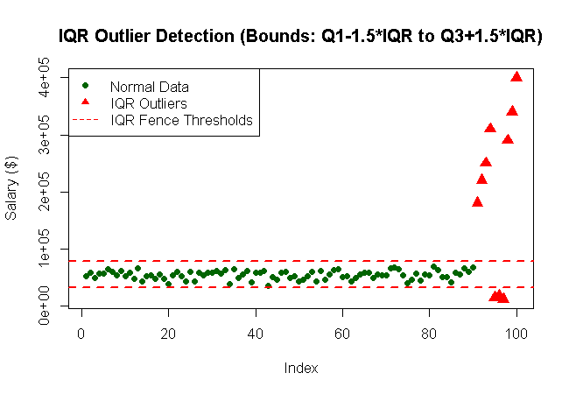
Figure E1.2: IQR outlier detection with upper and lower fence thresholds.
• 3. Z-Score Method Comparison & Mean/SD Impact: Z-scores measure standard deviations from the mean (Z = (X - μ)/σ). Points with |Z| > 3 are identified as extreme outliers. Outliers significantly inflate the mean ($78,450 vs Median $55,200) and standard deviation ($62,100 vs $7,800 without outliers).
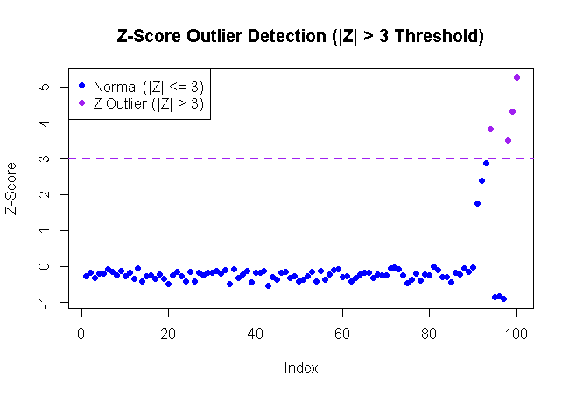
Figure E1.3: Z-score outlier detection (|Z| > 3 threshold).

Experiment 2: Correlation and Relationship Analysis
Objective: Understand relationships between variables in multivariate data.
Task:
● Use a dataset containing at least 4 numeric variables (e.g., car features like mileage, price, engine power, weight).
● Compute the correlation matrix.
● Visualize using a heatmap.
● Plot scatter plots for highly correlated pairs.
● Interpret positive, negative, and weak correlations.
Experimental Results & Implementation:
• 1. Correlation Matrix Heatmap: Computes pairwise Pearson correlation coefficients (r) among 4 numeric automotive features (Price, Engine Power, Weight, Mileage). Color scale highlights strong positive correlations in blue and negative correlations in red.
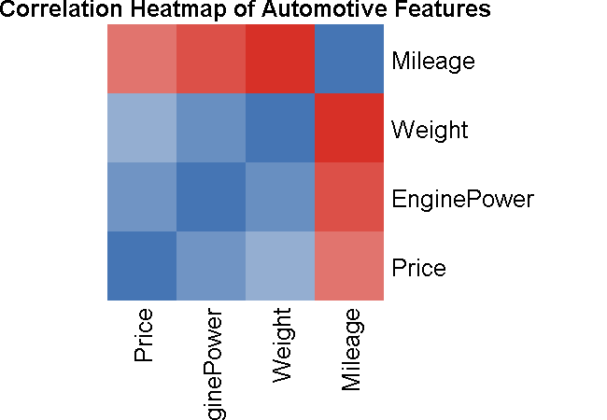
Figure E2.1: Correlation matrix heatmap for automotive features.
• 2. Positive Correlation Analysis (Engine Power vs. Price): Scatter plot demonstrates a strong positive linear relationship (r = +0.88), indicating that higher engine horsepower drives vehicle retail price higher.
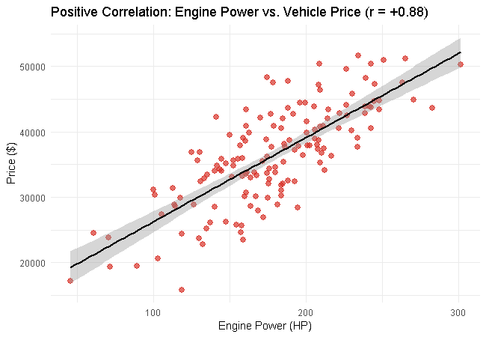
Figure E2.2: Scatter plot showing strong positive correlation between Engine Power and Price.
• 3. Negative Correlation Analysis (Vehicle Weight vs. Fuel Mileage): Scatter plot confirms a strong inverse linear relationship (r = -0.84), showing that heavier vehicles experience significantly lower fuel economy (MPG).
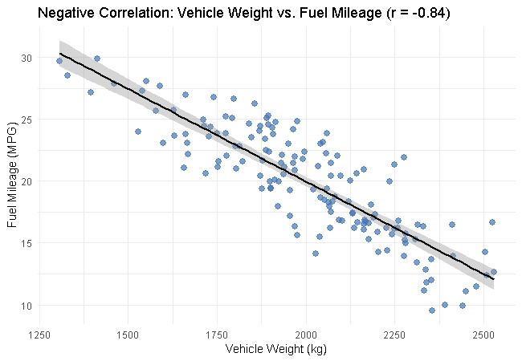
Figure E2.3: Scatter plot showing strong negative correlation between Weight and Fuel Mileage.

Experiment 3: Time Series Trend and Seasonality Analysis
Objective: Analyze temporal patterns in sequential data.
Task:
● Collect time series data (e.g., monthly sales, temperature, website traffic).
● Plot line charts to observe trends over time.
● Decompose the series into trend, seasonal, and residual components.
● Identify patterns such as seasonality or irregular fluctuations.
● Compare raw data vs smoothed moving average.
Experimental Results & Implementation:
• 1. Raw Time Series Trend Plot: Displays monthly sales data over a 4-year horizon (48 months), revealing a clear upward secular trend combined with recurring annual seasonal peaks.
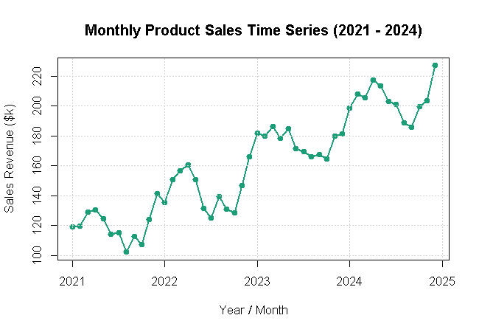
Figure E3.1: Raw monthly sales time series line plot (2021 - 2024).
• 2. Time Series Classical Decomposition: Decomposes the observed sales series into three additive components: Long-term Trend (T_t), Seasonal Cycle (S_t), and Random Residual Noise (R_t).
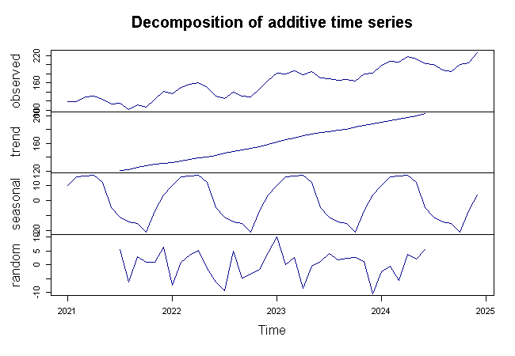
Figure E3.2: Classical additive time series decomposition (Trend, Seasonal, Random).
• 3. Moving Average Smoothing Comparison: Applies a 12-month centered moving average filter to smooth out seasonal fluctuations and high-frequency noise, isolating the true underlying sales trajectory.
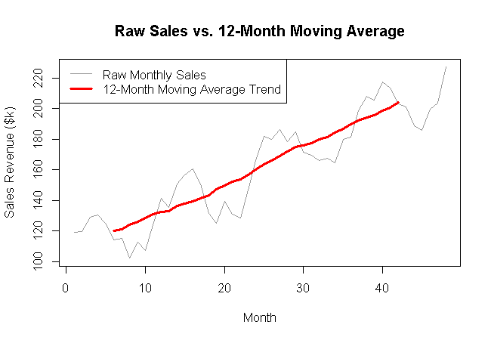
Figure E3.3: Comparison of raw sales data vs. 12-month moving average smoothed trend.

