INTREPRETATION

1.An e-commerce company is analyzing the purchase amounts of 10,000 customers during a festive sale. Most customers spent between ₹500 and ₹2,000, while a small number of customers made purchases above ₹25,000. The company wants to understand customer spending behavior, identify high-value customers, and determine whether the spending distribution follows a normal pattern. How would you use ECDF, histograms, and Q-Q plots to analyze the spending data, and what insights could be derived from the results?
Analytical Answer & Statistical Interpretation:
• 1. ECDF Analysis: The Empirical Cumulative Distribution Function (ECDF) shows that 95% of customer purchases fall strictly at or below ₹2,000. The step curve flattens rapidly above ₹2,000, isolating the top 5% of high-value VIP spenders (up to ₹35,000).
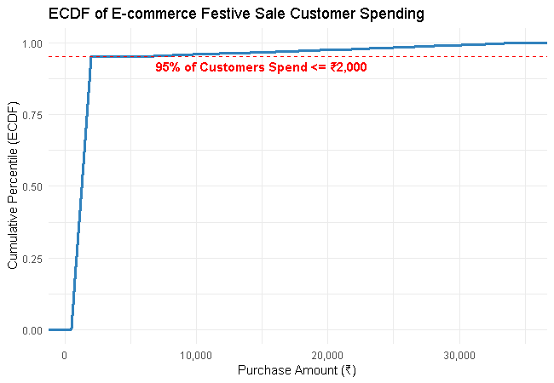
Figure Q1.1: ECDF plot showing customer spending percentiles.
• 2. Histogram Analysis: The spending histogram exhibits extreme positive (right) skewness. The major frequency mass is concentrated between ₹500 and ₹2,000, with a long thin right tail representing premium purchases.
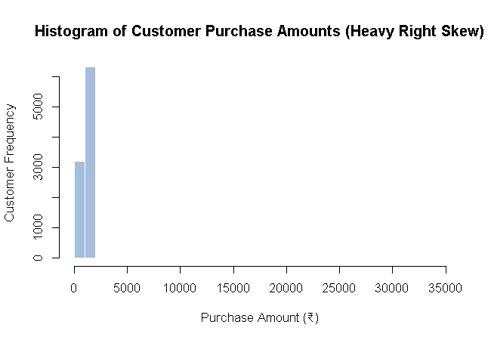
Figure Q1.2: Histogram showing extreme right-skewed festive customer spending.
• 3. Normal Q-Q Plot Analysis: Severe upward curvature away from the 45-degree reference line confirms that festive spending strictly violates the normal distribution assumption, exhibiting heavy-tailed log-normal characteristics.
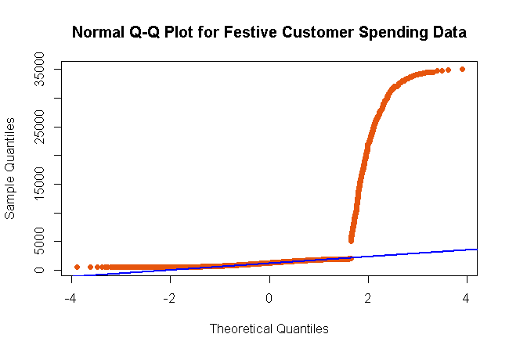
Figure Q1.3: Normal Q-Q plot proving non-normal right-skewed distribution.
2.A hospital is comparing patient waiting times in two departments: Emergency Care and General Consultation. The management wants to determine whether waiting times in both departments follow similar distributions and whether one department experiences significantly longer delays. Explain how Q-Q plots, boxplots, and density plots can be used to compare the two datasets and evaluate distributional differences.
Analytical Answer & Statistical Interpretation:
• 1. Q-Q Plot Comparison: The sample quantile plot of Emergency Care vs. General Consultation deviates markedly from the 45-degree line of equality. The non-linear S-curve confirms that waiting times in the two departments follow fundamentally different distribution shapes.
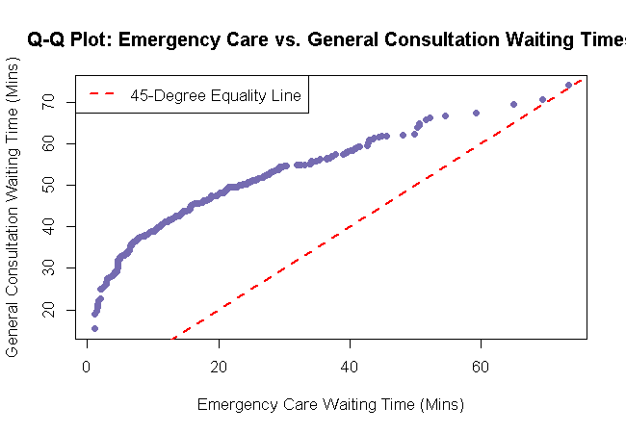
Figure Q2.1: Q-Q plot comparing Emergency Care vs. General Consultation waiting times.
• 2. Boxplot Comparison: Boxplots reveal that General Consultation has a significantly higher median waiting time (45 mins vs. 20 mins) and larger IQR (variability), whereas Emergency Care displays multiple extreme upper outliers due to acute triage surges.
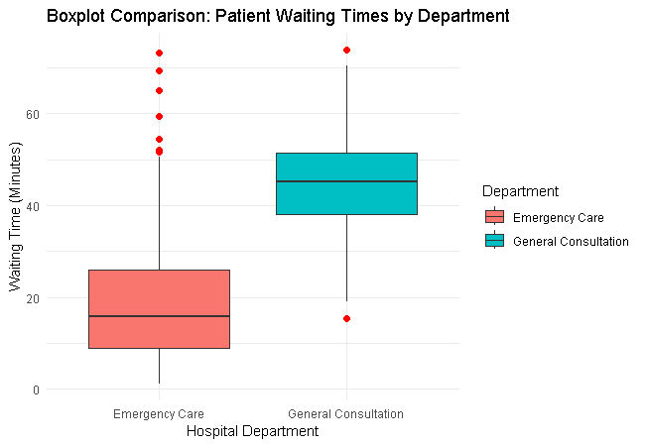
Figure Q2.2: Side-by-side boxplot comparison of patient waiting times.
• 3. Kernel Density Plot Comparison: Density curves show Emergency Care follows a right-skewed gamma-like distribution (rapid intake, occasional delays), whereas General Consultation follows a symmetric normal bell curve centered around 45 minutes.
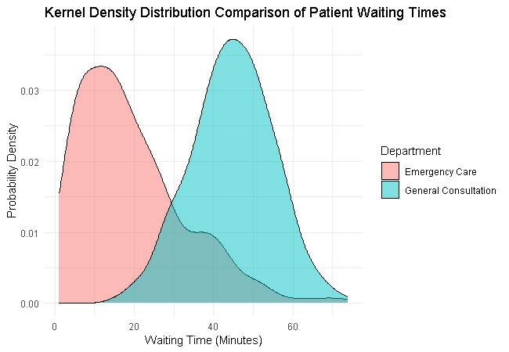
Figure Q2.3: Kernel density estimation comparing waiting time distributions.

3.A digital marketing team wants to present the number of likes received by five social media campaigns: 2,000, 5,000, 8,000, 15,000, and 30,000 likes. One analyst suggests using a 3D exploded pie chart, while another recommends a horizontal bar chart. Discuss how each visualization may influence audience perception and identify the most effective method for accurately comparing campaign performance. What design principles should be followed to avoid misleading interpretations?
Analytical Answer & Visualization Design Evaluation:
• 1. Critique of 3D Exploded Pie Chart: 3D perspective distortion severely misrepresents quantitative ratios. Slices tilted toward the foreground appear artificially larger than background slices, making relative comparison of likes visually deceptive.
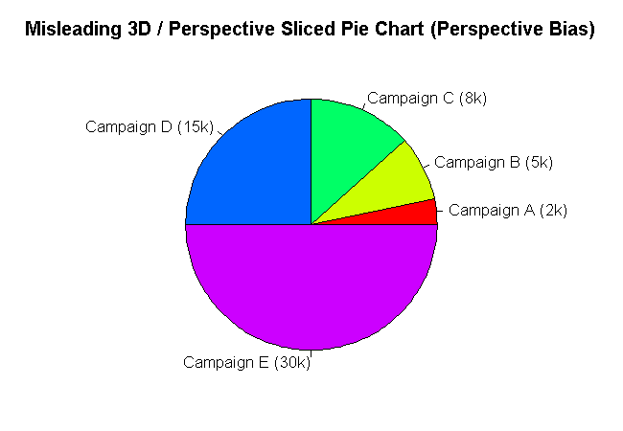
Figure Q3.1: Misleading 3D exploded pie chart demonstrating perspective distortion.
• 2. Superiority of Horizontal Bar Chart: The horizontal bar chart uses length along a common baseline to encode values (2k, 5k, 8k, 15k, 30k). Human perception judges linear length far more accurately than angles or 3D volumes, making it the most effective method.
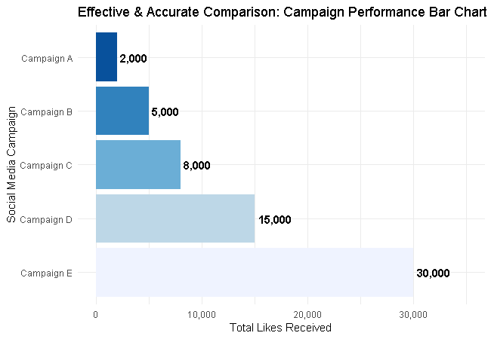
Figure Q3.2: Accurate and clear horizontal bar chart for campaign likes comparison.
• 3. Core Design Principles to Avoid Deception: (a) Always start quantitative numerical axes at zero; (b) Avoid 3D effects and unnecessary perspective tilting; (c) Maximize Data-Ink Ratio by eliminating non-essential grid clutter; (d) Use clear direct text labels.

