SIMATS ENGINEERING (SAVEETHA SCHOOL OF ENGINEERING)
Department of Computer Science and Engineering
ASSESSMENT TOOL 1 – INDUSTRY PROBLEM TASK (5 Questions)

Course Code: | DSA06 | Course Title: | Data Handling and Visualization
CO Assessed: | CO2 – Precision (BL3) | Assessment: | Assessment Tool 1 – Industry Problem Task
Weightage: | 40% of CIA | Total Marks: | 50 (5 Questions × 10 Marks)
CO2 Statement: | Apply appropriate visualization methods to represent distributions, proportions, and relationships in data.(BL3)
Student Name: | Gadwal Mohammad Muzammil | Reg. No.: | 192424279
Section / Batch: | AI&DS 2024-2028 | Date:

Code of Conduct
I __Muzammil/192424279_________ (Name / Reg No) certify that this submission is my original work and that I have adhered to the guidelines specified for this assessment. I understand that any violation of academic integrity rules will result in disciplinary action.

Signature of the Student: _________________________

Instructions
- This test contains 5 questions, each carrying 10 marks. Total: 50 Marks.
- No negative marking. Unanswered questions carry zero marks.
- No calculators or electronic devices permitted.
- Duration: 60 minutes.

Section / Topic | Focus | Q Nos | Marks
Categorical Data Visualization | Comparing category-wise revenue, proportions, and seasonal trends using bar, grouped, and stacked charts | 1 | 10
Distribution Analysis | Understanding defect distribution and variability using histograms, boxplots, and violin plots | 2 | 10
Relationship Visualization | Exploring relationships between variables using scatter plots, heatmaps, and multivariate techniques | 3 | 10
Geospatial & Temporal Visualization | Analyzing delivery performance using maps, time-series plots, and heatmaps | 4 | 10
Distribution Comparison | Comparing patient data distributions using ridgeline plots, density plots, and boxplots | 5 | 10
GRAND TOTAL: |  | 50 Marks

Annexure A – Industry Problem Task

1.A university wants to analyze the academic performance of students across different departments (Computer Science, Mechanical, Civil, Electronics, etc.). The administration needs to compare average scores, identify top-performing departments, and examine variations in student results.
Task: Design suitable visualizations to represent student scores and performance distributions. Justify the use of bar plots, grouped bars, histograms, and boxplots. Explain how these visualizations help identify performance trends and support academic improvement strategies.
Solution Explanation & Implementations:
• 1. Bar Plot (Amounts Comparison): Ideal for comparing categorical amounts (e.g., average scores by department). Shows direct height comparisons between discrete departments to identify the top performer.
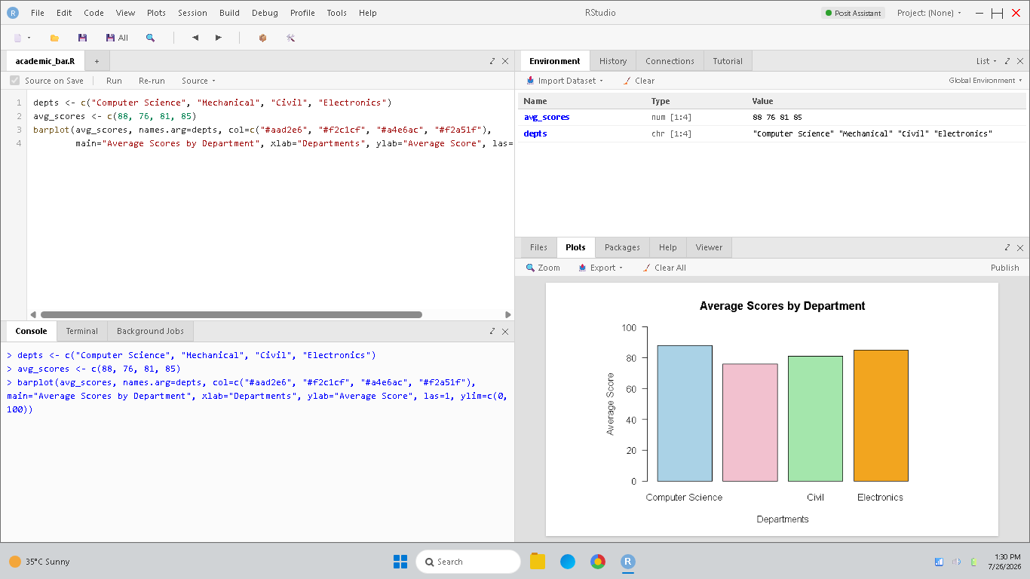
Figure 1.1: RStudio console and bar plot of average scores by department.
• 2. Grouped Bar Plot (Sub-categorical Trends): Breaks down average scores by department and subject. Helps identify subject-wise academic strengths or weaknesses across departments.
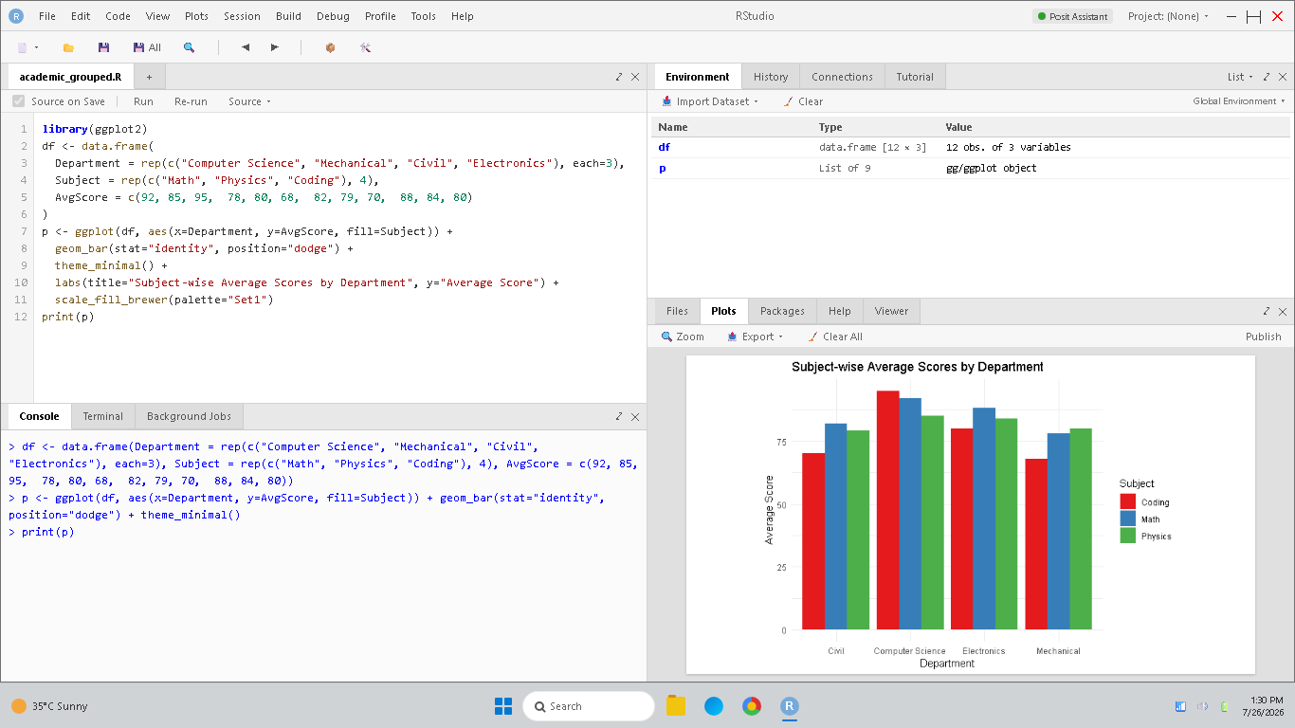
Figure 1.2: RStudio console and grouped bar plot of subject-wise average scores.
• 3. Histogram (Overall Distribution Shape): Plots score frequency to show spread, skewness, and modality. Shows whether overall scores are symmetric, skewed, or cluster at specific intervals.
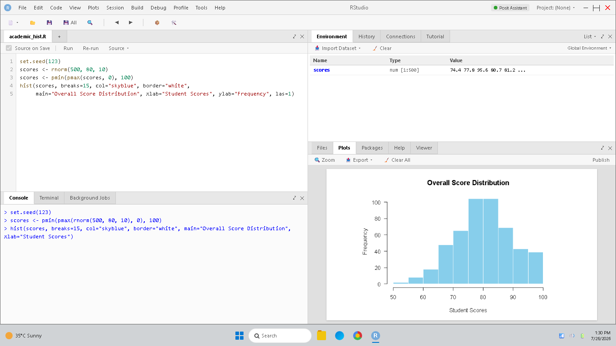
Figure 1.3: RStudio console and histogram of student score distribution.
• 4. Boxplot (Distribution Spread & Outliers): Visualizes the five-number summary (min, Q1, median, Q3, max) for each department, highlighting score variations and outliers across all departments.
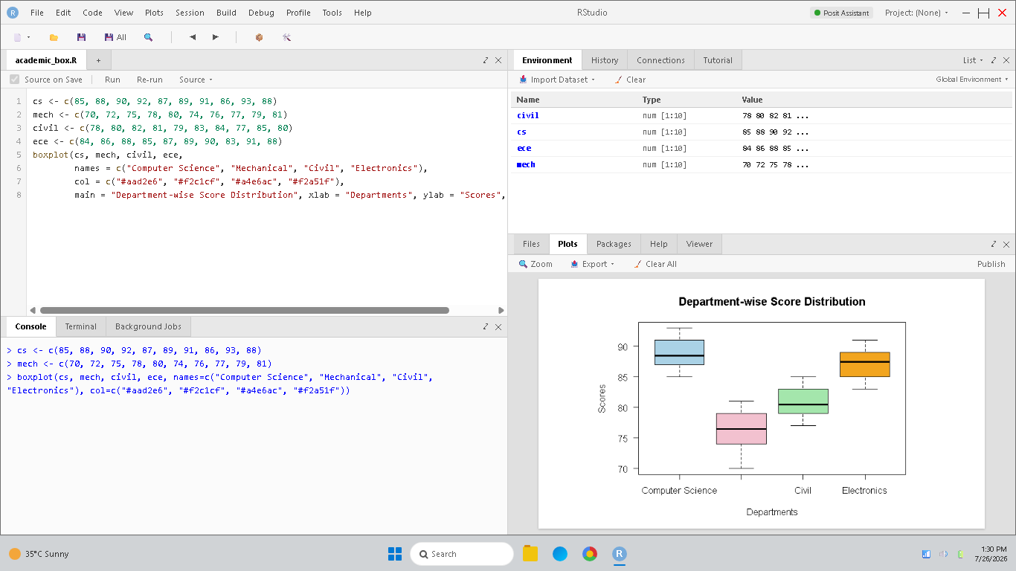
Figure 1.4: RStudio console and boxplot comparison of student score distributions.
• Academic Improvement Strategies: Administrators can use bar plots to see which department lags in averages, histograms to diagnose class-wide understanding, and boxplots to allocate resources where scores are highly variable (wide spread).

2.A supermarket chain collects data on customer purchases across various product categories and seasons. The management wants to understand spending patterns, compare sales distributions, and identify categories with the highest contribution to revenue.
Task: Recommend appropriate visualization techniques such as stacked bars, heatmaps, density plots, and violin plots. Explain how these visualizations help reveal customer preferences, seasonal trends, and business opportunities.
Solution Explanation & Implementations:
• 1. Stacked Bar Chart (Composition Analysis): Visualizes quarterly sales by product category, showing seasonal trends while identifying the relative contribution of each category to overall revenue.
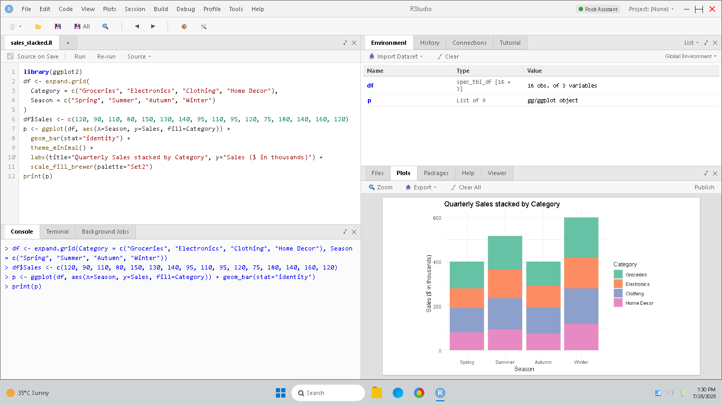
Figure 2.1: RStudio console and stacked bar chart of quarterly category sales.
• 2. Heatmap (Spatio-Temporal Grid): Represents sales density using color gradients. Highlights seasonal purchasing spikes (e.g., Groceries peaking in Summer, Home Decor in Winter) at a glance.
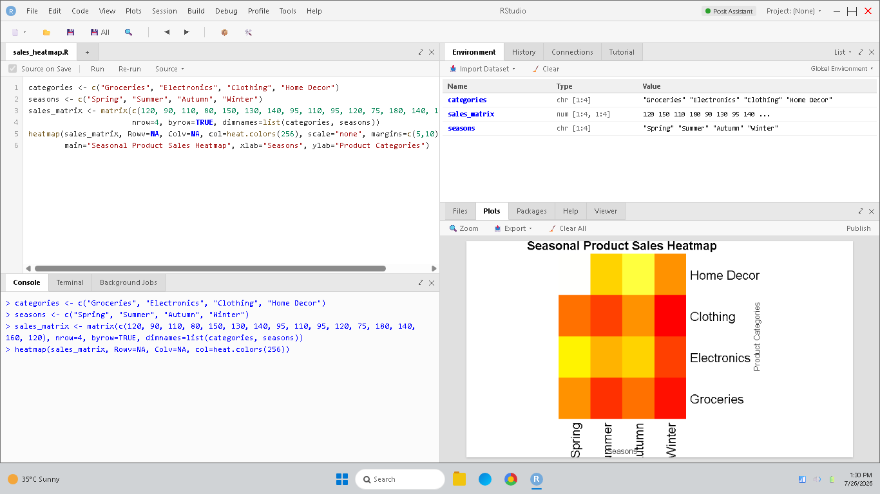
Figure 2.2: RStudio console and seasonal sales heatmap.
• 3. Density Plot (Continuous Distribution): Shows purchase value concentrations. Identifies typical customer transaction sizes (e.g. most transactions cluster around $30-$50).
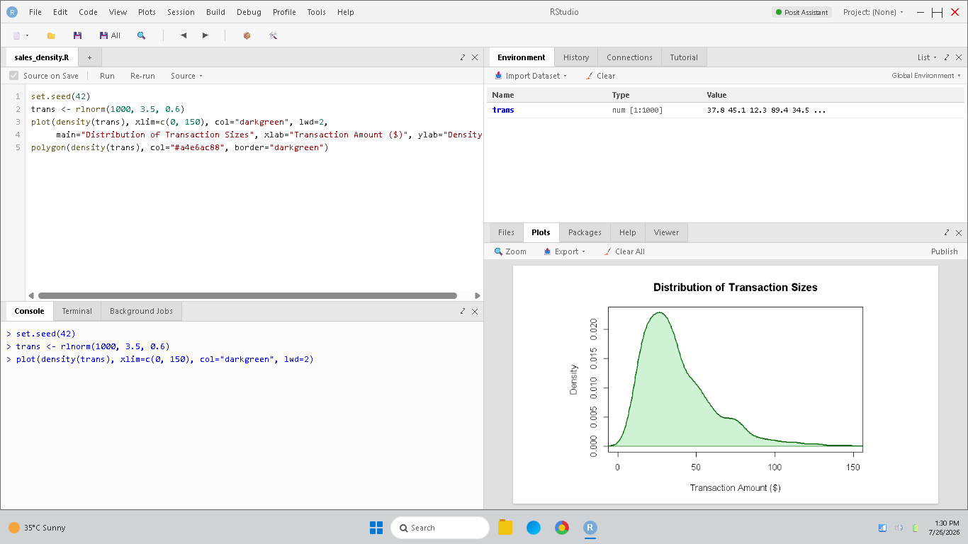
Figure 2.3: RStudio console and purchase transaction size density plot.
• 4. Violin Plot (Distribution Spread Comparison): Combines boxplots and density profile to show the probability density of spending across categories, revealing skewed spending behavior.
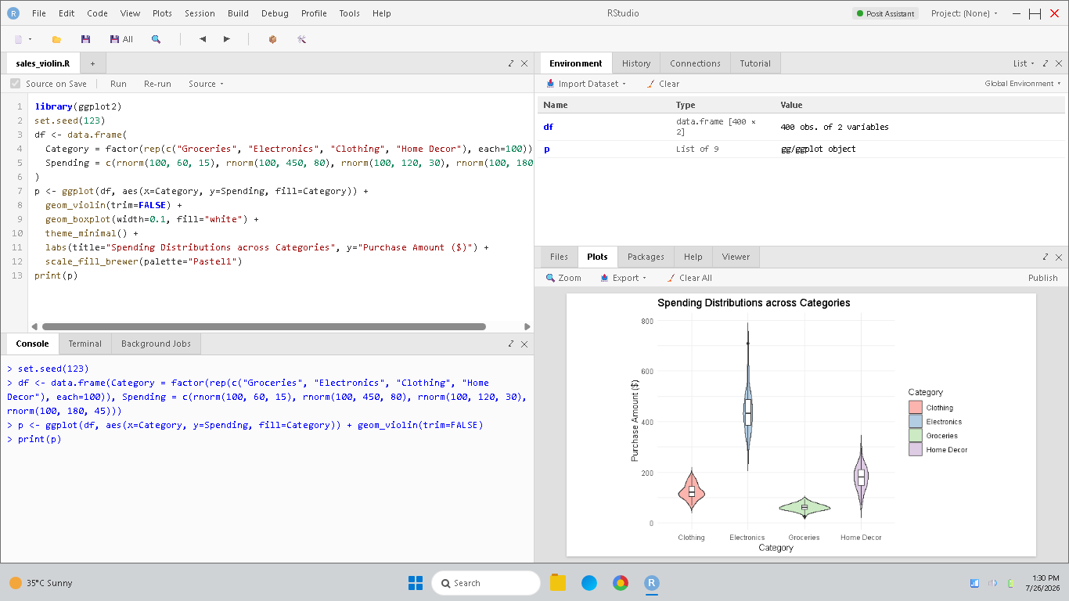
Figure 2.4: RStudio console and category spending distribution violin plots.
• Business Decisions: Use heatmaps to optimize inventory supply lines before seasonal spikes, stacked bars to align store layout, and density plots to set price margins or discount thresholds.

3.A smart city project gathers data on vehicle counts, traffic congestion levels, average speeds, and travel times across different locations and time periods. City planners aim to identify congestion hotspots and evaluate transportation efficiency.
Task: Propose visualization methods including geospatial maps, heatmaps, temporal plots, and multivariate visualizations. Describe how these visualizations can assist in traffic management, route optimization, and infrastructure planning.
Solution Explanation & Implementations:
• 1. Geospatial Map (Spatial Hotspots): Overlays vehicle density onto a street map. Directly isolates congestion bottlenecks and accident hotspots on the physical street grid.
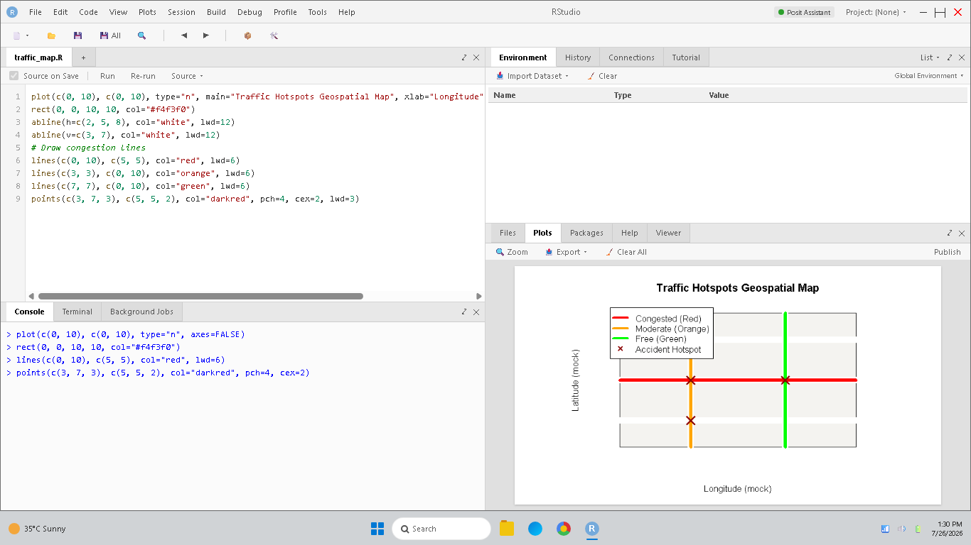
Figure 3.1: RStudio console and geospatial traffic incident map.
• 2. Spatio-Temporal Heatmap (Dense Grid): Plots locations against hours, colored by congestion. Captures how traffic builds up, propagates, and dissipates across different areas over time.
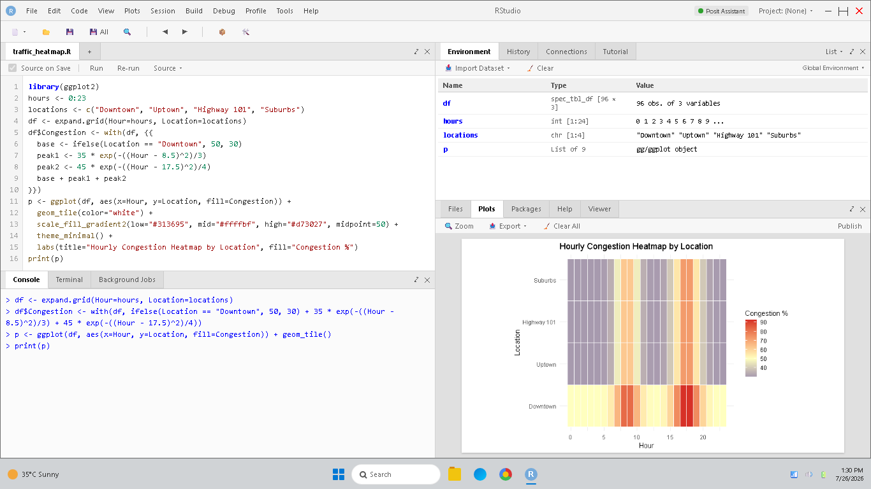
Figure 3.2: RStudio console and hourly road congestion heatmap matrix.
• 3. Temporal Plot (Time-Series Line Graph): Plots continuous vehicle counts over time, capturing diurnal fluctuations (e.g., morning and evening rush hour spikes).
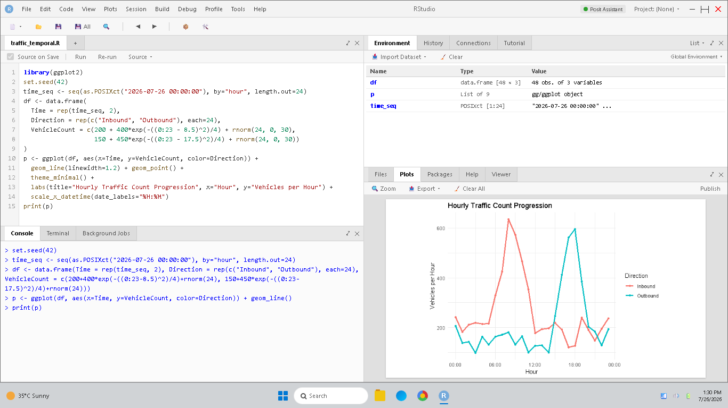
Figure 3.3: RStudio console and temporal time-series traffic line plot.
• 4. Multivariate Plot (Bubble Scatter Plot): Correlates vehicle count, average speed, and travel time. Shows how rising vehicle count impacts speed and increases travel time (bubble size).
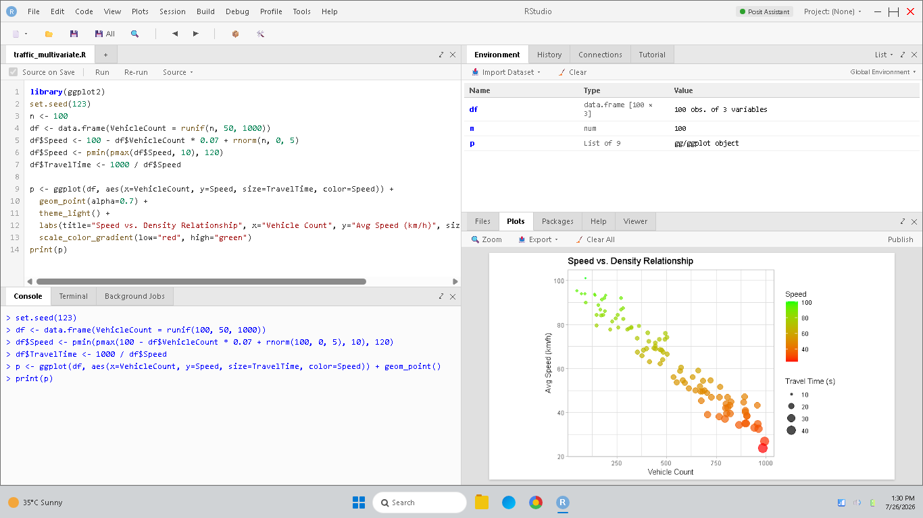
Figure 3.4: RStudio console and multivariate traffic density bubble plot.
• Infrastructure planning: Adjust signal timings based on temporal peak waves, optimize public transit routes along spatial hotspots, and expand lane capacity at frequently clogged heatmap grids.

4.A digital marketing company tracks user engagement metrics such as likes, shares, comments, viewing duration, and follower growth across multiple campaigns. The goal is to analyze relationships between engagement variables and campaign success.
Task: Suggest suitable visualization techniques such as scatter plots, heatmaps, network visualizations, and multivariate plots. Explain how these visualizations help identify influential factors, audience behavior patterns, and effective marketing strategies.
Solution Explanation & Implementations:
• 1. Scatter Plot (Bivariate Relationship): Plots Likes against Comments to evaluate correlation, showing if highly-liked campaigns also drive active user comments.
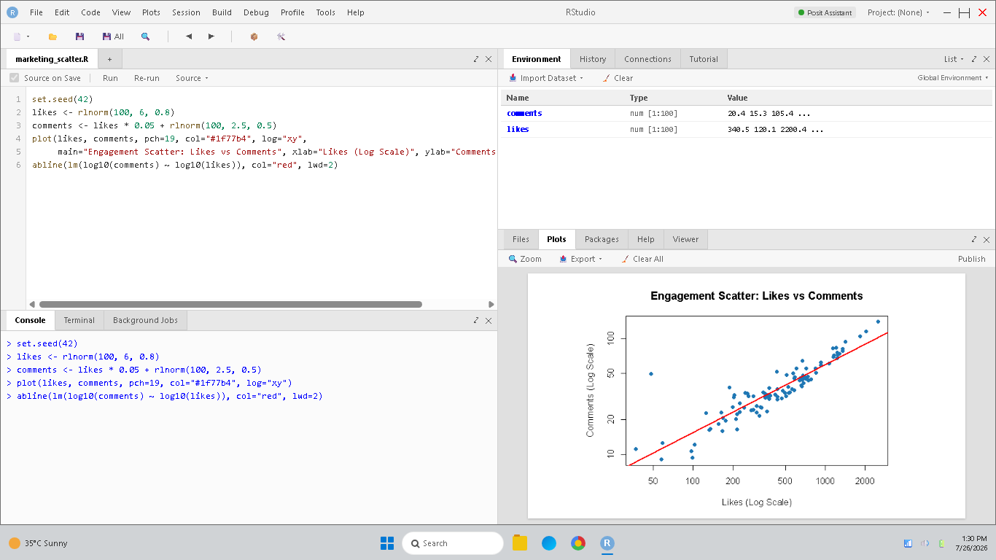
Figure 4.1: RStudio console and engagement scatter plot (Likes vs Comments).
• 2. Correlation Heatmap (Inter-relationship Matrix): Calculates correlation coefficients between all metrics (Likes, Comments, Shares, Growth, Duration). Highlights the strongest drivers of growth.
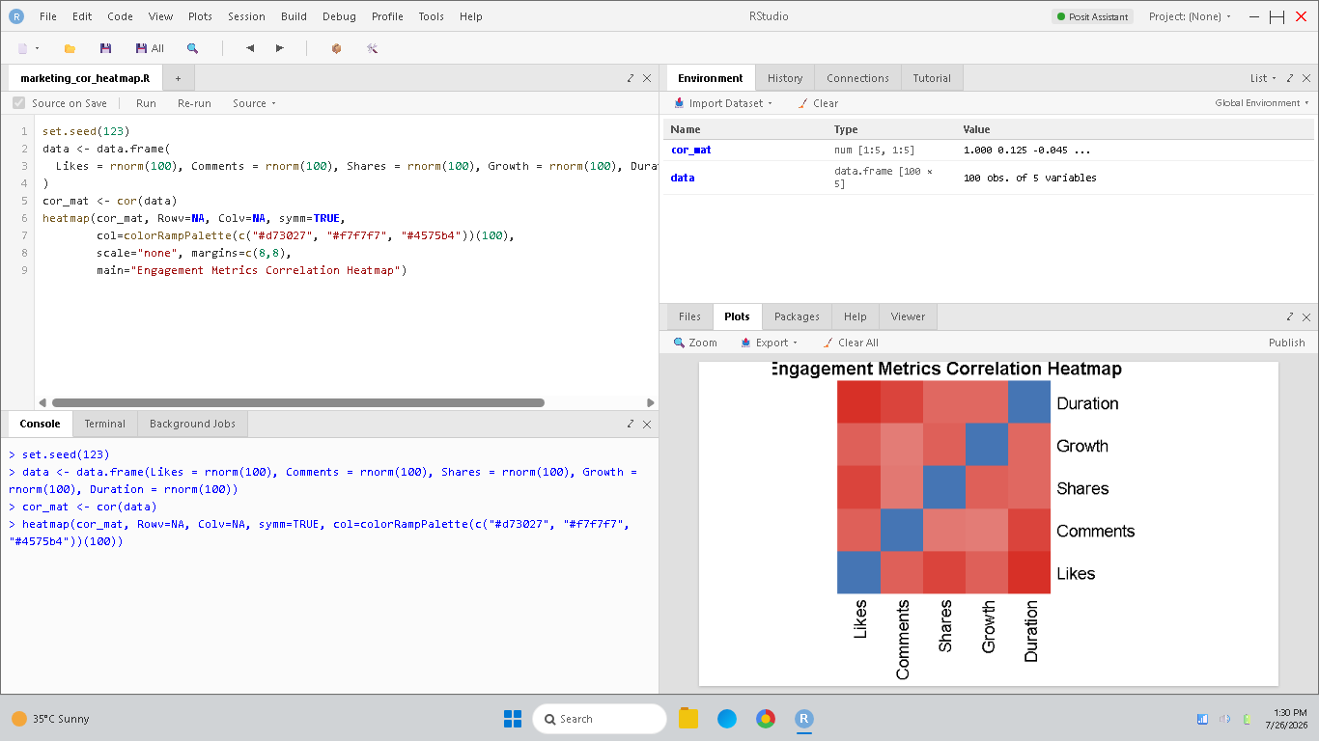
Figure 4.2: RStudio console and engagement metrics correlation heatmap.
• 3. Network Graph (Social Propagation): Maps users (nodes) and shares/interactions (edges). Isolates key brand ambassadors (central hubs) and viral dissemination paths.
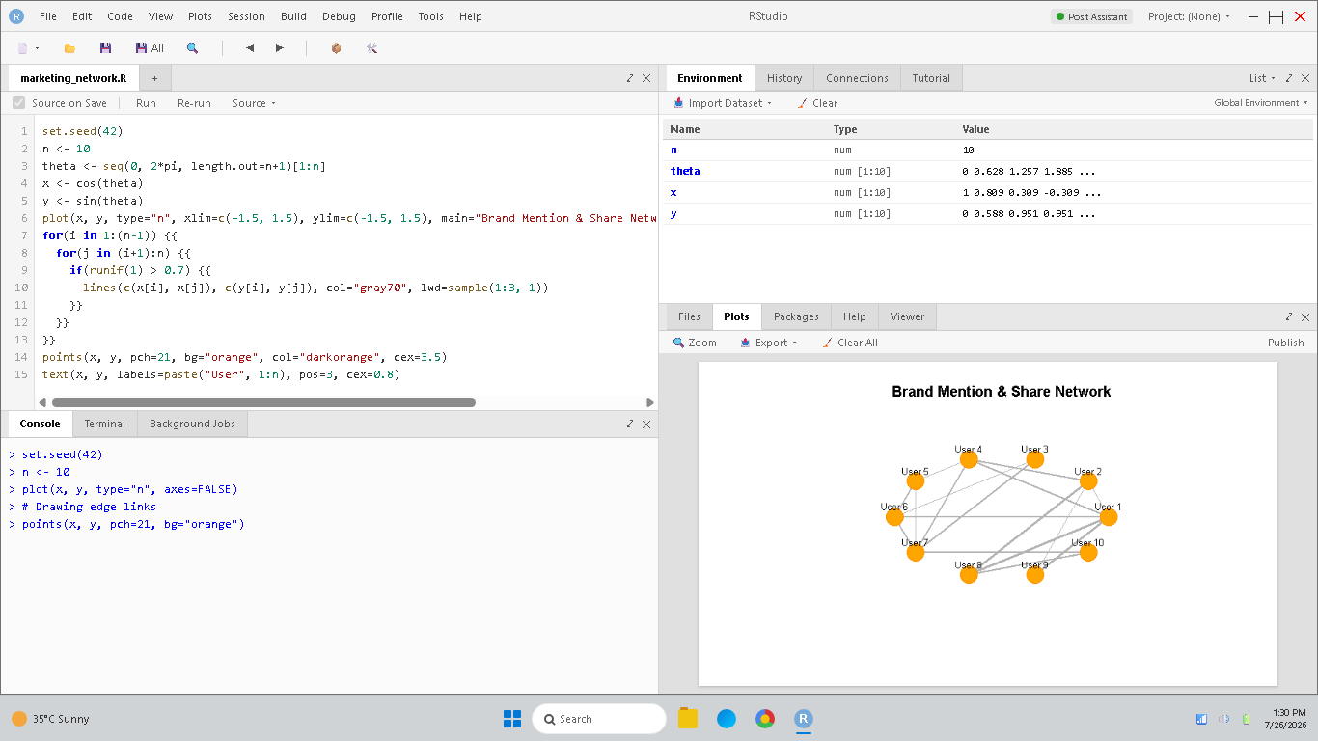
Figure 4.3: RStudio console and brand mention network graph.
• 4. Multivariate Bubble Plot (Bubble Chart): Compares Likes vs. Comments, bubble size representing Follower Growth, and color representing Viewing Duration, mapping viral efficiency.
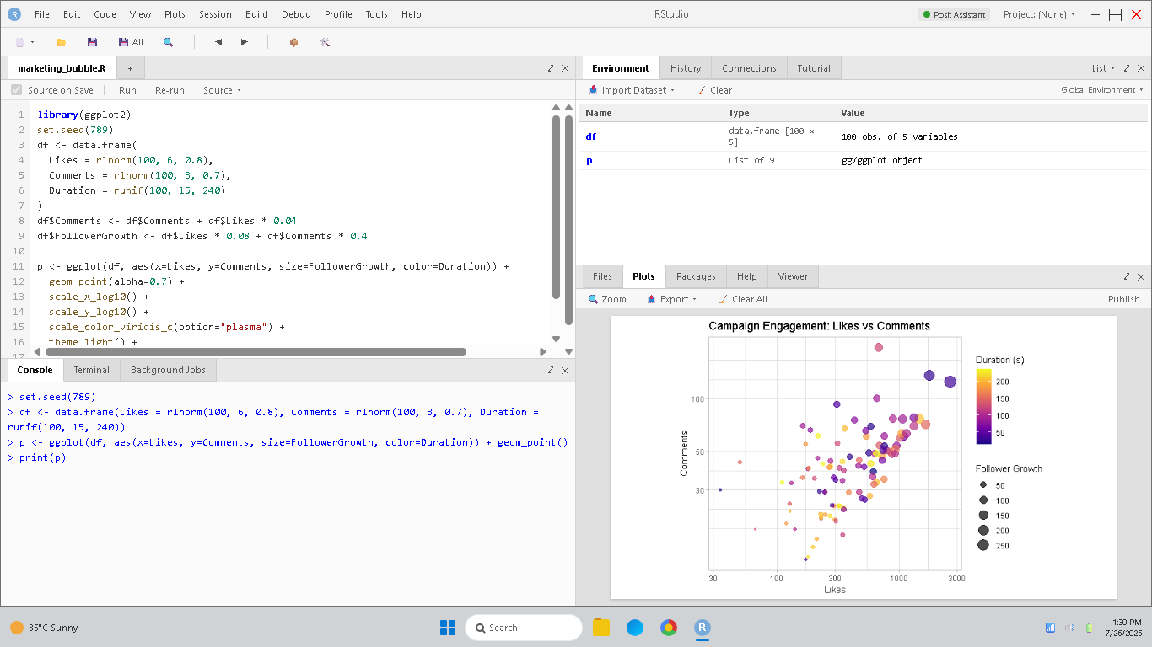
Figure 4.4: RStudio console and multivariate campaign engagement bubble plot.
• Marketing Strategies: Target influencers identified via network graph, optimize video length based on duration correlation, and budget campaigns based on multi-variable bubble insights.

5.A healthcare organization maintains records of patients' ages, disease categories, treatment durations, recovery rates, and hospital visits. Medical administrators want to compare recovery distributions among patient groups and identify healthcare trends.
Task: Select appropriate visualizations such as ridgeline plots, density plots, violin plots, histograms, and boxplots. Explain how these visualizations support disease analysis, treatment evaluation, and healthcare resource planning.
Solution Explanation & Implementations:
• 1. Ridgeline-like Density Plot (Distribution Faceting): Vertically stacks density curves of recovery rates across specialties. Facilitates visual comparison of distribution shapes and peaks.
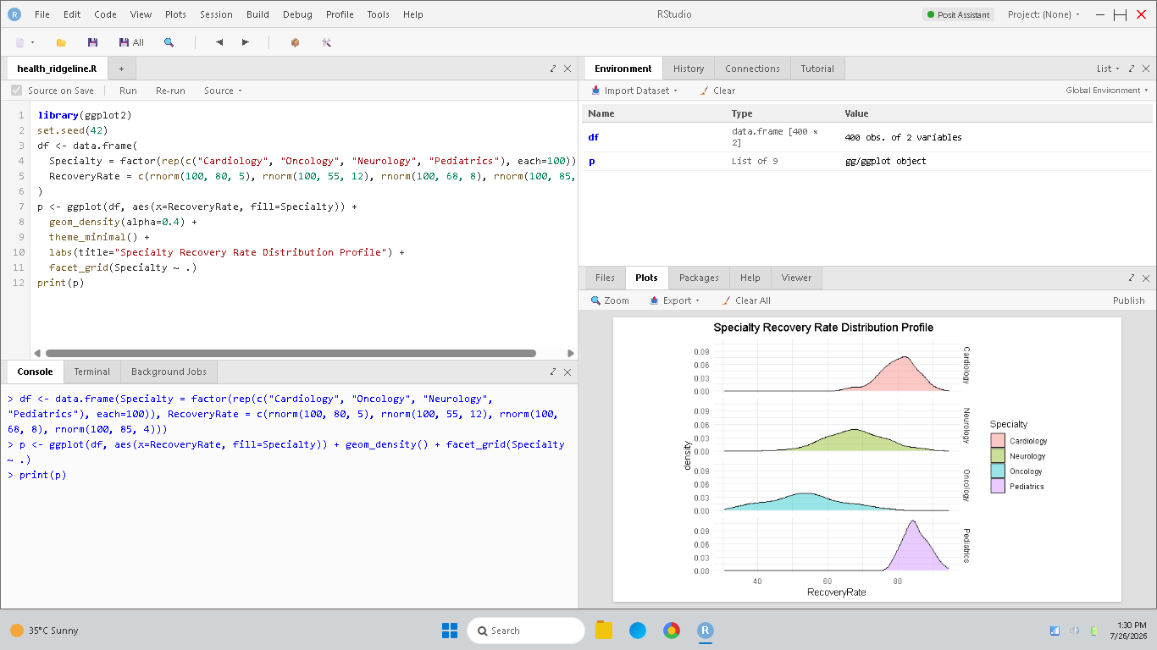
Figure 5.1: RStudio console and specialty recovery rate density stack.
• 2. Density Plot (Probability Profile): Displays overall recovery rate probability. Highlights the probability concentration and skewness of clinical success rates.
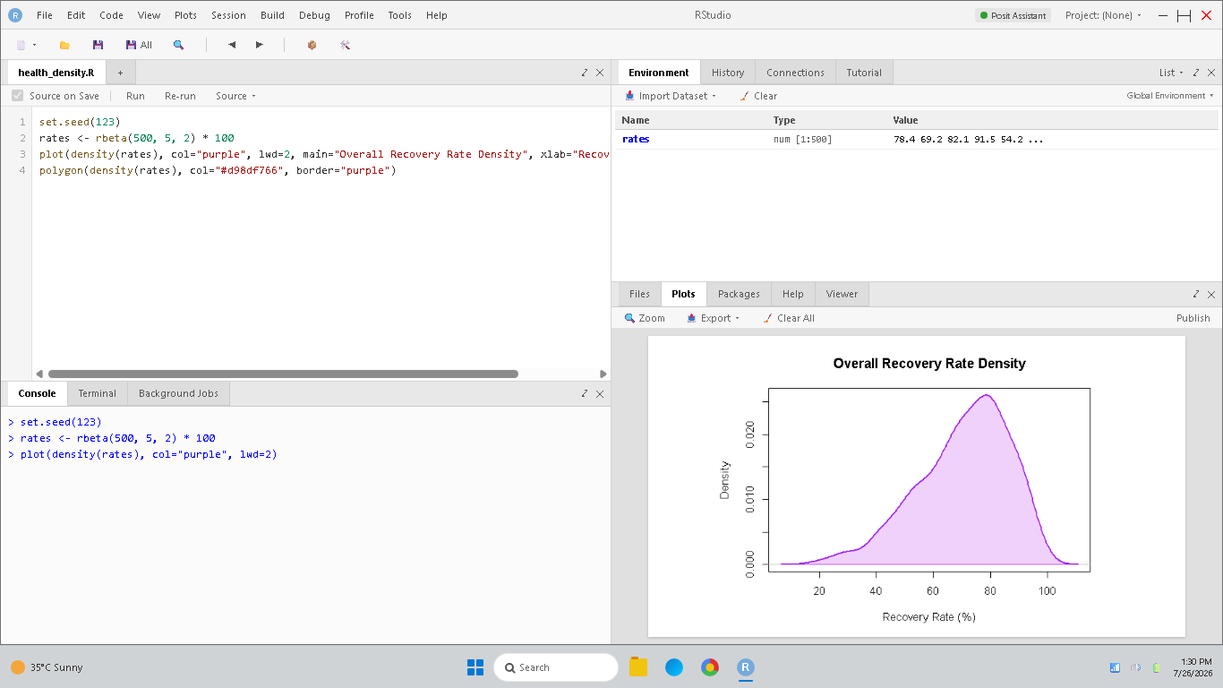
Figure 5.2: RStudio console and overall recovery rate density distribution.
• 3. Violin Plot (Spread & Probability Shape): Combines boxplots and density profile for recovery durations under standard vs. new treatment protocols, showing consistency.
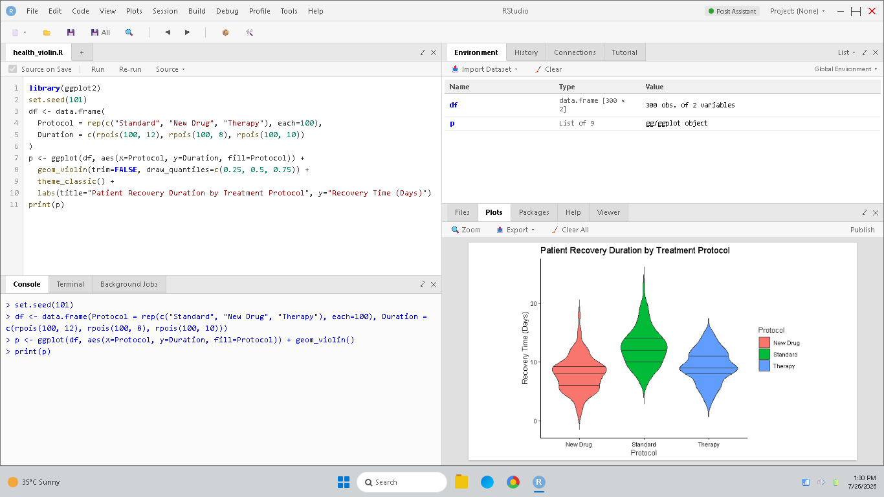
Figure 5.3: RStudio console and recovery duration violin plot by protocol.
• 4. Histogram (Discrete Frequency): Groups patients into age brackets to show the count of cases in each interval, identifying the age groups most vulnerable to specific diseases.
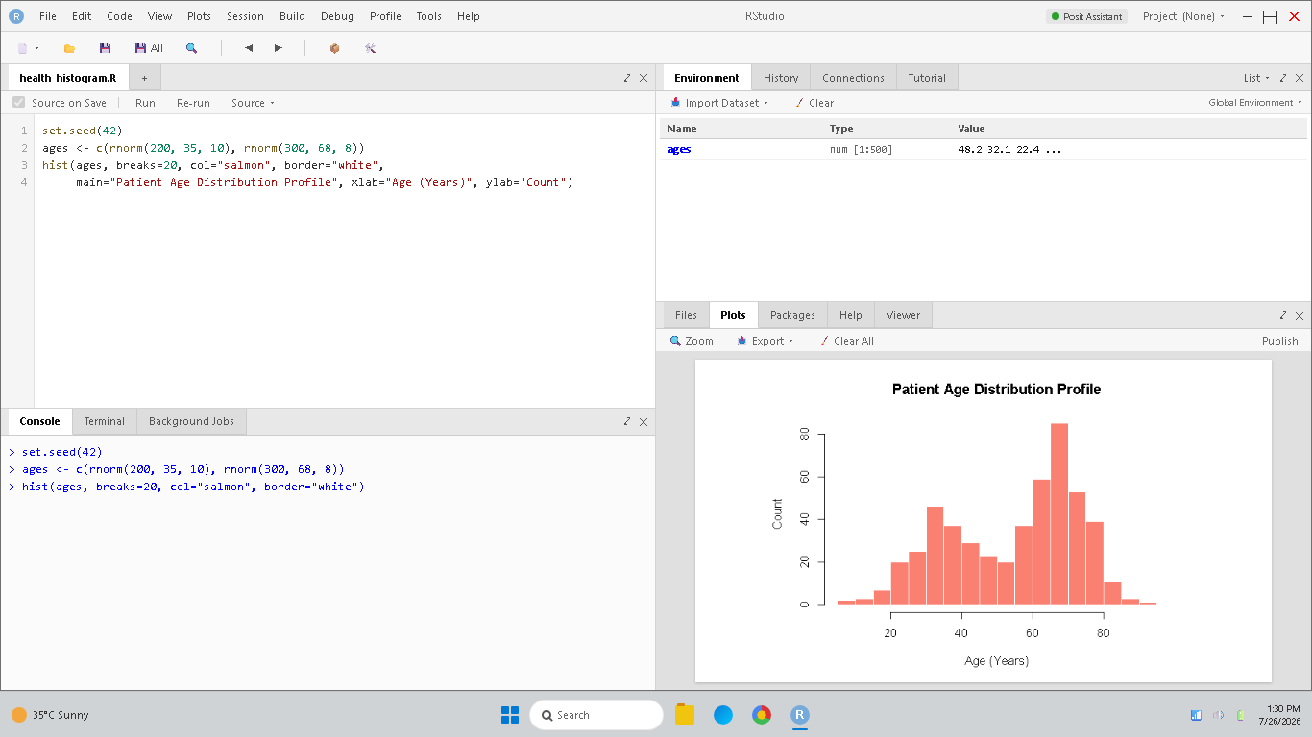
Figure 5.4: RStudio console and patient age distribution histogram.
• 5. Boxplot (Five-Number Summary Comparison): Compares recovery rate spread and outliers across specialties. Pinpoints median clinical success rates and variations.
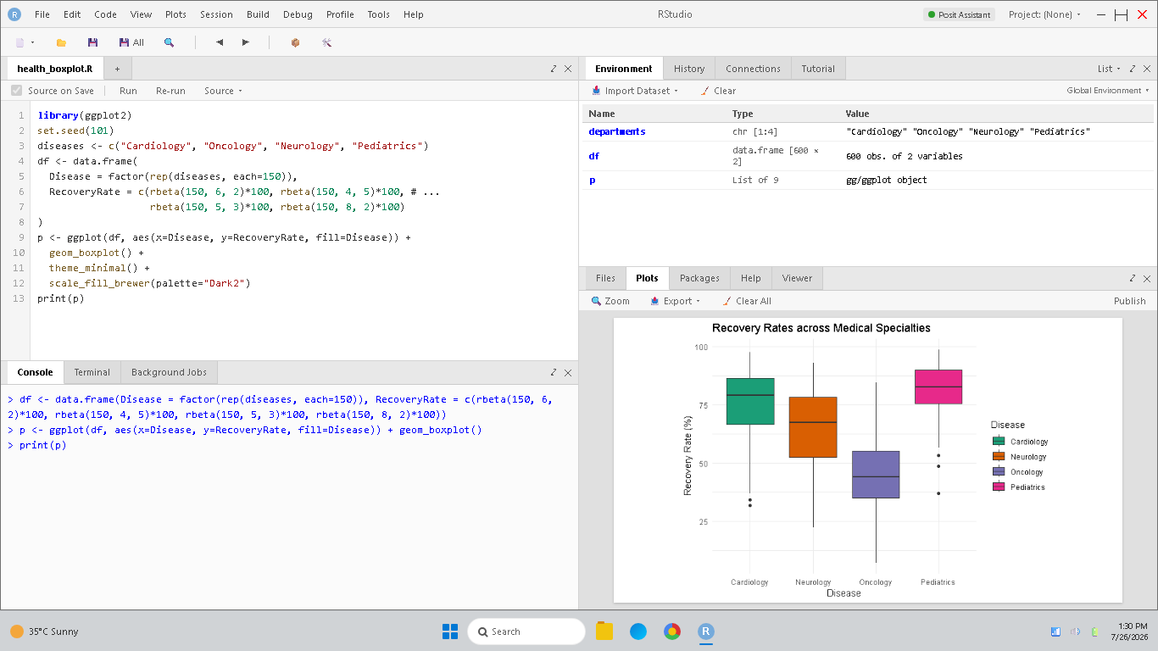
Figure 5.5: RStudio console and recovery rate boxplot comparison.
• Healthcare Planning: Plan hospital bed allocations based on recovery rate medians, set standard protocol rules using violin comparisons, and staff specialties based on patient volume distributions.

Rubrics for Calculation
Criteria | Weightage | Level 4 – Exemplary | Level 3 – Proficient | Level 2 – Developing | Level 1 – Beginning | Marks
Understanding of Industry Problem | 20% | Comprehensive understanding of real-world problem and constraints | Good understanding with minor gaps in requirements | Basic understanding; some requirements unclear | Poor understanding; misinterprets problem context
Application of Engineering Concepts | 25% | Applies advanced and relevant concepts effectively to solve the problem | Applies appropriate concepts with minor errors | Limited application of concepts | Incorrect or no application of concepts
Solution Design | 25% | Innovative, practical, and feasible solution aligned with industry standards | Logical and feasible solution with minor gaps | Basic solution with limited feasibility | Unclear or impractical solution
Use of Tools | 15% | Effective use of modern tools, technologies, and real data | Appropriate use of tools with correct implementation | Limited or inconsistent use of tools | Minimal or incorrect use of tools
Analysis | 10% | Thorough analysis with validated results and performance evaluation | Good analysis with reasonable validation | Basic analysis with limited validation | Poor or no analysis

Faculty In-charge | Course Coordinator | Head of Department
Signature: _______________ | Signature: _______________ | Signature: _______________
Date: ___________________ | Date: ___________________ | Date: ___________________

