SIMATS ENGINEERING (SAVEETHA SCHOOL OF ENGINEERING)
Department of Computer Science and Engineering
ASSESSMENT TOOL 2 – APPLICATION BASED QUESTIONS (5 Questions)

Course Code: | DSA06 | Course Title: | Data Handling and Visualization
CO Assessed: | CO2 – Precision (BL3) | Assessment: | Assessment Tool 2 – Application Based Questions
Weightage: | 20% of CIA | Total Marks: | 25 (5 Questions × 5 Marks)
CO1 Statement: | Apply appropriate visualization methods to represent distributions, proportions, and relationships in data (BL3).
Student Name: | Gadwal Mohammad Muzammil | Reg. No.: | 192424279
Section / Batch: | AI&DS 2024-2028 | Date:

Code of Conduct
I _Muzammil/192424279____ (Name / Reg No) certify that this submission is my original work and that I have adhered to the guidelines specified for this assessment. I understand that any violation of academic integrity rules will result in disciplinary action.
Signature of the Student: _________________________

Instructions
- This test contains 5 questions, each carrying 5 marks. Total: 25 Marks.
- No negative marking. Unanswered questions carry zero marks.
- No calculators or electronic devices permitted.
- Duration: 60 minutes.

Section / Topic | Focus | Q Nos | Marks
Amounts & Proportions | Category-wise comparison and proportion analysis using bar charts | 1 | 5
Distributions | Analyzing data spread and patterns using histograms, density plots, boxplots | 2 | 5
Temporal & x–y Relationships | Studying trends over time and relationships between variables | 3 | 5
Geospatial & Temporal Data | Mapping locations and analyzing delivery patterns over time | 4 | 5
Multivariate Data Visualization | Exploring multiple variables and comparing distributions | 5 | 5
GRAND TOTAL: |  | 25 Marks

Annexure A – Application Based Questions

1.A university wants to analyze student enrollments across various departments such as Computer Science, Mechanical Engineering, Civil Engineering, and Electronics. The administration aims to identify departments with the highest enrollments, compare enrollment trends over multiple semesters, and understand the proportion of students in each department. How would you categorize the data and choose appropriate visualizations to represent enrollment amounts, proportions, and temporal trends across departments?
Solution Explanation & Implementations:
• 1. Bar Chart (Enrollment Amounts): Translates student enrollment totals for each department into visual heights, allowing clear side-by-side comparison of sizes.
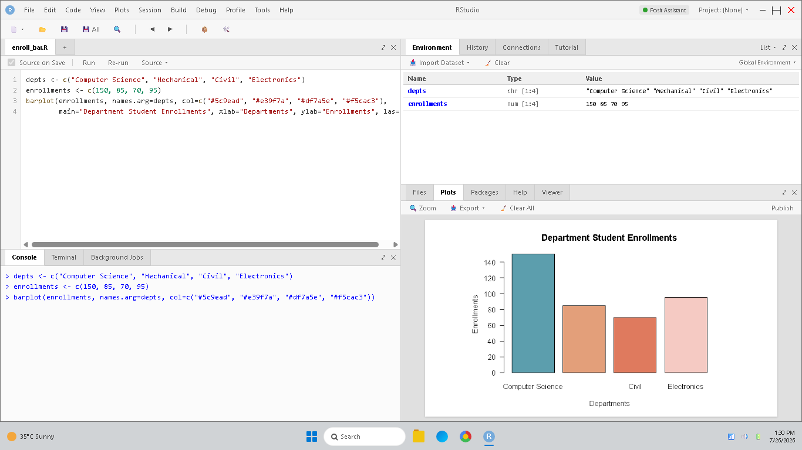
Figure 1.1: RStudio console and department enrollment bar chart.
• 2. Pie Chart (Enrollment Proportions): Divides a circular chart into segments proportional to each department's enrollment count, representing relative shares of the whole student body.
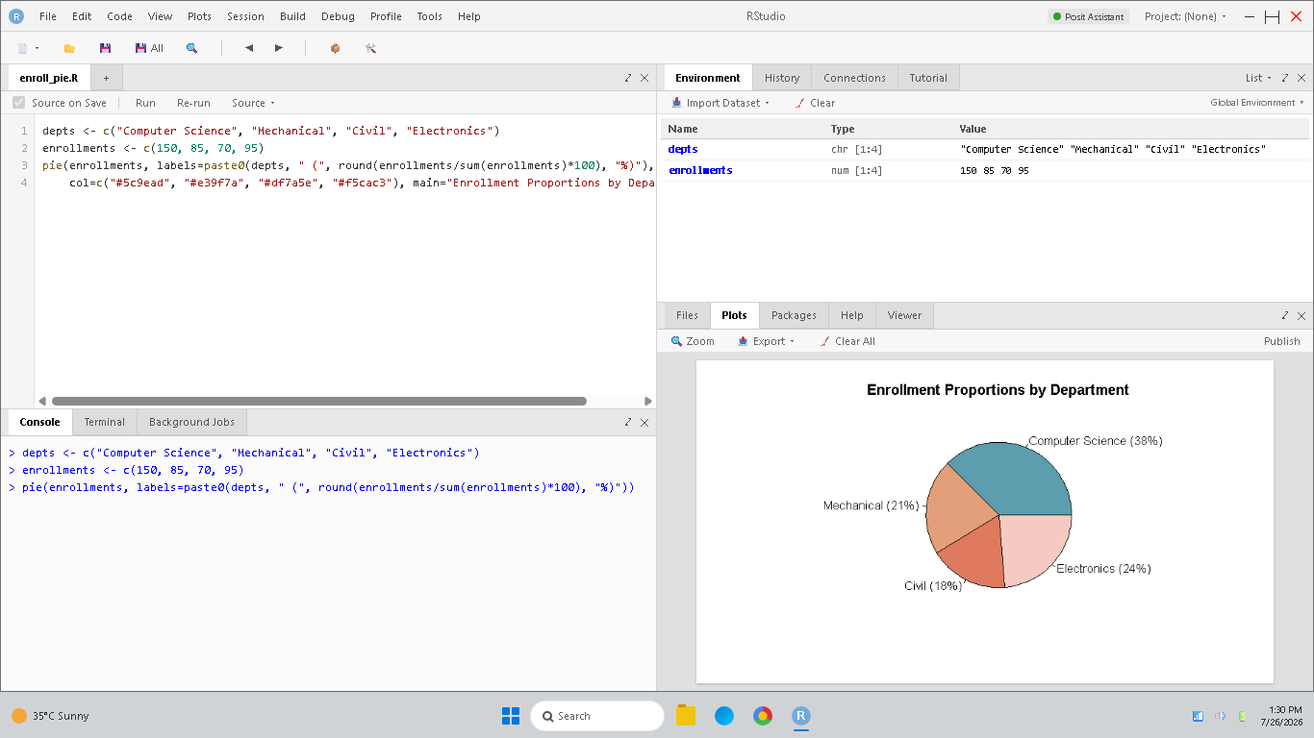
Figure 1.2: RStudio console and enrollment proportion pie chart.
• 3. Grouped Bar Chart (Temporal Trends): Compares student enrollment amounts for each department across multiple semesters, illustrating the growth or decline in interest over time.
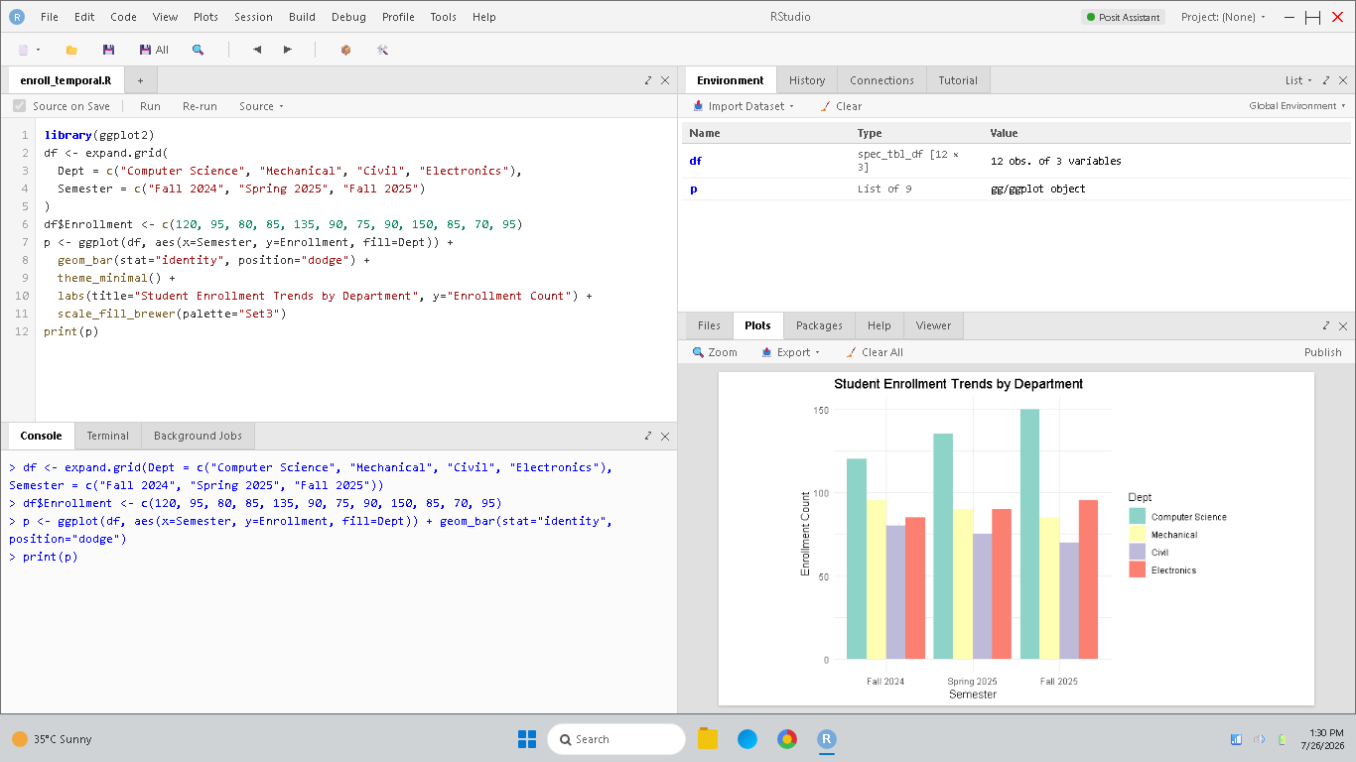
Figure 1.3: RStudio console and grouped bar plot of enrollment trends across semesters.

2.A manufacturing company records the number of defects found in products produced by different production lines. The quality assurance team wants to examine the distribution of defects, identify variability among production units, and detect unusual patterns. How would you use histograms, density plots, violin plots, and boxplots to analyze defect distributions and compare quality performance across production lines?
Solution Explanation & Implementations:
• 1. Histogram (Defects Frequency): Groups defect counts into bins and plots case frequencies, showing if defect occurrences follow a Poisson or normal curve.
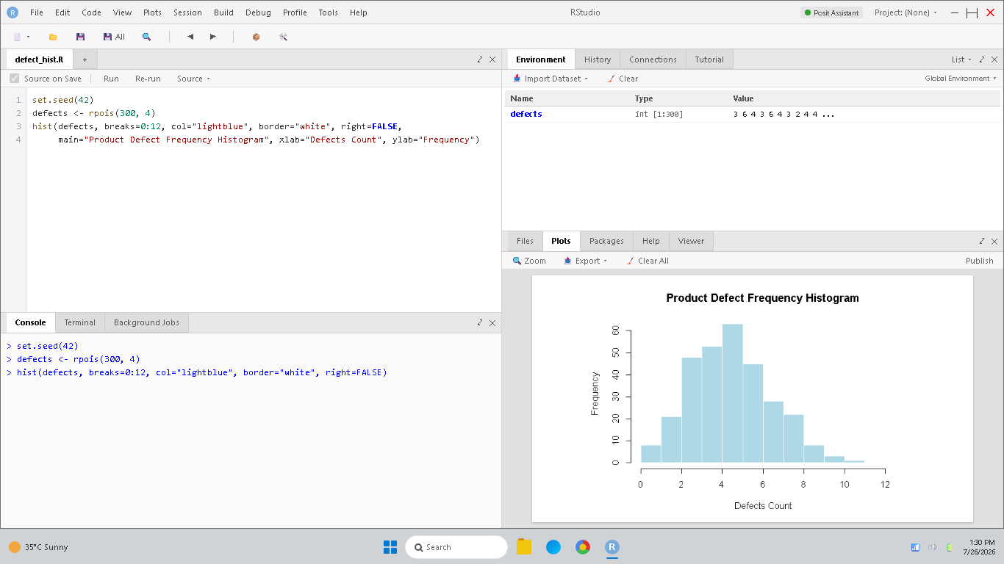
Figure 2.1: RStudio console and defects frequency histogram.
• 2. Density Plot (Probability Distribution): Plots continuous probability density curves for defects. Overlaying multiple curves allows direct comparisons of defect probabilities.
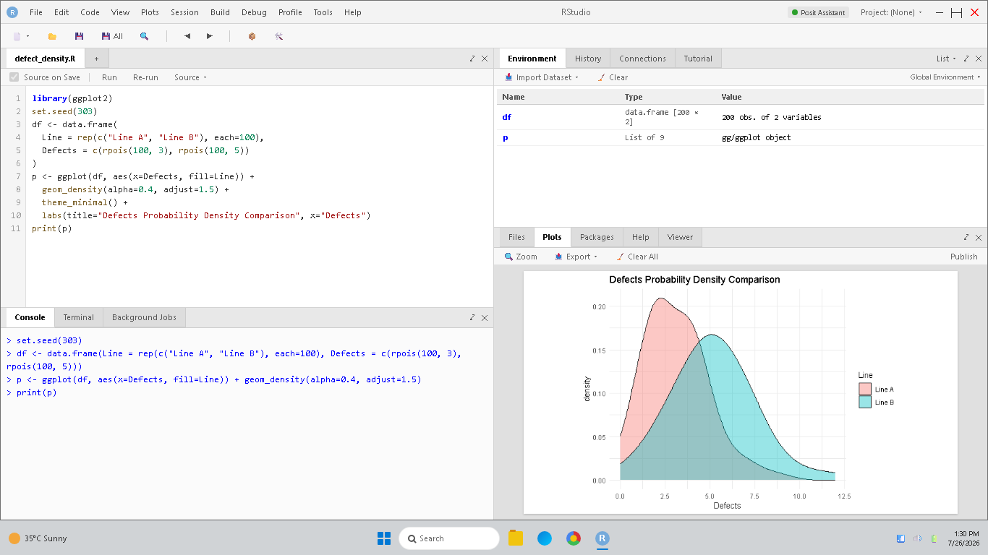
Figure 2.2: RStudio console and defect probability density comparison.
• 3. Violin Plot (Spread Shape Comparison): Combines density plot and scatter points, displaying the probability distribution shape of defects for each production line side-by-side.
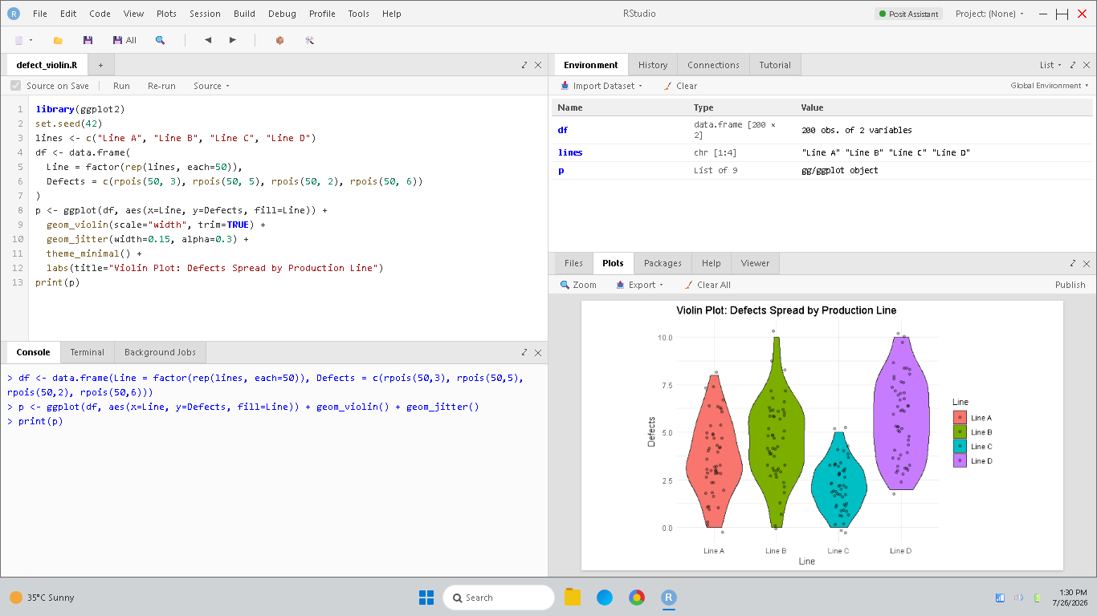
Figure 2.3: RStudio console and defects spread violin plots by production line.
• 4. Boxplot (Five-Number Summary Comparison): Summarizes median, IQR, and outliers (extreme defects) of lines, helping identify consistent quality vs. unstable production units.
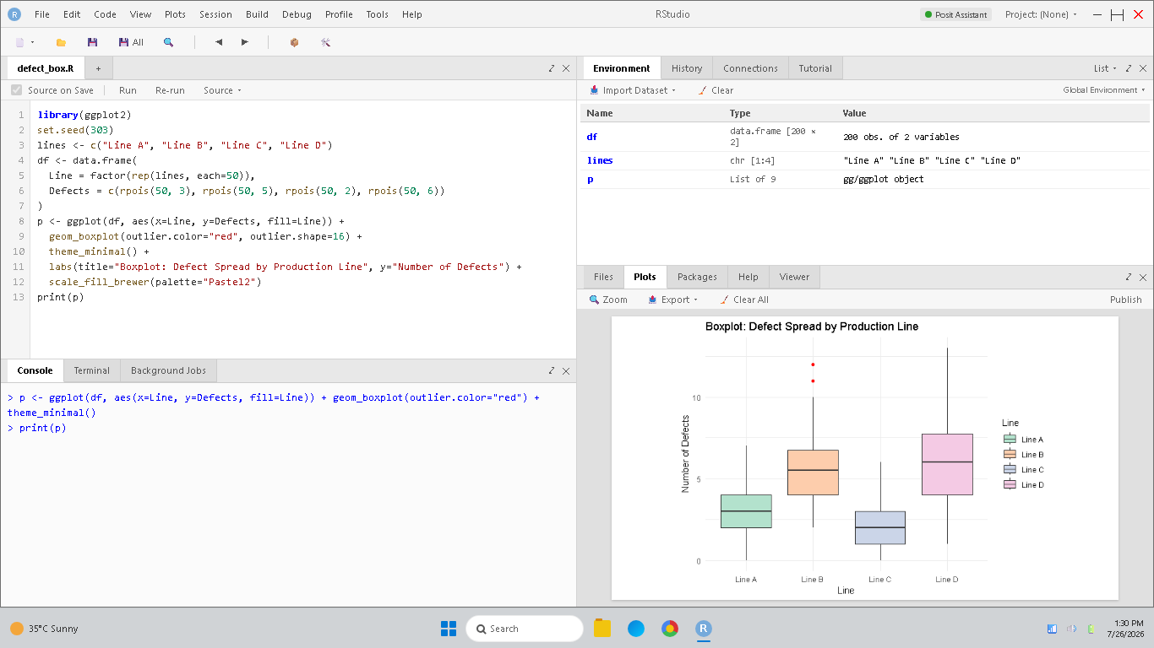
Figure 2.4: RStudio console and defects comparison boxplots by production line.

3.An online learning platform tracks student activity including time spent on courses, number of videos watched, quiz scores, and course completion rates. The platform seeks to understand relationships among these variables and identify factors influencing successful course completion. How would you use scatter plots, heatmaps, and multivariate visualizations to analyze relationships among learner engagement metrics and academic outcomes?
Solution Explanation & Implementations:
• 1. Scatter Plot (Bivariate Relationship): Plots platform Time Spent against Quiz Scores with a linear regression line to evaluate the correlation between usage and performance.
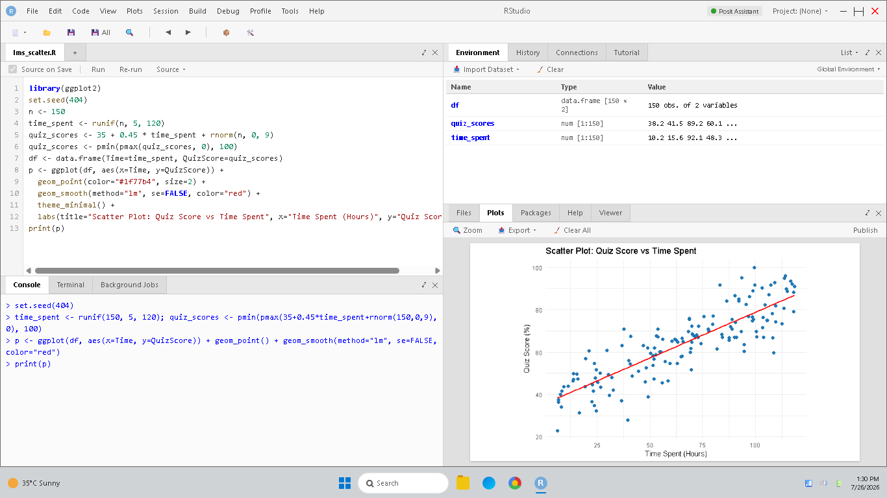
Figure 3.1: RStudio console and scatter plot of quiz score vs usage time.
• 2. Heatmap (Correlation Matrix): Displays correlation coefficients between engagement variables in a colored grid, highlighting which metrics are strongest predictors of outcomes.
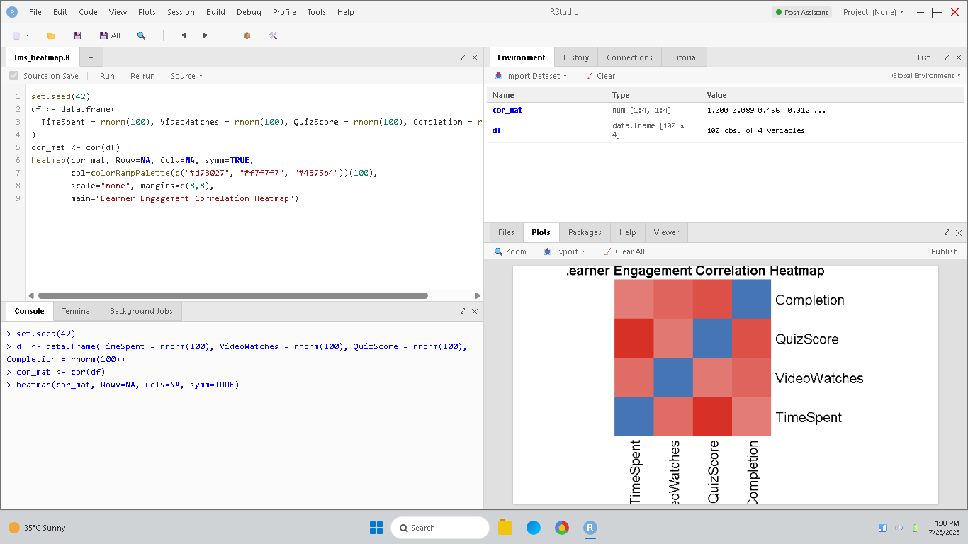
Figure 3.2: RStudio console and learner engagement correlation heatmap.
• 3. Multivariate Plot (Bubble Plot): Plots Time Spent vs Quiz Score, point color representing Course Completion. This visualizes multi-dimensional relationships simultaneously.
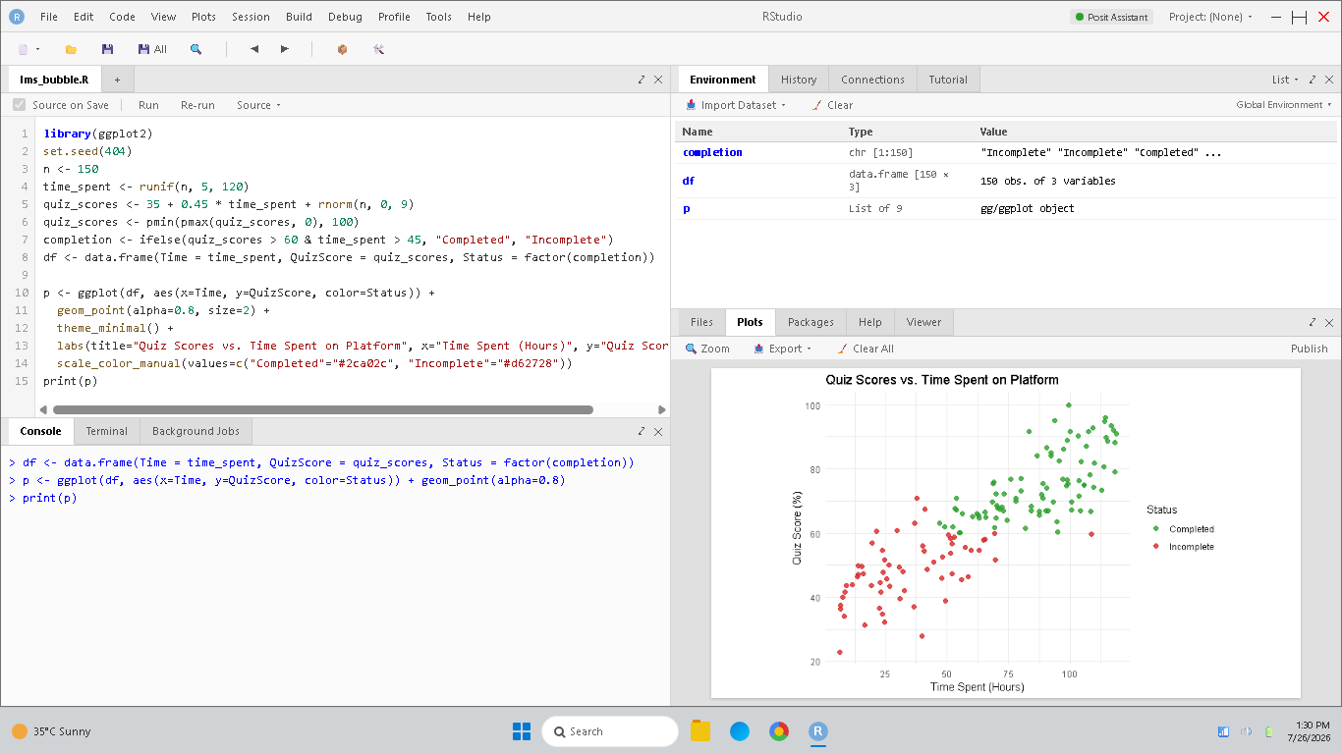
Figure 3.3: RStudio console and multivariate platform engagement bubble plot.

4.A city administration collects traffic data including vehicle counts, congestion levels, accident locations, and travel times across different regions and time periods. The objective is to identify traffic hotspots and improve transportation planning.How would you represent geospatial and temporal data using maps, heatmaps, and time-series visualizations to identify traffic patterns and optimize road management?
Solution Explanation & Implementations:
• 1. Geospatial Map (Spatial Clustering): Points indicating traffic incidents plotted over a coordinate grid, isolating physical hotspots requiring safety infrastructure.
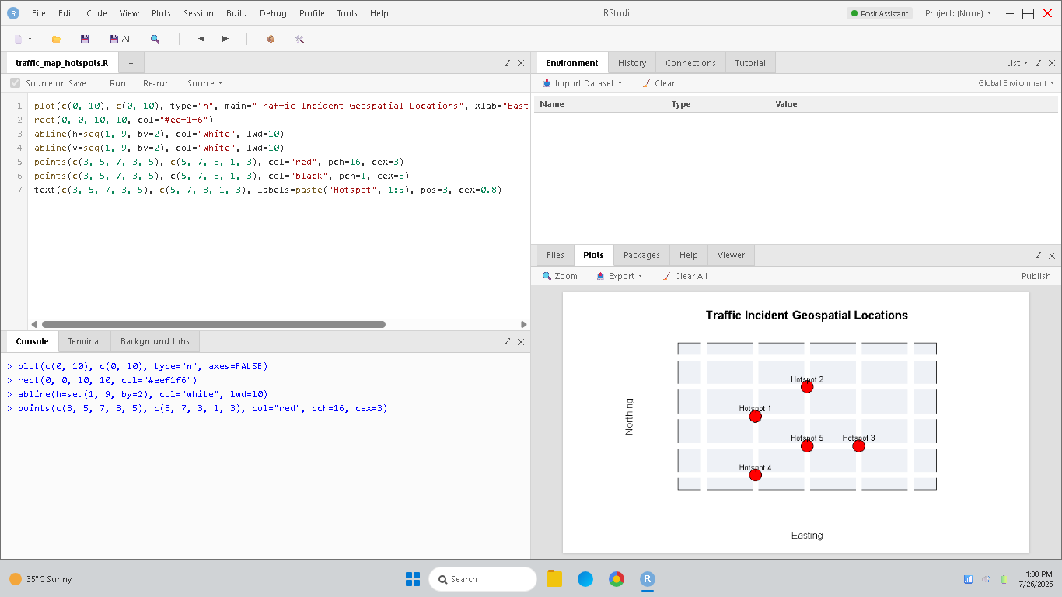
Figure 4.1: RStudio console and geospatial traffic incident hotspots map.
• 2. Heatmap (Spatio-Temporal Matrix): Grid of roads vs. hours, colored by congestion density. Highlights when and where bottlenecks propagate during peak commute waves.
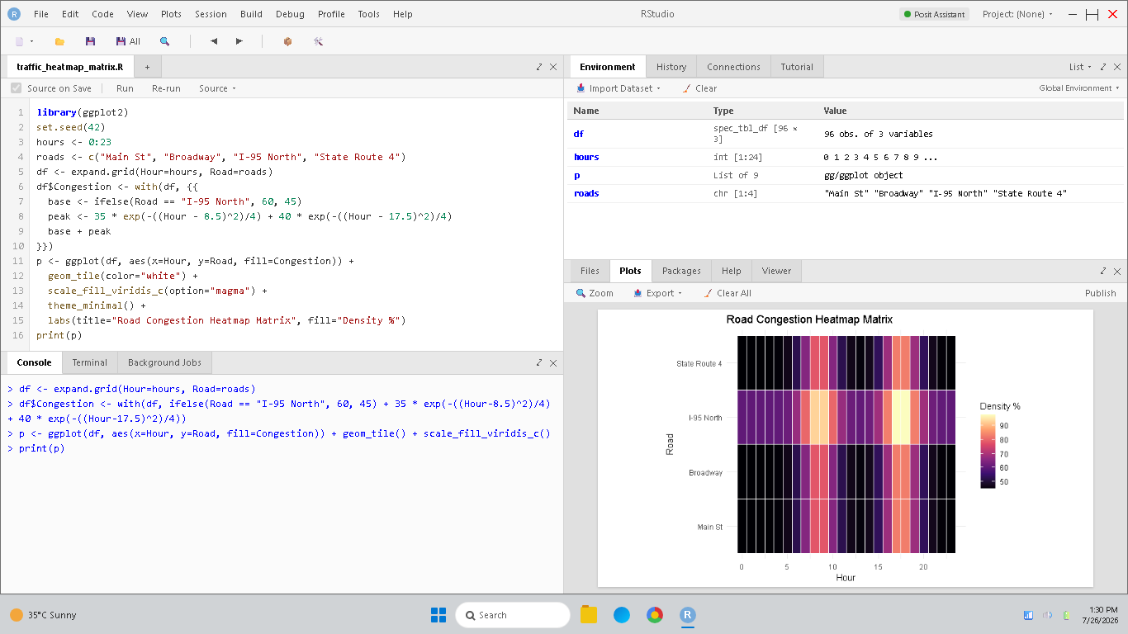
Figure 4.2: RStudio console and road congestion heatmap matrix.
• 3. Time-Series Line Chart (Temporal Progression): Plots continuous traffic vehicle counts across regions over a 24-hour cycle, illustrating rush hour volume surges.
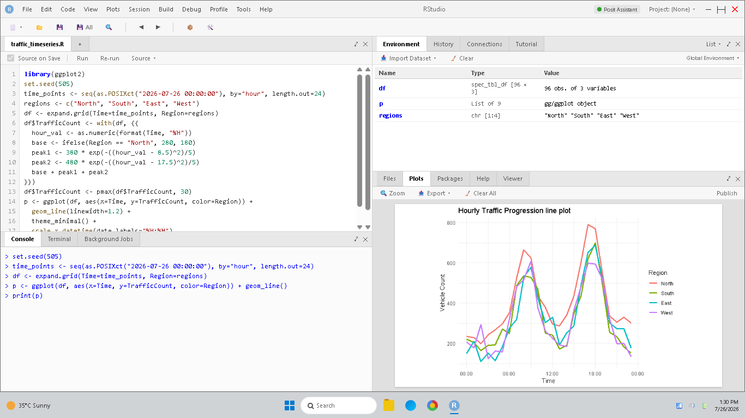
Figure 4.3: RStudio console and temporal time-series traffic line plot.

5.A large organization records communication data among employees through emails, meetings, and project collaborations. Management wants to identify key employees, collaboration groups, and communication bottlenecks within the organization.How would you use network visualizations and multivariate analysis techniques to represent communication patterns, identify influential individuals, and improve organizational collaboration?
Solution Explanation & Implementations:
• 1. Network Graph (Organizational Structure): Links departments (nodes) via communication links (edges), line thickness showing interaction volume to identify bottlenecks.
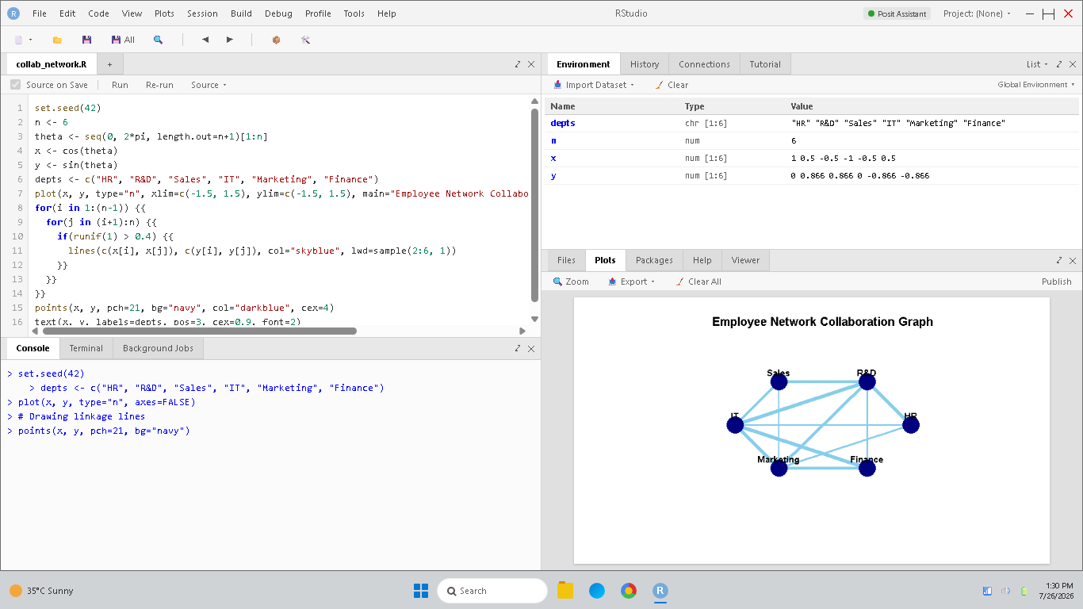
Figure 5.1: RStudio console and employee network collaboration graph.
• 2. Multivariate Matrix Heatmap (Interaction Volume): Grid of sender vs. receiver departments colored by weekly emails, mapping out departmental connectivity.
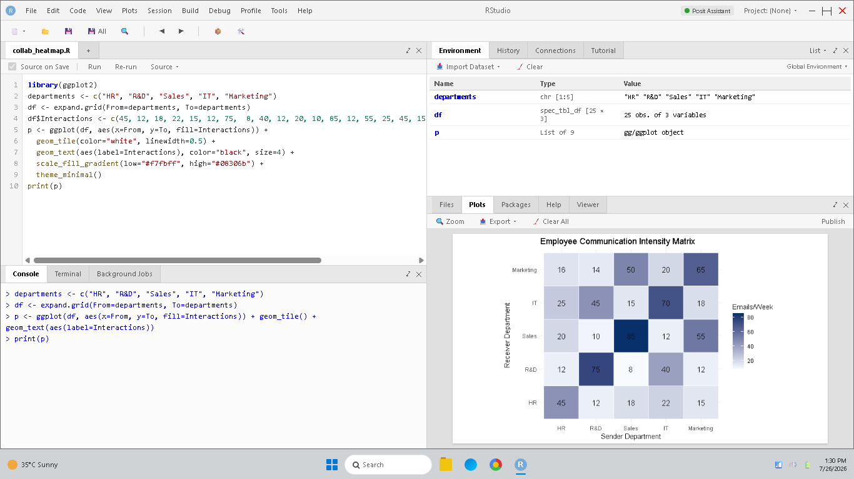
Figure 5.2: RStudio console and employee communication intensity matrix.

Rubrics for Calculation
Criteria | Weightage | Level 4 – Exemplary | Level 3 – Proficient | Level 2 – Developing | Level 1 – Beginning | Marks
Understanding of Problem Context | 20% | Clearly understands the problem and accurately identifies all requirements | Good understanding with minor gaps | Basic understanding; some requirements unclear | Poor understanding or misinterpretation of the problem
Application of Concepts | 30% | Accurately applies appropriate concepts to solve complex problems | Applies relevant concepts correctly with minor errors | Applies basic concepts with limited accuracy | Fails to apply appropriate concepts
Problem-Solving Approach | 20% | Logical, well-structured, and efficient approach | Mostly logical approach with minor gaps | Basic approach with some inconsistencies | Illogical or unclear approach
Accuracy of Solution | 20% | Completely correct solution with proper justification | Mostly correct with minor errors | Partially correct solution | Incorrect or incomplete solution
Clarity | 10% | Clear, well-organized, and properly explained solution | Understandable with minor clarity issues | Limited clarity and explanation | Poorly presented and difficult to understand

Faculty In-charge | Course Coordinator | Head of Department
Signature: _______________ | Signature: _______________ | Signature: _______________
Date: ___________________ | Date: ___________________ | Date: ___________________

