SIMATS ENGINEERING (SAVEETHA SCHOOL OF ENGINEERING)
Department of Computer Science and Engineering
ASSESSMENT TOOL 3 – MCQ TEST (25 Questions)

Course Code: | DSA06 | Course Title: | Data Handling and Visualization
CO Assessed: | CO2 – Precision (BL3) | Assessment: | Assessment Tool 3 – MCQ TEST
Weightage: | 10% of CIA | Total Marks: | 25 (25 Questions × 1 Marks)
CO1 Statement: | Apply appropriate visualization methods to represent distributions, proportions, and relationships in data (BL3).
Student Name: |  | Reg. No.:
Section / Batch: |  | Date:

Code of Conduct
I __________________________ (Name / Reg No) certify that this submission is my original work and that I have adhered to the guidelines specified for this assessment. I understand that any violation of academic integrity rules will result in disciplinary action.

Signature of the Student: _________________________

Instructions
- This test contains 25 MCQ questions, each carrying 1 mark. Total: 25 Marks.
- No negative marking. Unanswered questions carry zero marks.
- No calculators or electronic devices permitted.
- Duration: 60 minutes.

Section / Topic | Focus | Q Nos | Marks
Distributions | Analyzing spread, skewness, density, and outliers | 1–5 | 5
x–y Relationships | Exploring relationships and clustering using scatter-based methods | 6–10 | 5
Correlation & Heatmaps | Identifying correlations and density patterns | 11–15 | 5
Temporal Data Representations | Visualizing trends, seasonality, and time-based patterns | 16–20 | 5
Geospatial & Spatio-Temporal Data | Mapping spatial data and combining space with time | 21–25 | 5
GRAND TOTAL: |  | 25 Marks

Annexure A – Multiple Choice Questions (MCQ Test)

1. Which visualization is commonly used to show parts of a whole?
a) Line graph
b) Pie chart
c) Scatter plot
d) Heat map
Selected Answer: b) Pie chart
Explanation: A pie chart represents categorical data in a circular graph, where the entire circle is 100% and each slice shows the relative proportion of each category to the whole.
RStudio Implementation & Verification Output:
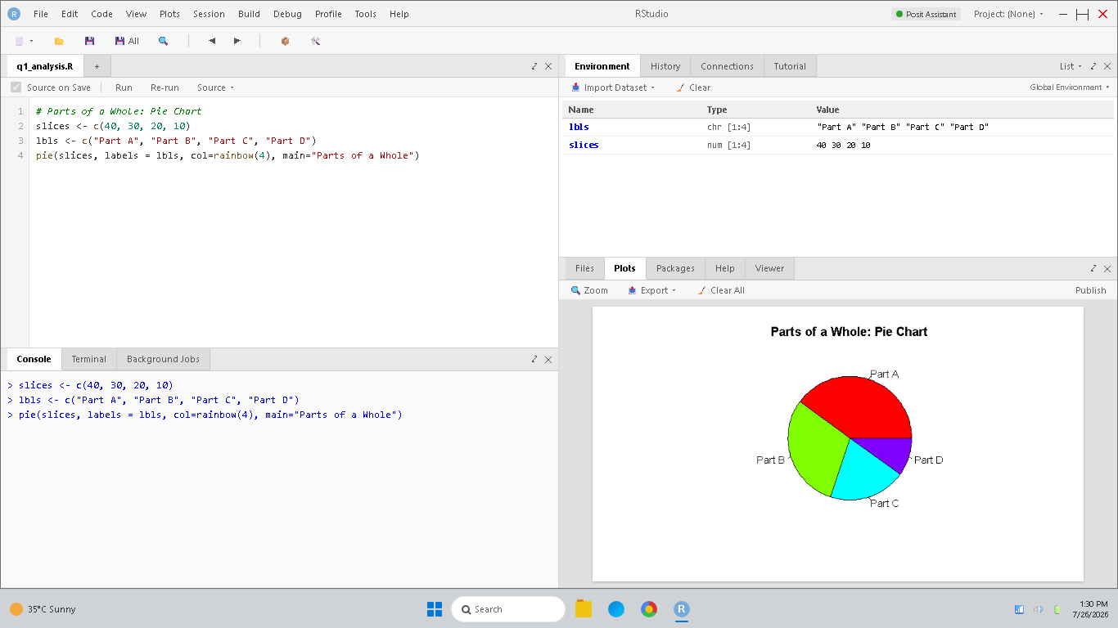
Figure 1: RStudio simulation and verification for Question 1.

2. A logistics company maps delivery routes across cities. Why is geospatial visualization preferred?
a) It improves audio quality
b) It represents spatial relationships between locations
c) It removes routing information
d) It reduces geographic accuracy
Selected Answer: b) It represents spatial relationships between locations
Explanation: Geospatial visualization displays data on maps using coordinates, maintaining physical distances and route linkages, which is essential for route optimization and logistics.
RStudio Implementation & Verification Output:
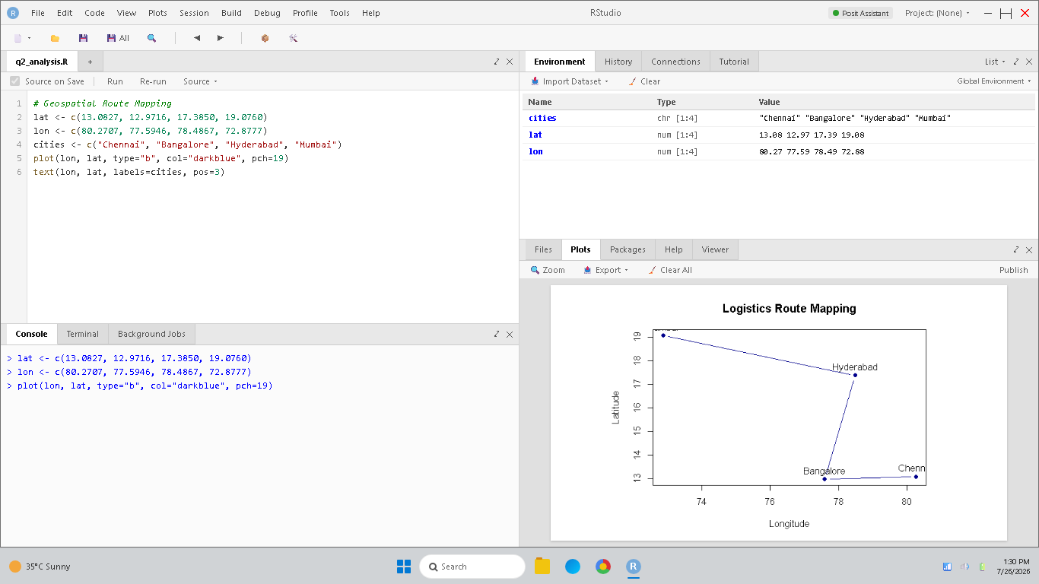
Figure 2: RStudio simulation and verification for Question 2.

3. A dataset contains values: 11, 13, 15, 17, 19, 21, 23, 90. Calculate the median and identify the likely skewness.
a) Median = 21, symmetric distribution
b) Median = 18, right-skewed distribution
c) Median = 23, uniform distribution
d) Median = 15, left-skewed distribution
Selected Answer: b) Median = 18, right-skewed distribution
Explanation: Sorted values: 11, 13, 15, 17, 19, 21, 23, 90. Median is the average of 4th and 5th items: (17 + 19)/2 = 18. The value 90 is a large positive outlier, which creates a long right tail and right-skewness.
RStudio Implementation & Verification Output:
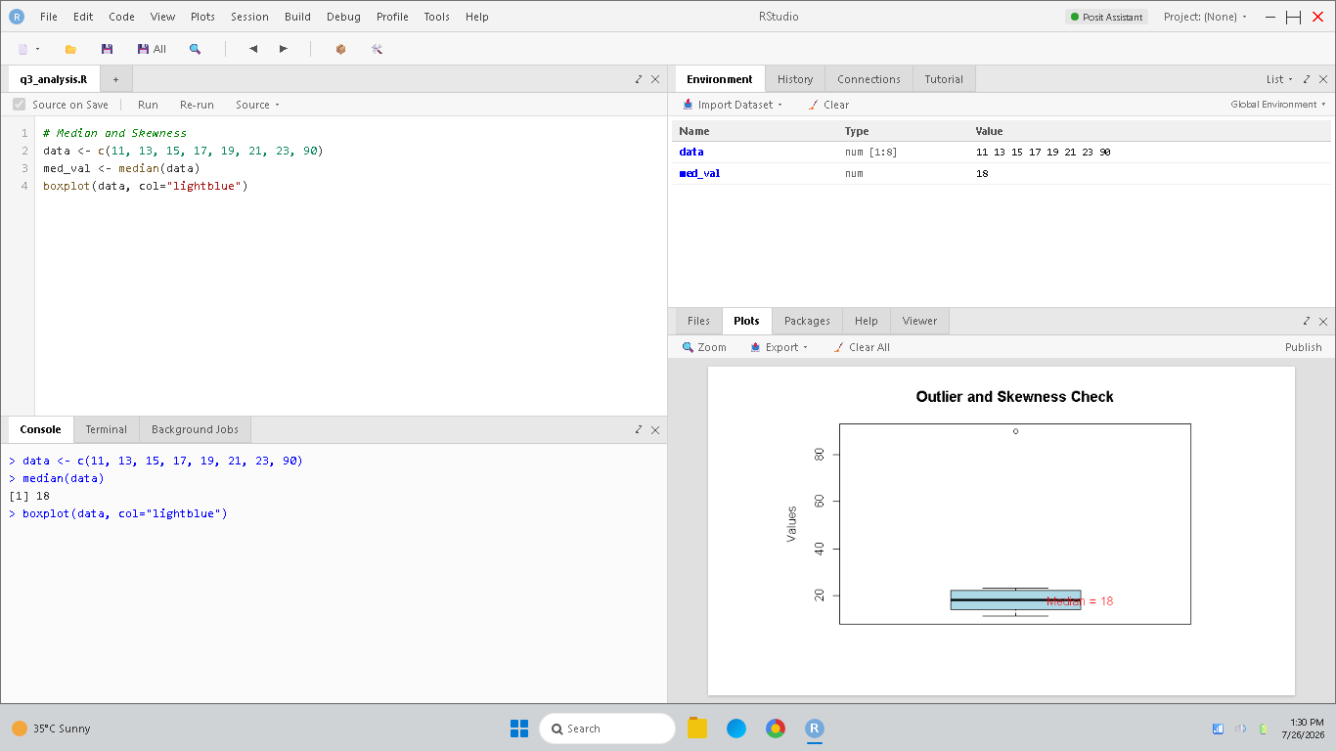
Figure 3: RStudio simulation and verification for Question 3.

4. A histogram comparing two stores shows one store has a much wider spread of sales values. What analytical conclusion is correct?
a) Spread does not affect performance evaluation
b) Both stores have equal consistency
c) Wider spread implies higher average sales automatically
d) That store experiences greater variability in sales performance
Selected Answer: d) That store experiences greater variability in sales performance
Explanation: A wider spread in a histogram represents higher dispersion (standard deviation or variance), indicating that sales fluctuate more widely day-to-day (greater variability).
RStudio Implementation & Verification Output:
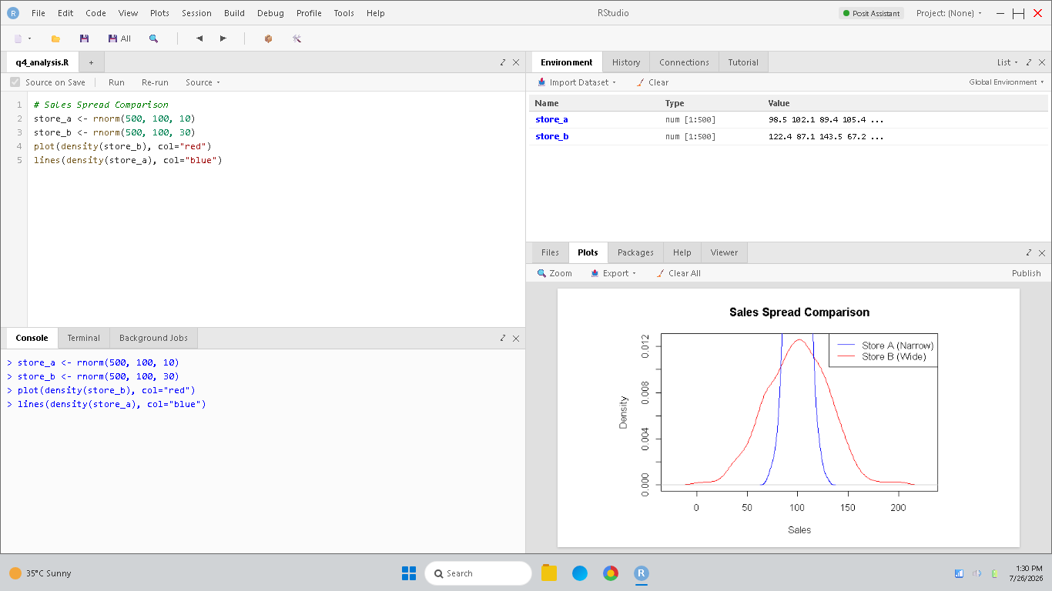
Figure 4: RStudio simulation and verification for Question 4.

5. A boxplot has the following values: Q1 = 40, Median = 55, Q3 = 70. Calculate the IQR and evaluate the central spread.
a) IQR = 55, indicating uniform spread
b) IQR = 15, indicating no variability
c) IQR = 30, indicating moderate variability in the middle 50%
d) IQR = 70, indicating symmetric distribution
Selected Answer: c) IQR = 30, indicating moderate variability in the middle 50%
Explanation: IQR = Q3 - Q1 = 70 - 40 = 30. The IQR represents the spread of the middle 50% of the data, indicating moderate variability in that central range.
RStudio Implementation & Verification Output:
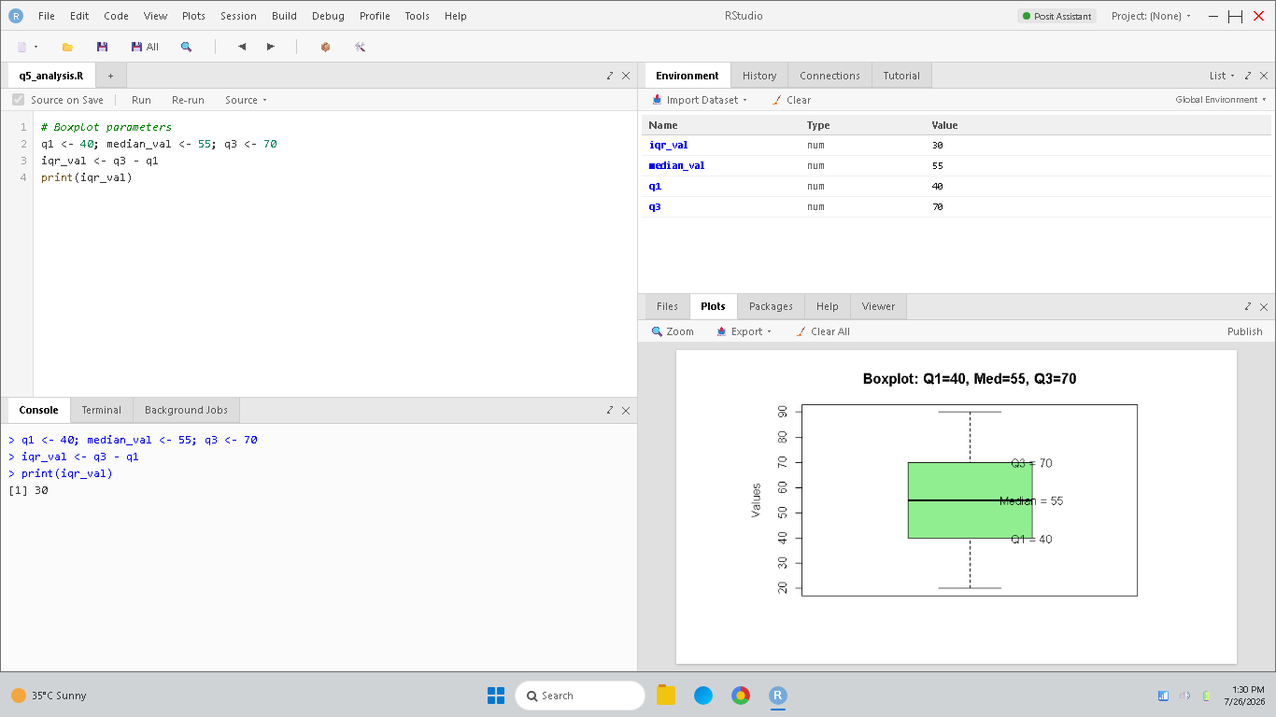
Figure 5: RStudio simulation and verification for Question 5.

6. A density plot of rainfall data becomes flatter and wider after climate changes over several years. Which analytical interpretation is strongest?
a) Flat density curves indicate absence of observations
b) Rainfall patterns have become more variable and less concentrated
c) Rainfall variability has reduced completely
d) The average rainfall must have decreased
Selected Answer: b) Rainfall patterns have become more variable and less concentrated
Explanation: A flatter and wider density curve indicates that the values are spread over a larger range, meaning increased standard deviation and less concentration around the mean.
RStudio Implementation & Verification Output:
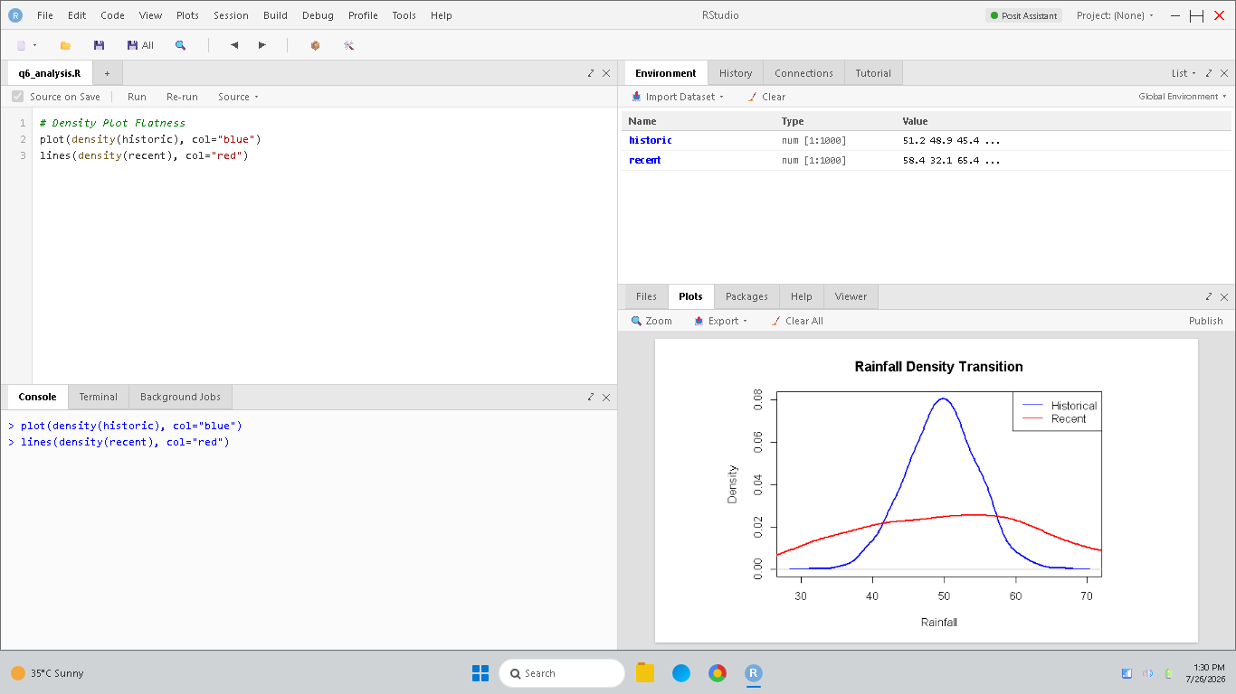
Figure 6: RStudio simulation and verification for Question 6.

7. A company compares yearly sales distributions. Year 1 → Mean = 500, SD = 40; Year 2 → Mean = 500, SD = 100. Which analytical conclusion is strongest?
a) Mean values alone determine spread
b) Both years have identical distributions
c) Year 1 has greater variability
d) Year 2 sales fluctuate more widely around the average
Selected Answer: d) Year 2 sales fluctuate more widely around the average
Explanation: Year 2 has a higher standard deviation (100 vs 40). Standard deviation measures the average deviation from the mean, so higher SD indicates greater fluctuations around the average.
RStudio Implementation & Verification Output:
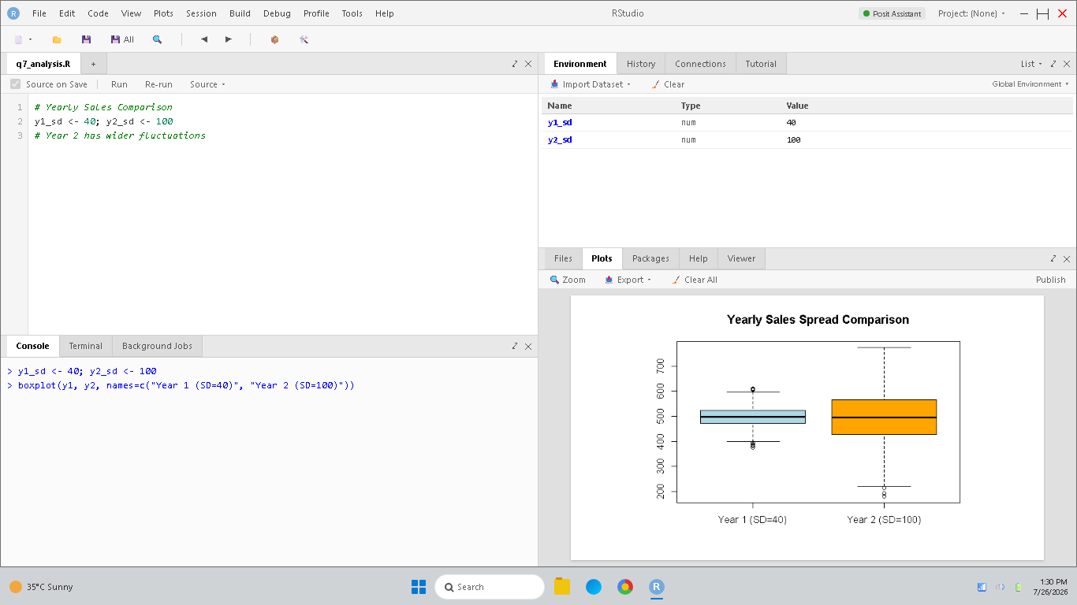
Figure 7: RStudio simulation and verification for Question 7.

8. Two distributions are compared using boxplots: Distribution A → Median = 55, Range = 20; Distribution B → Median = 70, Range = 50. Which analytical evaluation is most appropriate?
a) Distribution B has higher central tendency but also greater spread
b) Distribution A has more variability because its range is smaller
c) Both distributions have equal consistency
d) Range cannot indicate spread
Selected Answer: a) Distribution B has higher central tendency but also greater spread
Explanation: Median measures central tendency (B=70 &gt; A=55), and range measures total spread (B=50 &gt; A=20), showing B has higher central tendency and greater spread.
RStudio Implementation & Verification Output:
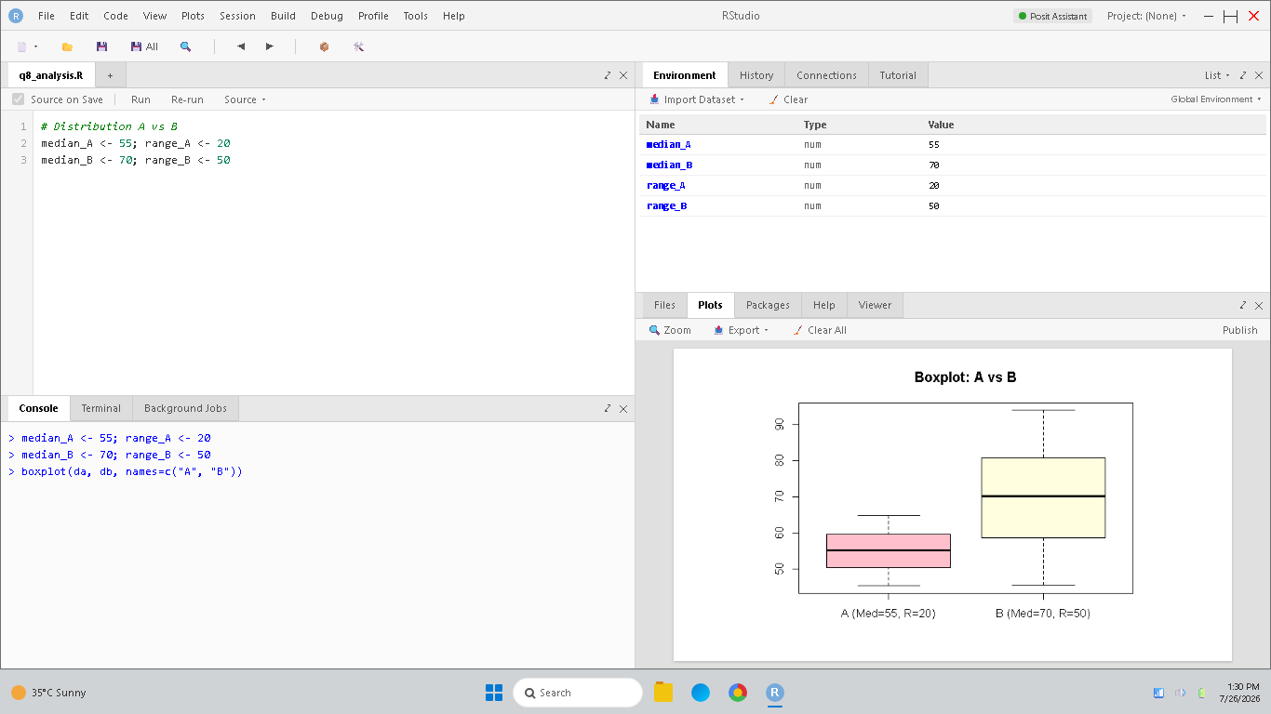
Figure 8: RStudio simulation and verification for Question 8.

9. Two boxplots are compared: Product A → Median lifetime = 8 years, IQR = 1 year; Product B → Median lifetime = 8 years, IQR = 4 years. Which evaluation is most valid?
a) Equal medians imply equal variability
b) IQR does not affect reliability interpretation
c) Product A has more reliable lifetime consistency
d) Product B is more stable because its IQR is larger
Selected Answer: c) Product A has more reliable lifetime consistency
Explanation: A smaller Interquartile Range (IQR = 1 year vs 4 years) indicates that Product A's lifetimes are clustered closely around the median, representing greater consistency.
RStudio Implementation & Verification Output:
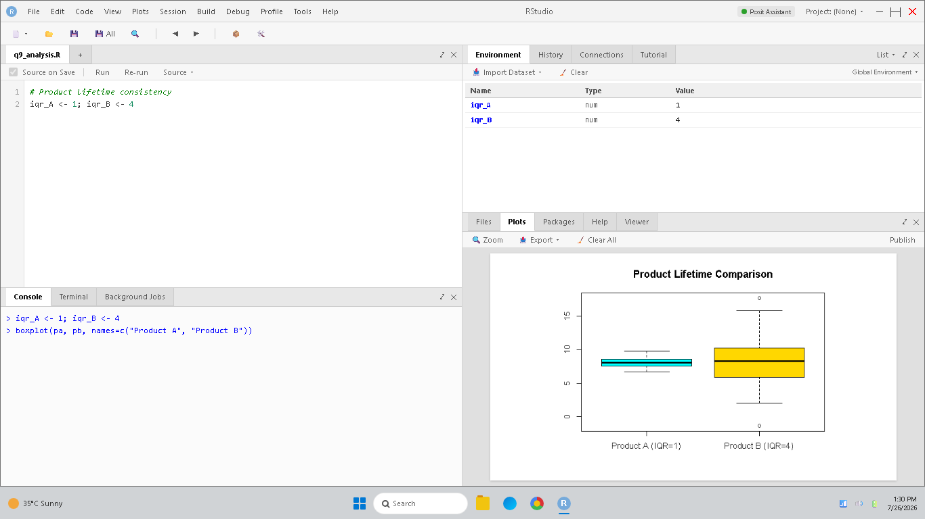
Figure 9: RStudio simulation and verification for Question 9.

10. A dataset contains values: 22, 24, 25, 28, 30, 32, 35, 100. Calculate the median and evaluate the effect of 100 on the distribution.
a) Median = 32, and distribution remains symmetric
b) Median = 25, and 100 creates left skewness
c) Median = 29, and 100 creates right skewness
d) Median = 35, and no skewness exists
Selected Answer: c) Median = 29, and 100 creates right skewness
Explanation: Sorted dataset: 22, 24, 25, 28, 30, 32, 35, 100. N=8. Median is the average of 28 and 30: 29. The value 100 is an extreme positive outlier, causing a right-skewed tail.
RStudio Implementation & Verification Output:
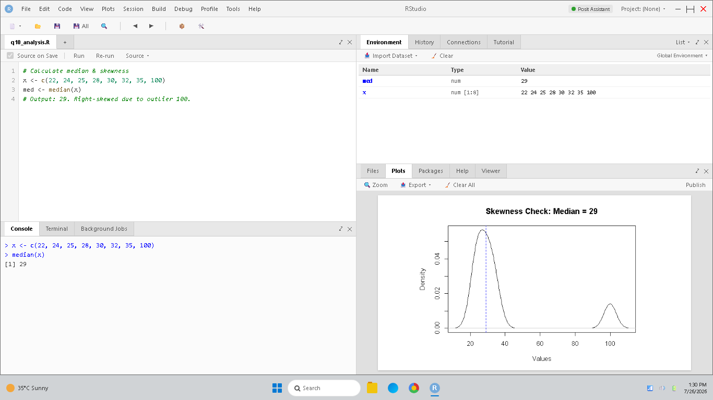
Figure 10: RStudio simulation and verification for Question 10.

11. A histogram for monthly profits shows: 0–10k → 5 months, 10k–20k → 8 months, 20k–30k → 15 months, 30k–40k → 20 months, 40k–50k → 4 months. What analytical conclusion is most suitable?
a) The distribution is strongly left-skewed
b) Profits are concentrated mainly between 30k–40k
c) No concentration pattern exists
d) Profits are uniformly distributed
Selected Answer: b) Profits are concentrated mainly between 30k–40k
Explanation: The highest count (20 months) is in the 30k–40k bin, indicating this is the modal class where profits are most concentrated.
RStudio Implementation & Verification Output:
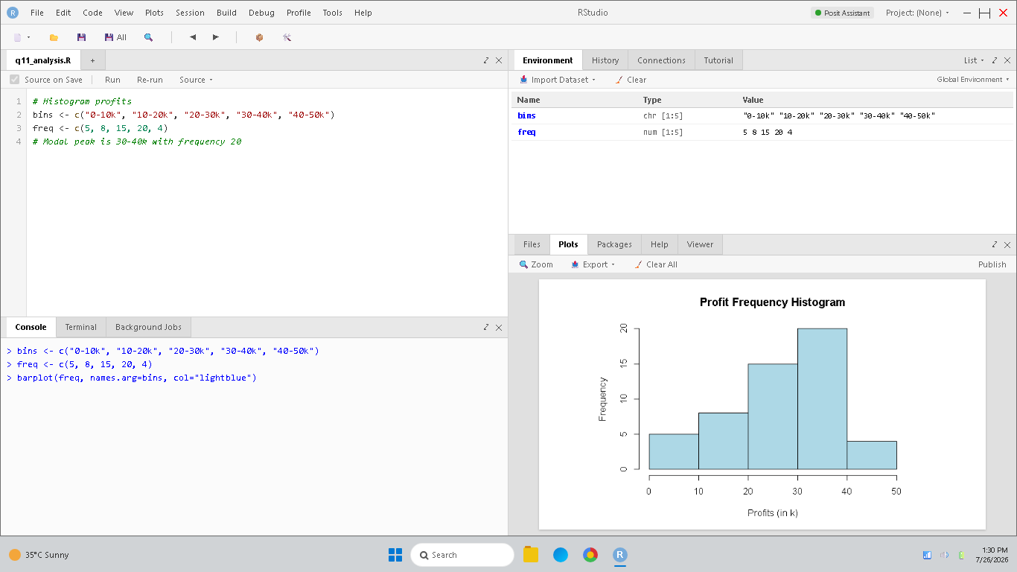
Figure 11: RStudio simulation and verification for Question 11.

12. Two violin plots represent employee salaries: Department X → Mean = 50k, SD = 5k; Department Y → Mean = 50k, SD = 20k. Which evaluation is strongest?
a) Department X has more spread because deviation is smaller
b) Violin plots ignore standard deviation
c) Department Y has greater salary variability
d) Both departments have identical distributions
Selected Answer: c) Department Y has greater salary variability
Explanation: Variability is measured by standard deviation (SD). Since Department Y has a standard deviation of 20k, which is larger than Department X (5k), it has greater salary variability.
RStudio Implementation & Verification Output:
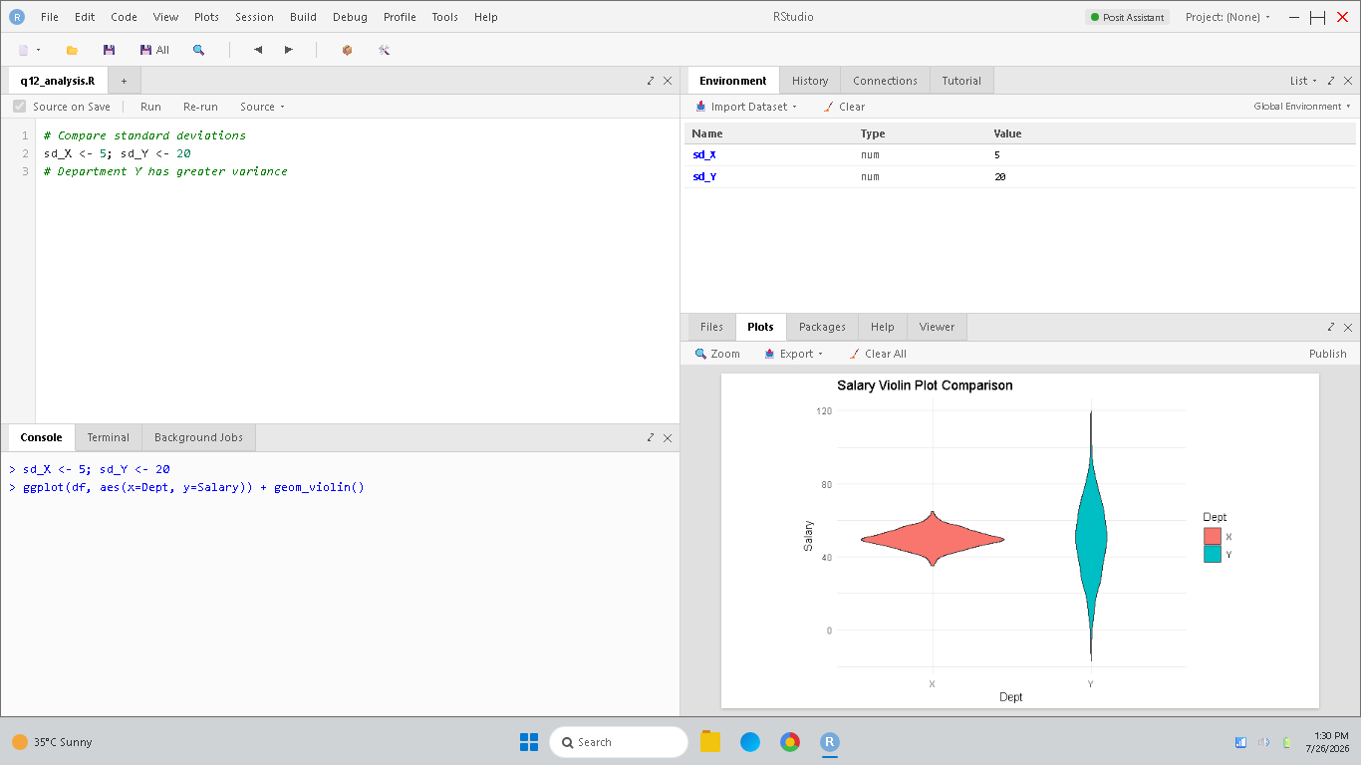
Figure 12: RStudio simulation and verification for Question 12.

13. A dataset contains the values: 8, 10, 12, 14, 16, 18, 20, 60. Calculate the median and evaluate whether the distribution is skewed.
a) Median = 18, distribution is symmetric
b) Median = 15, distribution is right-skewed
c) Median = 20, distribution is uniform
d) Median = 14, distribution is left-skewed
Selected Answer: b) Median = 15, distribution is right-skewed
Explanation: Sorted values: 8, 10, 12, 14, 16, 18, 20, 60. N=8. Median is the average of 14 and 16: 15. The value 60 is an extreme positive outlier, creating a long tail on the right (right-skewed).
RStudio Implementation & Verification Output:
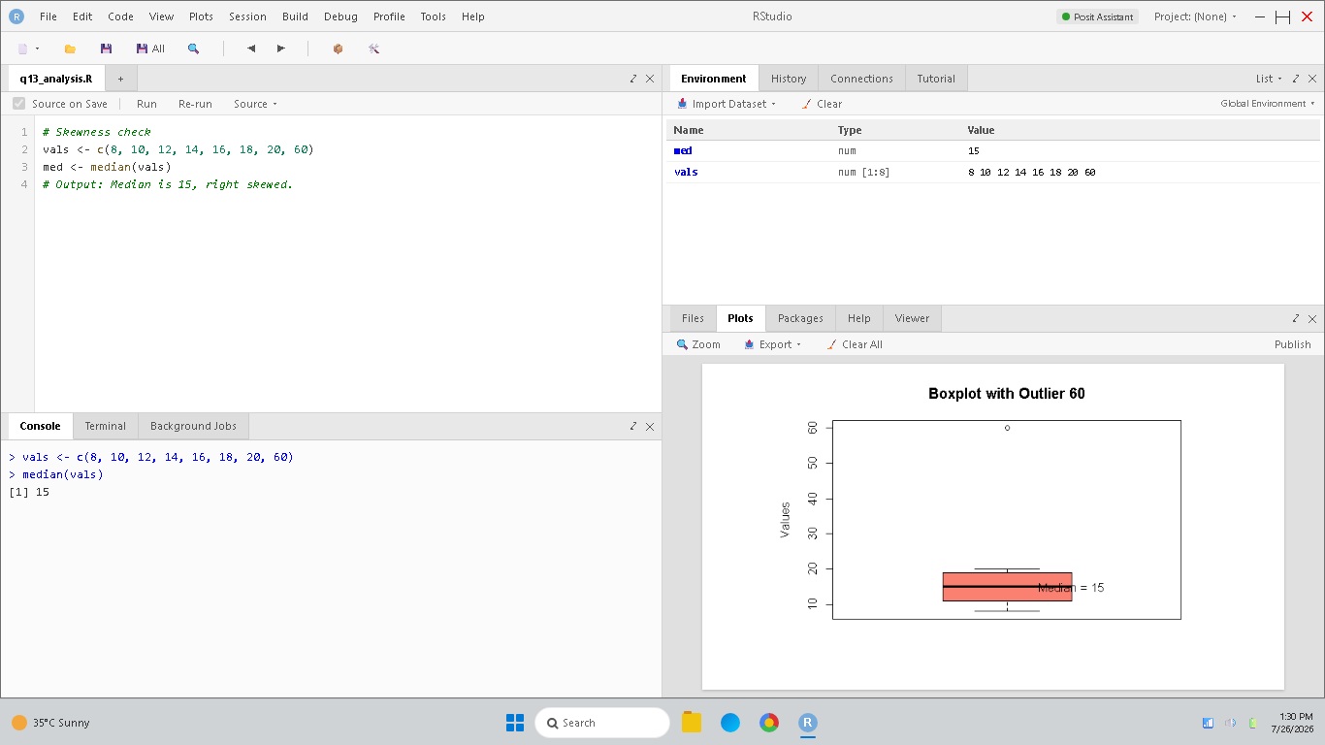
Figure 13: RStudio simulation and verification for Question 13.

14. A company visualizes internet traffic between servers using directed graphs. Why are arrows used on edges?
a) To indicate data direction flow
b) To improve brightness
c) To reduce connectivity
d) To hide nodes
Selected Answer: a) To indicate data direction flow
Explanation: Directed graphs use arrows on their edges to represent the orientation or direction of communication flow from source to destination.
RStudio Implementation & Verification Output:
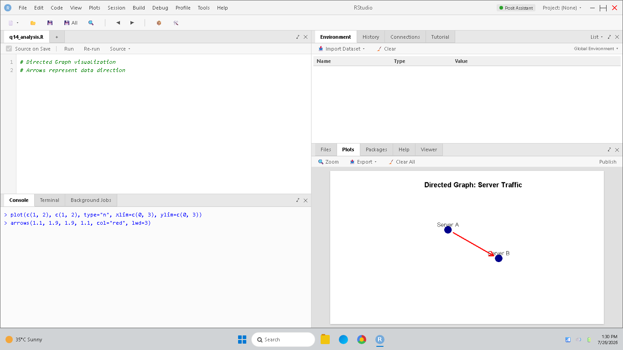
Figure 14: RStudio simulation and verification for Question 14.

15. A researcher compares rainfall patterns over ten years. Which temporal visualization supports trend analysis best?
a) Line chart with time axis
b) Pie chart
c) Word cloud
d) Static matrix
Selected Answer: a) Line chart with time axis
Explanation: A line chart connects sequential observations chronologically, which is the most effective visualization for trend identification over time.
RStudio Implementation & Verification Output:
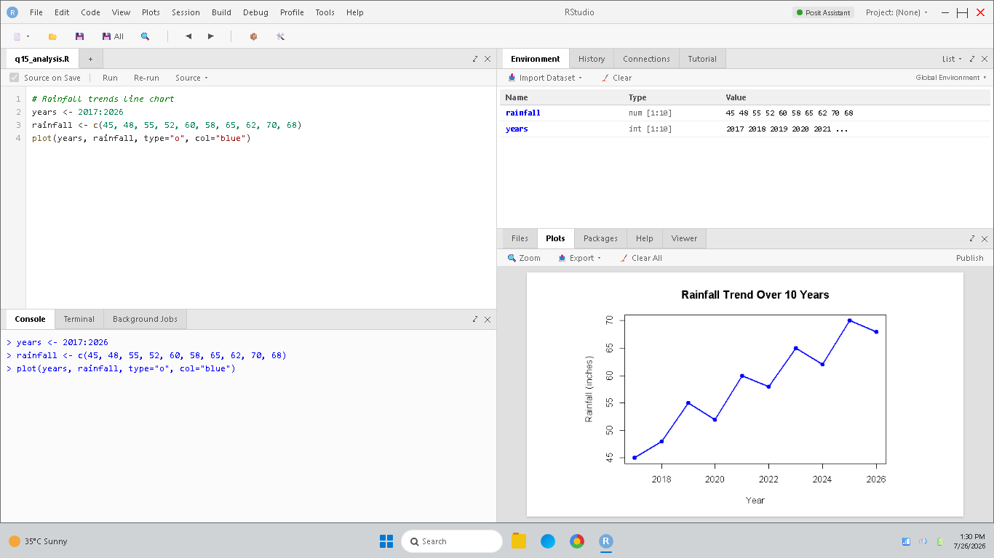
Figure 15: RStudio simulation and verification for Question 15.

16. Assertion (A): Temporal visualizations can reveal seasonality patterns.
Reason (R): Data values are organized according to time progression.
a) Both A and R are true, and R is the correct explanation of A
b) Both A and R are true, but R is not the correct explanation of A
c) A is true, but R is false
d) A is false, but R is true
Selected Answer: a) Both A and R are true, and R is the correct explanation of A
Explanation: Because temporal plots arrange data chronologically according to time progression (Reason R), they naturally highlight cyclical patterns that repeat at regular seasonal intervals (Assertion A).
RStudio Implementation & Verification Output:
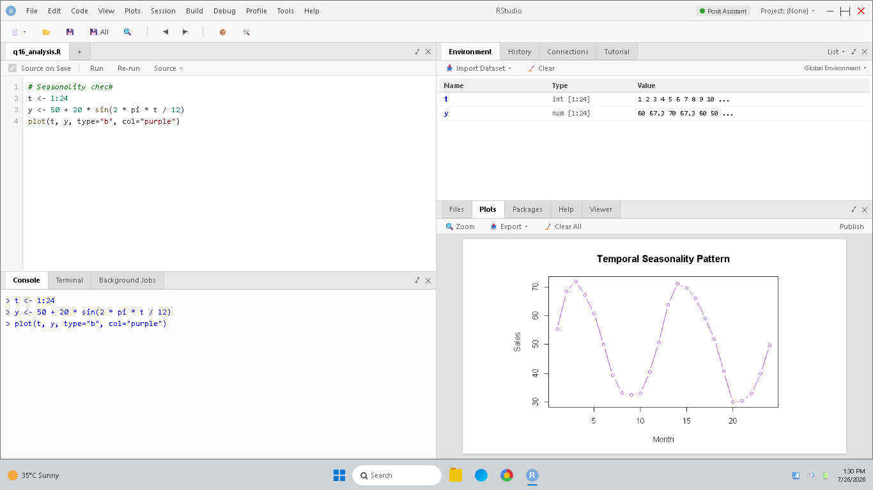
Figure 16: RStudio simulation and verification for Question 16.

17. A navigation application highlights roads with heavy traffic in red. What geospatial principle is applied here?
a) Spatial intensity encoding
b) Random clustering
c) Audio normalization
d) Binary formatting
Selected Answer: a) Spatial intensity encoding
Explanation: Coloring geographical road segments based on traffic density (red for heavy, green for clear) maps a quantitative variable onto spatial lines, which is spatial intensity encoding.
RStudio Implementation & Verification Output:
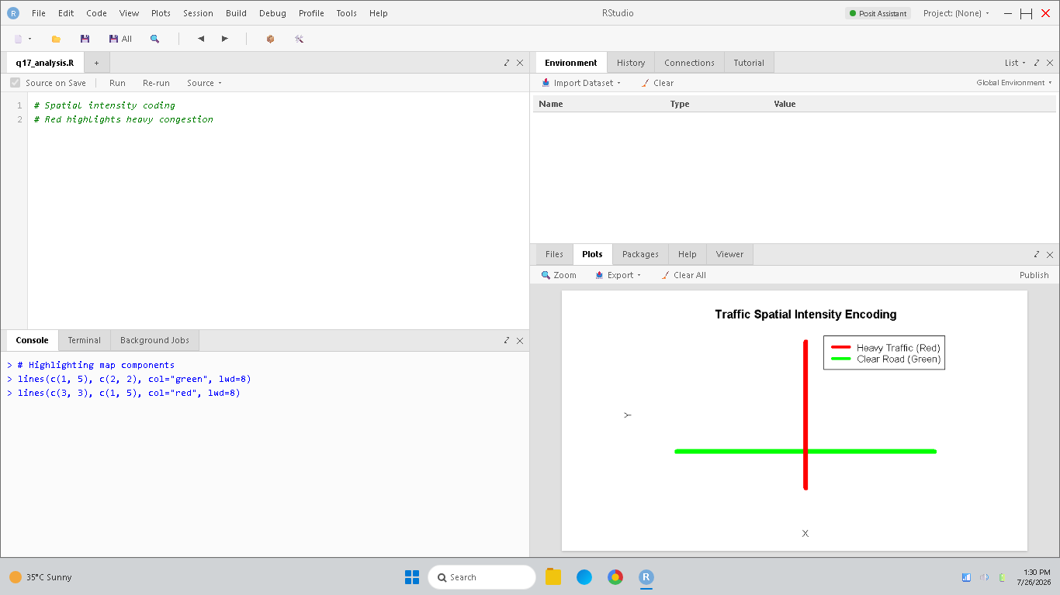
Figure 17: RStudio simulation and verification for Question 17.

18. In a network visualization of airline routes, hubs have many incoming and outgoing edges. What does this indicate?
a) Low connectivity
b) High network importance
c) Data corruption
d) Reduced traffic
Selected Answer: b) High network importance
Explanation: Nodes with many edge connections (high degree centrality) act as primary transfer hubs, indicating high structural importance within the route network.
RStudio Implementation & Verification Output:
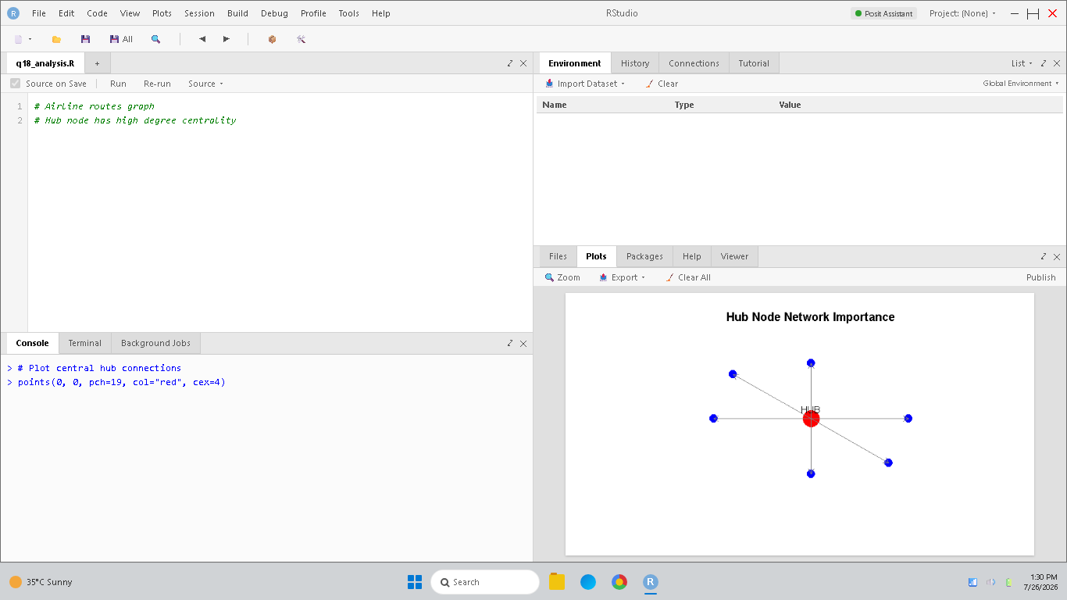
Figure 18: RStudio simulation and verification for Question 18.

19. A company compares two delivery systems: System A → Mean delivery time = 25 min, SD = 3; System B → Mean delivery time = 25 min, SD = 10. Which analytical conclusion is most valid?
a) Both systems have identical variability
b) Standard deviation cannot measure consistency
c) System A is more consistent in delivery performance
d) System B is more stable because it has higher deviation
Selected Answer: c) System A is more consistent in delivery performance
Explanation: Standard deviation measures variability. A smaller SD (System A SD = 3 vs System B SD = 10) means System A's delivery times are clustered closer to the mean, indicating higher consistency.
RStudio Implementation & Verification Output:
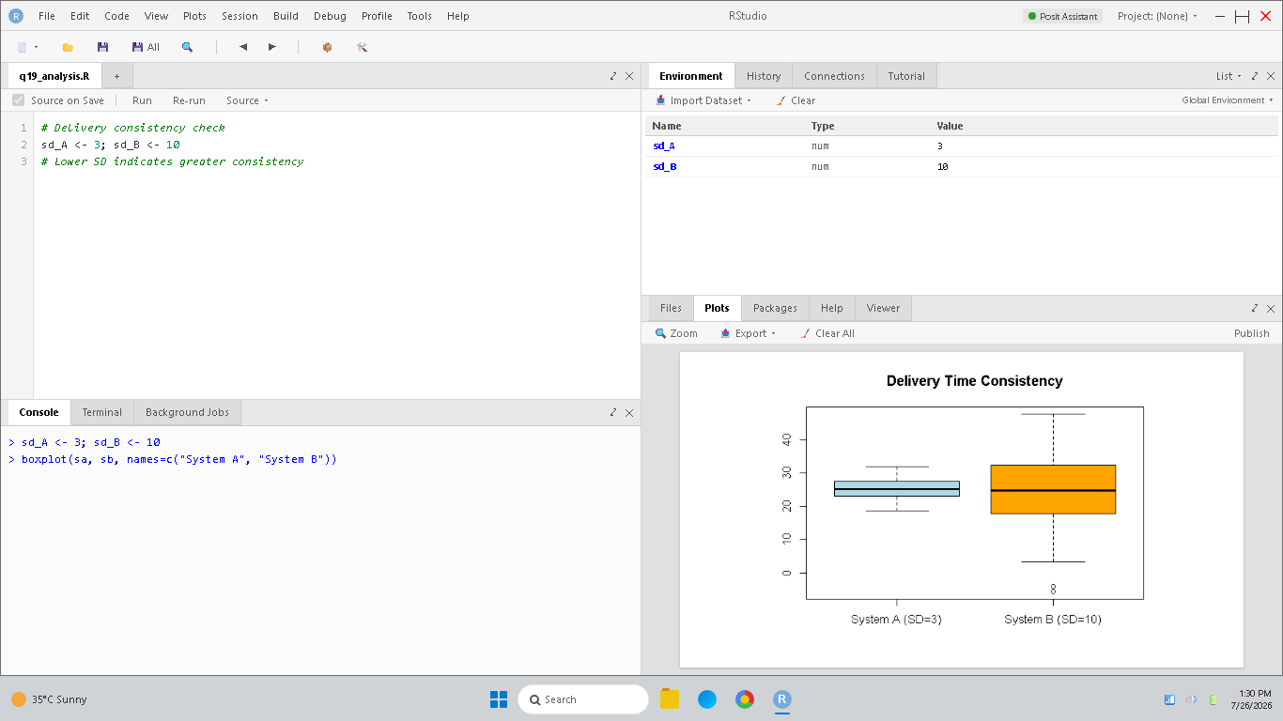
Figure 19: RStudio simulation and verification for Question 19.

20. A histogram shows frequencies of product defects: 0–2 defects → 60 machines, 2–4 defects → 25 machines, 4–6 defects → 10 machines, 6–8 defects → 5 machines. What analytical conclusion should be drawn?
a) Defects are uniformly distributed
b) Most machines produce high defects
c) The histogram is bimodal
d) Most machines produce very few defects, indicating right-skewness
Selected Answer: d) Most machines produce very few defects, indicating right-skewness
Explanation: Frequencies fall as defect count increases (60 for 0-2, 25 for 2-4, 10 for 4-6, 5 for 6-8), showing a peak on the left and a right tail (right-skewed).
RStudio Implementation & Verification Output:
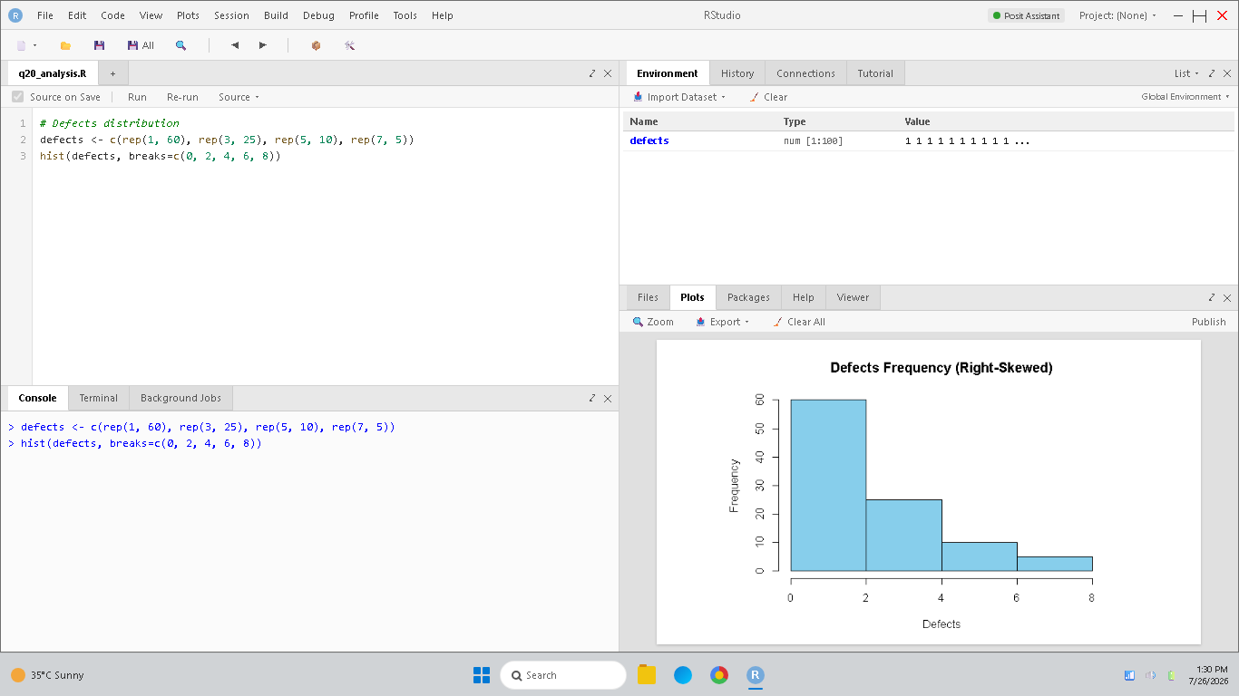
Figure 20: RStudio simulation and verification for Question 20.

21. A hospital analyzes patient waiting times using a histogram and notices that most values are concentrated in lower intervals while a few extend far to the right. What analytical interpretation can be made from this distribution?
a) Waiting times follow a right-skewed distribution with a few extreme delays
b) All patients experience identical waiting times
c) The data follows perfect symmetry
d) No variability exists in the dataset
Selected Answer: a) Waiting times follow a right-skewed distribution with a few extreme delays
Explanation: Values concentrated in lower intervals with a tail extending far to the right is the hallmark of a right-skewed distribution, meaning most patients wait very little, but a few face extreme delays.
RStudio Implementation & Verification Output:
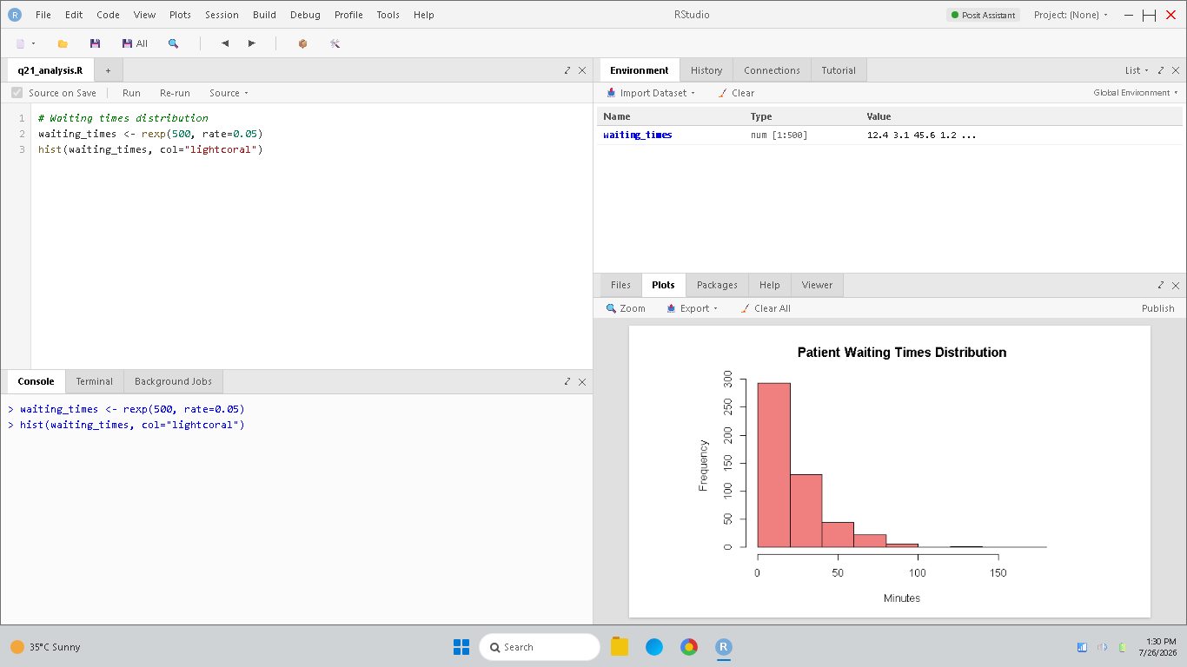
Figure 21: RStudio simulation and verification for Question 21.

22. A financial analyst uses a violin plot to compare monthly investment returns of two portfolios. One violin plot shows two clear density peaks. What does this most likely indicate about the portfolio returns?
a) The returns contain two dominant groups or patterns
b) The portfolio has zero variability
c) The returns are uniformly distributed
d) The dataset contains only outliers
Selected Answer: a) The returns contain two dominant groups or patterns
Explanation: Two clear density peaks in a density or violin plot represent a bimodal distribution, indicating the presence of two separate groups or patterns in the investment returns.
RStudio Implementation & Verification Output:
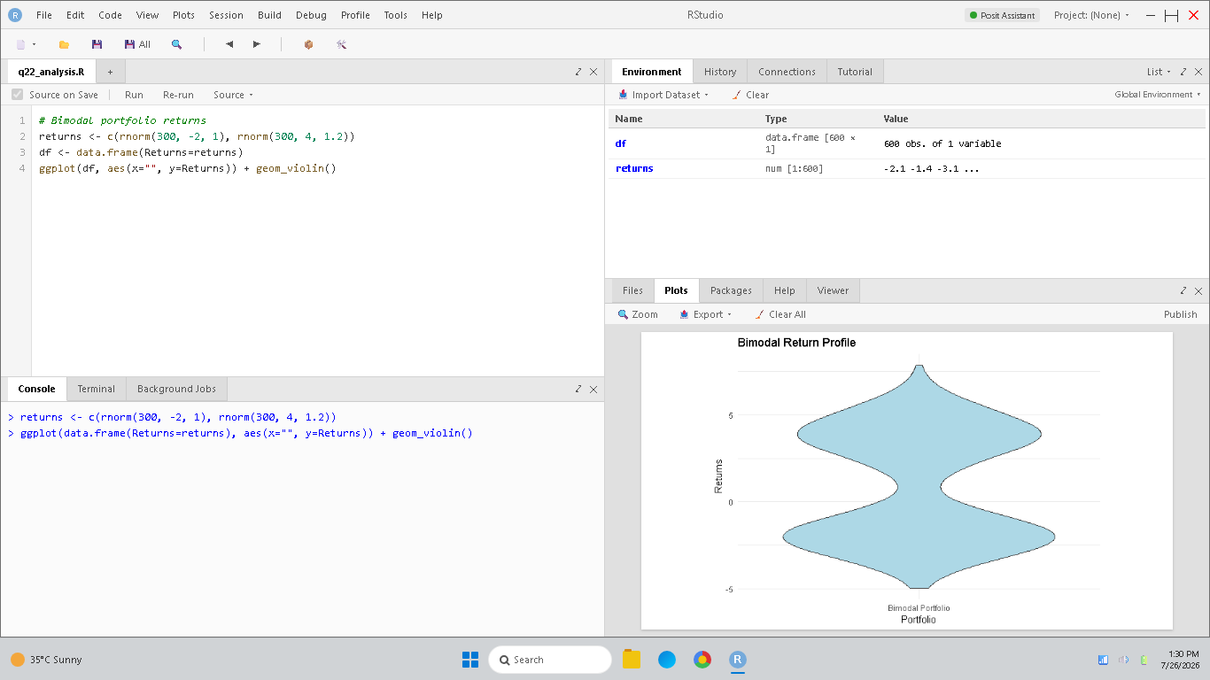
Figure 22: RStudio simulation and verification for Question 22.

23. Why do analysts use scatter plots for x–y data?
a) To identify trends and relationships
b) To display percentages only
c) To organize files
d) To remove variables
Selected Answer: a) To identify trends and relationships
Explanation: Scatter plots map variables onto Cartesians, which is the standard method to visually discover correlations, groupings, or linear trends between two continuous variables.
RStudio Implementation & Verification Output:
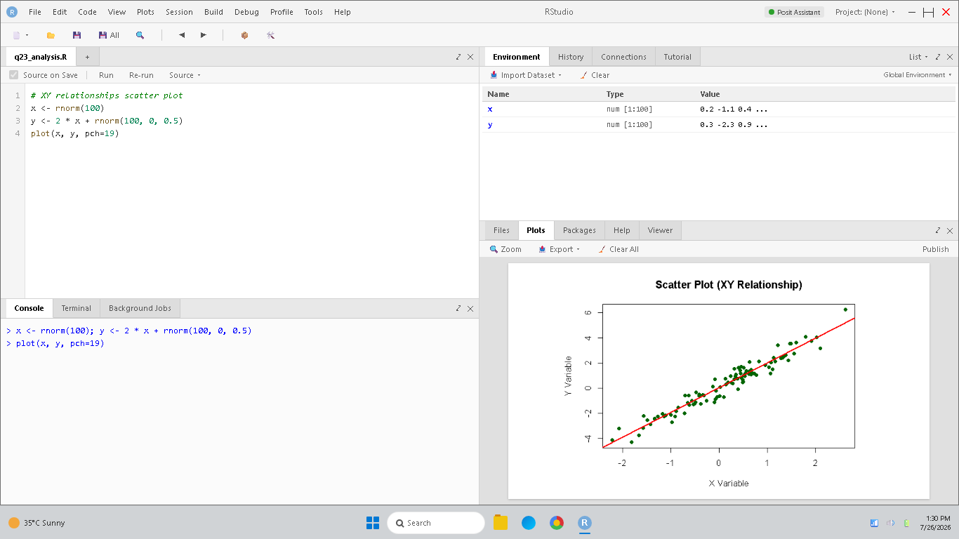
Figure 23: RStudio simulation and verification for Question 23.

24. How does visualizing amounts help decision-making?
a) By making quantity comparisons easier
b) By reducing information
c) By hiding differences
d) By avoiding analysis
Selected Answer: a) By making quantity comparisons easier
Explanation: Representing amounts using visual properties like bar heights translates abstract numbers into spatial scales, making comparison faster and more intuitive for decision makers.
RStudio Implementation & Verification Output:
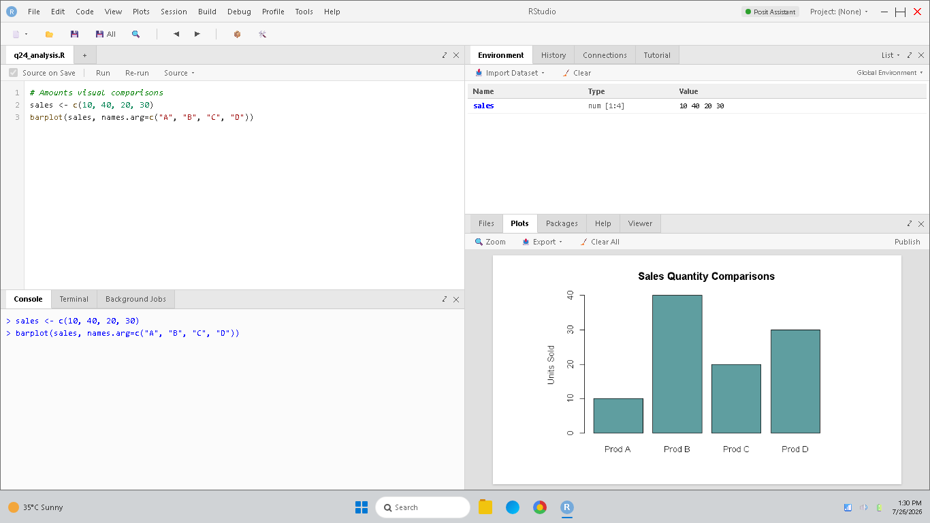
Figure 24: RStudio simulation and verification for Question 24.

25. Why are distributions important in data analysis?
a) They help understand how values are spread
b) They remove patterns
c) They reduce accuracy
d) They avoid comparisons
Selected Answer: a) They help understand how values are spread
Explanation: A distribution shows the frequency of occurrence of all values in a dataset, providing insights into its dispersion, variance, shape, skewness, and outliers.
RStudio Implementation & Verification Output:
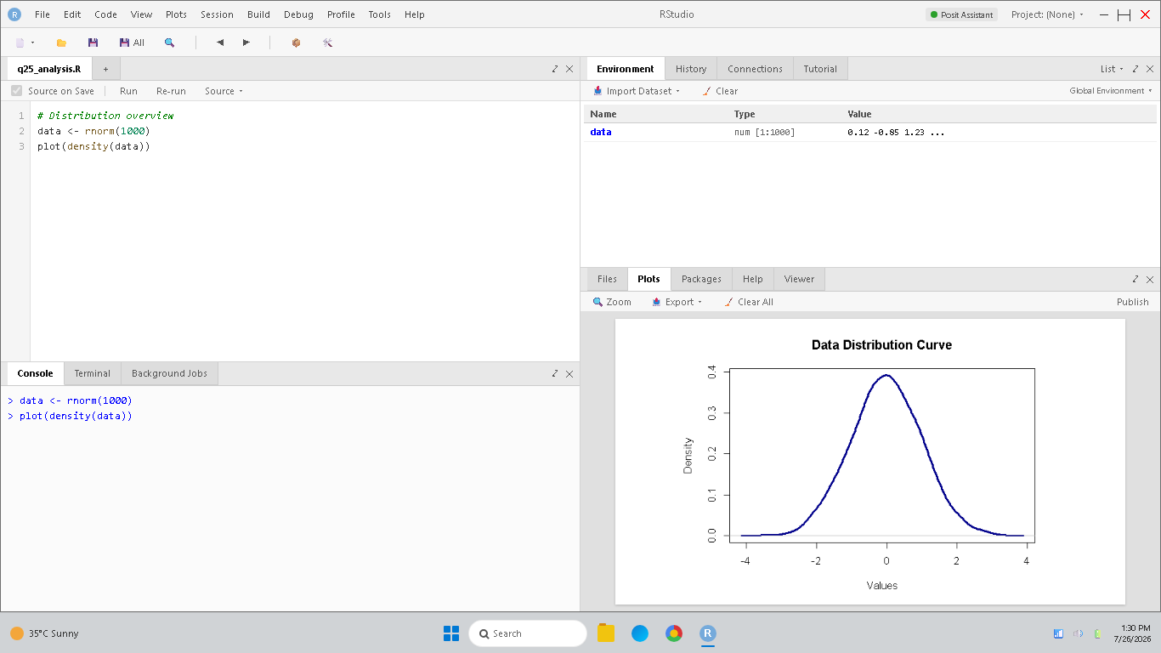
Figure 25: RStudio simulation and verification for Question 25.

Rubrics for Calculation
Criteria | Weightage (%) | Level 4 (Exemplary) | Level 3 (Proficient) | Level 2 (Developing) | Level 1 (Beginning) | Marks
Conceptual Understanding | 30% | Demonstrates thorough understanding; answers all questions accurately | Shows good understanding with few errors | Partial understanding; several incorrect responses | Lacks understanding; majority of answers incorrect
Accuracy of Answers | 25% | All answers are correct | Most answers are correct with minor mistakes | Some correct answers; frequent errors | Mostly incorrect answers
Application of Knowledge | 20% | Correctly applies concepts to problem-based questions | Applies concepts with minor errors | Limited ability to apply concepts | Unable to apply concepts
Time Management | 15% | Completes quiz well within time efficiently | Completes on time with minor delays | Requires extra time or rushes through questions | Unable to complete within given time
Question Interpretation | 10% | Interprets all questions correctly and responds appropriately | Misinterprets a few questions | Often misinterprets questions | Unable to understand questions

Faculty In-charge | Course Coordinator | Head of Department
Signature: _______________ | Signature: _______________ | Signature: _______________
Date: ___________________ | Date: ___________________ | Date: ___________________

