**Recipe Application Process Breakdown**

* When the console app first loads, it displays a menu of options to the user, including "Enter And Save Recipe", "Display Saved Recipe", "Scale Recipe", "Reset Quantities", "Clear All Recipe Data", and "Exit".
* If the user selects "Enter And Save Recipe" (option 1), the application prompts the user to enter the name of the recipe, the number of ingredients, and details for each ingredient (name, quantity, unit, food group, and calories). The user is also asked to enter the number of steps and provide details for each step. The recipe is then saved, and a message is displayed indicating that the recipe has been saved successfully.
* If the user selects "Display Saved Recipe" (option 2), the application checks if any recipes have been saved. If no recipes are found, it displays a message stating "No recipe found. Please enter and save recipe first." Otherwise, it displays a list of all previously saved recipes. The user can then choose to display a specific recipe by selecting its number or choose to display all recipes by entering 0.
* If the user selects "Scale Recipe" (option 3), the application prompts the user to enter the number of the recipe they want to scale. It then asks for a scale factor, which can be 0.5, 2, or 3. The selected recipe's quantities are scaled accordingly, and a message is displayed indicating that the recipe has been scaled successfully.
* If the user selects "Reset Quantities" (option 4), the application prompts the user to enter the number of the recipe they want to reset the quantities for. The quantities of the selected recipe are then reset to their originally entered values, and a message is displayed indicating that the quantities have been reset successfully.
* If the user selects "Clear All Recipe Data" (option 5), all previously saved recipe data is removed from the application, and a message is displayed indicating that the data has been cleared successfully.
* After each operation is completed, the menu of options is displayed again, and the user can choose another option. If the user selects "Exit" (option 6), the console application closes.

**Recipe Application Improvements**

* The code includes a delegate (RecipeExceedsCaloriesHandler) and an event (RecipeExceedsCaloriesEvent). It is designed to handle scenarios where a recipe exceeds a certain calorie limit.
* The Recipe class has additional properties like FoodGroup and Calories for each ingredient.
* The code includes a method called CalculateTotalCalories() in the Recipe class, which calculates and returns the total calories of a recipe based on the ingredients and their quantities.
* The code includes a method called DisplayScaledRecipe() in the RecipeManager class, which displays the scaled recipe after applying a scale factor.

**Recipe Application Output**

This is the first display when you run the code

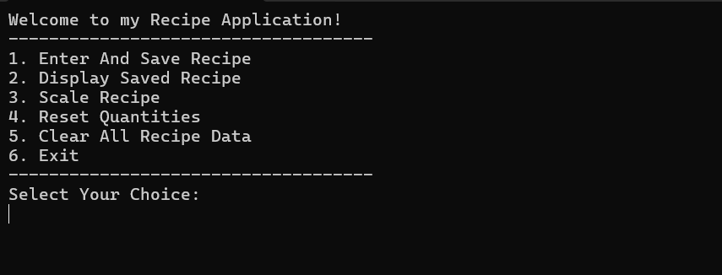

Recipe Input and Display

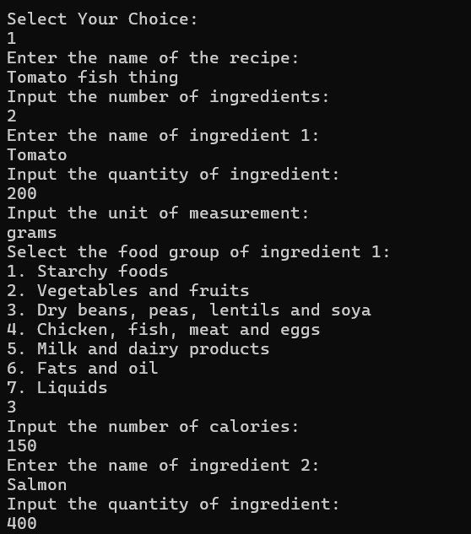

Recipe Input and Display (Continued)

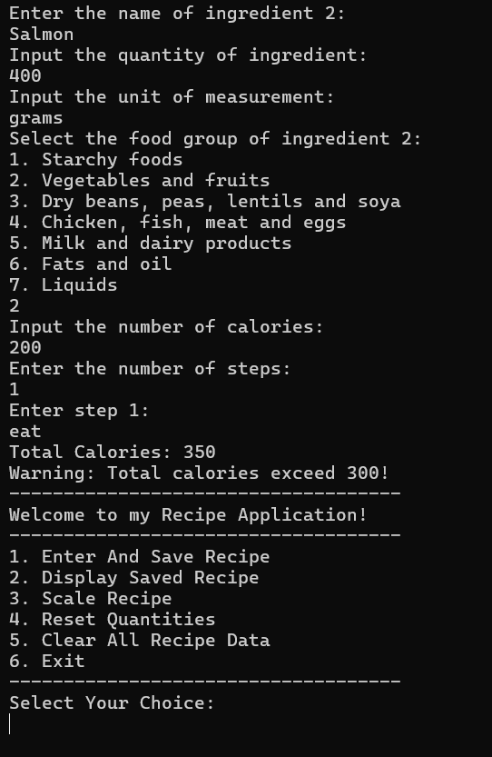

Scale Recipe

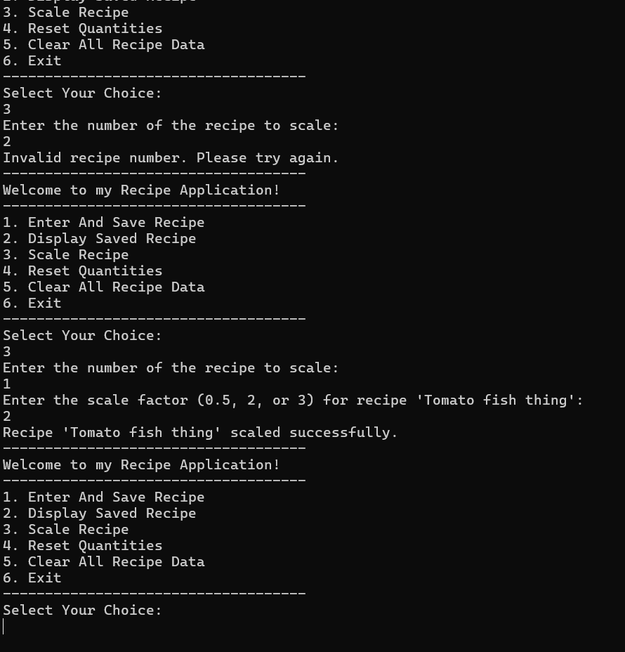

Scale Recipe (continued)

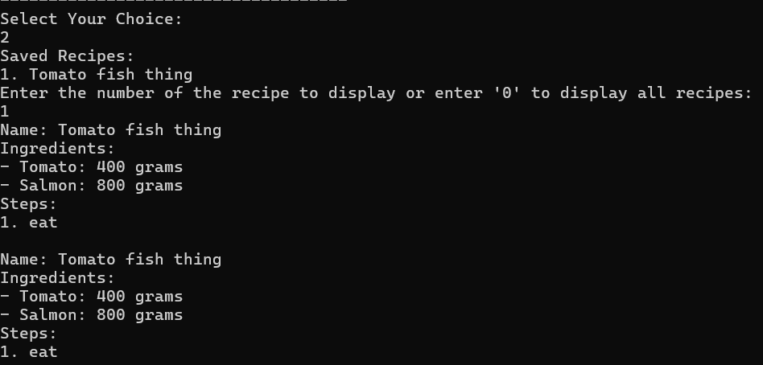

Reset Quantities and Clear All Recipe Data

