Sample manuscript showing style and formatting specifications for SPIE journal papers

First Author,a Second Author,a Third Author,b Fourth Authora,b,\*

aUniversity Name, Faculty Group, Department, Street Address, City, Country, Postal Code

bCompany Name, Street Address, City, Country, Postal Code

**Abstract**. This document shows the required format and appearance of a manuscript prepared for SPIE journals. Please note that the following journals encourage the use of **structured abstracts** in manuscript submissions: *Neurophotonics*,the *Journal of Biomedical Optics*, and the *Journal of Micro/Nanolithography, MEMS, and MOEMS*. Guidelines are available on the journal website. Whether structured or single-paragraph, the abstract should contain approximately 200 words. It should be a summary of the paper and not an introduction. Because the abstract may be used in abstracting and indexing databases, it should be self-contained (i.e., no numerical references) and substantive in nature, presenting concisely the objectives, methodology used, results obtained, and their significance. A list of up to six keywords should immediately follow.

**Keywords**: optics, photonics, light, lasers, templates, journals.

**\***Fourth Author**,** E-mail: [myemail@university.edu](mailto:myemail@university.edu)

# 1 Introduction

This document shows the suggested format and appearance of a manuscript prepared for SPIE journals. Accepted papers will be professionally typeset. This template is intended to be a tool to improve manuscript clarity for the reviewers. The final layout of the typeset paper will not match this template layout.

## 1.1 Use of This Template

Authors may use this Microsoft (MS) Word template by employing the relevant styles from the Styles and Formatting list (which is accessed from the Styles group in the Home ribbon, Fig. 1):

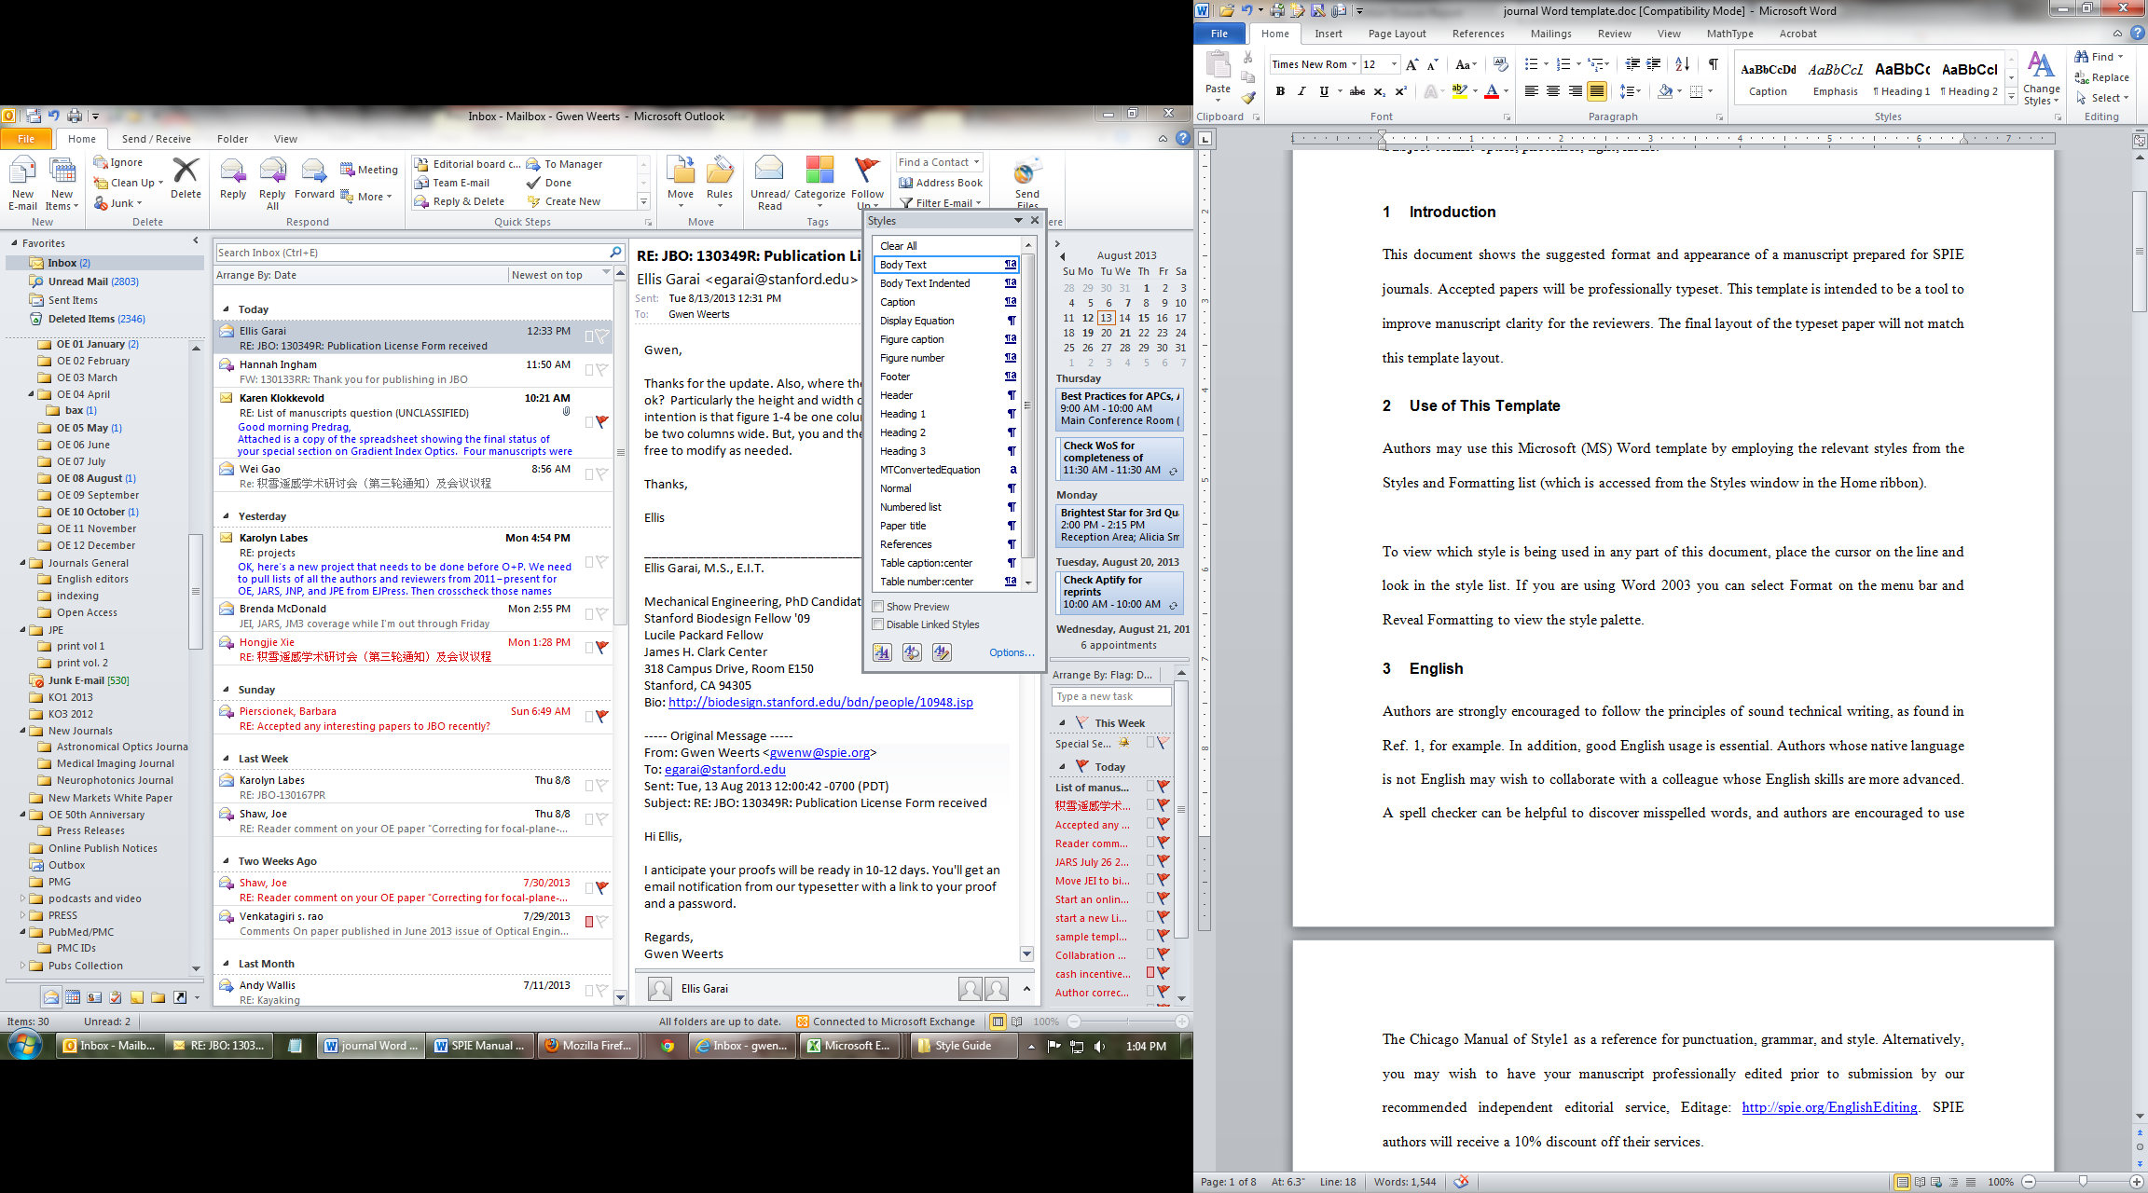

Fig. 1 MS Word 2010 Home ribbon. Red arrow indicates where to access Styles window.

To view which style is being used in any part of this document, place the cursor on the line and look in the style list (Fig. 2):

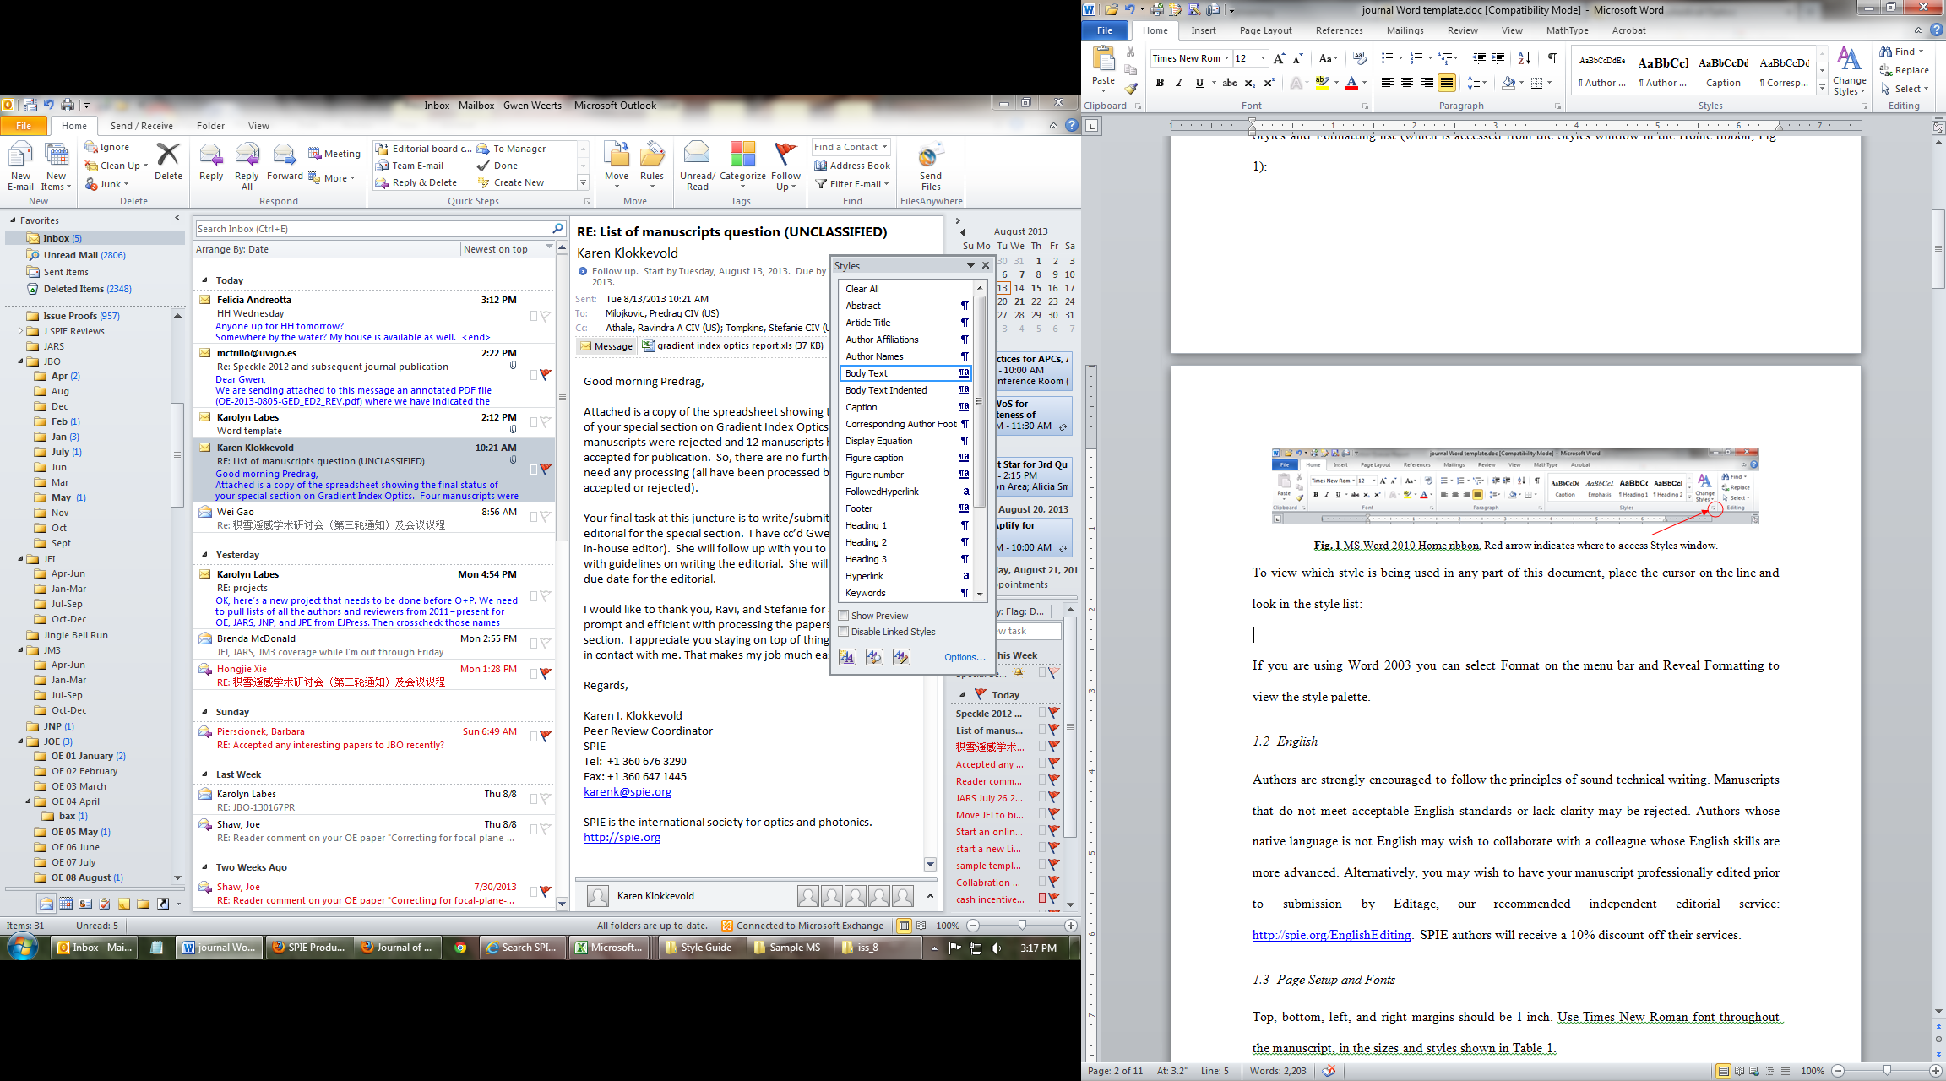

Fig. 2 Styles window.

If you are using Word 2003 you can select Format on the menu bar and Reveal Formatting to view the style palette.

## 1.2 English

Authors are strongly encouraged to follow the principles of sound technical writing. Manuscripts that do not meet acceptable English standards or lack clarity may be rejected. Authors whose native language is not English may wish to collaborate with a colleague whose English skills are more advanced. Alternatively, you may wish to have your manuscript professionally edited prior to submission by Editage, our recommended independent editorial service: <http://www.editage.com/spie>. SPIE authors will receive a 15% discount off their services.

## 1.3 Page Setup and Fonts

Top, bottom, left, and right margins should be 1 inch. Use Times New Roman font throughout the manuscript, in the sizes and styles shown in Table 1.

**Table 1** Recommended fonts and sizes.

|  |  |
| --- | --- |
| **Style name** | **Brief description** |
| **Article Title** | **16 pt, bold** |
| **Author Names** | **12 pt, bold** |
| Author Affiliations | 10 pt |
| Abstract | 10 pt |
| Keywords | 10 pt |
| **Heading 1** | **12 Pt, bold** |
| *Heading 2* | *12 pt, italic* |
| *Heading 3* | *11 pt, italic* |
| Body Text | 12 pt |
| Figure caption | 10 pt |
| Table caption | 10 pt |

# 2 Parts of a Manuscript

This section describes the normal structure of a manuscript and how each part should be handled.

## 2.1 Title and Author Names

The article title appears left justified at the top of the first page. The title font is 16 pt, bold. The rules for capitalizing the title are the same as for sentences; only the first word, proper nouns, and acronyms should be capitalized. Do not begin titles with articles (e.g., a, an, the) or prepositions (e.g., on, by, etc.). The word “novel” should not appear in the title, as publication will imply novelty. Avoid the use of acronyms in the title, unless they are widely understood. Appendix A contains more about acronyms.

The list of authors immediately follows the title. The font is 12 pt bold and the author names are left justified. The author affiliations and addresses follow the names, in 10 pt normal font and left justified. For multiple affiliations, each affiliation should appear on a separate line. Superscript letters (a, b, c, etc.) should be used to associate multiple authors with their respective affiliations. The corresponding author should be identified with an asterisk, and that person's email address should be provided below the keywords.

## 2.2 Abstract

The abstract should be a summary of the paper and not an introduction. Because the abstract may be used in abstracting journals, it should be self-contained (i.e., no numerical references) and substantive in nature, presenting concisely the objectives, methodology used, results obtained, and their significance. Please note that the following journals encourage the use of **structured abstracts** in manuscript submissions: *Neurophotonics*,the *Journal of Biomedical Optics*, and the *Journal of Micro/Nanolithography, MEMS, and MOEMS*. Helpful guidelines for structured abstracts are available on the website of the journal. Whether structured or single-paragraph, the abstract should contain approximately 200 words.

## 2.3 Subject Terms/Keywords

Keywords are required. Please provide 3-6 keywords related to your paper.

## 2.4 Body of Paper

The body of the paper consists of numbered sections that present the main findings. These sections should be organized to best present the material.

It is often important to refer back (or forward) to specific sections. Such references are made by indicating the section number, for example, “In Sec. 2 we showed…” or “Section 2.1 contained a description….” If the word Section, Reference, Equation, or Figure starts a sentence, it is spelled out. When occurring in the middle of a sentence, these words are abbreviated Sec., Ref., Eq., and Fig.

At the first occurrence of an acronym, spell it out followed by the acronym in parentheses, e.g., charge-coupled diode (CCD).

## 2.5 Footnotes

Use textual footnotes only when necessary to present important documentary or explanatory material whose inclusion in the text would be distracting.[[1]](#footnote-1)

## 2.6 Appendices

Brief appendices may be included when necessary, such as derivations of equations, proofs of theorems, and details of algorithms. Equations and figures appearing in appendices should continue sequential numbering from earlier in the paper.

## 2.7 Disclosures

Conflicts of interest should be declared under a separate header, above Acknowledgments. If the authors have no competing interests to declare, then a statement should be included declaring no conflicts of interest. For assistance generating a disclosure statement, see the form available from  the International Committee of Medical Journal Editors website: <http://www.icmje.org/conflicts-of-interest/>

## 2.8 Acknowledgments

Acknowledgments and funding information should be added after the conclusion, and before references. Include grant numbers and the full name of the funding body. The acknowledgments section does not have a section number.

## 2.8 References

The References section lists books, articles, and reports that are cited in the paper. The references are numbered in the order they are cited. Examples of reference styles are given at the end of this template.

For books1,2 the listing includes the list of authors (initials plus last name), book title (in italics), page or chapter numbers, publisher, city, and year of publication. Journal article references3,4 include the author list, title of the article (in quotes), journal name (in italics, properly abbreviated), volume number (in bold), inclusive page numbers or citation identifier, and year. A reference to a proceedings paper or a chapter in an edited book5,6 includes the author list, title of the article (in quotes), conference name (in italics), editors (if appropriate), volume title (in italics), volume number if applicable (in bold), inclusive page numbers, publisher, city, and year.

The references are numbered in the order of their first citation. Citations to the references are made using superscripts, as demonstrated in the preceding paragraph. One may also directly refer to a reference within the text, for example, “as shown in Ref. 5 ...” Two or more references should be separated by a comma with no space between them. Multiple sequential references should be displayed with a dash between the first and last numbers.1–5

### 2.8.1 Reference linking and DOIs

A Digital Object Identifier (DOI) is a unique alphanumeric string assigned to a digital object, such as a journal article or a book chapter, that provides a persistent link to its location on the internet. The use of DOIs allows readers to easily access cited articles. Authors should include the DOI at the end of each reference in brackets, if a DOI is available. See examples at the end of this manuscript. A free DOI lookup service is available from CrossRef at <http://www.crossref.org/freeTextQuery/>. The inclusion of DOIs will facilitate reference linking and is highly recommended.

## 2.9 Author Biographies and Photographs

Author biographies are encouraged, especially for primary and corresponding authors. Biographies are not to exceed 75 words. Biographies should be placed at the end of the manuscript. Personal information such as hobbies or birthplace/birthdate should not be included.

# 3 Section Formatting (Heading 1)

Type each section heading on a separate line using the appropriate style from the style list. Sections should be numbered sequentially.

Paragraphs that immediately follow a section heading are leading paragraphs and should not be indented, according to standard publishing style. The same goes for leading paragraphs of subsections and sub-subsections. In this MS Word template, use the Body Text style for leading paragraphs and the Body Text Indented style for all subsequent paragraphs.

## 3.1 Subsection Headings (Heading 2)

Subsection headings should be numbered 1.1, 1.2, etc.

### 3.1.1 Sub-subsection headings (Heading 3)

Sub-subsection headings should be numbered 1.1.1, 1.1.2, etc. Only the first word is capitalized.

# 4 Figures and Tables

## 4.1 Figures

Figures are numbered in the order in which they are called out in the text. Figures should be embedded in the manuscript for the initial submission, and individual figure files will be requested for the first revision in .tif, .eps, .png, or PDF format. We cannot accept application files, i.e., Corel Draw, Microsoft Word, PowerPoint, etc. All figure parts must be labeled (a), (b), etc. Each figure file should contain all parts of the figure. For example, Fig. 3 contains two parts (a) and (b); therefore, all of the labeled parts should be combined in a single file for Fig. 3. Further details about figure formatting can be found in the author guidelines for each specific SPIE journal: <https://www.spiedigitallibrary.org/journals/journal-authors>. A figure caption list should be provided after the references.

sy00590_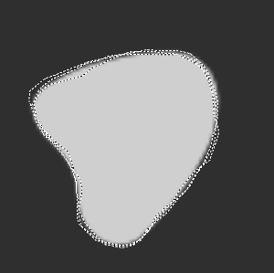

(b)

(a)

Fig. 3 Example of a figure caption: (a) sun and (b) blob.

## 4.2 Tables

Tables are numbered in the order in which they referred to. They should appear in the document in numerical order and as close as possible to their first reference in the text. Table captions are handled identically to those for figures, except that they appear above the table, and when called out in the text, the word “Table” is always spelled out. See Table 1 for an example.

## 4.3 Multimedia

Please refer to the multimedia section of the author guidelines (see link above) for specific submission guidelines and requirements. The following types of multimedia files are accepted: QuickTime Non-Streaming video (.qt or .mov), MPEG (.mpg or .mp4). The recommended maximum size for each multimedia file is 10-12 MB. Authors must insert a representative “still” image from the video file in the manuscript as a “figure.” This still image will be linked by the publisher to the actual video file, as will the caption label. Video files should be named Video 1, Video 2, etc. Otherwise multimedia files are treated in the same manner as figures. The multimedia file type should be included in parentheses at the end of the figure caption, along with the file size. See Video 1 for an example.

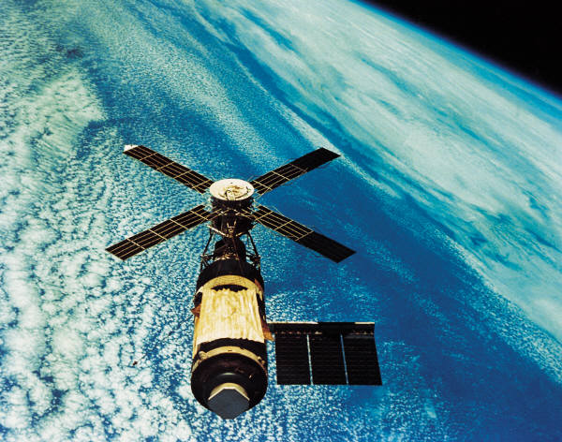

Video 1 Example of a multimedia still image (MPEG, 2.5 MB).

# Appendix A: Miscellaneous Formatting Details

## A.1 Formatting Equations

Equations may appear inline with the text, if they are simple, short, and not of major importance; e.g., a = b/c. Important equations appear on their own line. For example, “The expression for the field of view is

, (1)

where *a* is the …” Principal equations are numbered, with the equation number placed within parentheses and right justified. Authors are strongly encouraged to use MS Word Equation Editor or MathType to create both in-text and display equations. Equations are considered to be part of a sentence and should be punctuated accordingly.

## A.2 Formatting Theorems

To include theorems in a formal way, the theorem identification should appear in a 10-pt, bold font, left justified and followed by a period. Formal statements of lemmas and algorithms receive a similar treatment. The text of the theorem continues on the same line in normal, 10-pt font. For example,

**Theorem 1.** For any unbiased estimator…

## Disclosures

Conflicts of interest should be declared under a separate header. If the authors have no relevant financial interests in the manuscript and no other potential conflicts of interest to disclose, a statement to this effect should also be included in the manuscript.

## Acknowledgments

This unnumbered section is used to identify people who have aided the authors in accomplishing the work presented and to acknowledge sources of funding.

## References

1. G. J. Alred, C. T. Brusaw, and W. E. Oliu, *Handbook of Technical Writing*, 7th ed., St. Martin’s, New York (2003).
2. L. C. Perelman, J. Paradis, and E. Barrett, *Mayfield Handbook of Technical and Scientific Writing*, Mayfield, Mountain View, California (1997).
3. A. Harris et al., “Free-space optical wavelength diversity scheme for fog mitigration in a ground-to-unmanned-aerial-vehicle communications link,” *Opt. Eng.* **45**(8), 086001 (2006) [[doi:](http://spiedl.aip.org/jhtml/doi.jsp)10.1117/1.2338565].
4. N. Metropolis et al., “Equations of state calculations by fast computing machine,” *J. Chem. Phys****.* 21**(6), 1087-1091 (1953).
5. S. F. Gull, “Developments in maximum-entropy data analysis,” in *Maximum Entropy and Bayesian Methods*, J. Skilling, Ed., pp. 53-71, Kluwer Academic, Dordrecht, Netherlands (1989).
6. K. M. Hanson, “Introduction to Bayesian image analysis,” in Image Processing, M. H. Loew, Ed., *Proc. SPIE* **1898**, 716-731 (1993) [[doi:](http://spiedl.aip.org/jhtml/doi.jsp)10.1117/12.154577].

**First Author** is an assistant professor at the University of Optical Engineering. He received his BS and MS degrees in physics from the University of Optics in 1985 and 1987, respectively, and his PhD degree in optics from the Institute of Technology in 1991. He is the author of more than 50 journal papers and has written three book chapters. His current research interests include optical interconnects, holography, and optoelectronic systems. He is a member of SPIE.  
  
Biographies and photographs for the other authors are not available.

**Caption List**

Fig. 1 MS Word 2010 Home ribbon. Red arrow indicates where to access Styles window.

**Fig. 2** Styles window.

**Fig. 3** Example of a figure caption: (a) sun and (b) blob.

Video 1 Example of a multimedia still image (MPEG, 2.5 MB).

**Table 1** Recommended font sizes and styles.

1. Due to problems with HTML display, use of footnotes should be avoided. If absolutely necessary, the footnote mark must come at the end of a sentence. To insert a footnote, use the Insert menu, select Reference, then Footnote, change the number format to the style of asterisk, dagger, double-dagger, etc., and click OK. [↑](#footnote-ref-1)