**CENTENNIAL COLLEGE**

**COMP 397: WEB GAME PROGRAMMING**

**Project Part 1: Game Design Document**

**DUE DATE: May 19, 2025.**

**Student: Minh Khoi Phan - 30127813**

**Supervisor**: Prof. Alireza Moghaddam

2025/05/19

TABLE OF CONTENTS

VERSION HISTORY 3

I. GAME OVERVIEW 4

II. GAMEPLAY MECHANICS 4

III. CAMERA 4

IV. CONTROLS 5

Player 1: 5

Player 2: 5

V. GAME SKETCH 5

VI. MENU AND SCREEN DESCRIPTIONS 6

VII. GAME WORLD 6

VIII. LEVELS 6

IX. GAME PROGRESSION 6

X. CHARACTERS 6

XI. SCORE 7

XII. ITEMS 7

XIII. SOUND EFFECTS AND MUSIC 7

XIV. GAME ASSETS AND MULTIMEDIA 7

XV. DESIGN NOTES 7

XVI. FUTURE FEATURES 7

# VERSION HISTORY

Version alpha Date Created: TBD

Version beta Date Created: TBD

Version final Date Created: TBD

# I. GAME OVERVIEW

**Working Title:** Wanadanz.

**Genre:** Rhythm and music game.

**Target Audience:** General audiences.

**Scope:** This will be a simple personal project for the current Web Game Programming course.

**Features:** Character dancing animations along with gameplay.

# II. GAME PLAY MECHANICS

Wanadanz is a relaxing game where player will choose their characters, get into the dance floor and start smashing buttons when the prompts drop into the box and see their character dance.

**Game**

* **Character selection:** Game starts with character selection and customization screen.
* **Song selection:** Player can select a variety of songs based on their difficulty.
* **Dance floor selection:** Player will choose their dance area (theme)
* **Mechanics:** Button prompts will start appearing and when then enter the corresponding zones, the player should hit the corret keyboard to earn points
* **Points:** Hitting the key when the prompts is perfectly inside the zone will earn the most points. Missing a note will reduce point.
* **Leaderboard:** When a level is finished, players will be able to enter their record on the local leaderboard.

# III. CAMERA

This is a 2D game where the camera is fixed on the level, player is able to zoom-in during a specific time for free dance session.

# IV. CONTROLS

## The game will focus primarily on Keyboard.

## Player 1:

6 Keys: W,A,S,D,Q,E

## Player 2:

6 Keys: I,J,K,L,U,O

# V. GAME SKETCH

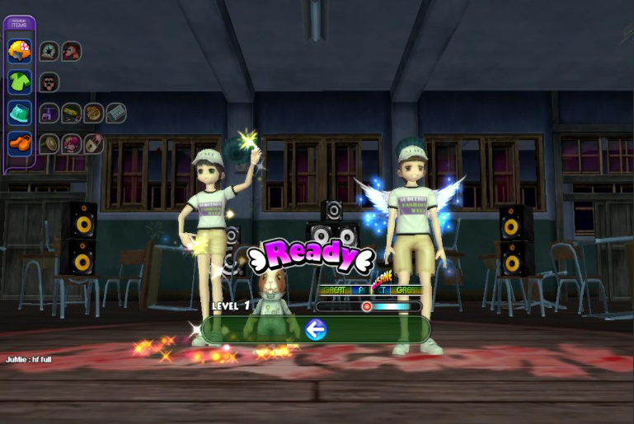

Inspired by Audition  
Source: Game-Stats.com

# VI. MENU AND SCREEN DESCRIPTIONS

**MAIN MENU** Screen: 4 Buttons for New Game, Options, Leaderboard and Quit.

**NEW GAME** Screen: 2 Tabs for character selection, level selection and 2 buttons to Start or Back.

**OPTIONS** Screen: 1 Slider for volumn controls, 1 Checkbox for fullscreen and 1 button to Back.

There will be no Pause Screen to avoid breaking players’ immersion.

There will be buttons to Quit or Restart level during gameplay.

# VII. GAME WORLD

The whole universe has joined their hands on one single purpose “To dance for Wanadanz”. Players will be able to see multiple characters coming from many universal races with their coolest dance moves. After all, everyone needs some time to relax.

# VIII. LEVELS

## 1-Player Level

## 2-Player Level

UI displays will be rearranged for the current number of players.

# IX. GAME PROGRESSION

Players will earn in-game currency after completing a level to buy cosmetics for their characters.

# X. CHARACTERS

Human, aliens, mystic beast with all kinds of dancing animations.

# XI. SCORE

Perfect keyhit: 100 pts

Good keyhit: 50 pts

Bad keyhit: 25 pts

Miss: -20 pts

# XII. ITEMS

Cosmetic items: hats, shoes, clothes, wings, outfits, …

# XIII. SOUND EFFECTS AND MUSIC

This is the most important part of the games.

Music will be play during the level and the prompts should appear following the beat to give the players an imemersive gameplay experience.

Cheering sound, keyhit and miss SFX will be implemented as sound cues to the players.

# XIV. GAME ASSETS AND MULTIMEDIA

Free game assets on Unity and different sources. Free non-copyright songs.

# XV. DESIGN NOTES

Further design notes will be added during development

# XVI. FUTURE FEATURES

Further notes will be added during development