1. ) Input op operations without scanner class

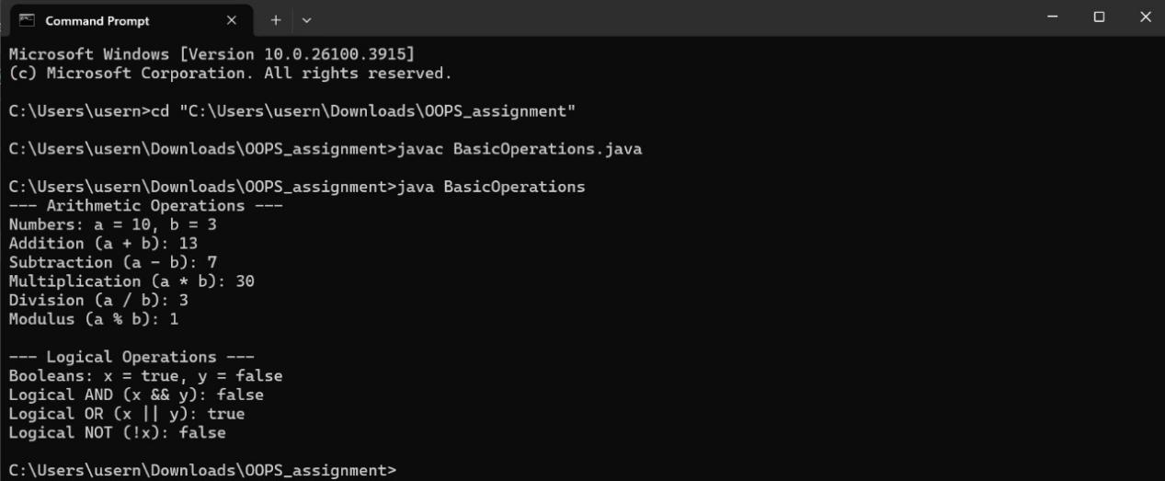

1. ) All operations arithmetic logical

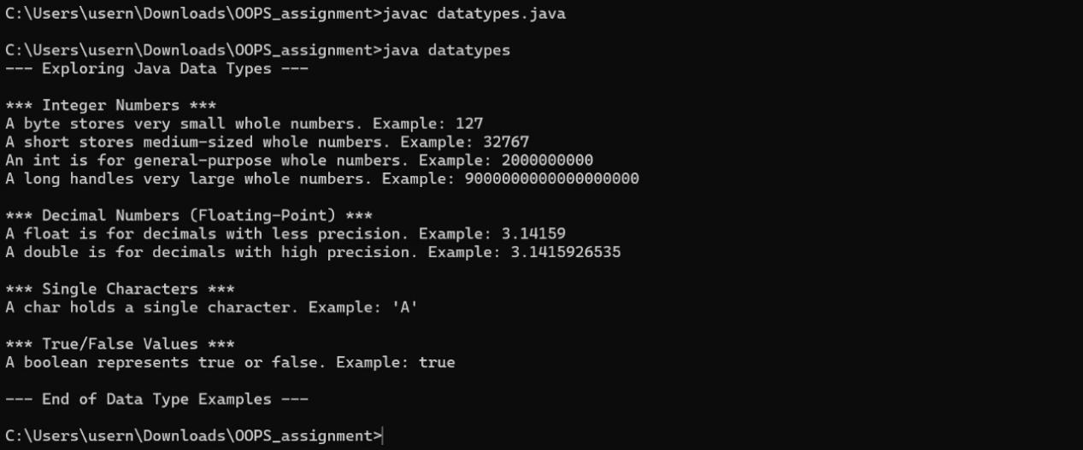

1. )Data types all Boolean also .3

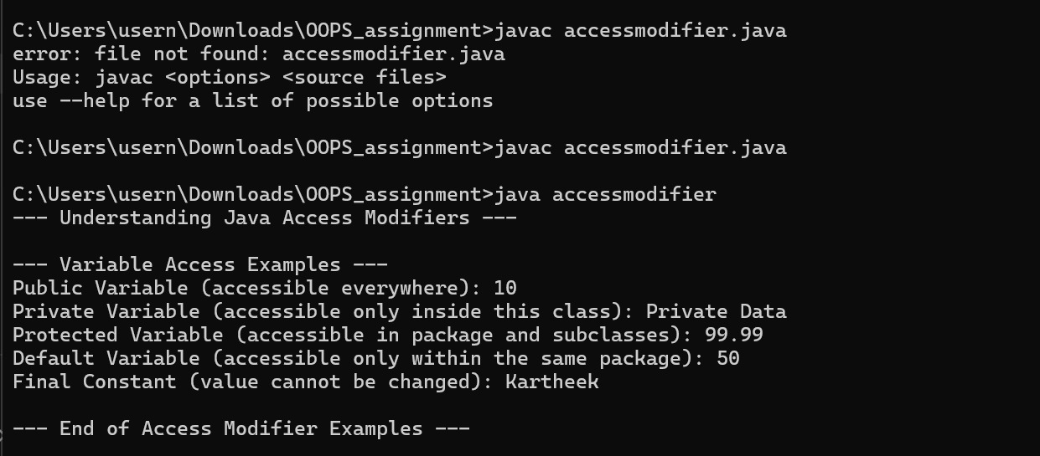

1. )Access modifiers final abstract

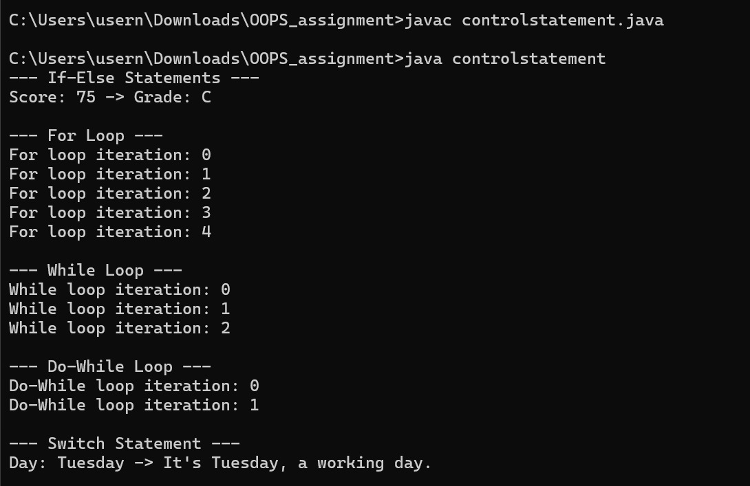

1. )All control statements in a single program

