TranMinhVu

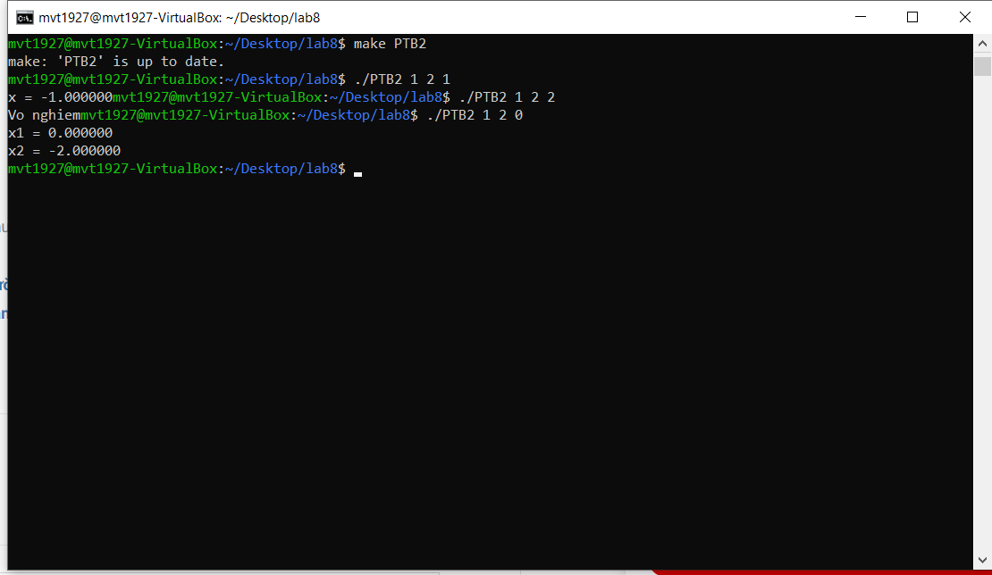

Code:

#include <stdio.h>

#include <math.h>

#include <stdlib.h>

float delta(float a,float b, float c){

return b\*b-4\*a\*c;

}

void giaiPT(float a,float b, float c){

float del = delta(a,b,c);

if (del<0) printf("Vo nghiem");

else if (del == 0) printf("x = %f",((-b)/(2\*a)));

else printf("x1 = %f\nx2 = %f\n",((-b+sqrt(del))/(2\*a)),((-b-sqrt(del))/(2\*a)));

}

int main(int argc,const char \*argv[])

{

if (argc>3)

giaiPT(atof(argv[1]),atof(argv[2]),atof(argv[3]));

else giaiPT(1,4,1);

return 0;

}