Technical Programming 2
Mnisi Sibusiso
Chapter1

1. Create a github account. Please choose a meaningful name, I don’t want to

guess who you are.

-https://github.com/Mvuleni1000/Assigment1

2. Create Maven Project

- Initialise git
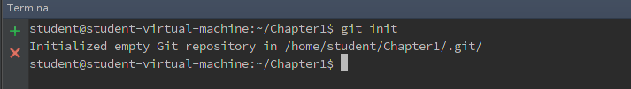

- Check status – explain what the output means
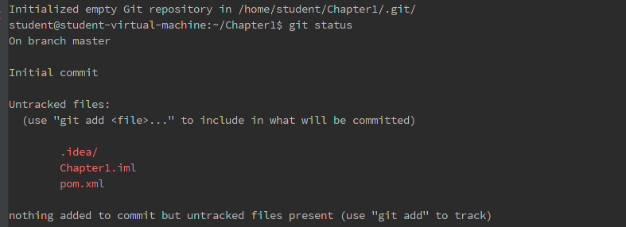
-The existing file are not added or committed hence they all appear in a red Color. The files are untracked.

- Add(track) your project to your repository

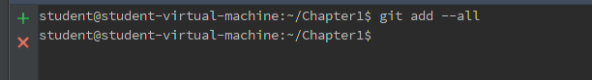

- Check status– explain what your output means.git
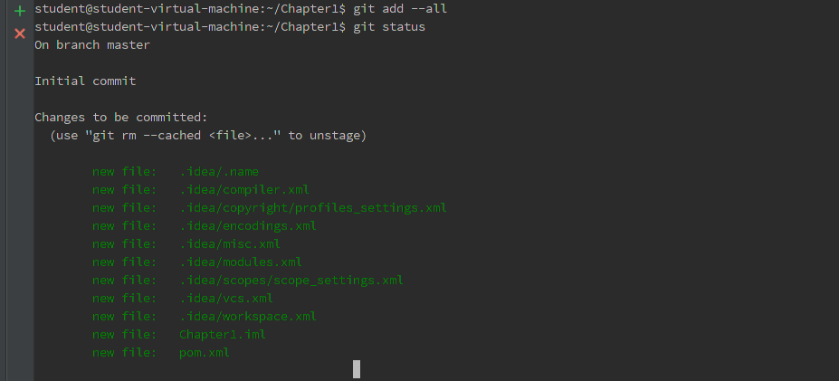
-All file are add and ready to be committed to the repository hence they turned green.

- Commit
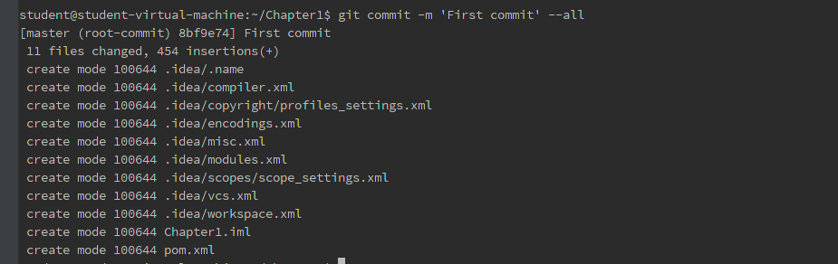
-All Files are committed and added.

- Add a new class to your project
-successfully added a new class

- Check status – explain what the output means
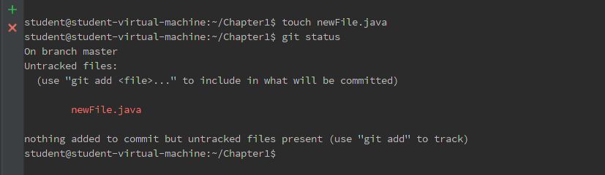
- The status shows that the new file is created but not added to the track.

- Add (track) your new file to repository

- Check status – explain what the output means
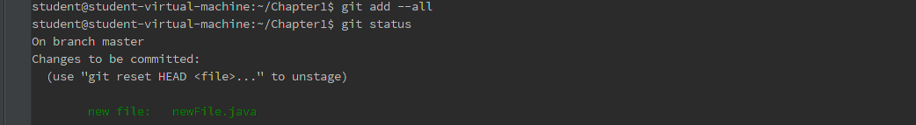
-The new file is successfully added hence it turned green in color.

- Commit your new file

13. Modify your new file

- Check status – explain what the output means
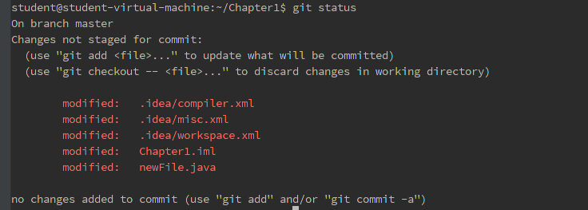
-The File has been modified hence all the modification are in red color showing us that the new change are not be track or added and committed

- Commit
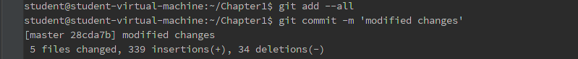
-The new modified changes are been added and committed to the project.

- Go to github. Create a repository
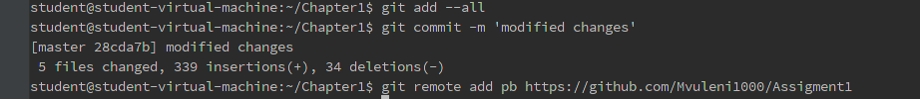
-added the remote for the project.

- Push your project to the newly created remote repository
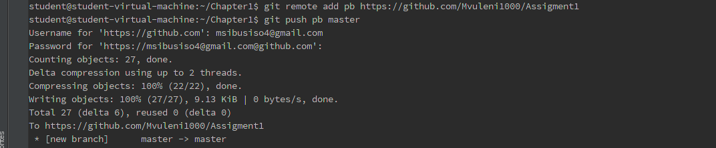
-All files have been added to the system.

- Remove a file from your project

- Check status – explain what the output mean
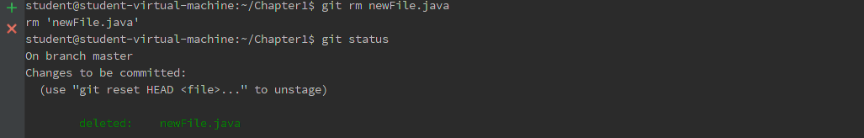
-The file has been successfully deleted from the Repository.

- Push your change to remote repository
