https://github.com/Mvuleni1000
Technical Programming 300
Mnisi Sibusiso
211183164

i and ii
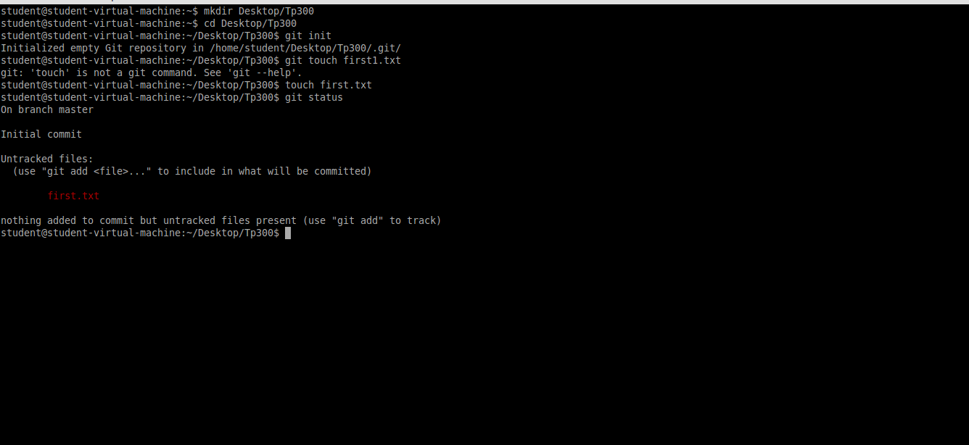
- I created the folder called Tp3 and a file called first.txt, status is in an untracked stage.
iii.
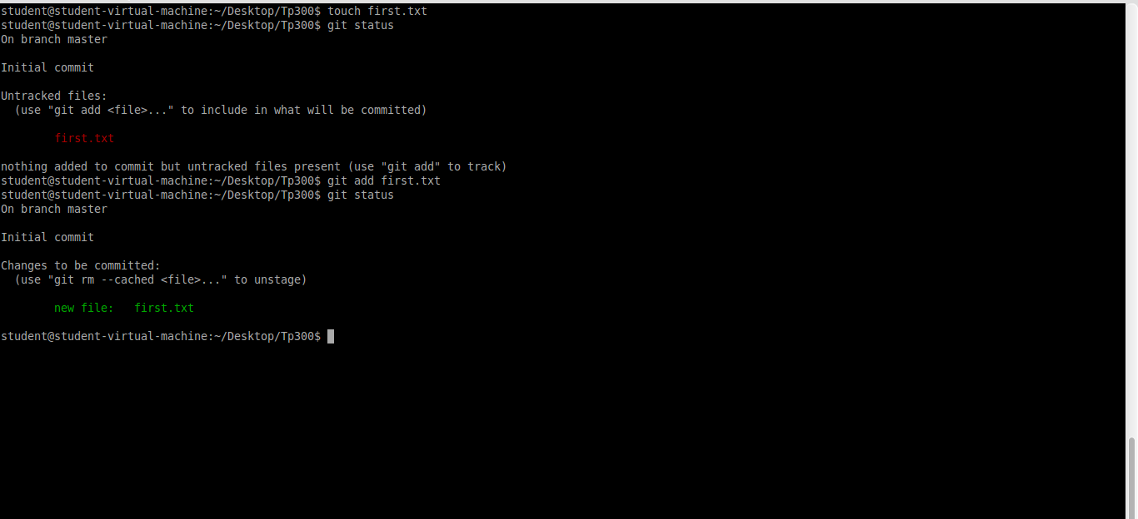
- File has been successfully tracked

iv.
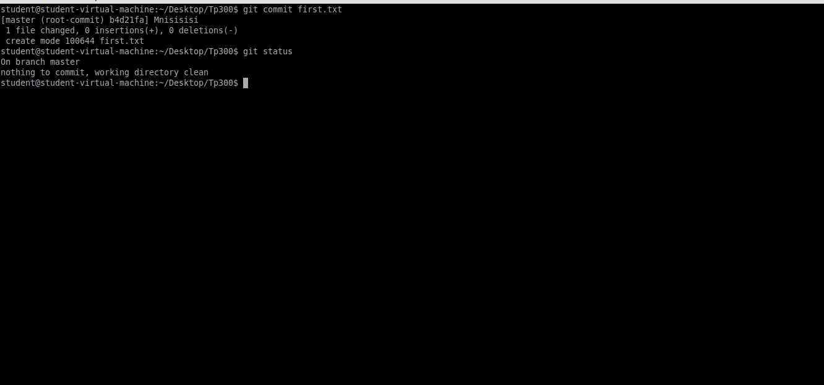
- File has been committed and it’s an unmodified stage.
v.
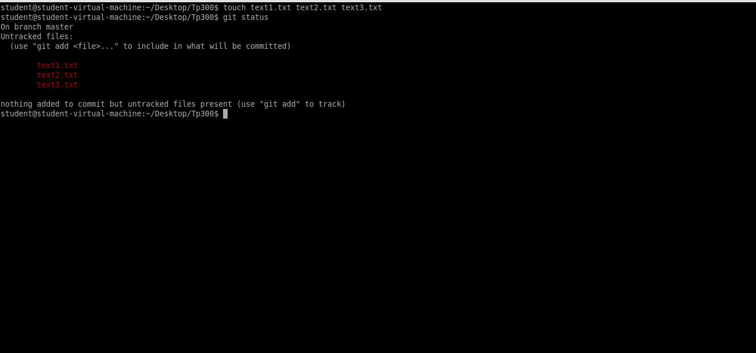
- Three files have been created and they are in an untracked state.

vi.
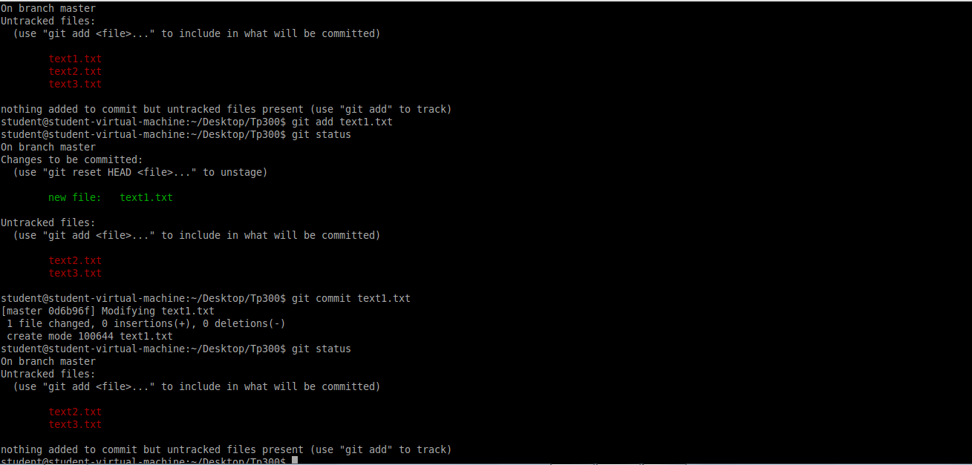

vii.
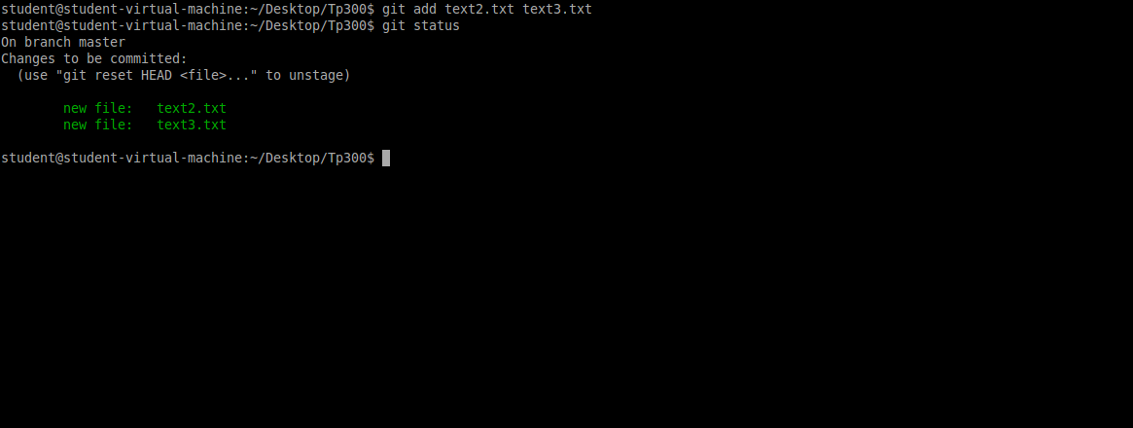
-Text2.txt and Text3.txt have been successfully add and they are and a staged point.
viii.

ix.
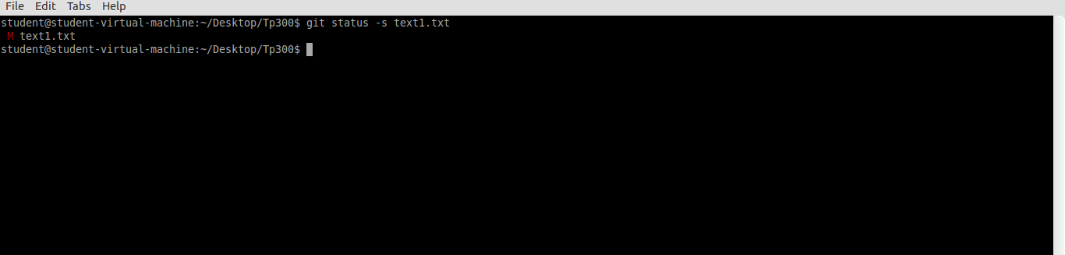

x. and xii
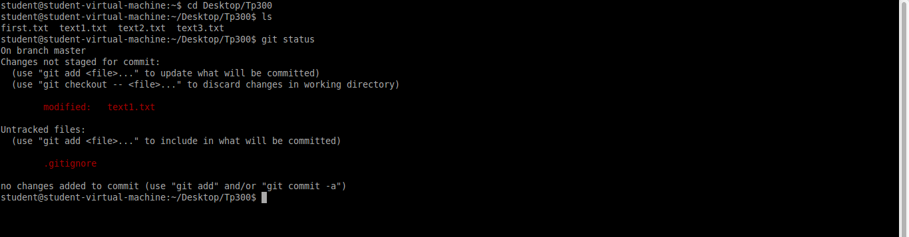

xii.
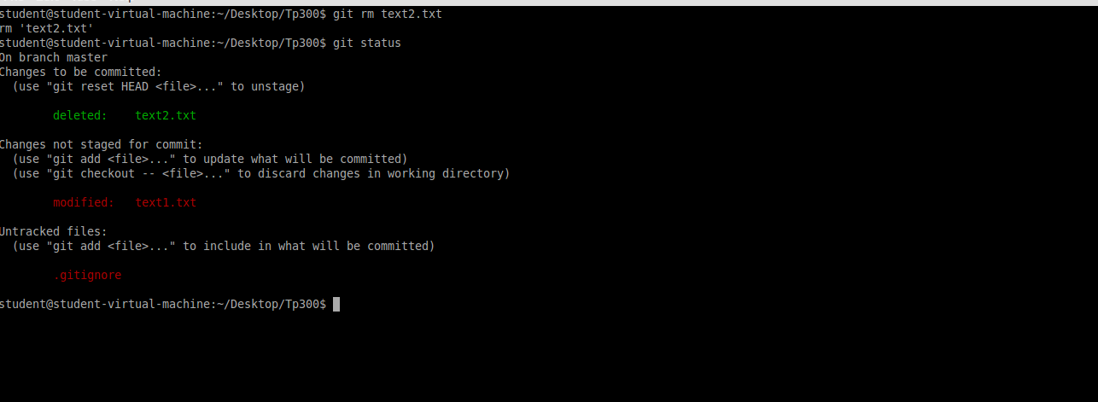
Delete text2.txt has been deleted and got the status show the ignored file.
xii.
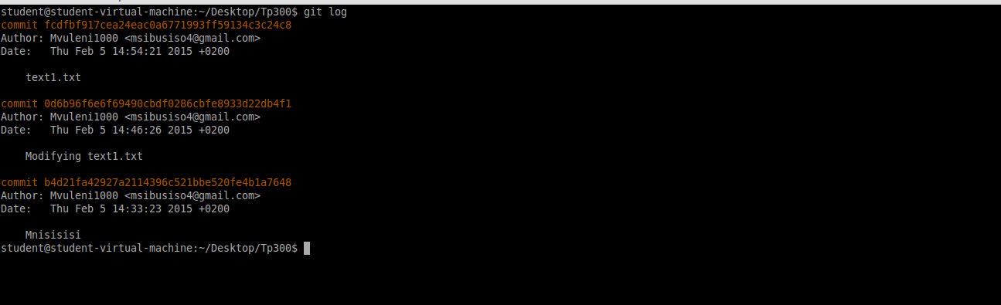

3.
i.
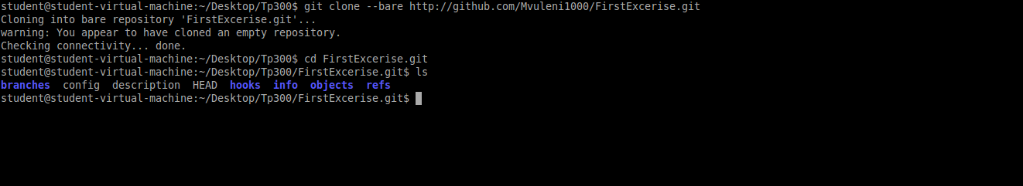

ii. Add file to a gitHub account
