**Computer Organization**

**Architecture diagrams:**

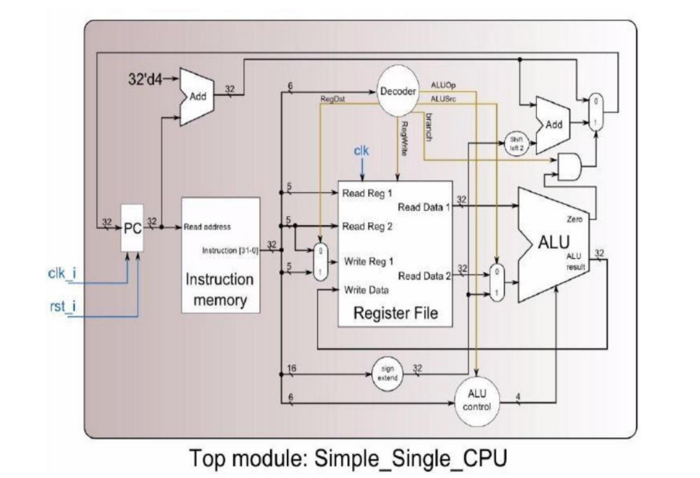

**Hardware module analysis:**

Decoder:

Every instruction starts with 6-bit opcode. By the table below, Decoder use the six bits to specifies the operation to be performed. In this lab, we can divide into 4 categories.

If these six bits are all zero(R-format), we should use the last six bits to determine which operation need to do.

Reg_Write=1, if the result need to write back.

ALUSrc_o=1,if the second operand comes from immediate

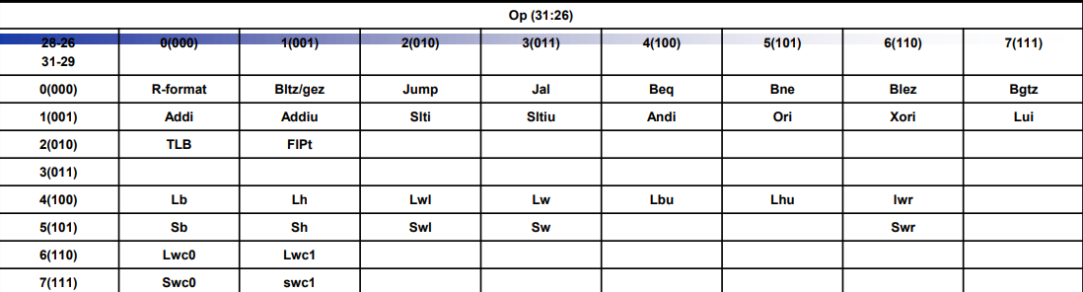

ALU:

Source1 from Register File, Source2 depends on the MUX

With the output of ALUCtrl, ALU knows what operation should do.

ALUCtrl:

Use the output of Decoder(ALUOp_i), if the ALUOp_i=000, we need to take a closer look at which operation need to be performed.

MUX_2to1:

Choose which input should be selected as output.

Sign_Extend:

According to the 15th bit, replicate the sign bit to the left.

**Finished part:**

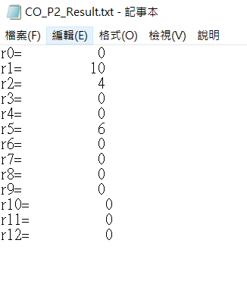>>data1

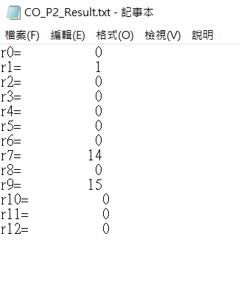>>data2

**Problems you met and solutions:**

1.The input and output of each submodule are east to confuse, so I did it step by step according to the architecture diagram, and took the easily recognizable variable name.

2.Almost every submodule needs the output of decoder to do their part, so I finished decoder before others.

**Summary:**

Seemingly complicated structure, it becomes much easier to complete each part separately. As mentioned in lab1, Implementing the design by connecting multiple modules together will reduce the complexity.