**Computer Organization Lab3**

**Name:**尤茂為

**ID:**110550065

**Architecture diagrams:**

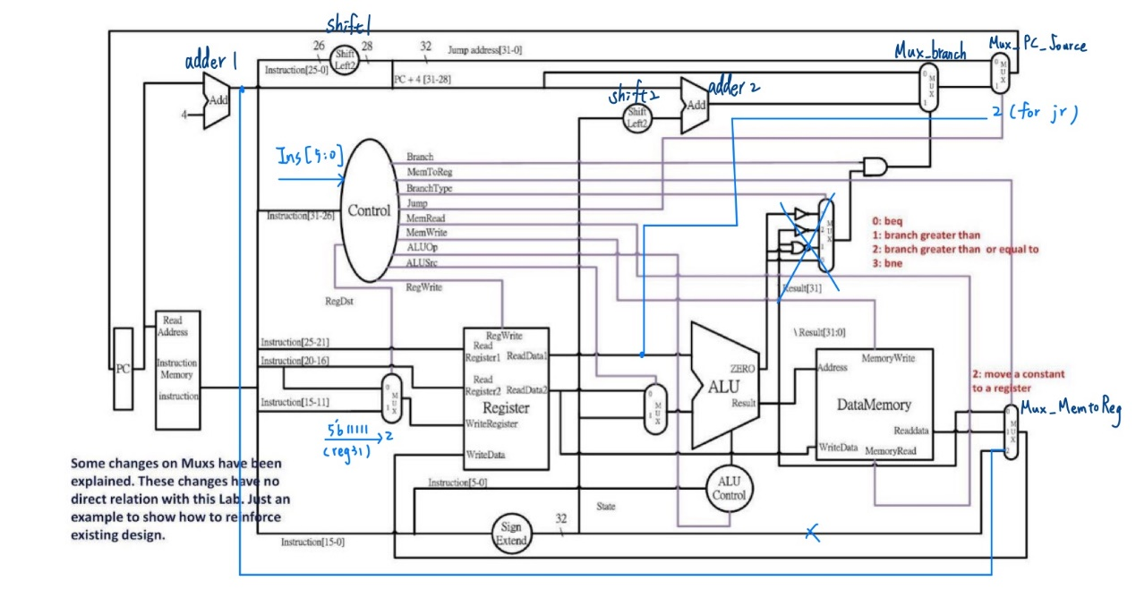

**Hardware module analysis:**

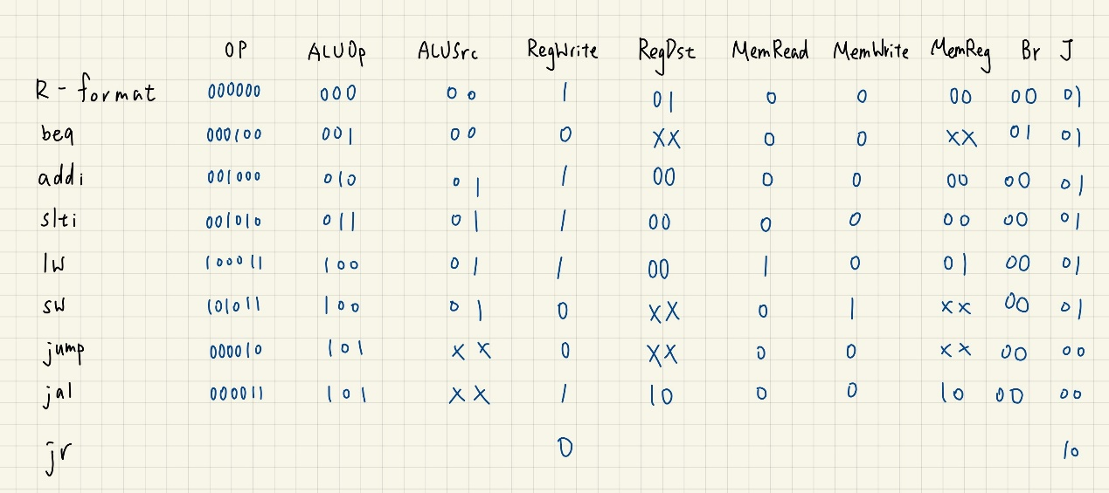

**Finished part:**

For Part 1:

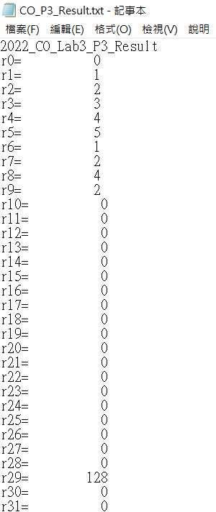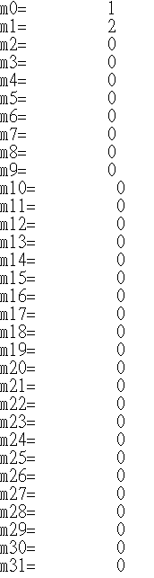

For Part 2:

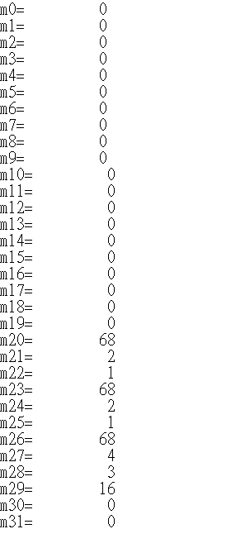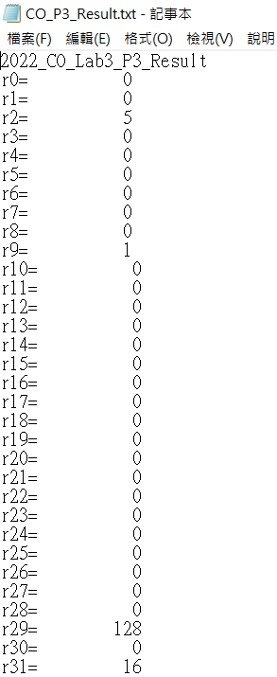

**Problems you met and solutions:**

**Summary:**