**STUDENT ACADEMIC ADVISORY MANAGEMENT SYSTEM**

YVONNE NJERI

REG NO: BIT/0007/15

SUPERVISOR

DR. P ANSELIMO

**PROJECT PROPOSAL**

**SCHOOL OF COMPUTING AND INFORMATICS DEPARTMENT OF INFORMATION TECHNOLOGY**

A system proposal for partial fulfillment of the requirement for the award of Degree of Bachelor of Science in Information Technology in Kibabii University.

**© February 2019**

# DECLARATION

I hereby declare that the project proposal is based on my own work carried out during the course of our study under the supervision of DR. P Anselimo. Due and clear reference is made to the works of other researches that have informed this project.

**Student:**

Sign…………………………………… Date……………………………….

Name………………………………. Reg. No:……………………………….

**Supervisor Approval**

I declare to have supervised the project and submitted the work for acceptance of **Student academic advisory management system.**

**Supervisor**…………………………………………………………………...

**Sign……………………………………….**

**Department of Information Technology**

**Kibabii University**

# Abstract

*Web presence is gradually becoming an essential part of every learning institute. This is why a large portion of academic activities is becoming available online. However, despite the emerging growth in the use of* information *technology towards academics, it is still a challenge for part advisers to effectively monitor and mentor their students' academic activities, progress and processes.*

*The student academic advisory management system (SAAMS) helps students stay up-to-date on their academic career by improving their level of communication with their assigned lecturers. It also helps lecturers and the institution administration better manage their students. This will help overcome the various challenges encountered by different categories of students especially the issue of missing marks which has become a dread in campuses, especially public Universities.*

Contents

I. DECLARATION ii

II. Abstract iii

**CHAPTER ONE: Introduction** 1

1.1 Background 1

1.2 Feasibility study 1

1.2.1 Economic feasibility 2

1.2.2 Time feasibility 2

1.2.3 Technical feasibility 2

1.3 Problem statement 3

**1.4** Objectives 3

1.4 Significance of the system 4

1.5 Project Justification 4

1.6 Project scope 4

**CHAPTER TWO: LITERATURE REVIEW** 5

2.1 Introduction 5

2.2 Student advisory system 5

**CHAPTER THREE: METHODOLOGY** 6

3.1 Introduction 6

3.2 Incremental Model 6

Incremental Model 6

3.2 Data collection 7

1.5 System Design 8

1.6 Resources required 8

1.6.1 Hardware requirements 8

1.6.2 Software requirements 9

1.7 Requirement specification and analysis 9

3.6.1 Functional requirements 9

3.6.2 Non-Functional requirements 10

Reference 10

PROJECT SCHEDULE 11

Project budget 12

# **CHAPTER ONE: Introduction**

## Background

Missing marks are a dread in campuses, especially public Universities. It is discovered that quite a number of students struggle whenever it’s time to graduate. Missing mark on the transcript, somewhere along a student’s academic journey is a painful thing. This happens when some of the students don’t sit the exams only to come asking for marks, while those who sit for special exams or supplementary most of the time cause confusion.

This study is set to evaluate the problem of missing marks in universities especially Kibabii University. This was done by analyzing the lecturers responsible for handling the students’ marks and assessing the present structure of handling students’ academics. To realize this objective, I collected relevant data through document review and this was by reading various articles by student who have experience this problem of having missing marks.

Through my personal experience, observation and reading, I analyzed that the current system of handling students missing marks involved a student having to follow up with the lecturer every time in order for his/her marks to be uploaded on the system. Therefore, developing a system that will automate the whole process of handling missing marks and other academic affairs will be of great help to students and lectures. With this system student will have a platform to complain on any missing marks to the respective lecturers. Lecturers will be able to provide a feedback to complain at an estimated time which if not complied, the Chairman Of the department (C.O.D) will then come in to help resolve the problem.

## Feasibility study

This is the viability measure of a proposed system that compares it to the existing one taking into account the cost acquiring the necessary implement to get the system into operation. Feasibility study involves measuring how the proposed system solves the problem at hand. The objectives of feasibility study is to understand how the proposed system, compare with the existing one in terms of cost.

### Economic feasibility

This was carried out to compare the cost of developing, operating and maintaining the proposed system, if this cost would be more than the system returns, then it would not be economically viable. The concern here was:

* How beneficial is the existing system?
* What are the costs associated with the existing system?
* What are the benefits of the proposed new system?
* What are the costs associated with the proposed system?

After all these questions were answered, conclusion was drawn that the system was economically viable.

### Time feasibility

In order to ascertain the time viability of the project, a preliminary study was undertaken to find out the amount of time that was required to finish the project tasks.

After this study, a conclusion was drawn that the project could take a time-line of between two to three months for completion. Since the system development time given was three months, the system passed time feasibility test.

### Technical feasibility

This was carried out by eliciting all user requirements, system requirement, Functional Requirements and Non-Functional requirement. After requirement elicitation was done it was found that there was enough technical manpower with enough PHP programming knowledge and resources to meet the project Technical requirements.

After this feasibility study, a conclusion was drawn that the project passed technical feasibility test and project tasks ware supposed to continue as normal.

## Problem statement

The issue of missing marks is a serious matter in several universities but when students try to bring it to the attention of the administration they get blacklisted for victimization by the lecturers concerned. A scenario that has contributed to many students not graduating at the time they completed their studies.

The problem on the high number of students and lack of proper organization has contributed to lecturers sometimes getting demotivated when they have to handle big classes that they do not care to follow up on undelivered assignments or cat marks. Sometimes part time lecturers are delayed on payments or are just not paid so they deliberately hold onto students’ marks. This has hugely contributed to students having incomplete marks in their transcripts.

Missing marks’ may be attributed to unstable computer systems. Lecturers mark exams and submit marks on time but after some time the marks get mixed up or in dire cases, disappear from the system. Often the administration is ‘too busy’ to notify the concerned lecturer and students end up with missing marks.

This predicament has affected many students. For instance In Kibabii University, the procedure for finding missing marks can be a long and winding journey. A student has to go through a long and complex procedure to get a solution. The student has to write a complaint letter to the lecturer concerned, who should respond within two weeks. Sometime the student is forced to go and look for the lecturer physically or make a call which may be costly. The lecturer will then establish if the student is indeed in the class registry, and then proceed to confirm that the affected student sat for the said exam.

If all this is ascertained, the student is referred to the responsible examination officer. This is the person whose responsibilities include taking custody of marked exam booklets. Should the examination officer fail to trace the student’s answer booklet in question, he/she will refer the student to the chairman of the department. If the matter is not resolved at that level, it is escalated to the dean of the school. This takes a long time to get the issue resolved and sometimes it ends up by the student having no option but to take a re-sit of the examination he/she had a missing mark or sometimes the lecturer will just forge the result.

## Objectives

1. To develop students complain capture module.
2. To design back end module for data storage.
3. To link the front end module to the back end module.

## 1.4 Significance of the system

Every higher education institution needs to have effective faculty lecturers in order to increase student development. Student development can in turn benefit enrollment, retention, and graduation rates which prove that an institution has done its job by giving students an education they desired. This study can help determine if faculty lecturers are doing what they say they are doing: enhancing student development and synthesizing students’ educational experiences with their aspirations which extend learning beyond the campus.

## 1.5 Project Justification

I believe the system will help to curb the problem of missing marks experienced by most students in the universities. Student academic advisory management system will provide a platform where a student can lay down complains and lecturers provide feedback to those complains hence solving the issue of missing marks. SAAMS shall provide an easier and faster way that lecturers and administration would provide feedback to complains to counter misplacement of students’ marks this because the system will be designed to always inform a lecturer of any complain made by a student concerning a unit having a missing mark.

## 1.6 Project scope

* **The system Functionalities** i.e. the feature which include database feature( data encryption, backup and recovery and data integrity)
* **Technologies** used which are operating system windows 8.1, DBMS MySQL5.5, PHP, JAVA and HTTP technologies.
* **The targeted users/beneficiaries** who are the students, the lecturers and the institution Administration.
* **System Deployment**. The system will be deployed to a school institution for example kibabii university
* **Methodology**. Incremental Model is the software development methodology that will be used to develop the SAAMS.

# **CHAPTER TWO: LITERATURE REVIEW**

## Introduction

It is fairly accurate to suggest that “missing marks” in public universities constitute something bordering on a national disaster. For any random Kenyan selected, one is either affected directly, or knows a Kenyan who is enduring or has survived, and probably recovering from the trauma of a “missing mark”.

Missing marks are the evidence of a poverty of academic leadership for more than 10 years. From the highest offices in the Education Ministry to academic leadership in departments, the rains started beating us when we lost sight of the true meaning of higher education and its role in society and in national development. Missing marks and lost grades are the outworking of unplanned university expansions, and the exaltation of a mercantile logic into higher education.

Education Principal Secretary, Colleta Suda (2017) has urged universities to end the problem of missing marks which has become the norm in a number of institutions of higher learning across the country. There are some universities which don’t give students transcripts for up to four years of their academic study which lead to loss of marks. The management of universities should ensure that students get transcripts at the end of each academic year and not any other time.   
Prof Suda, who was speaking to Education News said the ministry will do comprehensive audit of all universities in the country and those which will be found denying students marks will face the full force of the law.

## Student advisory system

With the advent of flexible curriculum systems in many Higher Educational Institutions and an ever wider variety range of courses and programs being offered, there is a present need to ensure that students make the best use of available information to make more informed decisions regarding their academic plan. The advisors who are the lecturer help students find ways to make their educational experience personally relevant. In order to support the educational process and to relief the institution administrations, a software system is needed that will handle the advisory process in an efficient and effective way. Student academic advisory management system can serve as a strategic partner responsible for the process of supporting, motivating the student’s study plan, and assisting in the achievement of their educational goal. However, unlike most existing recommendation systems, SAAMS require dealing with a large decision space, which grows combinatorial with the number of courses, programs, and the students’ different backgrounds, knowledge, and goals but is also subjected to many constraints (e.g., course prerequisites, maximum credit hour load, course priorities, etc.).

# **CHAPTER THREE: METHODOLOGY**

## 3.1 Introduction

A system development methodology is the framework used to structure, plan, and control the process of developing a system. A wide variety of such frameworks have evolved over the years, each with its own recognized strengths and weaknesses. One system development methodology is not necessarily suitable for use by all projects. Each of the available methodologies is best suited to specific kinds of projects, based on various technical, organizational, project and team considerations.

## 3.2 Incremental Model

Incremental Model is the software development methodology that will be used to develop the Student Academic Advisory Management System. Each model of the System will undergo through the requirement, design, coding and testing phase.

In this model the requirements divided in various builds. Multiple development cycle take place here making the life cycle multiple waterfall cycle. The cycles are divided into smaller, more easily managed modules; whereas each module passes through the requirements, design, coding and testing phases. A working version of system is produced during the first module, so you have a working system early on during the software life cycle. Each subsequent release of the module adds function to the previous release. The process continues till the complete system is achieved.

Each released will be having more features than the previous one.

Advantages of Incremental model

1. Generates working software quickly and early during the software life cycle.
2. This model is more flexible – less costly to change scope and requirements.
3. It is easier to test and debug during a smaller iteration.
4. In this model the user can respond to each built.
5. Lowers initial delivery cost.
6. Easier to manage risk because risky pieces are identified and handled during its iteration.

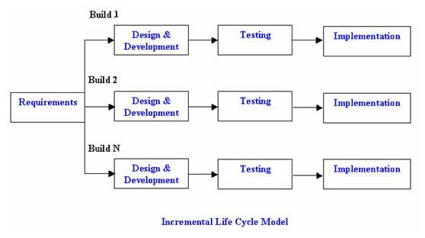

## 3.2 Data collection

During the course of data collection, face-to-face interviews (structured and unstructured methods) was carried out.

Collection of relevant data was through document review and this was by reading various articles by student who have experience this problem of having missing marks.

## System Design

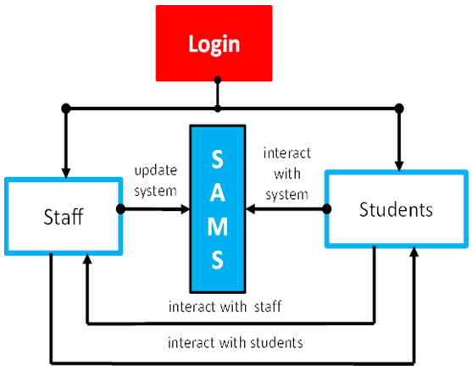

**S**

**A**

**A**

**M**

**S**

## Resources required

### Hardware requirements

* Processor-duo core
* Hard disc-5 GB
* Memory- 1GB RAM

### Software requirements

### 

* XAMPP server
* PHP
* MySQL 5.5
* Adobe Dream Weaver CS6
* HTML5
* Browser example chrome
* Diafaan SMS server console

## Requirement specification and analysis

### 3.6.1 Functional requirements

* The system shall allow the user to login to the system.
* The system shall allow the user that is the lecturer to receive a notification once a student sends a complain.
* The system shall allow the student to receive a feedback once a lecturer responds to a complain.
* The system shall allow a third party to be involved who is the COD( chairperson of department) in case the lecturer does not respond to the students complain.
* The system shall be able to print reports of the complains made by students.
* The system shall be able to print reports of analysis of the courses with various complains and their respective feedbacks.

|  |  |
| --- | --- |
| User | Description |
| Student | View the subject and the FAQ , create complain , view/add/update/delete complain and follow up answer survey question and give suggestions to subject |
| Lecturer | View the subject, respond to complain , follow up complains |
| Head of department | View system report, view system activities, view all complains, modify FAQ |
| Student Academic Advisor System | Generate system reports, set complain due dates and assign overdue complains to staff |

### 3.6.2 Non-Functional requirements

* Security: Provided through passwords where only authorized users are allowed to login to the system.
* Backup and recovery features: These are provided by the DBMS.
* Efficiency: The system functions online, when the network is down the system is inappropriate.
* Data integrity: The system provides data integrity using primary and foreign keys.
* Availability : the system shall be timely available to the user and reliable

## Reference

Kelly K. Parget (12-2011) the Effects of Academic Advising on College Student Development in Higher Education University of Nebraska – Lincoln Retrieved from <https://digitalcommons.unl.edu/cgi/viewcontent.cgi?article=1083&context=cehsedaddiss>

Wasike, E (April 2017) Commentary and Opinion, University to resolve “missing marks” problem. Retrieved on 13th Dec 2018 from http://educationnews.co.ke/2017/04/12/universities-told-to-resolve-missing-marks-problem/

Noaman, A.Y.; Ahmed, F.F. A new framework for e academic advising. Procedia Computer. Sci. 2015, 65, 358–367.

K. Kendal, J. Kendal (2011), System Analysis and Design, Eighth Edition, Pearson Education Inc, One Lake Street, Upper Saddle River, New Jersey 07458

## PROJECT SCHEDULE

SAAMS system will take a total of 3 months from the problem identification to the completion and documentation.

**The Gant Chart for the Project Activities**

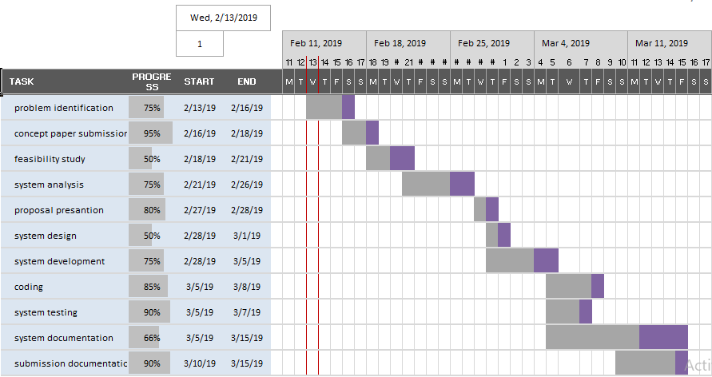

|  |  |  |
| --- | --- | --- |
|  | | |
|  |  | |
| Project budget  |  |  | | --- | --- | | **REQUIREMENT** | **COST** | | Laptop | 30,000/= | | Xampp | Free | | Macromedia Dreamweaver | Free | | Modem | 2000/= | | Printing | 1000/= | | Software purchase | 10000/= | | Data bundles | 2000/= | | **Total** | **45000/=** | |  |  |
|  |  |  |
|  |  |  |