**Voices Unheard: A Photographic Essay on Gender Inequality in the African**

**Community**

Name: Mark Mwangi

Reg No: C025-01-0654/2020

**Introduction:**

In many African communities, gender inequality remains a persistent issue despite progress in various sectors. This photographic essay seeks to illuminate the lived experiences of women and girls, shedding light on the challenges they face and the resilience they embody amidst systemic barriers.

# Everyday Struggles

Women in African communities often bear the disproportionate burden of domestic responsibilities, encompassing tasks such as cooking, cleaning, and childcare. This societal expectation confines them to traditional gender roles, relegating their opportunities for education 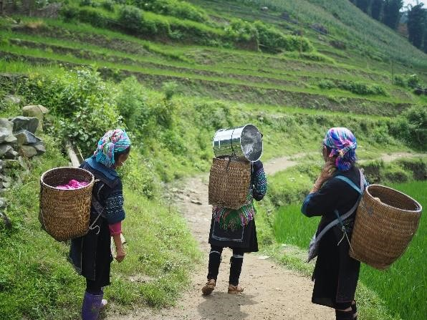 and employment. Consequently, many women find

themselves ensnared in cycles of poverty and dependency, unable to pursue personal aspirations beyond their domestic duties. This perpetuation of economic disparity exacerbates their vulnerability and marginalization within society.

# Educational Barriers

Despite strides towards gender equality in education, significant barriers persist for girls in many African communities.

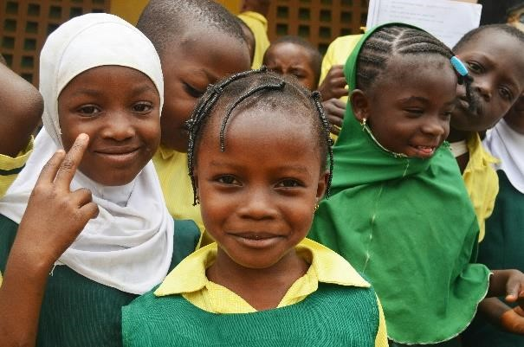 Cultural norms prioritizing boys' education, coupled

with early marriage practices and financial constraints, hinder girls' access to schooling. Forced to drop out at young ages to support their families or due to practices like female genital mutilation, many girls are denied their fundamental right to learn. This educational inequality not only stifles their individual potential but also perpetuates broader gender disparities, trapping generations in cycles of poverty and limited opportunity.

# Economic Empowerment

Despite facing numerous obstacles, African women are increasingly asserting their economic agency by entering the workforce and initiating entrepreneurial endeavors. However, pervasive gender-based discrimination impedes their full participation in economic activities.

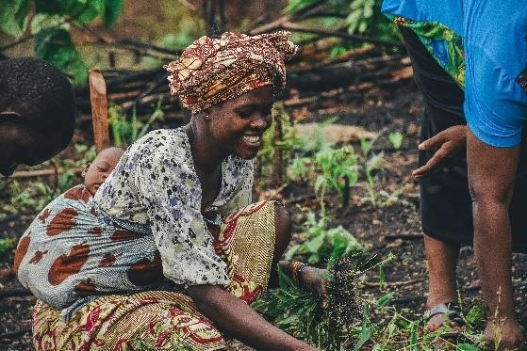 Limited access to financial resources, markets, and

opportunities for entrepreneurship constrain their potential, relegating many to informal and lowpaying sectors. Structural barriers such as discriminatory land ownership practices further exacerbate economic disparities, perpetuating a cycle of financial marginalization for women.

# Health Challenges

Caption: Women and girls across Africa confront significant health challenges, ranging from limited access to essential healthcare services to heightened risks of maternal mortality and HIV/AIDS. Structural factors such as poverty, inadequate healthcare infrastructure, and entrenched cultural norms impede their access to reproductive and maternal healthcare, resulting in preventable deaths and disabilities.

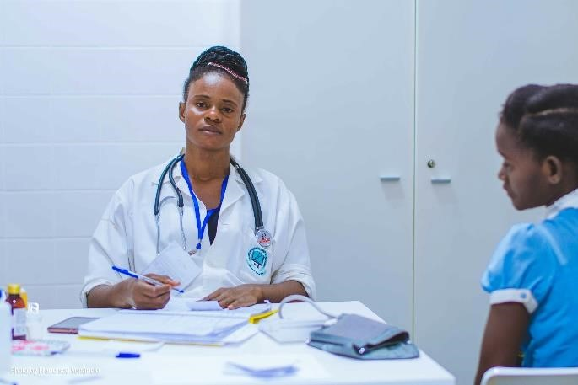 Additionally, the disproportionate burden of HIV/AIDS on women further compounds their health vulnerabilities, underscoring the urgent need for comprehensive, gender-sensitive healthcare interventions.

# Cultural Norms and Practices

Caption: Deep-seated cultural norms and practices, including child marriage and female genital mutilation, perpetuate gender inequality and violate the rights of women and girls. These harmful practices not only deprive girls of their autonomy and agency but also perpetuate cycles of poverty and marginalization.

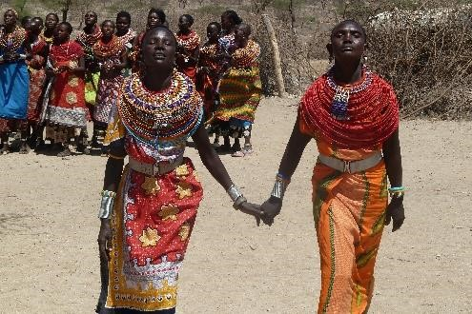 Addressing these entrenched cultural norms requires concerted

efforts to challenge harmful practices, promote gender-equitable values, and uphold the rights and dignity of women and girls.

# Political Representation

Caption: Despite comprising a significant portion of the population, women in many African countries remain underrepresented in political spheres. This lack of representation undermines their ability to influence decision-making processes and advocate for policies that address gender-based issues.

 To achieve meaningful gender equality, there is a pressing

need for greater representation of women in political institutions, ensuring that their voices are heard and their interests are prioritized in governance and policymaking.

# Resilience and Strength

Caption: Despite the myriad challenges they face, African women and girls demonstrate remarkable resilience and strength. Their ability to navigate adversity, challenge societal norms, and advocate for gender equality exemplifies their unwavering determination and resilience. By amplifying their voices and acknowledging their agency, we can work towards dismantling systemic barriers and fostering a more inclusive and equitable society for all.

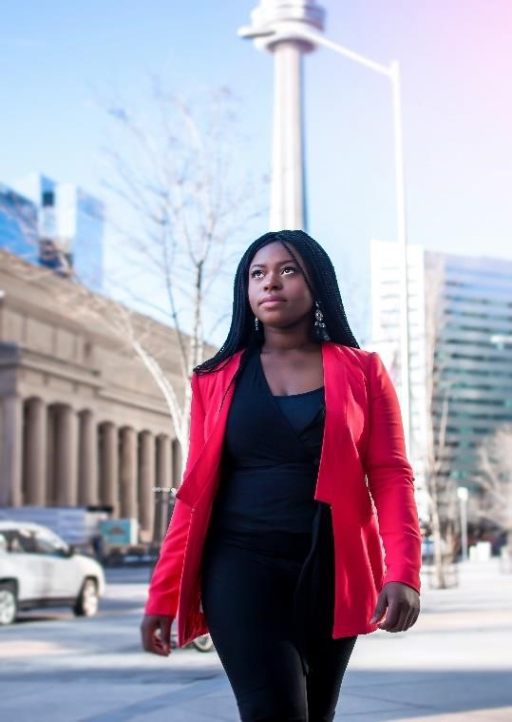

# Empowering Future Generations

Caption: Investing in the empowerment of women and girls is essential for breaking the cycles of poverty and inequality in African communities. By prioritizing girls' education, promoting economic opportunities, and ensuring access to comprehensive healthcare services, we can create a more just and equitable future for generations to come.

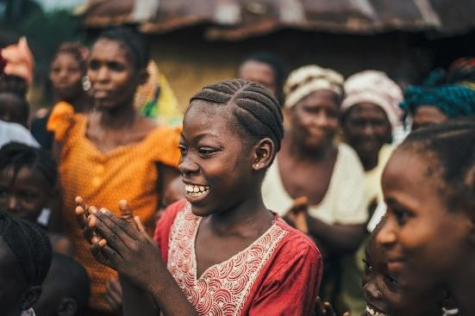 Empowering women and girls not only benefit individuals

but also catalyzes broader societal progress, driving economic growth, and fostering social cohesion.

**Conclusion:**

Through this photographic essay, we have illuminated the multifaceted nature of gender inequality in African communities. From educational barriers to economic disparities and health challenges, the obstacles facing women and girls are complex and interconnected. However, amidst these challenges, their resilience and determination shine through, inspiring hope for a brighter, more equitable future. By recognizing their voices, advocating for their rights, and addressing systemic barriers, we can collectively strive towards a more inclusive and just society, where every individual has the opportunity to thrive, regardless of gender.