**SCCJ/00653/2021**

**PETER MWANGI**

**BTECH IT**

**AQUAGROOVE SOFTWARE SYSTEM**

**DELIVERABLES**

**Software Engineering Methodology**

Agile Modeling Methodology: -Agile methodology is a collection of innovative, user-centered approach to develop a software system application.

**Deliverables**

* **Context Model**

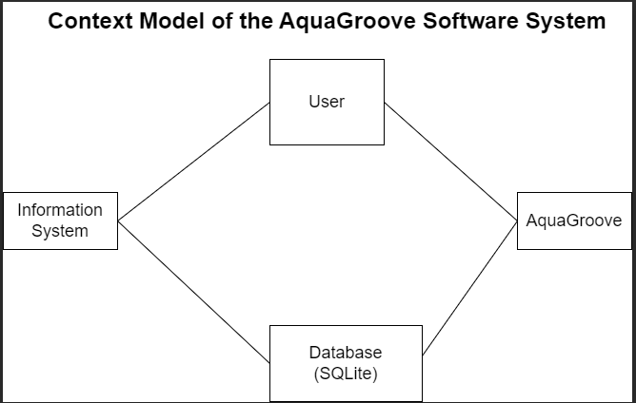

* **Interaction Model**

Use Case Diagram

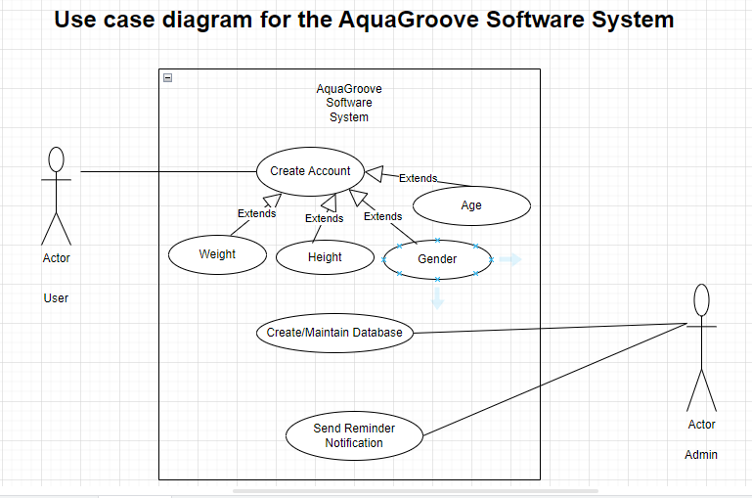

* **Structural Model**

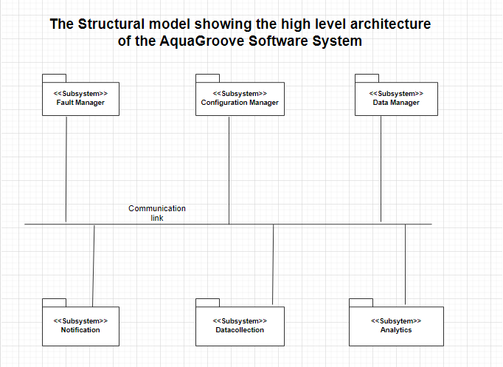

* **Behavioral Model**

