**SCCJ/00653/2021**

**PETER MWANGI**

**B TECH IT**

**SOFTWARE DEVELOPMENT**

**AQUAGROOVE - USER INTERFACE (UI)**

The main User Interface for The AquaGroove software application: -

https://www.figma.com/file/QLPIQqC5of1zLHDfPKAXXM/fustone?type=design&node-id=0%3A1&t=9qdVz2r042wmrZ7H-1

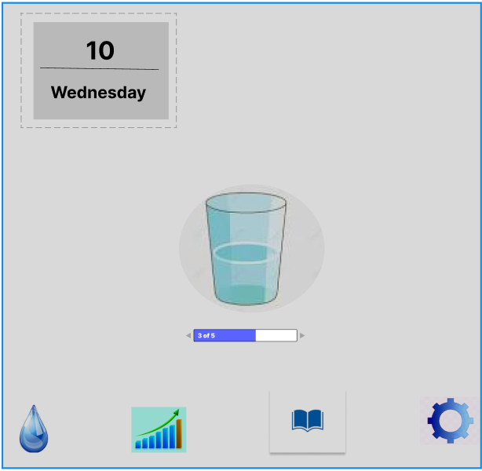

The AquaGroove software application has several tabs; which include: -

* The water intake tab

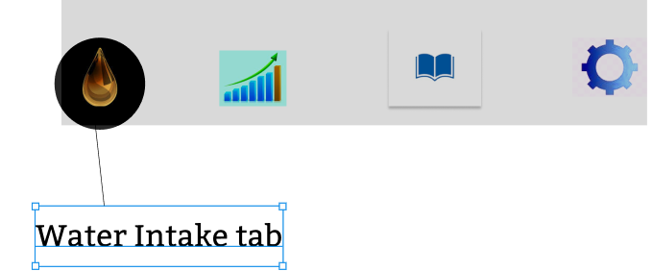

* The graph tab that records the water intake progress of the user.

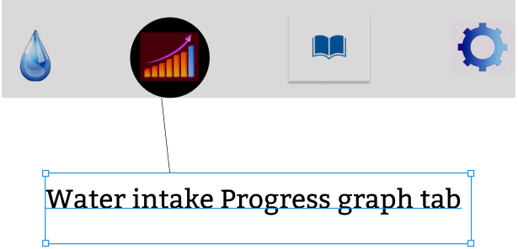

* Records tab – Allows the user to edit the user data such as; age, weight, water goals. The ‘Records tab’ also shows the records of the number of times the user drinks water.

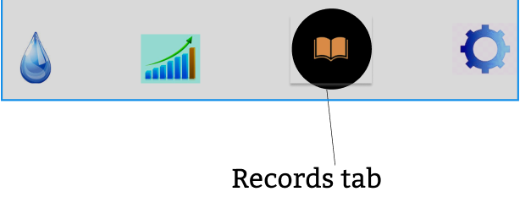

* Settings tab – Allow user to set reminders and to activate notifications. Enables user also to develop and upload a profile with an avator.

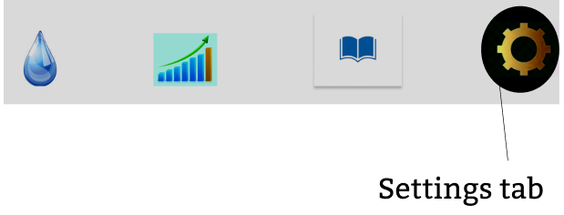

Apart from the tabs, the AquaGroove software application has several widgets which aids the users in recording their water intake.

These widgets include: -

* A glass of water with a progression bar – The progression bar records the number of cups of water the user drink and taps it in the AquaGroove software application.

The number on the progression bar indicates the number of glasses of water the user has drunk in a particular logged day.

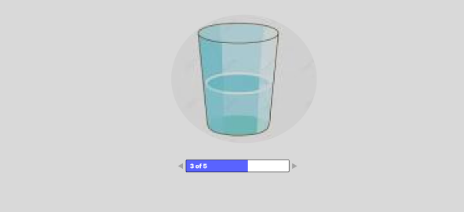

* Calendar – Shows the current date the user is recording the number of glasses of water he/she has drunk. The user could click on the calendar to view the records of the past days and also to set goals and reminders.

