**SCCJ/00653/2021**

**PETER MWANGI**

**B TECH IT**

**SOFTWARE DEVELOPMENT PROJECT**

**ONE PAGER**

**TITLE: AQUAGROOVE SOFTWARE APPLICATION**

Aquagroove software application is a software that helps individuals to track their daily water intake. It also sends periodic reminders to the individuals informing them to drink water regularly throughout the day.

The Aquagroove software application features include;

* Water tracking – It records and tracks the individuals water intake throughout the day and automatically generates a graph depicting the records at glance.
* Daily water goals – Allows the individual to set goals; e.g. to drink a certain amount of water in a day.
* Reminders – The Aquagroove software application sends periodic reminders to individuals, inform of notifications, to remind to drink water regularly.
* Progress record – The software records the progression streak of the user’s water intake.
* Acknowledgement – The software also acknowledges when the individual hits his/her set goals and congratulates him/her.

**Key: UML diagrams**

**Use case diagram components;**

Actor – refers to **any entity that performs a role**in one given system.

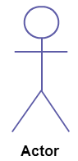

Use case - **represents a function or an action within the system.**

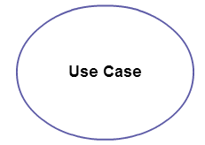

System – refers to a specific sequence of actions and interactions between actors and the system.

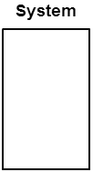

Package - **used to group together use cases**.

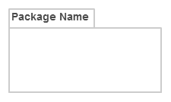

**Activity Diagram notations;**

Initial State – Depicts the starting state before an activity takes place.



Action / Activity state - Represents execution of an action on objects or by objects.



Action flow / Activity flow – Used to show the transition from one activity state to another.



Decision node – Used when deciding the flow of control.

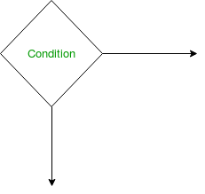

Fork Nodes – Used to support concurrent activities.

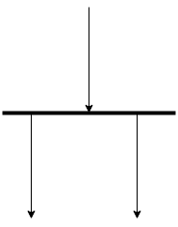

Join node - Join nodes are used to support concurrent activities converging into one.

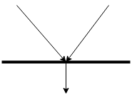

Final state – It indicates the end of a particular activity or process.



**Interaction diagrams;**

Sequence diagram notations: -

Lifeline notation – A lifeline represents a participant in an interaction and the role the participant plays in the interaction.

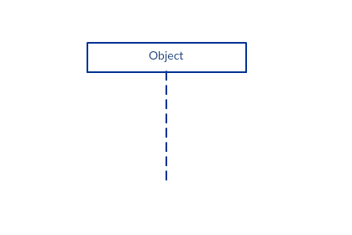

Activation bar – Indicates that an object is active during an interaction between two objects.

