**DHCPV4**

7.0.1

Why should I take this module?

Welcome to DHCPv4!

The Dynamic Host Configuration Protocol (DHCP) dynamically assigns IP addresses to devices. DHCPv4 is for an IPv4 network. (Don’t worry, you’ll learn about DHCPv6 in another module.) This means that you, the network administrator, do not have to spend your day configuring IP addresses for every device on your network. In a small home or office, that would not be very difficult, but any large network might have hundreds, or even thousands of devices.

In this module, you will learn how to configure a Cisco IOS router to be a DHCPv4 server. Then you will learn how to configure a Cisco IOS router as a client. This module includes a few Syntax Checkers and a Packet Tracer activity to help you try out your new knowledge. DHCPv4 configuration skills will significantly reduce your workload, and who doesn’t want that?

7.0.2

What will I learn to do in this module?

**Module Title**: DHCPv4

**Module Objective**: Implement DHCPv4 to operate across multiple LANs.

| Table caption | |
| --- | --- |
| **Topic Title** | **Topic Objective** |
| **DHCPv4 Concepts** | Explain how DHCPv4 operates in a small- to medium-sized business network. |
| **Configure a Cisco IOS DHCPv4 Server** | Configure a router as a DHCPv4 server. |
| **Configure a DHCPv4 Client** | Configure a router as a DHCPv4 client. |

**DHCP CONCEPTS**

7.1.2

## DHCPv4 Operation

DHCPv4 works in a client/server mode. When a client communicates with a DHCPv4 server, the server assigns or leases an IPv4 address to that client. The client connects to the network with that leased IPv4 address until the lease expires. The client must contact the DHCP server periodically to extend the lease. This lease mechanism ensures that clients that move or power off do not keep addresses that they no longer need. When a lease expires, the DHCP server returns the address to the pool where it can be reallocated as necessary.

7.1.3

## Steps to Obtain a Lease

When the client boots (or otherwise wants to join a network), it begins a four-step process to obtain a lease:

1. DHCP Discover (DHCPDISCOVER)
2. DHCP Offer (DHCPOFFER)
3. DHCP Request (DHCPREQUEST)
4. DHCP Acknowledgment (DHCPACK)

**Step 1. DHCP Discover (DHCPDISCOVER)**

The client starts the process using a broadcast ***DHCPDISCOVER message*** with its own MAC address to discover available DHCPv4 servers.

Because the client has no valid IPv4 information at bootup, it uses Layer 2 and Layer 3 broadcast addresses to communicate with the server. The purpose of the DHCPDISCOVER message is to find DHCPv4 servers on the network.

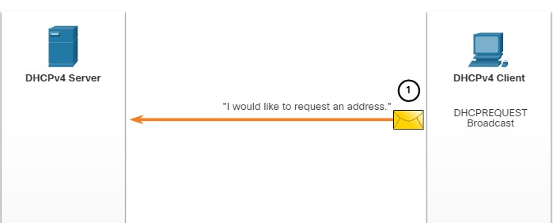

**Step 2. DHCP Offer (DHCPOFFER)**

When the DHCPv4 server receives a DHCPDISCOVER message, it reserves an available IPv4 address to lease to the client. The server also creates an ARP entry consisting of the ***MAC address*** of the requesting client and the ***leased IPv4 address*** of the client. The DHCPv4 server sends the binding DHCPOFFER message to the requesting client.

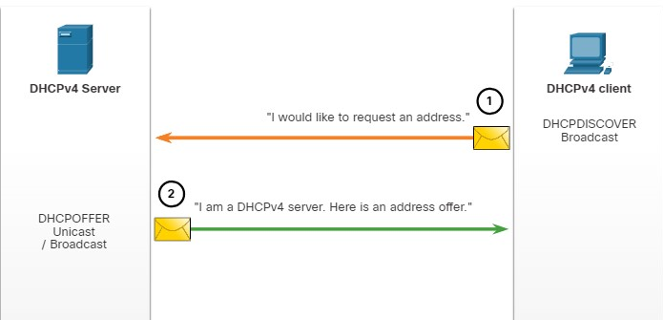

**Step 3. DHCP Request (DHCPREQUEST)**

When the client receives the DHCPOFFER from the server, it sends back a DHCPREQUEST message.

This message is used for both lease origination and lease renewal. When used for lease origination, the DHCPREQUEST serves as a binding acceptance notice to the selected server for the parameters it has offered and an implicit decline to any other servers that may have provided the client a binding offer.

Many enterprise networks use multiple DHCPv4 servers. The DHCPREQUEST message is sent in the form of a broadcast to inform this DHCPv4 server and any other DHCPv4 servers about the accepted offer.

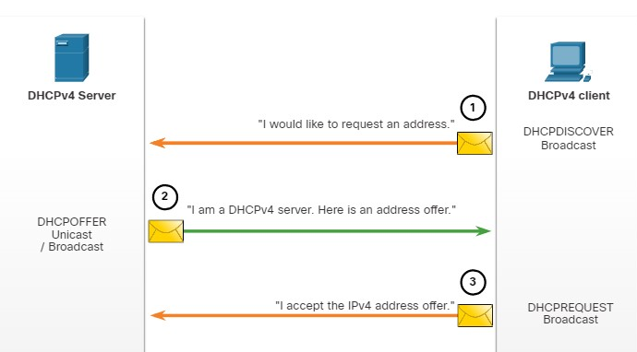

**Step 4. DHCP Acknowledgment (DHCPACK)**

On receiving the DHCPREQUEST message, the server may verify the lease information with an ICMP ping to that address to ensure it is not being used already, it will create a new ARP entry for the client lease, and reply with a DHCPACK message.

The DHCPACK message is a duplicate of the DHCPOFFER, except for a change in the message type field. When the client receives the DHCPACK message, it logs the configuration information and may perform an ARP lookup for the assigned address. If there is no reply to the ARP, the client knows that the IPv4 address is valid and starts using it as its own.

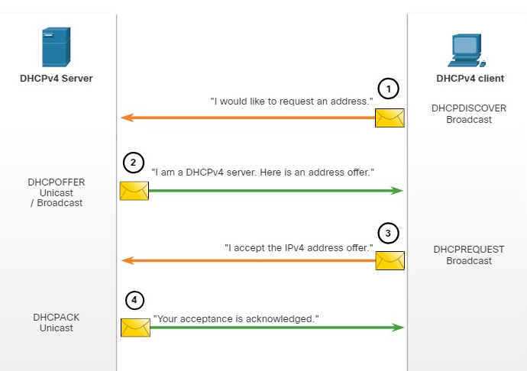

7.1.4

## Steps to Renew a Lease

Prior to lease expiration, the client begins a two-step process to renew the lease with the DHCPv4 server, as shown in the figure:

**1. DHCP Request (DHCPREQUEST)**

Before the lease expires, the client sends a DHCPREQUEST message directly to the DHCPv4 server that originally offered the IPv4 address. If a DHCPACK is not received within a specified amount of time, the client broadcasts another DHCPREQUEST so that one of the other DHCPv4 servers can extend the lease.

**2. DHCP Acknowledgment (DHCPACK)**

On receiving the DHCPREQUEST message, the server verifies the lease information by returning a DHCPACK.

**Note**: These messages (primarily the DHCPOFFER and DHCPACK) can be sent as unicast or broadcast according to IETF RFC 2131.

The diagram shows the two-step process and exchange of messages between a DHCPv4 client and a DHCPv4 server when the client wants to renew a lease. In step one, the client sends a DCHPREQUEST unicast message to the server saying, in essence, I would like to renew my lease. In step 2, the server responds with a DHCPACK unicast message saying, in essence, your request in acknowledged.

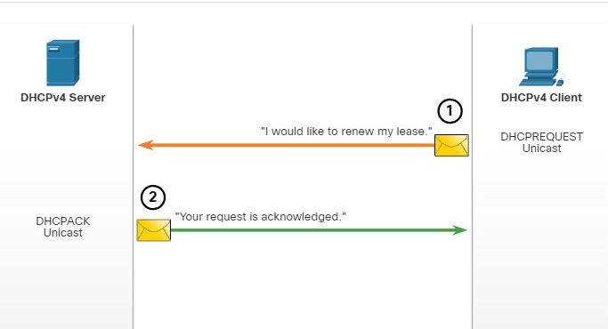

You have successfully identified the correct answers.

1. Which message is sent by a DHCPv4 client to initiate the lease obtaining process?



DHCPDISCOVER



DCHPOFFER



DHCPREQUEST



DHCPACK

**ANS: DHCPv4 clients initiate the lease process by sending a DHCPDISCOVER message as a broadcast onto the network to locate a DHCPv4 server.**

1. Which two DHCPv4 messages are sent by the server in the lease obtaining process? (Choose two.)



DHCPDISCOVER



DCHPOFFER



DHCPREQUEST



DHCPACK

**ANS: DCHPv4 servers send two messages in the lease origination process, the DHCPOFFER and the DHCPACK.**

1. Which two DHCPv4 messages are used in the lease renewal process? (Choose two.)



DHCPDISCOVER



DCHPOFFER



DHCPREQUEST



DHCPACK

**ANS: The lease renewal process involves two messages. The client sends a DHCPREQUEST and the server responds with a DHCPAK.**

**CONFIGURE A CISCO IOS DHCPV4 SERVER**

7.2.1

## Cisco IOS DHCPv4 Server

Now you have a basic understanding of how DHCPv4 works and how it can make your job a bit easier. If you do not have a separate DHCPv4 server, this topic will show you how to configure a Cisco IOS router to act as one.

A Cisco router running Cisco IOS software can be configured to act as a DHCPv4 server. The Cisco IOS DHCPv4 server assigns and manages IPv4 addresses from specified address pools within the router to DHCPv4 clients.

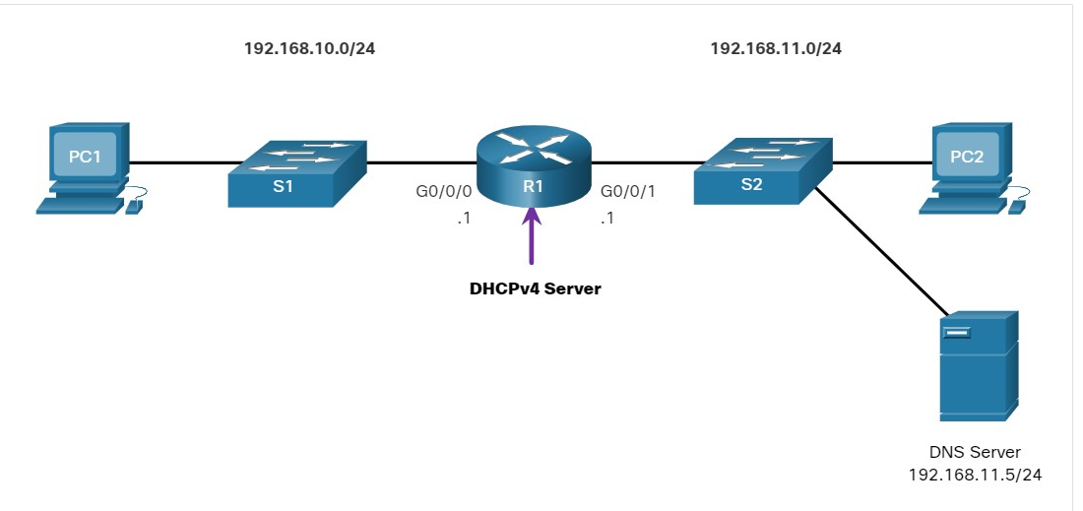

7.2.2

## Steps to Configure a Cisco IOS DHCPv4 Server

Use the following steps to configure a Cisco IOS DHCPv4 server:

**Step 1**. Exclude IPv4 addresses.  
**Step 2**. Define a DHCPv4 pool name.  
**Step 3**. Configure the DHCPv4 pool.

**Step 1. Exclude IPv4 Addresses**

The router functioning as the DHCPv4 server assigns all IPv4 addresses in a DHCPv4 address pool unless it is configured to exclude specific addresses. Typically, some IPv4 addresses in a pool are assigned to network devices that require static address assignments. Therefore, these IPv4 addresses should not be assigned to other devices. The command syntax to exclude IPv4 addresses is the following:



A single address or a range of addresses can be excluded by specifying the low-address and high-address of the range.

Excluded addresses should be those addresses that are assigned to routers, servers, printers, and other devices that have been, or will be, manually configured. You can also enter the command multiple times.

**Step 2. Define a DHCPv4 Pool Name**

Configuring a DHCPv4 server involves defining a pool of addresses to assign.

As shown in the example, the **ip dhcp pool** *pool-name* command creates a pool with the specified name and puts the router in DHCPv4 configuration mode, which is identified by the prompt Router(dhcp-config)#.

The command syntax to define the pool is the following:



**Step 3. Configure the DHCPv4 Pool**

The table lists the tasks to complete the DHCPv4 pool configuration.

The address pool and default gateway router must be configured. Use the **network** statement to define the range of available addresses. Use the **default-router** command to define the default gateway router. Typically, the gateway is the LAN interface of the router closest to the client devices. One gateway is required, but you can list up to eight addresses if there are multiple gateways.

Other DHCPv4 pool commands are optional. For example, the IPv4 address of the DNS server that is available to a DHCPv4 client is configured using the **dns-server** command. The **domain-name** command is used to define the domain name. The duration of the DHCPv4 lease can be changed using the **lease** command. The default lease value is one day. The **netbios-name-server** command is used to define the NetBIOS WINS server.

| **Task** | **IOS Command** |
| --- | --- |
| Define the address pool. | **network** *network-number* [*mask* | / *prefix-length*] |
| Define the default router or gateway. | **default-router** address [ *address2….address8*] |
| Define a DNS server. | **dns-server** *address* [ *address2…address8*] |
| Define the domain name. | **domain-name** *domain* |
| Define the duration of the DHCP lease. | **lease** {*days* [*hours* [ *minutes*]] | **infinite**} |
| Define the NetBIOS WINS server. | **netbios-name-server** *address* [ *address2…address8*] |

**Note**: Microsoft recommends not deploying WINS, instead configure DNS for Windows name resolution and decommission WINS.

7.2.3

## Configuration Example

The topology for the example configuration is shown in the figure.

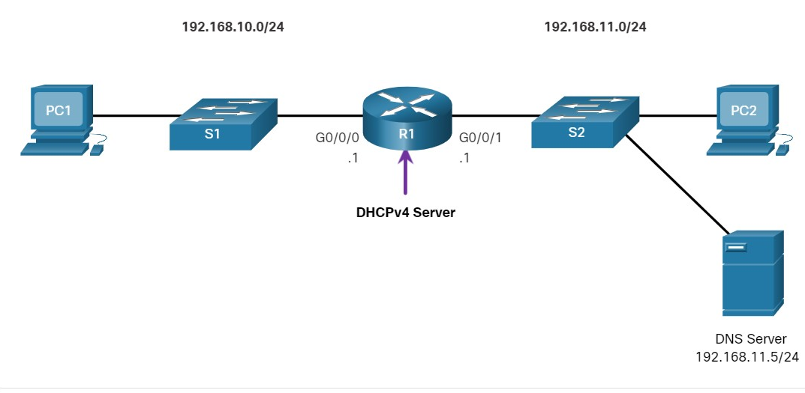

The example shows the configuration to make R1 a DHCPv4 server for the 192.168.10.0/24 LAN

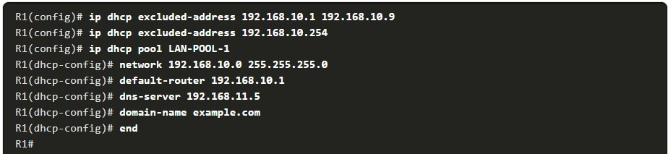

7.2.4

## DHCPv4 Verification Commands

Use the commands in the table to verify that the Cisco IOS DHCPv4 server is operational.

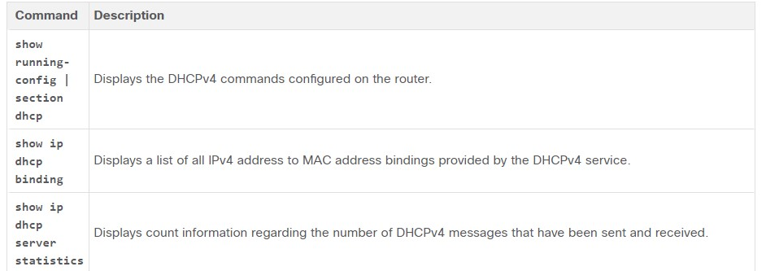

## Verify DHCPv4 is Operational

The topology shown in the figure is used in the example output. In this example, R1 has been configured to provide DHCPv4 services. PC1 has not been powered up and, therefore, does not have an IP address.

.



The output for the following commands assumes PC1 has received its IPv4 addressing information from the DHCPv4 server. You may need to enter ipconfig /renew on a Windows PC to force it to send out a DHCPDISCOVER message.Click each button to see the command output verifying that DHCPv4 is operational.

**Verify the DHCPv4 Configuration**

As shown in the example, the **show running-config | section dhcp** command output displays the DHCPv4 commands configured on R1. The **| section** parameter displays only the commands associated with DHCPv4 configuration.

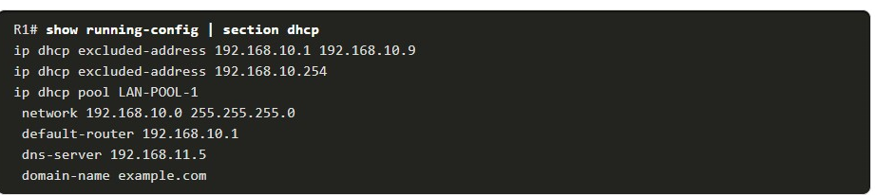

**Verify DHCPv4 Bindings**

As shown in the example, the operation of DHCPv4 can be verified using the **show ip dhcp binding** command. This command displays a list of all IPv4 address to MAC address bindings that have been provided by the DHCPv4 service.

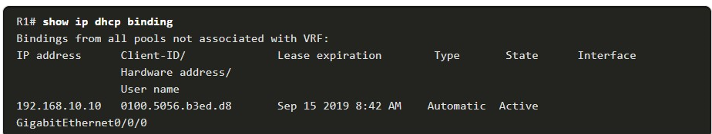

**Verify DHCPv4 Statistics**

The output of the **show ip dhcp server statistics** is used to verify that messages are being received or sent by the router. This command displays count information regarding the number of DHCPv4 messages that have been sent and received.

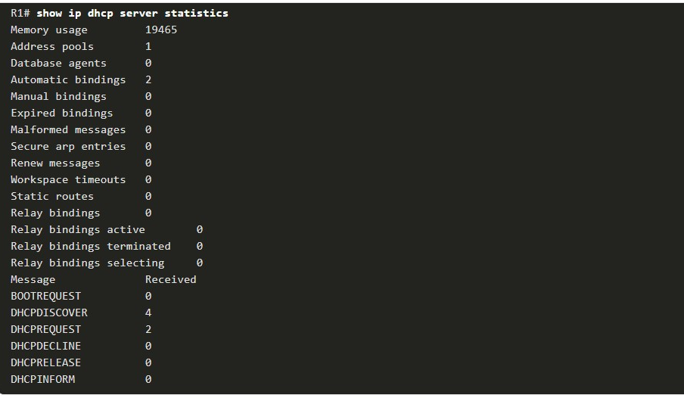

**Verify DHCPv4 Client Received IPv4 Addressing**

The **ipconfig /all** command, when issued on PC1, displays the TCP/IP parameters, as shown in the example. Because PC1 was connected to the network segment 192.168.10.0/24, it automatically received a DNS suffix, IPv4 address, subnet mask, default gateway, and DNS server address from that pool. No DHCP-specific router interface configuration is required. If a PC is connected to a network segment that has a DHCPv4 pool available, the PC can obtain an IPv4 address from the appropriate pool automatically.

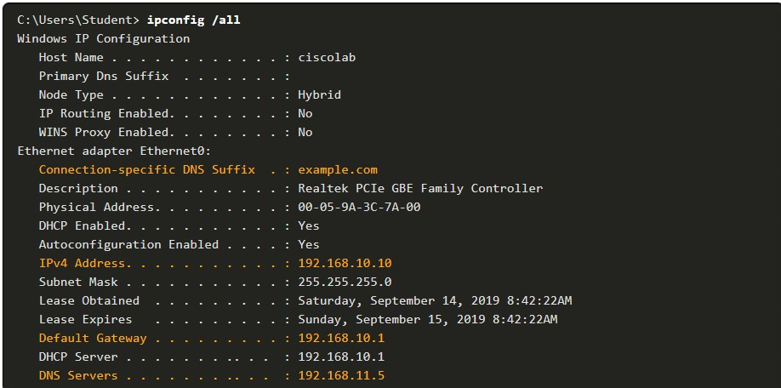

7.2.7

## Disable the Cisco IOS DHCPv4 Server

The DHCPv4 service is enabled by default. To disable the service, use the **no service dhcp** global configuration mode command. Use the **service dhcp** global configuration mode command to re-enable the DHCPv4 server process, as shown in the example. Enabling the service has no effect if the parameters are not configured.

**Note**: Clearing the DHCP bindings or stopping and restarting the DHCP service may result in duplicate IP addresses being temporarily assigned on the network.



7.2.8

## DHCPv4 Relay

In a complex hierarchical network, enterprise servers are usually located centrally. These servers may provide DHCP, DNS, TFTP, and FTP services for the network. Network clients are not typically on the same subnet as those servers. In order to locate the servers and receive services, clients often use broadcast messages.

In the figure, PC1 is attempting to acquire an IPv4 address from a DHCPv4 server using a broadcast message. In this scenario, R1 is not configured as a DHCPv4 server and does not forward the broadcast. Because the DHCPv4 server is located on a different network, PC1 cannot receive an IP address using DHCP. R1 must be configured to relay DHCPv4 messages to the DHCPv4 server.

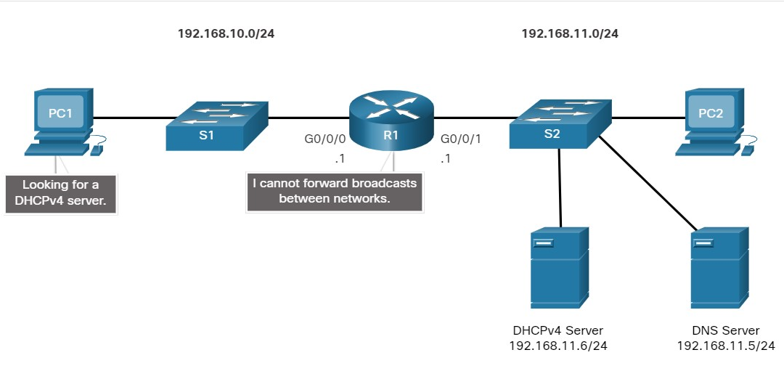

In this scenario, a network administrator is attempting to renew IPv4 addressing information for PC1

**1.ipconfig /release**

PC1 is a Windows computer. The network administrator releases all current IPv4 addressing information using the **ipconfig /release** command. Notice that the IPv4 address is released and no address is shown.

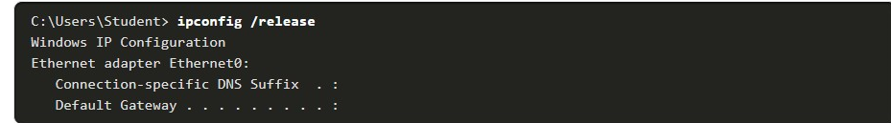

**2.** **ipconfig /renew**

Next, the network administrator attempts to renew the IPv4 addressing information with the **ipconfig /renew** command. This command causes PC1 to broadcast a DHCPDISCOVER message. The output shows that PC1 is unable to locate the DHCPv4 server. Because routers do not forward broadcasts, the request is not successful.

The network administrator could add DHCPv4 servers on R1 for all subnets. However, this would create additional cost and administrative overhead.

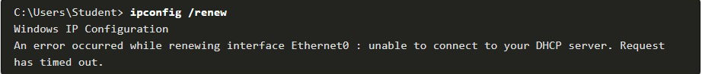

**3. ip helper-address**

A better solution is to configure R1 with the **ip helper-address** *address* interface configuration command. This will cause R1 to relay DHCPv4 broadcasts to the DHCPv4 server. As shown in the example, the interface on R1 receiving the broadcast from PC1 is configured to relay DHCPv4 address to the DHCPv4 server at 192.168.11.6.

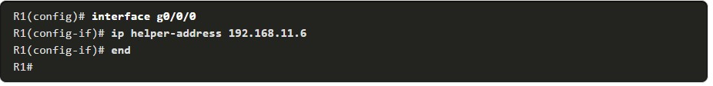

**4.show ip interface**

When R1 has been configured as a DHCPv4 relay agent, it accepts broadcast requests for the DHCPv4 service and then forwards those requests as a unicast to the IPv4 address 192.168.11.6. The network administrator can use the **show ip interface** command to verify the configuration.

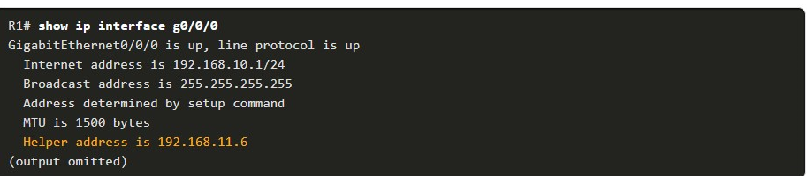

**5.ipconfig /all**

As shown in the output, PC1 is now able to acquire an IPv4 address from the DHCPv4 server as verified with the **ipconfig /all** command.

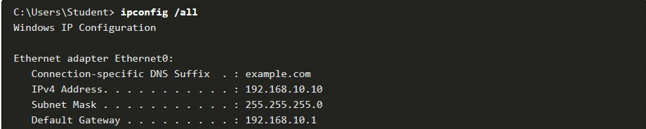

7.2.9

Other Service Broadcasts Relayed

DHCPv4 is not the only service that the router can be configured to relay. By default, the **ip helper-address** command forwards the following eight UDP services:

* Port 37: Time
* Port 49: TACACS
* Port 53: DNS
* Port 67: DHCP/BOOTP server
* Port 68: DHCP/BOOTP client
* Port 69: TFTP
* Port 137: NetBIOS name service
* Port 138: NetBIOS datagram service

7.2.10

Packet Tracer - Configure DHCPv4(pending)

In this Packet Tracer Activity, you will complete the following objectives:

* Part 1: Configure a Router as a DHCP Server
* Part 2: Configure DHCP Relay
* Part 3: Configure a Router as a DHCP Client
* Part 4: Verify DHCP and Connectivity

**CONFIGURE A DHCPV4 CLIENT**

7.3.1

## Cisco Router as a DHCPv4 Client

There are scenarios where you might have access to a DHCP server through your ISP. In these instances, you can configure a Cisco IOS router as a DHCPv4 client. This topic walks you through that process.

Sometimes, Cisco routers in a small office or home office (SOHO) and branch sites have to be configured as DHCPv4 clients in a similar manner to client computers. The method used depends on the ISP. However, in its simplest configuration, the Ethernet interface is used to connect to a cable or DSL modem.

To configure an Ethernet interface as a DHCP client, use the **ip address dhcp** interface configuration mode command.

In the figure, assume that an ISP has been configured to provide select customers with IP addresses from the 209.165.201.0/27 network range after the G0/0/1 interface is configured with the **ip address dhcp** command.

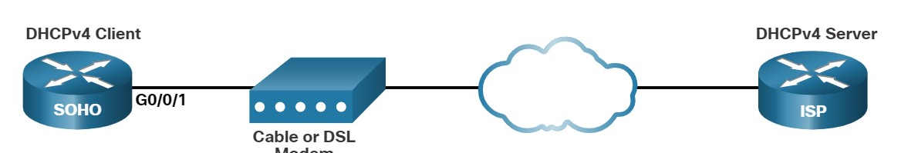

7.3.2

## Configuration Example

To configure an Ethernet interface as a DHCP client, use the **ip address dhcp** interface configuration mode command, as shown in the example. This configuration assumes that the ISP has been configured to provide select customers with IPv4 addressing information.

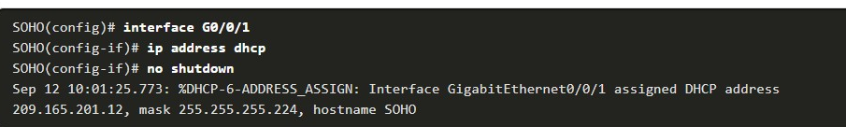

The **show ip interface g0/0/1** command confirms that the interface is up and that the address was allocated by a DHCPv4 server.

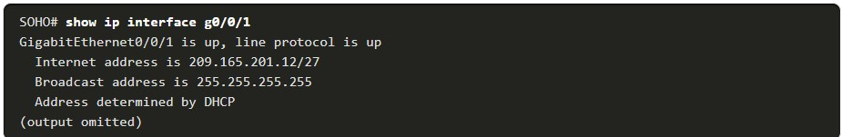

7.3.3

## Home Router as a DHCPv4 Client

Home routers are typically already set to receive IPv4 addressing information automatically from the ISP. This is so that customers can easily set up the router and connect to the internet.

For example, the figure shows the default WAN setup page for a Packet Tracer wireless router. Notice that the internet connection type is set to **Automatic Configuration - DHCP**. This selection is used when the router is connected to a DSL or cable modem and acts as a DHCPv4 client, requesting an IPv4 address from the ISP.

Various manufacturers of home routers will have a similar setup.

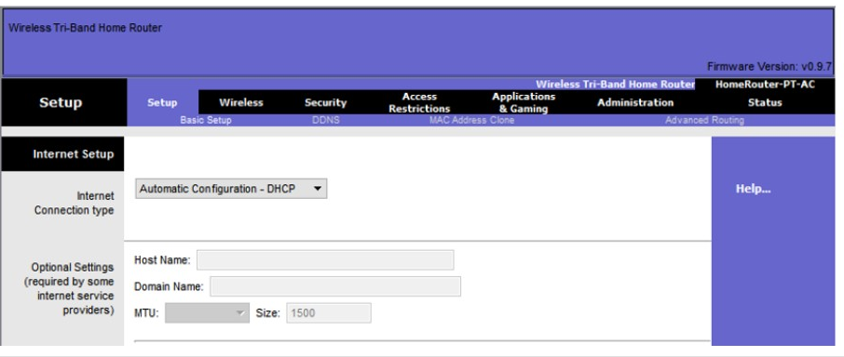

7.4.1

## Packet Tracer - Implement DHCPv4(pending)

As the network technician for your company, you are tasked with configuring a Cisco router as a DHCP server to provide dynamic allocation of addresses to clients on the network. You are also required to configure the edge router as a DHCP client so that it receives an IP address from the ISP network. Because the server is centralized, you will need to configure the two LAN routers to relay DHCP traffic between the LANs and the router that is serving as the DHCP server.

7.4.2

Lab - Implement DHCPv4

In this lab, you will complete the following objectives:

* Part 1: Build the Network and Configure Basic Device Settings
* Part 2: Configure and Verify Two DHCPv4 Servers on R1
* Part 3: Configure and Verify a DHCP Relay on R2

7.4.3

What did I learn in this module?

**DHCPv4 Concepts**

The DHCPv4 server dynamically assigns, or leases, an IPv4 address to a client from a pool of addresses for a limited period of time chosen by the server, or until the client no longer needs the address.

The DHCPv4 lease process begins with the client sending message requesting the services of a DHCP server. If there is a DHCPv4 server that receives the message it will respond with an IPv4 address and possible other network configuration information.

The client must contact the DHCP server periodically to extend the lease. This lease mechanism ensures that clients that move or power off do not keep addresses that they no longer need. When the client boots (or otherwise wants to join a network), it begins a four-step process to obtain a lease: DHCPDISCOVER, then DHCPOFFER, then DHCPREQUEST, and finally DHCPACK. Prior to lease expiration, the client begins a two-step process to renew the lease with the DHCPv4 server: DHCPREQUEST then DHCPACK.

**Configure a Cisco IOS DHCPv4 Server**

A Cisco router running Cisco IOS software can be configured to act as a DHCPv4 server. Use the following steps to configure a Cisco IOS DHCPv4 server:

* **exclude IPv4 addresses,**
* **define a DHCPv4 pool name,**
* **configure the DHCPv4 pool.**

Verify your configuration using the **show running-config | section dhcp**, **show ip dhcp binding**, and **show ip dhcp server statistics** commands.

The DHCPv4 service is enabled, by default. To disable the service, use the **no service dhcp** global configuration mode command. In a complex hierarchical network, enterprise servers are usually located centrally.

These servers may provide DHCP, DNS, TFTP, and FTP services for the network. Network clients are not typically on the same subnet as those servers. In order to locate the servers and receive services, clients often use broadcast messages.

A PC is attempting to acquire an IPv4 address from a DHCPv4 server using a broadcast message. If the router is not configured as a DHCPv4 server, it will not forward the broadcast. If the DHCPv4 server is located on a different network, the PC cannot receive an IP address using DHCP.

The router must be configured to relay DHCPv4 messages to the DHCPv4 server. The network administrator releases all current IPv4 addressing information using the **ipconfig /release** command.

Next, the network administrator attempts to renew the IPv4 addressing information with the **ipconfig /renew** command. A better solution is to configure R1 with the **ip helper-address** *address interface* configuration command.

The network administrator can use the **show ip interface** command to verify the configuration. The PC is now able to acquire an IPv4 address from the DHCPv4 server as verified with the **ipconfig /all** command. By default, the **ip helper-address** command forwards the following eight UDP services:

* Port 37: Time
* Port 49: TACACS
* Port 53: DNS
* Port 67: DHCP/BOOTP server
* Port 68: DHCP/BOOTP client
* Port 69: TFTP
* Port 137: NetBIOS name service
* Port 138: NetBIOS datagram service

**Configure a DHCPv4 Client**

The Ethernet interface is used to connect to a cable or DSL modem. To configure an Ethernet interface as a DHCP client, use the **ip address dhcp interface** configuration mode command. Home routers are typically already set to receive IPv4 addressing information automatically from the ISP. The internet connection type is set to Automatic Configuration - DHCP. This selection is used when the router is connected to a DSL or cable modem and acts as a DHCPv4 client, requesting an IPv4 address from the ISP.

1. A DHCP-enabled client PC has just booted. During which two steps will the client PC use broadcast messages when communicating with a DHCP server? (Choose two.)

Topic 7.1.0 - All DHCP messages between a DHCP-enabled client and a DHCP server are using broadcast messages until after the DHCPACK message. The DHCPDISCOVER and DHCPREQUEST messages are the only messages that are sent by a DHCP-enabled client. All DHCP messages between a DHCP-enabled client and a DHCP server use broadcast messages when the client is obtaining a lease for the first time.



DHCPREQUEST



DHCPOFFER



DHCPNAK



DHCPDISCOVER



DHCPACK

1. An administrator issues the commands:

Router(config)# **interface g0/1**  
Router(config-if)# **ip address dhcp**

What is the administrator trying to achieve?

Topic 7.3.0 - The **ip address dhcp** command activates the DHCPv4 client on a given interface. By doing this, the router will obtain the IP parameters from a DHCPv4 server.



configuring the router to obtain IP parameters from a DHCPv4 server



configuring the router to act as a relay agent



configuring the router to act as a DHCPv4 server



configuring the router to resolve IP address conflicts

1. When a client is requesting an initial address lease from a DHCP server, why is the DHCPREQUEST message sent as a broadcast?

Topic 7.1.0 - During the initial DHCP exchange between a client and server, the client broadcasts a DHCPDISCOVER message looking for DHCP servers. Multiple servers may be configured to respond to this request with DHCPOFFER messages. The client will choose the lease from one of the servers by sending a DHCPREQUEST message. It sends this message as a broadcast so that the other DHCP servers that sent offers will know that their offers were declined and the corresponding address can go back into the pool.



The client does not yet know the IP address of the DHCP server that sent the offer.



The client does not have a MAC address assigned yet, so it cannot send a unicast message at Layer 2.



The client may have received offers from multiple servers, and the broadcast serves to implicitly decline those other offers.



The DHCP server may be on a different subnet, so the request must be sent as a broadcast.

1. Which DHCP IPv4 message contains the following information?

Destination address: 255.255.255.255  
Client IPv4 address: 0.0.0.0  
Default gateway address: 0.0.0.0  
Subnet mask: 0.0.0.0

Topic 7.1.0 - A client will first send the DHCPDISCOVER broadcast message to find DHCPv4 servers on the network. This message will have the limited broadcast address, 255.255.255.255, as the destination address. The client IPv4 address, the default gateway address, and subnet fields will all be 0.0.0.0 because these have not yet been configured on the client. When the DHCPv4 server receives a DHCPDISCOVER message, it reserves an available IPv4 address to lease to the client and sends the unicast DHCPOFFER message to the requesting client. When the client receives the DHCPOFFER from the server, it sends back a DHCPREQUEST broadcast message. On receiving the DHCPREQUEST message, the server replies with a unicast DHCPACK message.



DHCPACK



DHCPREQUEST



DHCPDISCOVER



DHCPOFFER

1. What kind of message is sent by a DHCPv4 client requesting an IP address?

Topic 7.1.0 - When the DHCPv4 client requests an IP address, it sends a DHCPDISCOVER broadcast message seeking a DHCPv4 server on the network.



DHCPDISCOVER broadcast message



DHCPOFFER unicast message



DHCPACK unicast message



DHCPDISCOVER unicast message

1. As a DHCPv4 client lease is about to expire, what is the message that the client sends the DHCP server?

Topic 7.1.0 - When a DHCP client lease is about to expire, the client sends a DHCPREQUEST message to the DHCPv4 server that originally provided the IPv4 address.​ This allows the client to request that the lease be extended.​



DHCPREQUEST



DHCPDISCOVER



DHCPACK



DHCPOFFER

1. What is the destination IP address when an IPv4 host sends a DHCPDISCOVER message?

Topic 7.1.0 - Because a DHCP client does not have a valid IPv4 address, it must use a broadcast IP address of 255.255.255.255 as the destination address to communicate with the DHCP server. The DHCPDISCOVER message sent by the client is the first message sent in order to make initial contact with a DHCP server.



192.168.1.1



0.0.0.0



255.255.255.255



224.0.0.1

1. If more than one DHCP server is available on the local network, in which order will DHCP messages be sent between a host and a DHCP server?

Topic 7.1.0 - A DHCP host broadcasts a DHCP discover message to locate available servers. If more than one DHCP server is available, each server will respond to the host with a unicast DHCP offer message, which offers a lease to the client. The client then broadcasts a DHCP request message that identifies the specific server and offer that the client will accept. The identified server will unicast a DHCP acknowledgment message to finalize the offer.



request, acknowledgment, discover, offer



request, discover, offer, acknowledgment



acknowledgment, request, offer, discover



discover, offer, request, acknowledgment

1. What is the most likely scenario in which the WAN interface of a router would be configured as a DHCP client to be assigned a dynamic IP address from an ISP?

Topic 7.3.0 - SOHO and home broadband routers are typically set to acquire an IPv4 address automatically from the ISP. The IP address that is assigned is typically a dynamic address to reduce the cost, but a static IP address is possible with more cost. However, if the router is assigned a dynamic IP address, DNS issues will result in the web server behind the router not being easily accessible to the public. Routers are typically also gateways for LANs, but this has no bearing on whether the router is configured as a DHCP client on its WAN link or not. Likewise, a router can be configured to be a DHCP client in order to obtain an IP address from the ISP, but at the same time, it can be configured as a DHCP server to serve the IP addressing for the devices on its LAN.



There is a web server for public access on the LAN that is attached to the router.



The router is also the gateway for a LAN.



It is a SOHO or home broadband router.



The router is configured as a DHCP server.

1. Which is a DHCPv4 address allocation method that assigns IPv4 addresses for a limited lease period?

Topic 7.1.0 - Dynamic allocation is the most commonly implemented allocation mechanism. It leases the IP parameters for a predefined period of time.



pre-allocation



manual allocation



automatic allocation



dynamic allocation

1. What is the reason why the DHCPREQUEST message is sent as a broadcast during the DHCPv4 process?

Topic 7.1.0 - The DHCPREQUEST message is broadcast to inform other DHCP servers that an IP address has been leased.



to notify other hosts not to request the same IP address



for hosts on other subnets to receive the information



for routers to fill their routing tables with this new information



to notify other DHCP servers on the subnet that the IP address was leased

1. How is a DHCPDISCOVER transmitted on a network to reach a DHCP server?

Topic 7.1.0 - The DHCPDISCOVER message is sent by a DHCPv4 client and targets a broadcast IP along with the destination port 67. The DHCPv4 server or servers respond to the DHCPv4 clients by targeting port 68.



A DHCPDISCOVER message is sent with the broadcast IP address as the destination address.



A DHCPDISCOVER message is sent with the IP address of the default gateway as the destination address.



A DHCPDISCOVER message is sent with the IP address of the DHCP server as the destination address.



A DHCPDISCOVER message is sent with a multicast IP address that all DHCP servers listen to as the destination address.

1. Which destination IPv4 address does a DHCPv4 client use to send the initial DHCP Discover packet when the client is looking for a DHCP server?

Topic 7.1.0 - Broadcast communications on a network may be directed or limited. A directed broadcast is sent to all hosts on a specific network. A limited broadcast is sent to 255.255.255.255. When a DHCP client needs to send a DHCP Discover packet in order to seek DHCP servers, the client will use this IP address of 255.255.255.255 as the destination in the IP header because it has no knowledge of the IP addresses of DHCP servers.



255.255.255.255



127.0.0.1



224.0.0.1



the IP address of the default gateway

1. Under which two circumstances would a router usually be configured as a DHCPv4 client? (Choose two.)

Topic 7.3.0 - SOHO routers are frequently required by the ISP to be configured as DHCPv4 clients in order to be connected to the provider.



The administrator needs the router to act as a relay agent.



This is an ISP requirement.



The router has a fixed IP address.



The router is intended to be used as a SOHO gateway.



The router is meant to provide IP addresses to the hosts.

15. Which address does a DHCPv4 server target when sending a DHCPOFFER message to a client that makes an address request?

Topic 7.1.0 - When a DHCPv4 client does not have an IPv4 address, a DHCPv4 server will send a DHCPOFFER message back to the client hardware address of the requesting DHCPv4 client.



broadcast MAC address



gateway IP address



client hardware address



client IP address