**ETHECHANNELING**

6.0.1

Why should I take this module?

Welcome to EtherChannel!

Your network design includes redundant switches and links. You have some version of STP configured to prevent Layer 2 loops.

But now, like most network administrators, you realize that you could use more bandwidth and redundancy in your network. Not to worry, EtherChannel is here to help! EtherChannel aggregates links between devices into bundles. These bundles include redundant links. STP may block one of those links, but it will not block all of them. With EtherChannel your network can have redundancy, loop prevention, and increased bandwidth!

There are two protocols, PAgP and LACP. This module explains them both and also shows you how to configure, verify and troubleshoot them! A Syntax Checker and two Packet Tracer activities help you to better understand these protocols. What are you waiting for?

6.0.2

What will I learn to do in this module?

**Module Title**: EtherChannel

**Module Objective**: Troubleshoot EtherChannel on switched links.

| Table caption | |
| --- | --- |
| **Topic Title** | **Topic Objective** |
| **EtherChannel Operation** | Describe EtherChannel technology. |
| **Configure EtherChannel** | Configure EtherChannel. |
| **Verify and Troubleshoot EtherChannel** | Troubleshoot EtherChannel. |

**ETHERCHANNEL OPERATIONS**

6.1.1

Link Aggregation

There are scenarios in which more bandwidth or redundancy between devices is needed than what can be provided by a single link.

Multiple links could be connected between devices to increase bandwidth. However, Spanning Tree Protocol (STP), which is enabled on Layer 2 devices like Cisco switches by default, will block redundant links to prevent switching loops, as shown in the figure.

A link aggregation technology is needed that allows redundant links between devices that will not be blocked by STP. That technology is known as ***EtherChannel.***

EtherChannel is a link aggregation technology that groups multiple physical Ethernet links together into one single logical link.

It is used to provide

* **Fault-tolerance,**
* **Load sharing,**
* **Increased bandwidth,**
* **Redundancy between switches, routers, and servers.**

EtherChannel technology makes it possible to combine the number of physical links between the switches to increase the overall speed of switch-to-switch communication.

***EtherChannel.-a link aggregation technology needed that allows redundant links between devices without being blocked by STP.***

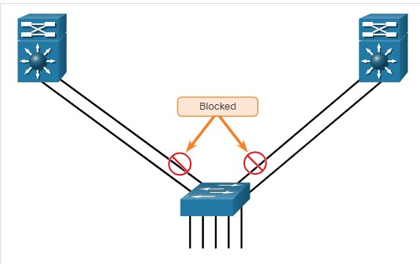

By default, STP will block redundant links.

6.1.2

EtherChannel

EtherChannel technology was originally developed by Cisco as a LAN switch-to-switch technique of grouping several Fast Ethernet or Gigabit Ethernet ports into one logical channel.

When an EtherChannel is configured, the resulting virtual interface is called a ***port channel***. The physical interfaces are bundled together into a port channel interface, as shown in the figure

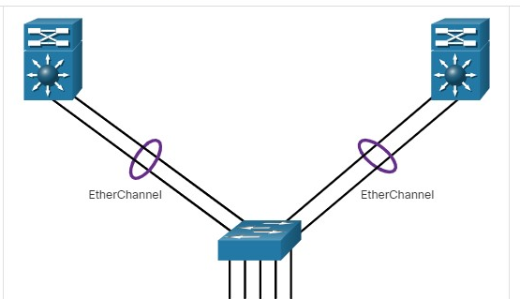

6.1.3

## Advantages of EtherChannel

EtherChannel technology has many advantages, including the following:

* Most configuration tasks can be done on the EtherChannel interface instead of on each individual port, ensuring configuration consistency throughout the links.
* EtherChannel relies on existing switch ports. There is no need to upgrade the link to a faster and more expensive connection to have more bandwidth.
* Load balancing takes place between links that are part of the same EtherChannel. Depending on the hardware platform, one or more load-balancing methods can be implemented. These methods include source MAC and destination MAC load balancing, or source IP and destination IP load balancing, across the physical links.
* EtherChannel creates an aggregation that is seen as one logical link. When several EtherChannel bundles exist between two switches, STP may block one of the bundles to prevent switching loops. When STP blocks one of the redundant links, it blocks the entire EtherChannel. This blocks all the ports belonging to that EtherChannel link. Where there is only one EtherChannel link, all physical links in the EtherChannel are active because STP sees only one (logical) link.
* EtherChannel provides redundancy because the overall link is seen as one logical connection. Additionally, the loss of one physical link within the channel does not create a change in the topology. Therefore, a spanning tree recalculation is not required. Assuming at least one physical link is present; the EtherChannel remains functional, even if its overall throughput decreases because of a lost link within the EtherChannel.

6.1.4

## Implementation Restrictions

EtherChannel has certain implementation restrictions, including the following:

* Interface types cannot be mixed. For example, Fast Ethernet and Gigabit Ethernet cannot be mixed within a single EtherChannel.
* Currently each EtherChannel can consist of up ***to eight compatibly-configured Ethernet ports***. EtherChannel provides full-duplex bandwidth up to 800 Mbps (Fast EtherChannel) or 8 Gbps (Gigabit EtherChannel) between one switch and another switch or host.
* The Cisco Catalyst 2960 Layer 2 switch currently supports up to six EtherChannels. However, as new IOSs are developed and platforms change, some cards and platforms may support increased numbers of ports within an EtherChannel link, as well as support an increased number of Gigabit EtherChannels.
* The individual EtherChannel group member port configuration must be consistent on both devices. If the physical ports of one side are configured as trunks, the physical ports of the other side must also be configured as trunks within the same native VLAN. Additionally, all ports in each EtherChannel link must be configured as Layer 2 ports.
* Each EtherChannel has a logical port channel interface, as shown in the figure. A configuration applied to the port channel interface affects all physical interfaces that are assigned to that interface.

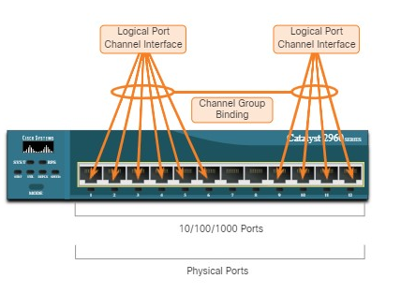

6.1.5

## AutoNegotiation Protocols

EtherChannels can be formed through negotiation using one of two protocols,

* **Port Aggregation Protocol (PAgP)**
* **Link Aggregation Control Protocol (LACP).**

These protocols allow ports with similar characteristics to form a channel through dynamic negotiation with adjoining switches.

**Note**: It is also possible to configure a static or unconditional EtherChannel without PAgP or LACP.

6.1.6

PAgP Operation

PAgP (pronounced “Pag - P”) is a Cisco-proprietary protocol that aids in the ***automatic creation of*** EtherChannel links. When an EtherChannel link is configured using PAgP, PAgP packets are sent between EtherChannel-capable ports to negotiate the forming of a channel. When PAgP identifies matched Ethernet links, it groups the links into an EtherChannel. The EtherChannel is then added to the spanning tree as a single port.

When enabled, PAgP also manages the EtherChannel. PAgP packets are sent every 30 seconds. PAgP checks for configuration consistency and manages link additions and failures between two switches. It ensures that when an EtherChannel is created, all ports have the same type of configuration.

**Note**: In EtherChannel, it is mandatory that all ports have the same speed, duplex setting, and VLAN information. Any port-channel modification after the creation of the channel also changes the aggregated channel ports.

PAgP helps create the EtherChannel link by detecting the configuration of each side and ensuring that links are compatible so that the EtherChannel link can be enabled when needed. The modes for PAgP as follows:

**On** - This mode forces the interface to channel without PAgP. Interfaces configured in the on mode do not exchange PAgP packets.

**PAgP desirable** - This PAgP mode places an interface in an active negotiating state in which the interface initiates negotiations with other interfaces by sending PAgP packets.

**PAgP auto** - This PAgP mode places an interface in a passive negotiating state in which the interface responds to the PAgP packets that it receives but does not initiate PAgP negotiation.

The modes must be compatible on each side. If one side is configured to be in auto mode, it is placed in a passive state, waiting for the other side to initiate the EtherChannel negotiation. If the other side is also set to auto, the negotiation never starts and the EtherChannel does not form. If all modes are disabled by using the **no** command, or if no mode is configured, then the EtherChannel is disabled.

The on mode manually places the interface in an EtherChannel, without any negotiation. It works only if the other side is also set to on. If the other side is set to negotiate parameters through PAgP, no EtherChannel forms, because the side that is set to on mode does not negotiate.

No negotiation between the two switches means there is no checking to make sure that all the links in the EtherChannel are terminating on the other side, or that there is PAgP compatibility on the other switch.

6.1.7

## PAgP Mode Settings Example

Consider the two switches in the figure. Whether S1 and S2 establish an EtherChannel using PAgP depends on the mode settings on each side of the channel.

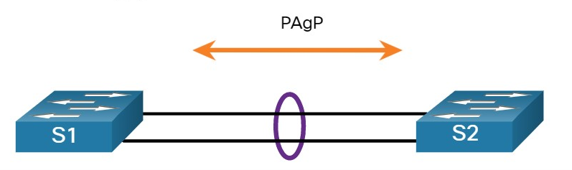

The table shows the various combination of PAgP modes on S1 and S2 and the resulting channel establishment outcome.

### **PAgP Modes**

| **S1** | **S2** | **Channel Establishment** |
| --- | --- | --- |
| On | On | Yes |
| On | Desirable/Auto | No |
| Desirable | Desirable | Yes |
| Desirable | Auto | Yes |
| Auto | Desirable | Yes |
| Auto | Auto | No |

6.1.8

## LACP Operation

LACP is part of an IEEE specification (802.3ad) that allows several physical ports to be bundled to form a single logical channel.

LACP allows a switch to negotiate an automatic bundle by sending LACP packets to the other switch. It performs a function similar to PAgP with Cisco EtherChannel. Because LACP is an IEEE standard, it can be used to facilitate EtherChannels in multivendor environments. On Cisco devices, both protocols are supported.

**Note**: LACP was originally defined as IEEE 802.3ad. However, LACP is now defined in the newer IEEE 802.1AX standard for local and metropolitan area networks.

LACP provides the same negotiation benefits as PAgP. LACP helps create the EtherChannel link by detecting the configuration of each side and making sure that they are compatible so that the EtherChannel link can be enabled when needed. The modes for LACP are as follows:

* **On** - This mode forces the interface to channel without LACP. Interfaces configured in the on mode do not exchange LACP packets.
* **LACP active** - This LACP mode places a port in an active negotiating state. In this state, the port initiates negotiations with other ports by sending LACP packets.
* **LACP passive** - This LACP mode places a port in a passive negotiating state. In this state, the port responds to the LACP packets that it receives but does not initiate LACP packet negotiation.

Just as with PAgP, modes must be compatible on both sides for the EtherChannel link to form. The on mode is repeated, because it creates the EtherChannel configuration unconditionally, without PAgP or LACP dynamic negotiation.

LACP allows for eight active links, and also eight standby links. A standby link will become active should one of the current active links fail.

6.1.9

## LACP Mode Settings Example

Consider the two switches in the figure. Whether S1 and S2 establish an EtherChannel using LACP depends on the mode settings on each side of the channel.

two LAN switches connected together via two physical network connections that have formed an EtherChannel using LACP

| **S1** | **S2** | **Channel Establishment** |
| --- | --- | --- |
| On | On | Yes |
| On | Active/Passive | No |
| Active | Active | Yes |
| Active | Passive | Yes |
| Passive | Active | Yes |
| Passive | Passive | No |

You have successfully identified the correct answers.

Y

1. Which are benefits of EtherChannel technology? (Choose all that apply.)



fault-tolerance



load sharing



increased bandwidth



link redundancy

**ANS: EtherChannel groups multiple physical Ethernet links together into a single logical link and provides the benefits of redundancy, fault-tolerance increase bandwidth, and load sharing.**

1. True or False? FastEthernet and GigabitEthernet links can be combined into a single EtherChannel.



True



False

**ANS: The correct answer is False. The interfaces combined into an EtherChannel must be the same type and speed.**

1. True or False? PAgP and LACP are both Cisco-proprietary link aggregation protocols.



True



False

**ANS: The correct answer is False. PAgP is Cisco-proprietary. LACP is an IEEE 802.3ad specification.**

1. Which three are PAgP interface modes? (Choose three.)



on



auto



active



passive



Desirable

**ANS: On, Auto, and Desirable are PAgP modes. On, Active, and Passive are LACP modes.**

1. Which PAgP interface mode will initiate negotiation with other interfaces?



on



desirable



Auto

**ANS: Only the PAgP Desirable mode initiates negotiations. On and Auto modes do not.**

1. Which combinations of PAgP modes will form an EtherChannel? (Choose all that apply.)



auto > desirable



desirable > on



auto > on



on > on



on > active



active > passive

**ANS: On > On and Auto > Desirable will form an EtherChannel.**

**On > Auto and On > Desirable will not. This is because On mode does not exchange PAgP packets.**

**CONFIGURE ETHERCHANNEL**

6.2.1

Configuration Guidelines

Now that you know what EtherChannel is, this topic explains how to configure it. The following guidelines and restrictions are useful for configuring EtherChannel:

**EtherChannel support** - All Ethernet interfaces must support EtherChannel with no requirement that interfaces be physically contiguous.

**Speed and duplex** - Configure all interfaces in an EtherChannel to operate at the same speed and in the same duplex mode.

**VLAN match** - All interfaces in the EtherChannel bundle must be assigned to the same VLAN or be configured as a trunk (shown in the figure).

**Range of VLANs** - An EtherChannel supports the same allowed range of VLANs on all the interfaces in a trunking EtherChannel. If the allowed range of VLANs is not the same, the interfaces do not form an EtherChannel, even when they are set to **auto** or **desirable** mode.

The figure shows a configuration that would allow an EtherChannel to form between S1 and S2.

The diagram shows two LAN switches connected together via two physical network connections that have formed an EtherChannel based on their port configurations. Both S1 and S2 port configurations are; speed 1 Gbps, duplex full, and VLAN 10.

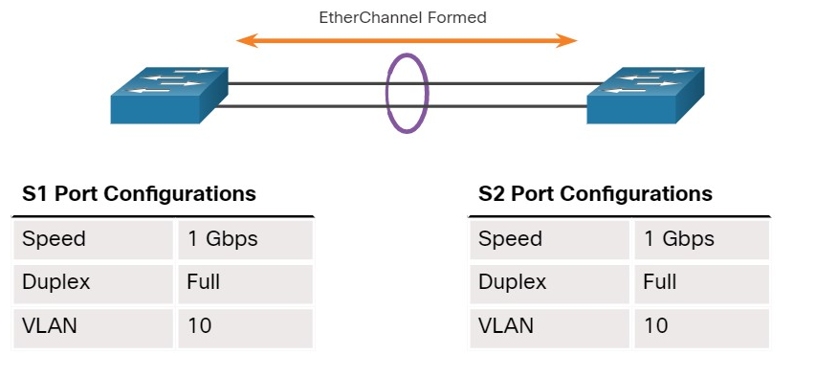

An EtherChannel is formed when configuration settings match on both switches.

In the next figure, S1 ports are configured as half duplex. Therefore, an EtherChannel will not form between S1 and S2.

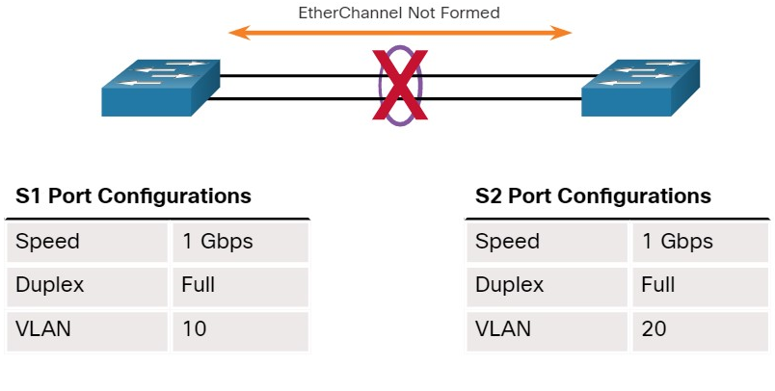

An EtherChannel is not formed when configuration settings are different on each switch.

If these settings must be changed, configure them in port channel interface configuration mode. Any configuration that is applied to the port channel interface also affects individual interfaces.

However, configurations that are applied to the individual interfaces do not affect the port channel interface. Therefore, making configuration changes to an interface that is part of an EtherChannel link may cause interface compatibility issues.

The port channel can be configured in access mode, trunk mode (most common), or on a routed port.

6.2.2

## LACP Configuration Example

EtherChannel is disabled by default and must be configured. The topology in the figure will be used to demonstrate an EtherChannel configuration example using LACP.

Two switches, S1 and S2, are connected together via two physical network connections that have formed an EtherChannel; port F0/1 on S1 is connected to port F0/1 on S2; port F0/2 on S1 is connected to port F0/2 on S2

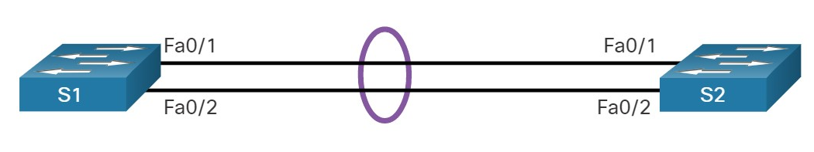

Configuring EtherChannel with LACP requires the following three steps:

**Step 1.** Specify the interfaces that compose the EtherChannel group using the **interface range** *interface* global configuration mode command. The **range** keyword allows you to select several interfaces and configure them all together.

**Step 2.** Create the port channel interface with the **channel-group** *identifier* **mode active** command in interface range configuration mode. The identifier specifies a channel group number. The **mode active** keywords identify this as an LACP EtherChannel configuration.

**Step 3.** To change Layer 2 settings on the port channel interface, enter port channel interface configuration mode using the **interface port-channel** command, followed by the interface identifier. In the example, S1 is configured with an LACP EtherChannel. The port channel is configured as a trunk interface with the allowed VLANs specified.

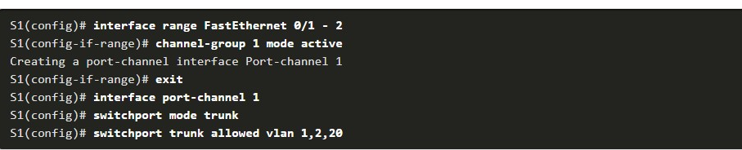

## Syntax Checker - Configure EtherChannel

Configure the EtherChannel for S2 based on the specified requirements



6.2.4

## Packet Tracer - Configure EtherChannel(pending)

Three switches have just been installed. There are redundant uplinks between the switches. As configured, only one of these links can be used; otherwise, a bridging loop might occur. However, using only one link utilizes only half of the available bandwidth. EtherChannel allows up to eight redundant links to be bundled together into one logical link. In this lab, you will configure Port Aggregation Protocol (PAgP), a Cisco EtherChannel protocol, and Link Aggregation Control Protocol (LACP), an IEEE 802.3ad open standard version of EtherChannel.

**VERIFY AND TROUBLESHOOT ETHERCHANNEL**

6.3.1

## Verify EtherChannel

As always, when you configure devices in your network, you must verify your configuration. If there are problems, you will also need to be able to troubleshoot and fix them. This topic gives you the commands to verify, as well as some common EtherChannel network problems and their solutions.

The verification command examples will use the topology shown in the figure.



1. The **show interfaces port-channel** command displays the general status of the port channel interface. In the figure, the Port Channel 1 interface is up.

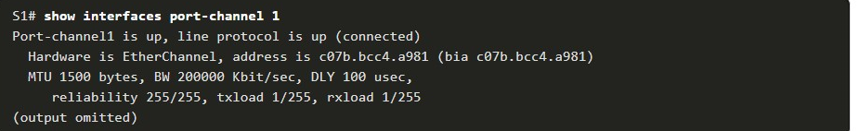

2. **Show etherchannel summary**

When several port channel interfaces are configured on the same device, use the **show etherchannel summary** command to display one line of information per port channel. In the output, the switch has one EtherChannel configured; group 1 uses LACP.

The interface bundle consists of the FastEthernet0/1 and FastEthernet0/2 interfaces. The group is a Layer 2 EtherChannel and it is in use, as indicated by the letters SU next to the port channel number.

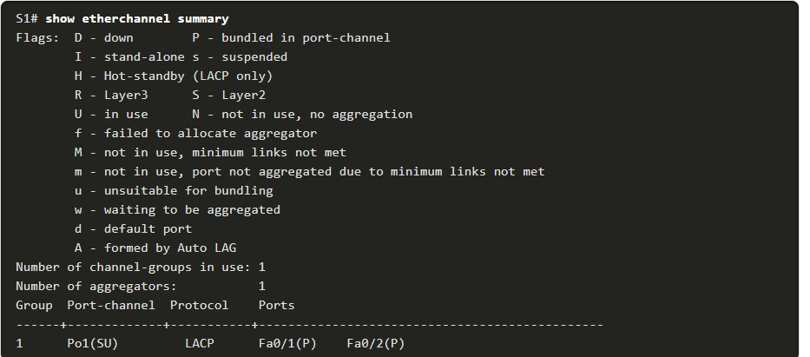

**3. Show etherchannel port-channel**

Use the **show etherchannel port-channel** command to display information about a specific port channel interface, as shown in the output. In the example, the Port Channel 1 interface consists of two physical interfaces, FastEthernet0/1 and FastEthernet0/2. It uses LACP in active mode. It is properly connected to another switch with a compatible configuration, which is why the port channel is said to be in use.

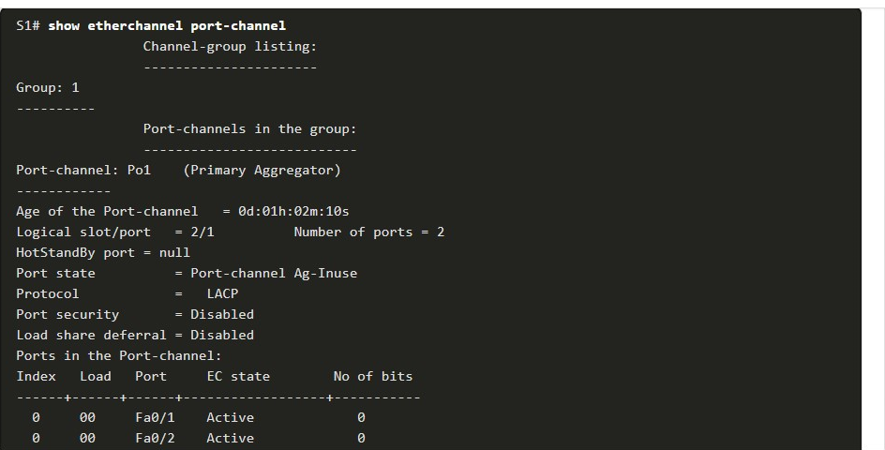

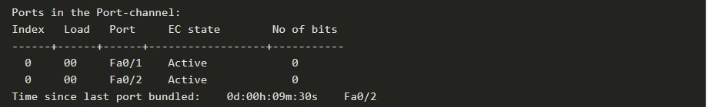

**4.** **Show interfaces etherchannel**

On any physical interface member of an EtherChannel bundle, the **show interfaces etherchannel** command can provide information about the role of the interface in the EtherChannel, as shown in the output.

The interface FastEthernet0/1 is part of the EtherChannel bundle 1. The protocol for this EtherChannel is LACP.

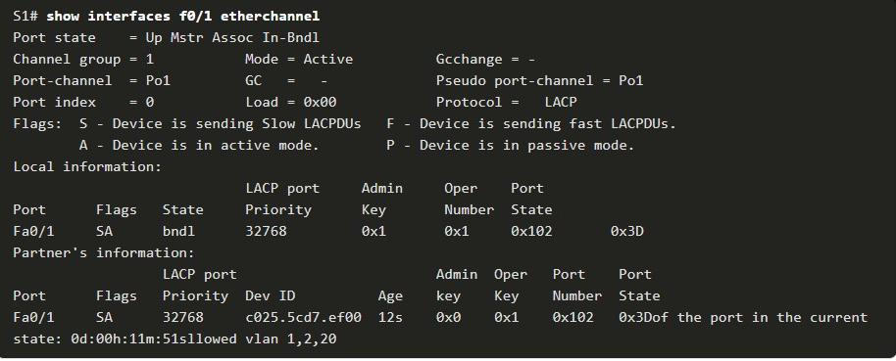

6.3.2

Common Issues with EtherChannel Configurations

All interfaces within an EtherChannel must have the same configuration of speed and duplex mode, native and allowed VLANs on trunks, and access VLAN on access ports. Ensuring these configurations will significantly reduce network problems related to EtherChannel. Common EtherChannel issues include the following:

* Assigned ports in the EtherChannel are not part of the same VLAN, or not configured as trunks. Ports with different native VLANs cannot form an EtherChannel.
* Trunking was configured on some of the ports that make up the EtherChannel, but not all of them. It is not recommended that you configure trunking mode on individual ports that make up the EtherChannel. When configuring a trunk on an EtherChannel, verify the trunking mode on the EtherChannel.
* If the allowed range of VLANs is not the same, the ports do not form an EtherChannel even when PAgP is set to the **auto** or **desirable** mode.
* The dynamic negotiation options for PAgP and LACP are not compatibly configured on both ends of the EtherChannel.

**Note**: It is easy to confuse PAgP or LACP with DTP, because they are all protocols used to automate behavior on trunk links.

PAgP and LACP are used for link aggregation (EtherChannel). DTP is used for automating the creation of trunk links. When an EtherChannel trunk is configured, typically EtherChannel (PAgP or LACP) is configured first and then DTP.

6.3.3

## Troubleshoot EtherChannel Example

In the figure, interfaces F0/1 and F0/2 on switches S1 and S2 are connected with an EtherChannel. However, the EtherChannel is not operational.



**Step 1. View the EtherChannel Summary Information**

The output of the **show etherchannel summary** command indicates that the EtherChannel is down.

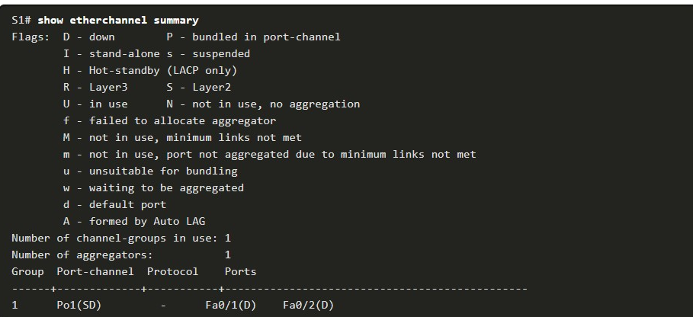

**Step 2. View Port Channel Configuration**

In the **show run | begin interface port-channel** output, more detailed output indicates that there are incompatible PAgP modes configured on S1 and S2.

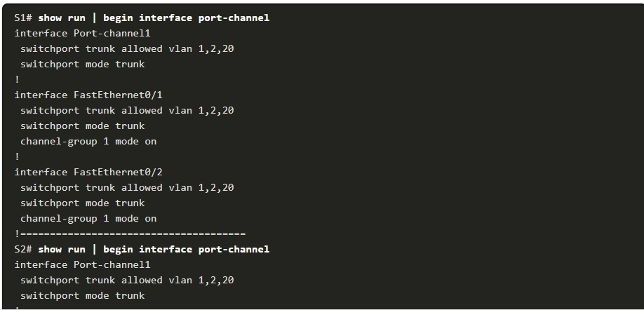

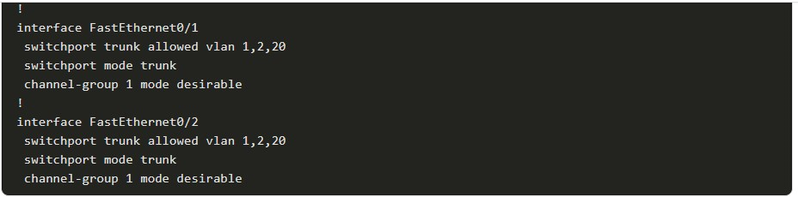

**Step 3: Correct the Misconfiguration**

To correct the issue, the PAgP mode on the EtherChannel is changed to desirable.

**Note**: EtherChannel and STP must interoperate. For this reason, the order in which EtherChannel-related commands are entered is important, which is why you see interface Port-Channel 1 removed and then re-added with the **channel-group** command, as opposed to directly changed. If one tries to change the configuration directly, STP errors cause the associated ports to go into blocking or errdisabled state.

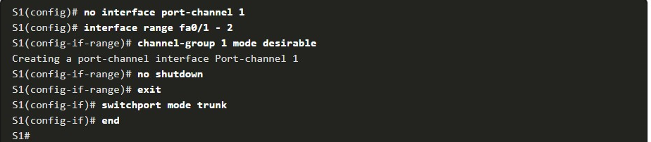

**Step 4. Verify EtherChannel is Operational**

The EtherChannel is now active as verified by the output of the **show etherchannel summary** command.

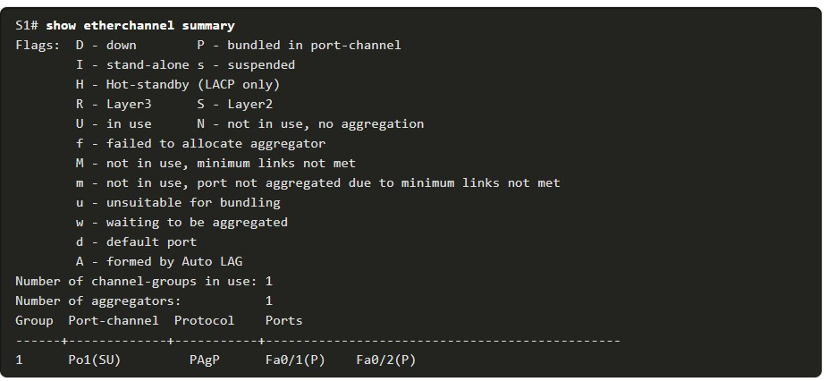

6.3.4

## Packet Tracer - Troubleshoot EtherChannel

## (Pending 6.3.4)

Four switches were recently configured by a junior technician. Users are complaining that the network is running slowly and would like you to investigate.

6.4.1

## Packet Tracer - Implement EtherChannel(pending 6.4.1)

You have been tasked with designing an EtherChannel implementation for a company that wants to improve the performance of the switch trunk links. You will try several different ways of implementing the EtherChannel links in order to evaluate which is the best for the company. You will build the topology, configure trunk ports and implement LACP and PAgP EtherChannels.

6.4.2

Lab - Implement EtherChannel

In this lab, you will complete the following objectives:

* Part 1: Build the Network and Configure Basic Device Settings
* Part 2: Create VLANs and Assign Switch Ports
* Part 3: Configure 802.1Q Trunks between the Switches
* Part 4: Implement and Verify an EtherChannel between the switches

6.4.3

What did I learn in this module?

**EtherChannel Operation**

To increase bandwidth or redundancy, multiple links could be connected between devices. However, STP will block redundant links to prevent switching loops.

EtherChannel is a link aggregation technology that allows redundant links between devices that will not be blocked by STP.

EtherChannel groups multiple physical Ethernet links together into one single logical link.

It provides:

* **fault-tolerance,**
* **load sharing,**
* **increased bandwidth,**
* **redundancy between switches, routers, and servers.**

When an EtherChannel is configured, the resulting virtual interface is called ***a port channel***. EtherChannel has several advantages, as well as some restrictions to implementation. EtherChannels can be formed through negotiation using one of two protocols, PAgP or LACP.

These protocols allow ports with similar characteristics to form a channel through dynamic negotiation with adjoining switches. When an EtherChannel link is configured using Cisco-proprietary PAgP, PAgP packets are sent between EtherChannel-capable ports to negotiate the forming of a channel.

Modes for PAgP are:

* **On,**
* **PAgP desirable,**
* **PAgP auto.**

LACP performs a function similar to PAgP with Cisco EtherChannel. Because LACP is an IEEE standard, it can be used to facilitate EtherChannels in multivendor environments.

Modes for LACP are

* **On,**
* **LACP active,**
* **LACP passive.**

**Configure EtherChannel**

The following guidelines and restrictions are useful for configuring EtherChannel:

* **EtherChannel support** - All Ethernet interfaces on all modules must support EtherChannel with no requirement that interfaces be physically contiguous, or on the same module.
* **Speed and duplex** - Configure all interfaces in an EtherChannel to operate at the same speed and in the same duplex mode.
* **VLAN match** - All interfaces in the EtherChannel bundle must be assigned to the same VLAN or be configured as a trunk.
* **Range of VLANs** - An EtherChannel supports the same allowed range of VLANs on all the interfaces in a trunking EtherChannel.

Configuring EtherChannel with LACP requires three steps:

**Step 1.** Specify the interfaces that compose the EtherChannel group using the interface range interface global configuration mode command.

**Step 2.** Create the port channel interface with the channel-group identifier mode active command in interface range configuration mode.

**Step 3.** To change Layer 2 settings on the port channel interface, enter port channel interface configuration mode using the interface port-channel command, followed by the interface identifier.

**Verify and Troubleshoot EtherChannel.**

There are a number of commands to verify an EtherChannel configuration including **show interfaces port-channel**, **show etherchannel summary**, **show etherchannel port-channel**, and **show interfaces etherchannel**. Common EtherChannel issues include the following:

* Assigned ports in the EtherChannel are not part of the same VLAN, or not configured as trunks. Ports with different native VLANs cannot form an EtherChannel.
* Trunking was configured on some of the ports that make up the EtherChannel, but not all of them.
* If the allowed range of VLANs is not the same, the ports do not form an EtherChannel even when PAgP is set to the auto or desirable mode.
* The dynamic negotiation options for PAgP and LACP are not compatibly configured on both ends of the EtherChannel.

6.4.4

Module Quiz - Etherchannel

Top of Form

1. An EtherChannel link using LACP was formed between two switches, S1 and S2. While verifying the configuration, which mode combination could be utilized on both switches?​

Topic 6.1.0 - An EtherChannel link will be formed using LACP when both switches are in on mode or in active mode, or when one of them is in passive mode and the other is in active mode.



S1-on and S2-active​



S1-on and S2-passive



S1-passive and S2-passive​



S1-passive and S2-active

1. When a range of ports is being configured for EtherChannel, which mode will configure PAgP so that it initiates the EtherChannel negotiation?

Topic 6.1.0 - The command **channel-group mode active** enables LACP unconditionally, and the command **channel-group mode passive** enables LACP only if the port receives an LACP packet from another device. The command **channel-group mode desirable** enables PAgP unconditionally, and the command **channel-group mode auto** enables PAgP only if the port receives a PAgP packet from another device.



desirable



auto



passive



active

1. Which three interface parameters must match for an EtherChannel to form? (Choose three.)

Topic 6.1.0 - There are some EtherChannel modes that can be different and an EtherChannel will form, such as auto/desirable and active/passive. A port that is currently in the spanning tree blocking mode or has been configured for PortFast can still be used to form an EtherChannel.



trunking mode



native VLAN



allowed VLANs



spanning-tree state



PortFast mode



EtherChannel mode

1. What are three advantages of using EtherChannel technology? (Choose three.)

Topic 6.1.0 - Most configuration tasks can be done on the EtherChannel interface, rather than on individual ports. Existing ports can be used, eliminating the need to upgrade ports to faster speeds. Spanning Tree Protocol runs on EtherChannel links in the same manner as it does on regular links, but it does not recalculate when an individual link within the channel goes down. EtherChannel also supports load balancing.



There is no need to upgrade links to faster connections to increase bandwidth.



The Spanning Tree Protocol shuts down the unused interfaces in the bundle to avoid loops.



EtherChannel uses multiple logical links to provide redundancy.



Load balancing is not needed with EtherChannel.



Configuration tasks can be done on the EtherChannel interface.



A spanning tree recalculation is not required when a single link within the channel goes down.

1. A network administrator is configuring an EtherChannel link between two physical ports on a switch. Which statement describes the result when one of the physical ports fails?

Topic 6.1.0 - An EtherChannel is seen as one logical connection. The loss of one physical link within the channel does not create a change in the topology and therefore a spanning tree recalculation is not required. When one of the member ports in the EtherChannel fails, the EtherChannel link remains functional, although its overall throughput decreases because of a lost link within the EtherChannel.



The EtherChannel link fails.



The EtherChannel stops transmitting data until it is restarted.



An STP recalculation is needed.



The EtherChannel continues transmitting data with reduced bandwidth.

1. When EtherChannel is implemented, multiple physical interfaces are bundled into which type of logical connection?

Topic 6.1.0 - When EtherChannel is being configured, the first step is to specify what physical ports will be used in an EtherChannel group. The second step is to create the logical EtherChannel port channel interface which contains the group of physical interfaces.



interface range



port channel



VLAN interface



loopback

1. When a range of ports is being configured for EtherChannel by the use of PAgP, which mode will form the bundled channel only if the port receives PAgP packets from another device?

Topic 6.1.0 - The command **channel-group mode active** enables LACP unconditionally, and the command **channel-group mode passive** enables LACP only if the port receives an LACP packet from another device. The command **channel-group mode desirable** enables PAgP unconditionally, and the command **channel-group mode auto** enables PAgP only if the port receives a PAgP packet from another device.



auto



desirable



passive



active

1. Which two load balancing methods can be implemented with EtherChannel technology? (Choose two.)

Topic 6.1.0 - Source MAC to destination MAC load balancing and source IP to destination IP load balancing are two implementation methods used in EtherChannel technology.



source MAC to destination MAC



destination MAC to destination IP



destination MAC to source MAC



destination IP to destination MAC



source IP to destination IP



destination IP to source IP

1. Which function is provided by EtherChannel?

Topic 6.1.0 - EtherChannel technology allows the grouping, or aggregating, of several Fast Ethernet or Gigabit switch ports into one logical channel.



dividing the bandwidth of a single link into separate time slots



creating one logical link by using multiple physical links between two LAN switches



spreading traffic across multiple physical WAN links



enabling traffic from multiple VLANs to travel over a single Layer 2 link

1. Which statement is true about EtherChannel technology?

Topic 6.1.0 - EtherChannel relies on existing switch ports, so there is no need to upgrade the links. Some configuration tasks are done on individual ports and some configuration tasks are done on the EtherChannel group. STP operates on EtherChannel in the same manner as it does on other redundant links.



STP does not run on redundant EtherChannel links.



Links must be upgraded to support EtherChannel.



All configuration tasks must be done on the individual ports in the EtherChannel link.



EtherChannel uses existing switch ports.

1. Which two mode combinations would result in the successful negotiation of an EtherChannel? (Choose two.)

Topic 6.1.0 - The combinations of modes that will form an EtherChannel are as follows: on/on, active/passive, active/active, desirable/auto, and desirable/desirable.



desirable; active



desirable; desirable



auto; auto



active; passive



active; on



passive; auto

1. Which two protocols are link aggregation protocols? (Choose two.)

Topic 6.1.0 - The two protocols that can be used to form an EtherChannel are PAgP (Cisco proprietary) and LACP, also know as IEEE 802.3ad. STP (Spanning Tree Protocol) or RSTP (Rapid Spanning Tree Protocol) is used to avoid loops in a Layer 2 network. EtherChannel is the term that describes the bundling of two or more links that are treated as a single link for spanning tree and configuration.



802.3ad



STP



EtherChannel



PAgP



RSTP

1. When a range of ports is being configured for EtherChannel, which mode will configure LACP so that it initiates the EtherChannel negotiation?

Topic 6.1.0 - The command **channel-group mode active** enables LACP unconditionally, and the command **channel-group mode passive** enables LACP only if the port receives an LACP packet from another device. The command **channel-group mode desirable** enables PAgP unconditionally, and the command **channel-group mode auto** enables PAgP only if the port receives a PAgP packet from another device.



active



passive



desirable



auto

1. What will happen if a network administrator puts a port that is part of an EtherChannel bundle into a different VLAN than the other ports in that bundle?

Topic 6.2.0 - All ports in an EtherChannel bundle must either be trunk ports or be access ports in the same VLAN. If VLAN pruning is enabled on the trunk, the allowed VLANs must be the same on both sides of the EtherChannel.



The EtherChannel bundle will stay up only if PAgP is used.



The EtherChannel bundle will stay up if the ports were configured with no negotiation between the switches to form the EtherChannel.



The EtherChannel bundle will stay up only if LACP is used.



The EtherChannel will fail.



The EtherChannel bundle will stay up if either PAgP or LACP is used.

1. When a range of ports is being configured for EtherChannel, which mode will configure LACP on a port only if the port receives LACP packets from another device?

Topic 6.1.0 - The command **channel-group mode active** enables LACP unconditionally, and the command **channel-group mode passive** enables LACP only if the port receives an LACP packet from another device. The command **channel-group mode desirable** enables PAgP unconditionally, and the command **channel-group mode auto** enables PAgP only if the port receives a PAgP packet from another device.



desirable



passive



active



auto