Large Language Translative Model for Cultural Heritage Preservation in Kenya
Conceptual Framework
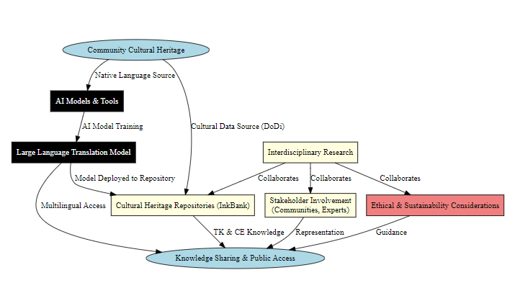
Background and Motivation
Kenya is home to more than 44 diverse ethnic communities, each with unique languages, traditions, and cultural expressions that define their identity. The Traditional Knowledge and Cultural Expressions (TK & CE) Act 2016 recognizes the importance of preserving these cultural assets. It defines cultural heritage in tangible and intangible forms and highlights the need for legal protection and sustainable management.
As part of the Constitution of Kenya 2010 implementation, the National Museums of Kenya (NMK) has been working through the Natural Product Industries (NPI) to document and digitize cultural heritage. A key milestone in this effort is the InkBank, a national repository designed to archive traditional knowledge from all Kenyan communities.
However, despite these efforts, critical challenges remain in making this knowledge accessible to various stakeholders, including researchers, communities, policymakers, and technologists.

Problem Statement
Several barriers hinder the effective documentation, preservation, and accessibility of Kenya’s cultural heritage. Language barrier is the main challenge given that most traditional knowledge is preserved in indigenous languages that lack digital documentation and translation tools. This limits interdisciplinary research and community access. Another challenge is the limited knowledge sharing where the current heritage databases (e.g., InkBank) contain valuable cultural information but are not easily accessible due to linguistic and structural limitations. This makes the researchers, policymakers, and communities to struggle to access and interpret the data. The third challenge encompasses interdisciplinary gaps. This exists because cultural experts, linguistic researchers, and AI technologists lack a common platform to collaborate effectively. This is specifically because there is no technological framework to integrate AI models into existing heritage repositories for better accessibility. The fourth challenge is the risk of cultural erosion. Without digital preservation, many indigenous languages are at risk of disappearing. The lack of a standardized AI-based documentation approach means Kenya's rich cultural heritage remains fragmented and vulnerable.
Proposed Solution: AI-Powered Large Language Translative Model
To address these challenges, we propose developing a Large Language Translative Model (LLM) trained specifically on Kenyan indigenous languages to facilitate: (1) Language Documentation & Preservation. The LLM will be trained on indigenous Kenyan languages, ensuring their digital preservation. This will also serve as a foundation for future language revitalization efforts. (2) Close-to-Source Translation. The model will enable translation between Kenyan languages using an intermediary language (English/Kiswahili) to improve accessibility. This will ensure that communities, researchers, and policymakers can access cultural knowledge in a language they understand. (3) Integration with Cultural Heritage Repositories. The LLM will be deployed into existing cultural databases (e.g., InkBank) to process, organize, and retrieve knowledge dynamically. Users can then query the database in their native language and receive translated responses. (4) Interdisciplinary Knowledge Sharing. The model will facilitate collaboration among cultural experts, computational linguists, and AI researchers. This will create a sustainable ecosystem where AI and cultural heritage intersect. And finally (5) Sustainability & Ethical Considerations. The model will be closed source, which will ensure Kenyan ownership of cultural data. The model deployment will be restricted to national platforms to protect indigenous knowledge from exploitation.
Expected Impact
This initiative will:
- Ensure long-term preservation of Kenyan languages and cultural heritage.
- Break language barriers, enabling interdisciplinary research and collaboration.
- Enhance public access to cultural repositories through AI-driven translation.
- Support sustainable cultural innovation while maintaining ethical safeguards.
By leveraging AI and computational tools, Kenya can unlock new research and development opportunities, which will ensure cultural sustainability for future generations.

