Irene Data Analysis Progress

Mwaura Patrick

2/8/2021

### Summary of the data

View the summary of the data

### Number of camels from each of the Livestock Production System

With their Percentages and Bar Graph

| Community | Extensive | Intensive | Total |
| --- | --- | --- | --- |
| Ilmotiok | 100% (129) | 0% (0) | 43% (129) |
| Loisaba Ranch | 0% (0) | 33% (57) | 19% (57) |
| Mpala Ranch | 0% (0) | 48% (83) | 27% (83) |
| Suyian Ranch | 0% (0) | 19% (33) | 11% (33) |
| Total | 100% (129) | 100% (173) | 100% (302) |

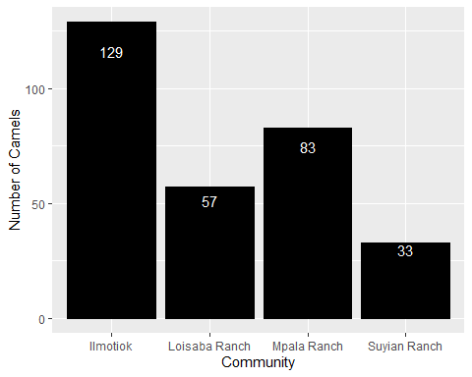

### Counts and Percentages of E.coli Isolated from all the camels

This table counts and percentages of E.coli isolates in Extensive/Intensive location/Livestock procuction system

| mo | Extensive | Intensive | Total |
| --- | --- | --- | --- |
| Escherichia coli | 42% (54) | 47% (82) | 45% (136) |
| Others | 58% (75) | 53% (91) | 55% (166) |

### 

### Pie Chart

The above table can be visualised as a pie chart 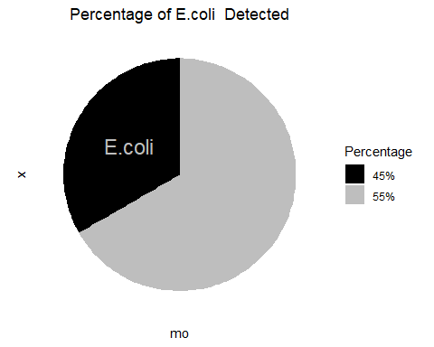

### Counts and percentages of the number of camels (female and male) from each livestock production system

| Gender | Extensive | Intensive |
| --- | --- | --- |
| Female | 48% (106) | 52% (113) |
| Male | 28% (23) | 72% (60) |

Pearson's Chi-squared test with Yates' continuity correction   
data:  
X-squared = 9.702, df = 1, p-value = 0.001841

### The count and percentages of Resistance/Intermediate/Susceptible E.coli to all the antibiotics

| antibiotic | S | I | R |
| --- | --- | --- | --- |
| Amoxicillin/clavulanic acid | 99% | 1% | 0% |
| Ampicillin | 86% | 5% | 9% |
| Cefaclor | 24% | 48% | 28% |
| Cefepime | 75% | 22% | 3% |
| Cefotaxime | 62% | 22% | 16% |
| Ceftazidime | 70% | 23% | 7% |
| Ceftriaxone | 90% | 7% | 3% |
| Cefuroxime | 84% | 12% | 4% |
| Chloramphenicol | 100% | 0% | 0% |
| Ciprofloxacin | 61% | 38% | 1% |
| Gentamicin | 91% | 8% | 1% |
| Norfloxacin | 100% | 0% | 0% |
| Spectinomycin | 90% | 8% | 2% |
| Tetracycline | 93% | 1% | 5% |
| Trimethoprim/sulfamethoxazole | 96% | 1% | 3% |

### Beta-lactams/penicillin’s

Beta-lactam antibiotics are one of the most commonly prescribed drug classes with numerous clinical indications.

From a biochemical point of view, these drugs have a common feature, which is the 3-carbon and 1-nitrogen ring (beta-lactam ring) that is highly reactive. This class includes:

Penicillins,Cephalosporins,Carbapenems,Monobactams,Beta-lactamase inhibitors

column ‘AMC’ (amoxicillin/clavulanic acid), column ‘AMP’ (ampicillin), column ‘OXA’ (oxacillin), column ‘TEM’ (temocillin) NOTE: No antimicrobial agents of class cephalosporins (1st gen.) found (such as cefacetrile, cephapirin). Selecting cephalosporins (2nd gen.): column ‘CEC’ (cefaclor), column ‘CXM’ (cefuroxime) NOTE: No antimicrobial agents of class carbapenems found (such as doripenem, imipenem).

| antibiotic | S | I | R |
| --- | --- | --- | --- |
| Ampicillin | 86% (117) | 5% (7) | 9% (12) |
| Cefaclor | 24% (33) | 48% (65) | 28% (38) |
| Cefepime | 75% (102) | 22% (30) | 3% (4) |
| Cefotaxime | 62% (84) | 22% (30) | 16% (22) |
| Ceftazidime | 70% (95) | 23% (31) | 7% (10) |
| Ceftriaxone | 90% (123) | 7% (9) | 3% (4) |
| Cefuroxime | 84% (114) | 12% (17) | 4% (5) |

### Resistance

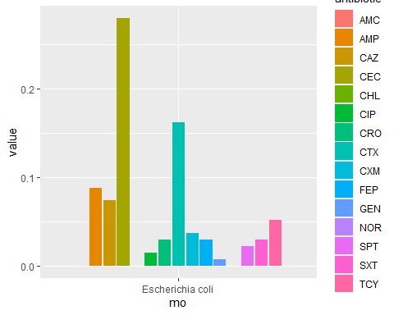

### Comparison table(extensive and Intensive)-count and percentage , resistance to all antibiotics

## interpretation S I R  
## LPS variable   
## Extensive AMC 1.00000000 0.00000000 0.00000000  
## AMP 0.85185185 0.07407407 0.07407407  
## CAZ 0.59259259 0.31481481 0.09259259  
## CEC 0.22222222 0.44444444 0.33333333  
## CHL 1.00000000 0.00000000 0.00000000  
## CIP 0.64814815 0.35185185 0.00000000  
## CRO 0.92592593 0.05555556 0.01851852  
## CTX 0.59259259 0.24074074 0.16666667  
## CXM 0.85185185 0.12962963 0.01851852  
## FEP 0.75925926 0.22222222 0.01851852  
## GEN 0.88888889 0.09259259 0.01851852  
## NOR 1.00000000 0.00000000 0.00000000  
## SPT 0.92592593 0.05555556 0.01851852  
## SXT 0.98148148 0.00000000 0.01851852  
## TCY 0.98148148 0.01851852 0.00000000  
## Intensive AMC 0.98780488 0.01219512 0.00000000  
## AMP 0.86585366 0.03658537 0.09756098  
## CAZ 0.76829268 0.17073171 0.06097561  
## CEC 0.25609756 0.50000000 0.24390244  
## CHL 1.00000000 0.00000000 0.00000000  
## CIP 0.58536585 0.39024390 0.02439024  
## CRO 0.89024390 0.07317073 0.03658537  
## CTX 0.63414634 0.20731707 0.15853659  
## CXM 0.82926829 0.12195122 0.04878049  
## FEP 0.74390244 0.21951220 0.03658537  
## GEN 0.92682927 0.07317073 0.00000000  
## NOR 1.00000000 0.00000000 0.00000000  
## SPT 0.87804878 0.09756098 0.02439024  
## SXT 0.95121951 0.01219512 0.03658537  
## TCY 0.90243902 0.01219512 0.08536585

### 

### Multdrug Resistance Organisms MDR

## Warning:   
## one unique value (covering 55.0%) could not be coerced and was considered  
## 'unknown': "Others".  
## Use mo_failures() to review it. Edit the `allow_uncertain` argument if  
## needed (see ?as.mo).  
## You can also use your own reference data, e.g.:  
## as.mo("mycode", reference_df = data.frame(own = "mycode", mo  
## = "B_ESCHR_COLI"))  
## mo_name("mycode", reference_df = data.frame(own = "mycode", mo  
## = "B_ESCHR_COLI"))

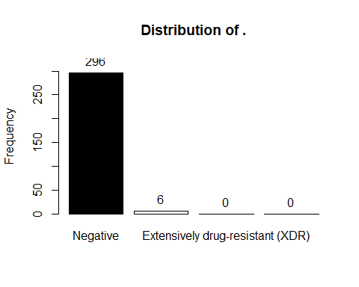

Frequency Percent  
Negative 296 98  
Multi-drug-resistant (MDR) 6 2  
Extensively drug-resistant (XDR) 0 0  
Pandrug-resistant (PDR) 0 0  
 Total 302 100

### Antibiotic Profiling

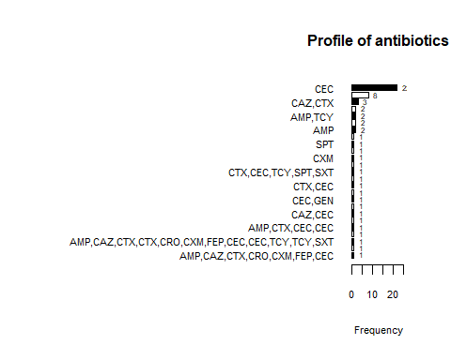

## Profile$antibiotics :   
## Frequency Percent  
## CEC 22 37.3  
## CTX 8 13.6  
## CAZ,CTX 3 5.1  
## CAZ 2 3.4  
## AMP,TCY 2 3.4  
## AMP,CEC 2 3.4  
## AMP 2 3.4  
## TCY 1 1.7  
## SPT 1 1.7  
## FEP 1 1.7  
## CXM 1 1.7  
## CTX,CXM 1 1.7  
## CTX,CEC,TCY,SPT,SXT 1 1.7  
## CTX,CEC,CEC 1 1.7  
## CTX,CEC 1 1.7  
## CIP 1 1.7  
## CEC,GEN 1 1.7  
## CAZ,CTX,CRO 1 1.7  
## CAZ,CEC 1 1.7  
## AMP,CTX,CEC,CIP 1 1.7  
## AMP,CTX,CEC,CEC 1 1.7  
## AMP,CEC,TCY,SPT,SXT 1 1.7  
## AMP,CAZ,CTX,CTX,CRO,CXM,FEP,CEC,CEC,TCY,TCY,SXT 1 1.7  
## AMP,CAZ,CTX,CRO,CXM,FEP,CEC,SXT 1 1.7  
## AMP,CAZ,CTX,CRO,CXM,FEP,CEC 1 1.7  
## Total 59 100.0