MDRO

Mwaura Patrick

1/27/2021

title: “Irene Data analysis” author: “Mwaura Patrick” date: “1/27/2021” output: word_document: default pdf_document: default html_document: default —

options( warn = -1 )  
library(tidyverse)

## -- Attaching packages --------------------------------------- tidyverse 1.3.0 --

## v ggplot2 3.3.3 v purrr 0.3.4  
## v tibble 3.0.5 v dplyr 1.0.3  
## v tidyr 1.1.2 v stringr 1.4.0  
## v readr 1.4.0 v forcats 0.5.0

## -- Conflicts ------------------------------------------ tidyverse_conflicts() --  
## x dplyr::filter() masks stats::filter()  
## x dplyr::lag() masks stats::lag()

library(dplyr)  
library(readxl)  
library(here)

## here() starts at E:/RESULTS/Mwaura/mwaura/WORK1/Covid19

library(skimr)  
library(kableExtra)

##   
## Attaching package: 'kableExtra'

## The following object is masked from 'package:dplyr':  
##   
## group_rows

library(AMR)  
library(scales)

##   
## Attaching package: 'scales'

## The following object is masked from 'package:purrr':  
##   
## discard

## The following object is masked from 'package:readr':  
##   
## col_factor

library(pipeR)  
library(cleaner)

# Set the working directory and load the data

setwd("E:/RESULTS/Mwaura/mwaura/WORK1/Covid19/Irene Work")  
IRENE_DATA_ANALYSIS_R <- read_csv("IRENE DATA ANALYSIS R.csv")

##   
## -- Column specification --------------------------------------------------------  
## cols(  
## .default = col_character(),  
## CAMEL_ID_NUMBER = col_double(),  
## MDR = col_double()  
## )  
## i Use `spec()` for the full column specifications.

# Explore the data

#skimr::skim(IRENE_DATA_ANALYSIS_R)

# Brief summary

knitr::kable(IRENE_DATA_ANALYSIS_R %>% select(mo,CAMEL_ID_NUMBER) %>% group_by(mo) %>% summarize(Count=n()) %>% mutate(Percentage=paste0(round(Count/sum(Count)*100,2),"%")),"pipe")

|  |  |  |
| --- | --- | --- |
| mo | Count | Percentage |
| enterobacter | 3 | 0.99% |
| Escherichia coli | 136 | 45.03% |
| no growth | 141 | 46.69% |
| non-Escherichia coli | 22 | 7.28% |

knitr::kable(IRENE_DATA_ANALYSIS_R %>% freq(mo))

item

count

percent

cum_count

cum_percent

no growth

141

0.4668874

141

0.4668874

Escherichia coli

136

0.4503311

277

0.9172185

non-Escherichia coli

22

0.0728477

299

0.9900662

enterobacter

3

0.0099338

302

1.0000000

IRENE_DATA_ANALYSIS_R %>% select(mo,CAMEL_ID_NUMBER) %>% group_by(mo) %>% summarize(Count=n()) %>% mutate(Percentage=paste0(round(Count/sum(Count)*100,2),"%")) %>% ggplot(aes(x="", y=mo, fill=Percentage)) + geom_bar(stat="identity", width=1)+ coord_polar("y", start=0) +theme_classic()+labs( title = "Percentage of Particular Organism Detected")+scale_fill_manual(values=c("#55DDE0", "#33658A", "#2F4858", "#F6AE2D"))+theme(axis.line = element_blank(),axis.text = element_blank(),axis.ticks = element_blank(), plot.title = element_text(hjust = 0.5, color = "#666666"))+geom_text(aes(y = mo, label = mo), position = position_stack(vjust = .5),color = "white", size=3)

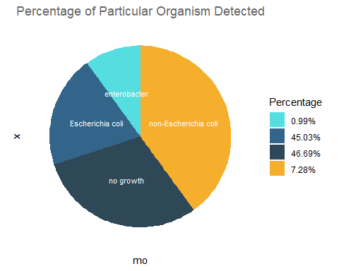 # Cross tabulation by Ranch_community vs the livestock production system

IRENE_DATA_ANALYSIS_R %>% select(Ranch_Community,Livestock_production_system) %>% pivot_wider(names_from = Livestock_production_system, values_from= Livestock_production_system,values_fn=list(Livestock_production_system=list))

## # A tibble: 5 x 3  
## Ranch_Community Intensive Extensive   
## <chr> <list> <list>   
## 1 Mpala Ranch <chr [83]> <NULL>   
## 2 Ilmotiok <NULL> <chr [129]>  
## 3 Loisaba Ranch <chr [55]> <chr [1]>   
## 4 loisaba Ranch <chr [1]> <NULL>   
## 5 Suyian Ranch <chr [33]> <NULL>

IRENE_DATA_ANALYSIS_R %>% select(Ranch_Community,Livestock_production_system) %>% ggplot(aes(x=Ranch_Community,fill=Livestock_production_system))+geom_bar()+ylab("Count of Camels")+stat_count(geom="text",aes(label=stat(count)), position = position_stack(vjust = .5),color="black")

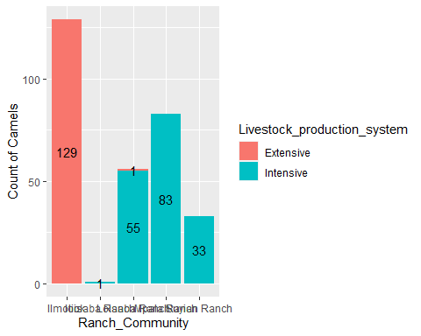 # MDRO analysis

IRENE_DATA_ANALYSIS_R %>% select(mo,Amoxicillin_clavulanic_acid:Norfloxacin) %>% mutate_at(vars(Amoxicillin_clavulanic_acid:Norfloxacin), as.rsi)%>% mdro()%>% freq()

##   
##   
## **Frequency table**   
##   
## Class: factor > ordered (numeric)   
## Length: 302   
## Levels: 4: Negative < Multi-drug-resistant (MDR) < Extensively drug-resistant ...   
## Available: 158 (52.32%, NA: 144 = 47.68%)   
## Unique: 2  
##   
##   
## | |Item | Count| Percent| Cum. Count| Cum. Percent|  
## |:--|:--------------------------|-----:|-------:|----------:|------------:|  
## |1 |Negative | 152| 96.20%| 152| 96.20%|  
## |2 |Multi-drug-resistant (MDR) | 6| 3.80%| 158| 100.00%|

# Resistance

knitr::kable(IRENE_DATA_ANALYSIS_R %>% select(mo,Amoxicillin_clavulanic_acid:Norfloxacin) %>% mutate_at(vars(Amoxicillin_clavulanic_acid:Norfloxacin), as.rsi) %>% group_by(mo) %>% summarise(amoxiclav = resistance(Amoxicillin_clavulanic_acid), Ampicillin = resistance(Ampicillin), Norflaxin = resistance(Norfloxacin)))

mo

amoxiclav

Ampicillin

Norflaxin

enterobacter

NA

NA

NA

Escherichia coli

0

0.0882353

0

no growth

NA

NA

NA

non-Escherichia coli

NA

NA

NA

IRENE_DATA_ANALYSIS_R %>% select(mo,Amoxicillin_clavulanic_acid:Norfloxacin) %>% mutate_at(vars(Amoxicillin_clavulanic_acid:Norfloxacin), as.rsi) %>% group_by(mo) %>% summarise(amoxiclav = resistance(Amoxicillin_clavulanic_acid), Ampicillin = resistance(Ampicillin), Norflaxin = resistance(Norfloxacin)) %>% tidyr::pivot_longer(-mo, names_to = "antibiotic") %>% ggplot(aes(x = mo,y = value,fill = antibiotic)) +geom_col(position = "dodge2")

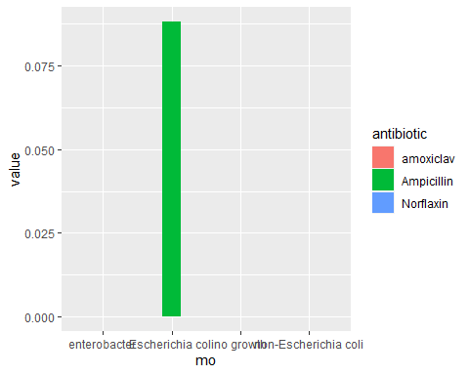

IRENE_DATA_ANALYSIS_R %>% select(mo,Amoxicillin_clavulanic_acid:Norfloxacin) %>% mutate_at(vars(Amoxicillin_clavulanic_acid:Norfloxacin), as.rsi) %>% group_by(mo) %>% summarise(amoxiclav = resistance(Amoxicillin_clavulanic_acid), Ampicillin = resistance(Ampicillin), Norflaxin = resistance(Norfloxacin)) %>% tidyr::pivot_longer(-mo, names_to = "antibiotic") %>%ggplot(mapping = aes(x = mo,y = value)) +geom_col() +labs(title = "Micro-organisms",subtitle = "Resistance to Antibiotics", x = "Organism",y = "Resistance Rates")

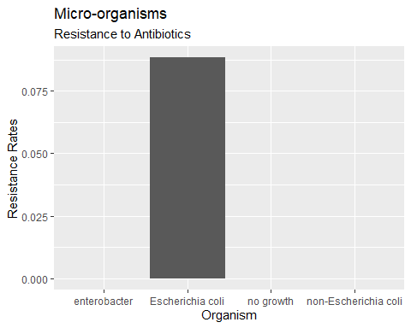 # Conduct principal component analysis (PCA) for AMR

options(warn = -1)  
resistance_data<-IRENE_DATA_ANALYSIS_R %>% select(mo,Amoxicillin_clavulanic_acid:Norfloxacin) %>% mutate_at(vars(Amoxicillin_clavulanic_acid:Norfloxacin), as.rsi) %>% group_by(mo) %>% summarise_if(is.rsi, resistance) %>% select(mo,Amoxicillin_clavulanic_acid:Norfloxacin)  
  
  
knitr::kable(resistance_data)

mo

Amoxicillin_clavulanic_acid

Ampicillin

Ceftazidime

Cefotaxime

Ceftriaxone

Cefuroxime

Cefepime

Cefaclor

Tetracycline

Gentamicin

Spectinomycin

Chloramphenicol

Ciprofloxacin

Trimethoprim_sulfamethoxazole

Norfloxacin

enterobacter

NA

NA

NA

NA

NA

NA

NA

NA

NA

NA

NA

NA

NA

NA

NA

Escherichia coli

0

0.0882353

0.0735294

0.1617647

0.0294118

0.0367647

0.0294118

0.2794118

0.0514706

0.0073529

0.0220588

0

0.0147059

0.0294118

0

no growth

NA

NA

NA

NA

NA

NA

NA

NA

NA

NA

NA

NA

NA

NA

NA

non-Escherichia coli

NA

NA

NA

NA

NA

NA

NA

NA

NA

NA

NA

NA

NA

NA

NA

resistant_data_2<-data.frame(na.omit(resistance_data))  
  
knitr::kable(resistant_data_2)

mo

Amoxicillin_clavulanic_acid

Ampicillin

Ceftazidime

Cefotaxime

Ceftriaxone

Cefuroxime

Cefepime

Cefaclor

Tetracycline

Gentamicin

Spectinomycin

Chloramphenicol

Ciprofloxacin

Trimethoprim_sulfamethoxazole

Norfloxacin

Escherichia coli

0

0.0882353

0.0735294

0.1617647

0.0294118

0.0367647

0.0294118

0.2794118

0.0514706

0.0073529

0.0220588

0

0.0147059

0.0294118

0

## R Markdown

This is an R Markdown document. Markdown is a simple formatting syntax for authoring HTML, PDF, and MS Word documents. For more details on using R Markdown see <http://rmarkdown.rstudio.com>.

When you click the **Knit** button a document will be generated that includes both content as well as the output of any embedded R code chunks within the document. You can embed an R code chunk like this:

summary(cars)

## speed dist   
## Min. : 4.0 Min. : 2.00   
## 1st Qu.:12.0 1st Qu.: 26.00   
## Median :15.0 Median : 36.00   
## Mean :15.4 Mean : 42.98   
## 3rd Qu.:19.0 3rd Qu.: 56.00   
## Max. :25.0 Max. :120.00

## Including Plots

You can also embed plots, for example:



Note that the echo = FALSE parameter was added to the code chunk to prevent printing of the R code that generated the plot.