**Max Rink:**

**Unit 5 Assignment**

**Specification**

Use an interpolation search algorithm to search for an element in an array. This estimates the position of the goal value in the array then checks to see if the number at that position is the goal value. If it is greater search above that index. If it is smaller search below it. If it is the goal value return the index. For searching above and below a sub array is created of the numbers above or below the index searched depending on whether or not it is greater or less than the variable. The method calls itself recursively with the created sub array as an argument until the value is found.

**Algorithm**

1. Create an array of random integers
2. Sort the array
3. Estimate the location of the integer
4. Create a sub array
5. Call the interpolation search algorithm on the sub array

**Flowchart**

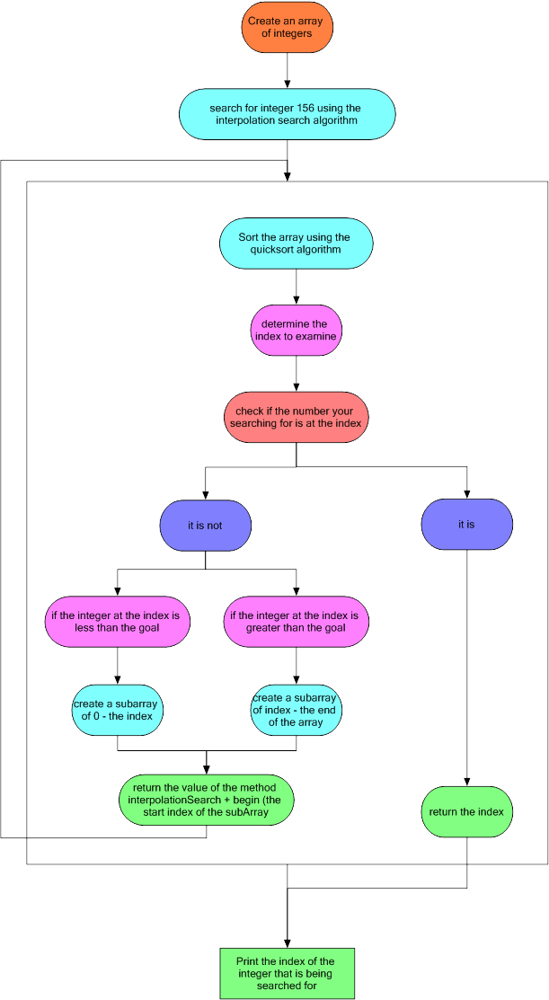

**Code Design**

**Class** –

A class is used to create a custom data type. It can store any other data types within it and keeps them all in one place. A class can be referenced statically or using an instance called an object. The object can store proprietary data within it. The statically referenced class is only for methods and not for storing data specific to the instance.

**Recursion** –

Recursion is used to call the search method from within itself in order to have more efficient code and to search through sub arrays until the goal value is found.

**Array** –

Arrays are used to store a large series of data in one variable. It is all stored next to each other in memory and can easily be accessed by an index number. In this case it is an array of integers to be sorted then searched through for a value.

**Implementation**

See the java files

**Testing and Debugging**

No testing was needed or bugs encountered in the development of this program