安装：

wget <http://download.redis.io/releases/redis-4.0.2.tar.gz>

tar xzf redis-4.0.2.tar.gz

cd redis-4.0.2

make

make install

查看redis线程是否被占用了：

ps -ef | grep -i redis

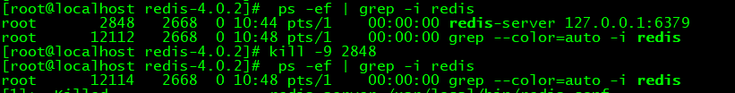

安装错误信息：

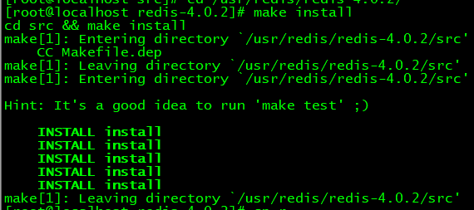

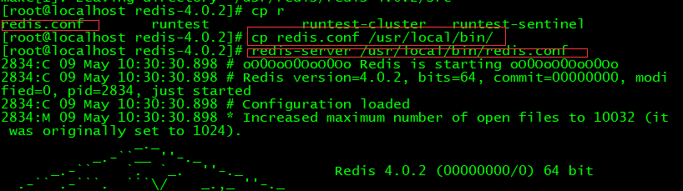

启动的问题处理：

WARNING overcommit_memory is set to 0! Background save may fail under low memory condition. To fix this issue add 'vm.overcommit_memory = 1' to /etc/sysctl.conf and then reboot or run the command 'sysctl vm.overcommit_memory=1' for this to take effect.

cd /etc/

echo 1 >/proc/sys/vm/overcommit_memory



或者

针对这两个问题，都要修改/etc/sysctl.conf文件，在文件末尾加入以下两句：

net.core.somaxconn= 1024  
vm.overcommit_memory = 1

WARNING you have Transparent Huge Pages (THP) support enabled in your kernel. This will create latency and memory usage issues with Redis. To fix this issue run the command 'echo never > /sys/kernel/mm/transparent_hugepage/enabled' as root, and add it to your /etc/rc.local in order to retain the setting after a reboot. Redis must be restarted after THP is disabled.

设置ip远程访问设置

将bin 127.0.0.1注释掉--允许其他ip都可以访问这个服务器

设置登录密码

设置开机自动启动

修改redis.config

重新回来redis目录打开redis.conf,修改如下图，no改成yes

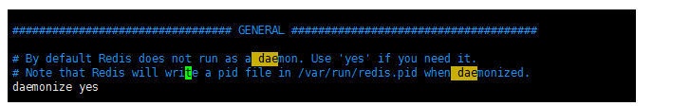

尝试启动或停止redis   
service redis start   
service redis stop

开启服务自启动   
chkconfig redis on

加入开机自启服务   
chkconfig –add redis