安装jdk
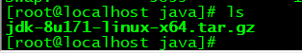
解压jdk
tar -zxvf jdk-8u171-linux-x64.tar.gz
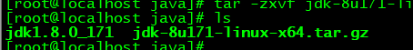

查看oracle的 sid是多少
select INSTANCE_NAME from v$instance;
配置Linux下的oracle自启文件
vim /etc/rc.d/rc.local
su oracle -lc "/ora01/app/oracle/product/11.2.0/db_1/bin/lsnrctl start"
su oracle -lc /ora01/app/oracle/product/11.2.0/db_1/bin/dbstart
给文件赋值权限 chmod +x /etc/rc.d/rc.local

export TMP=/tmp;
export ORACLE_HOSTNAME=localhost.localdomain
export ORACLE_UNQNAME=ORA11G
export ORACLE_BASE=/ora01/app/oracle
export ORACLE_HOME=$ORACLE_BASE/product/11.2.0/db_1
export ORACLE_SID=ORA11G
export ORACLE_TERM=xterm
export LANG=C
export NLS_LANG=AMERICAN_AMERICA.ZHS16GBK
PATH=/usr/sbin:$PATH:$ORACLE_HOME/bin
export LD_LIBRARY_PATH=$ORACLE_HOME/lib:/lib:/usr/lib;
export CLASSPATH=$ORACLE_HOME/jlib:$ORACLE_HOME/rdbms/jlib;
umask 022
export PATH

