四川奔腾信息产业公司

**单据处理_工具说明文档**

|  |  |
| --- | --- |
| 编 制 | 虞晓东 |
| 审 核 |  |
| 批 准 |  |

二〇〇九年六月十一日

修改历史

|  |  |  |  |
| --- | --- | --- | --- |
| **日 期** | **作者/修订者** | **版本** | **修改原因** |
| 2009-6-11 | 虞晓东 | 1.0 | 创建 |
| 2009-7-16 | 王祖乐 | 1.1 | 修改 |
|  |  |  |  |
|  |  |  |  |
|  |  |  |  |
|  |  |  |  |
|  |  |  |  |
|  |  |  |  |
|  |  |  |  |
|  |  |  |  |

目 录

1、目的 1

2、名称与编号 1

3、应用环境 1

4、适用范围 1

5、输入参数 1

6、输出结果 1

7、涉及的其它工具 1

8、使用说明 1

9、使用示例 2

# 1、目的

提供单据处理使用的说明。

# 2、名称与编号

名称：单据处理

编号：

# 3、应用环境

本工具应用HTML环境。

# 4、适用范围

本工具适用HTML运行环境。

# 5、输入参数

# 6、输出结果

# 7、涉及的其它工具

暂无。

# 8、使用说明

1. 利用HTML网页工具或手动设计单据的布局；
2. 构造动态数据或让用户手动输入数据来填充单据的内容；
3. 调用单据打印功能实现单据的打印
4. 引入javascript文件脚本
5. 定义打印相关的javascript变量
6. 定义浏览器对象
7. 增加打印相关的工具按钮

# 9、使用示例

1. 利用HTML网页工具或手动设计单据的布局；

<!DOCTYPE html PUBLIC "-//W3C//DTD XHTML 1.0 Transitional//EN" "http://www.w3.org/TR/xhtml1/DTD/xhtml1-transitional.dtd">

<html xmlns="http://www.w3.org/1999/xhtml" >

<head>

<title>打印</title>

<meta http-equiv="Content-Type" content="text/html; charset=utf-8" />

<style>

body, td, th {vnd.ms-excel.numberformat:@; font-family: "Arial" ,"宋体" , "Helvetica" , "sans-serif"; font-size: 12px; margin-top: 0px; margin-right: 0px; margin-bottom: 0px; margin-left: 0px; margin-top: 0px; SCROLLBAR-HIGHLIGHT-COLOR: #F5F9FF; SCROLLBAR-SHADOW-COLOR: #828282; SCROLLBAR-3DLIGHT-COLOR: #828282; SCROLLBAR-ARROW-COLOR: #797979; SCROLLBAR-TRACK-COLOR: #ECECEC; SCROLLBAR-DARKSHADOW-COLOR: #ffffff; }

.printTitle { font-size: 24px; font-weight:bold; }

.printTitle2 { font-size: 18px; font-weight:normal; }

.printTitle3 { font-size: 18px; font-weight:bold; }

.printTitle4 { font-size: 18px; font-weight:bold;font-style: italic }

.printEntryTable { border:#000000 solid 1px; border-collapse:collapse; }

.printEntryTable tr { height:20px;}

.printEntryTable th { font-weight: normal; border:#000000 solid 1px;}

.printEntryTable td { border:#000000 solid 1px;}

.PageNext{page-break-after:always;}

</style>

</head>

<body>

<form name="form1" method="post" action="invoiceprintdemo.html" id="form1">

<table align="center" border="0" style="width:730px;">

<tr>

<td colspan="2"><table border="0">

<tr>

<td rowspan="4" style="width:120px"></td><td class="printTitle3" colspan="3">单据打印</td>

</tr><tr>

<td colspan="3"></td>

</tr><tr>

<td class="printTitle3" colspan="3">&nbsp;</td>

</tr><tr>

<td colspan="3"></td>

</tr>

</table></td>

</tr><tr>

<td colspan="2"><table class="Title" border="0" style="width:100%">

<tr>

<td class="printTitle" style="text-align:center">XXXX单</td>

</tr>

</table></td>

</tr><tr>

<td colspan="2"></td>

</tr><tr>

<td colspan="2">

<table class='printEntryTable' width='100%'>

<tr align='center'>

<td>序号</td><td>编号</td><td>名称</td><td>数量</td><td>金额</td>

</tr>

<tr>

<td align='center'></td><td ></td><td ></td><td align='right'></td><td align='right'></td>

</tr>

<tr>

<td>&nbsp;</td><td>&nbsp;</td><td>&nbsp;</td><td>&nbsp;</td><td>&nbsp;</td>

</tr>

<tr>

<td>&nbsp;</td><td>&nbsp;</td><td>&nbsp;</td><td>&nbsp;</td><td>&nbsp;</td>

</tr>

<tr>

<td>&nbsp;</td><td>&nbsp;</td><td>&nbsp;</td><td>&nbsp;</td><td>&nbsp;</td>

</tr>

<tr>

<td colspan='3' align='right'>合计：</td><td align='right'></td><td align='right'></td>

</tr>

</table>

</td>

</tr><tr>

<td align="right" colspan="2"><table border="0">

<tr>

<td>优惠金额：</td><td></td><td style="padding-left:30px">优惠后金额：</td><td></td>

</tr>

</table></td>

</tr><tr>

<td colspan="2"><table border="0">

<tr>

<td>大写金额：</td><td></td>

</tr>

</table></td>

</tr>

</table>

<div style="height:10px;">

</div>

</form>

</body>

</html>

如图：

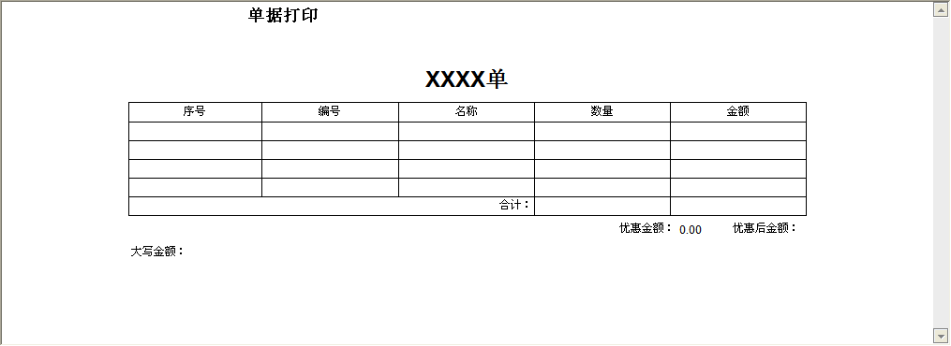

1. 构造动态数据或让用户手动输入数据来填充单据的内容；

<!DOCTYPE html PUBLIC "-//W3C//DTD XHTML 1.0 Transitional//EN" "http://www.w3.org/TR/xhtml1/DTD/xhtml1-transitional.dtd">

<html xmlns="http://www.w3.org/1999/xhtml" >

<head>

<title>打印</title>

<meta http-equiv="Content-Type" content="text/html; charset=utf-8" />

<style>

body, td, th {vnd.ms-excel.numberformat:@; font-family: "Arial" ,"宋体" , "Helvetica" , "sans-serif"; font-size: 12px; margin-top: 0px; margin-right: 0px; margin-bottom: 0px; margin-left: 0px; margin-top: 0px; SCROLLBAR-HIGHLIGHT-COLOR: #F5F9FF; SCROLLBAR-SHADOW-COLOR: #828282; SCROLLBAR-3DLIGHT-COLOR: #828282; SCROLLBAR-ARROW-COLOR: #797979; SCROLLBAR-TRACK-COLOR: #ECECEC; SCROLLBAR-DARKSHADOW-COLOR: #ffffff; }

.printTitle { font-size: 24px; font-weight:bold; }

.printTitle2 { font-size: 18px; font-weight:normal; }

.printTitle3 { font-size: 18px; font-weight:bold; }

.printTitle4 { font-size: 18px; font-weight:bold;font-style: italic }

.printEntryTable { border:#000000 solid 1px; border-collapse:collapse; }

.printEntryTable tr { height:20px;}

.printEntryTable th { font-weight: normal; border:#000000 solid 1px;}

.printEntryTable td { border:#000000 solid 1px;}

.PageNext{page-break-after:always;}

input{border:0;width:125px; size:23; maxlength:50; align:center;text-align:center}

</style>

</head>

<body>

<form name="form1" method="post" action="printtest.html" id="form1">

<script language="javascript" type="text/javascript" src='../js/pageprint.js'></script>

<script language="javascript" type="text/javascript" src='../js/jquery/jquery.js'></script>

<script language="javascript" type="text/javascript">var strQuery="";var billType="t_TranctionRecord";</script>

<object id="wb" style="display:none" height="0" width="0" classid="CLSID:8856F961-340A-11D0-A96B-00C04FD705A2" VIEWASTEXT></object>

<table width="100%" cellpadding="0px" cellspacing="0px" border="0px" style="position:relative ;top:expression(this.offsetParent.scrollTop);">

<tr style="background-color:#dcdcdc">

<td style=" font-size:14px"><b></b><input id="hidExportTag" type="hidden" /></td>

<td align="right" id="tdUCToolBar">

<span id="rpt_spanPageSet">

<input id="btnPrintSetting" type="button" onclick="javascript:ExecWB(8);" value="页面设置" />

<input id="btnPrintView" type="button" onclick="javascript:ExecWB(7);" value="打印预览" /></span>

<input id="printButton" type="button" onclick="javascript:hideOutputButton();window.print();hideOutputButton();" value="打印" />

<input id="closButton" type="button" onclick="javascript:try{document.all.wb.ExecWB(45,1);}catch(ex){window.close();}" value="关闭" />

</td>

</tr>

</table>

<table align="center" border="0" style="width:730px;">

<tr>

<td colspan="2"><table border="0">

<tr>

<td rowspan="4" style="width:120px"></td><td class="printTitle3" colspan="3"></td>

</tr><tr>

<td colspan="3"></td>

</tr><tr>

<td class="printTitle3" colspan="3">&nbsp;</td>

</tr><tr>

<td colspan="3"></td>

</tr>

</table></td>

</tr><tr>

<td colspan="2"><table class="Title" border="0" style="width:100%">

<tr>

<td class="printTitle" style="text-align:center">单据列表</td>

</tr>

</table></td>

</tr><tr>

<td colspan="2"></td>

</tr><tr>

<td colspan="2">

<table class='printEntryTable' width='100%'>

<tr align='center'>

<td>序号</td><td>编号</td><td>名称</td><td>数量</td><td>金额</td>

</tr>

<tr>

<td align='center'>

<div id='id1'>1</div></td>

<td align='center'> <input id='No' name='No'></td>

<td align='center'><input id='name' name='name'></td>

<td align='center'><input id='num' name='num' onKeyUp="setamount()"></td><td align='center'>

<input id='Amount' name='Amount' onKeyUp="setamount()"></td>

</tr>

<tr>

<td align='center'>

<div id='id1'>2</div></td>

<td align='center'> <input id='No' name='No'></td>

<td align='center'><input id='name' name='name'></td>

<td align='center'><input id='num2' name='num2' onKeyUp="setamount()"></td><td align='center'>

<input id='Amount2' name='Amount2' onKeyUp="setamount()"></td>

</tr>

<tr>

<td align='center'>

<div id='id1'>3</div></td>

<td align='center'> <input id='No' name='No'></td>

<td align='center'><input id='name' name='name'></td>

<td align='center'><input id='num3' name='num3' onKeyUp="setamount()"></td><td align='center'>

<input id='Amount3' name='Amount3' onKeyUp="setamount()"></td>

</tr>

<tr>

<td align='center'>

<div id='id1'>4</div></td>

<td align='center'> <input id='No' name='No'></td>

<td align='center'><input id='name' name='name'></td>

<td align='center'><input id='num4' name='num4' onKeyUp="setamount()"></td><td align='center'>

<input id='Amount4' name='Amount4' onKeyUp="setamount()"></td>

</tr>

<tr>

<td colspan='3' align='right'>合计：</td><td align='right'><input id='total_num' name='total_num' style='width:35px'></td><td align='right'>

<input id='total_amonut' style='width:55px'></div></td>

</tr>

</table>

</td>

</tr><tr>

<td align="right" colspan="2"><table border="0">

<tr>

<td>优惠金额：</td><td>0.00</td><td style="padding-left:30px">优惠后金额：</td><td><input id='total_amonuts' style='width:55px'></td>

</tr>

</table></td>

</tr><tr>

<td colspan="2"><table border="0">

<tr>

<td>大写金额：</td><td><div id='Upmount'></div></td>

</tr>

</table></td>

</tr>

</table>

<div style="height:10px;">

</div>

</form>

</body>

</html>

调用JS 当用户key up 时触发此function

function setamount()

{

var num = $('#num').val();

var num2 = $('#num2').val();

var num3 = $('#num3').val();

var num4 = $('#num4').val();

var amount = $('#Amount').val();

var amount2 = $('#Amount2').val();

var amount3 = $('#Amount3').val();

var amount4 = $('#Amount4').val();

var total_num = num-(-num2)-(-num3)-(-num4);

var total_amonut = num*amount+num2*amount2+num3*amount3+num4*amount4;

$("#total_amonut").val(total_amonut);

$("#total_amonuts").val(total_amonut);

$("#total_num").val(total_num);

}

如图：

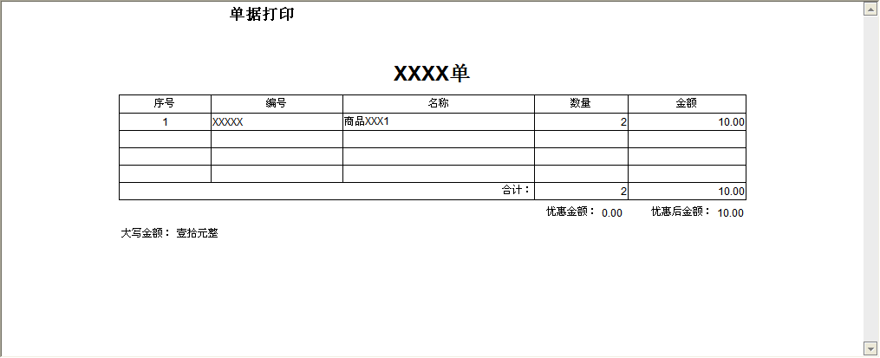

1. 调用单据打印功能实现单据的打印
2. 引入javascript文件脚本

…

<script language="javascript" type="text/javascript" src='../js/ invoiceprint.js'></script>

…

1. 定义打印相关的javascript变量

…

<script language="javascript" type="text/javascript">var strQuery="";var billType="t_TranctionRecord";</script>

…

1. 定义浏览器对象

…

<object id="wb" style="display:none" height="0" width="0" classid="CLSID:8856F961-340A-11D0-A96B-00C04FD705A2" VIEWASTEXT></object>

…

1. 增加打印相关的工具按钮

…

<table width="100%" cellpadding="0px" cellspacing="0px" border="0px" style="position:relative ;top:expression(this.offsetParent.scrollTop);">

<tr style="background-color:#dcdcdc">

<td style=" font-size:14px"><b></b><input id="hidExportTag" type="hidden" /></td>

<td align="right" id="tdUCToolBar">

<span id="rpt_spanPageSet">

<input id="btnPrintSetting" type="button" onclick="javascript:ExecWB(8);" value="页面设置" />

<input id="btnPrintView" type="button" onclick="javascript:ExecWB(7);" value="打印预览" /></span>

<input id="printButton" type="button" onclick="javascript:hideOutputButton();window.print();hideOutputButton();" value="打印" />

<input id="closButton" type="button" onclick="javascript:try{document.all.wb.ExecWB(45,1);}catch(ex){window.close();}" value="关闭" />

</td>

</tr>

</table>

…

　　　结果效果图：

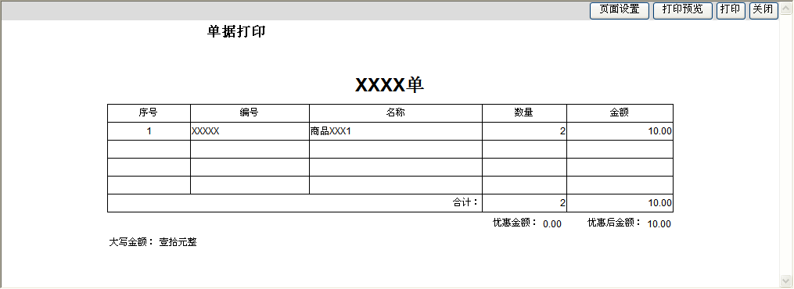

　　　单据页面

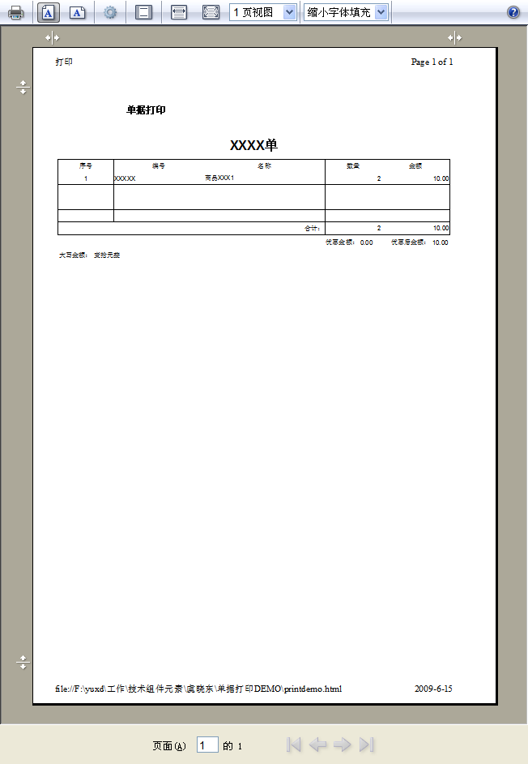

　　　打印预览