
RENTALPRO RMS
PROJECT REQUIREMENTS DOCUMENTATION
Property, Rental, Sales and Payment Management Platform

Document Type | Software Requirements Specification (SRS)
Version | 1.0
Source Baseline | RentalProRMS_fullProject.zip
Prepared Date | 1 July 2026

Document Control
Item | Details
Document title | RentalPro RMS Project Requirements Documentation
Purpose | Define the functional, data, interface, quality and deployment requirements for the implemented RentalPro RMS full-stack system.
Intended audience | Project owner, developers, supervisors, testers, database administrators and deployment personnel.
Technology baseline | React + Vite, Axios, React Router, ASP.NET Core Web API (.NET 8), ADO.NET, Microsoft.Data.SqlClient and SQL Server.
Document status | Baseline requirements derived from the supplied project implementation.

Revision History
Version | Date | Description | Status
1.0 | 1 July 2026 | Initial requirements baseline based on the uploaded RentalPro RMS full-stack project. | Approved baseline

Interpretation note This document distinguishes between the current educational implementation and production-grade requirements. Current behavior is documented accurately; security improvements are identified as mandatory before public deployment.

Table of Contents
The document is organized into the following requirement areas. Heading styles are applied so Microsoft Word can also generate an automatic table of contents if required.
Section | Contents
1 | Introduction: purpose, problem, objectives, scope and definitions
2 | Stakeholders and role access
3 | System overview, architecture, technology and operating environment
4 | Functional requirements by module
5 | Business rules
6 | Data requirements and entity relationships
7 | API and frontend integration requirements
8 | User interface and experience requirements
9 | Non-functional requirements
10 | Security and privacy requirements
11 | Configuration and deployment requirements
12 | Validation and error handling requirements
13 | Acceptance criteria and test scenarios
14 | Assumptions, constraints and dependencies
15 | Recommended future enhancements
16 | Requirements traceability summary
Appendix A | Baseline project structure
Appendix B | Baseline local URLs and configuration warning
Approval | Project sign-off table

1. Introduction

1.1 Purpose
This document defines the requirements for RentalPro RMS, a responsive web-based rental and property management system. The system centralizes property listings, owners, customers, rental agreements, property sales, payments, users, dashboards and reports. It also provides public Home, About and Contact pages.

1.2 Problem Statement
Property businesses that rely on spreadsheets, paper records or disconnected applications experience duplicate information, unclear property status, inconsistent payment balances and slow reporting. RentalPro RMS addresses these issues through one relational database, a REST API and a responsive React interface.

1.3 Business Objectives
- Maintain a single reliable source of property, owner, customer, rental, sales and payment data.
- Reduce errors caused by manual status updates and disconnected records.
- Provide role-appropriate access for Admin, Manager and User accounts.
- Allow users to search, create, view, update and delete records through a responsive web interface.
- Provide management summaries and grouped reports for operational decision-making.
- Run React and the ASP.NET Core API separately during development and from one host after production build.

1.4 Scope
In Scope | Out of Scope for Current Baseline
Public Home, About and Contact pages; login; role-aware navigation; CRUD for users, owners, customers, properties, apartments, rentals, sales and payments; dashboard; reports; SQL Server integration; Swagger; responsive design. | Online payment gateway, lease document upload, property image upload, email/SMS notifications, multi-company tenancy, accounting ledger, production identity provider, audit log, automated backups and external map integration.

1.5 Definitions and Acronyms
Term | Meaning
RMS | Rental Management System.
SRS | Software Requirements Specification.
API | Application Programming Interface.
CRUD | Create, Read, Update and Delete.
ADO.NET | Microsoft data-access technology used by the backend.
SPA | Single Page Application.
CORS | Cross-Origin Resource Sharing.
Vite | Frontend development server and production build tool.
Role | Authorization category: Admin, Manager or User.
Property status | Available, Rented or Sold.
Payment status | Unpaid, Partial or Paid.

2. Stakeholders and User Roles

2.1 Stakeholders
- System owner / rental business management
- Property managers and administrators
- Cashiers or payment-recording staff
- Property owners
- Tenants and buyers represented as customers
- System developers and database administrators
- Testers, project supervisors and support personnel

2.2 Role Access Matrix
Module / Action | Admin | Manager | User / Guest
Public Home, About, Contact | Yes | Yes | Yes
Login / Logout | Yes | Yes | Yes
Management overview | Yes | Yes | Authenticated User
Properties | Full | Full | No
Apartments | Full | Full | View / manage through current UI
Owners | Full | Full | No
Customers | Full | Full | No
Rentals | Full | Full | No
Sales | Full | Full | No
Payments | Full | Full | Available to authenticated User
Reports | Full | Full | No
System users | Full | No | No

Current authorization boundary Role checks are implemented in the React route layer. The current API registers authorization services but does not implement JWT/cookie authentication or controller-level authorization. Server-side role enforcement is a production requirement.

3. System Overview

3.1 Product Perspective
RentalPro RMS is a three-tier web application: a React/Vite presentation layer, an ASP.NET Core Web API application layer and a SQL Server data layer. Axios is used for HTTP communication. The production React build is served by ASP.NET Core from the web root.
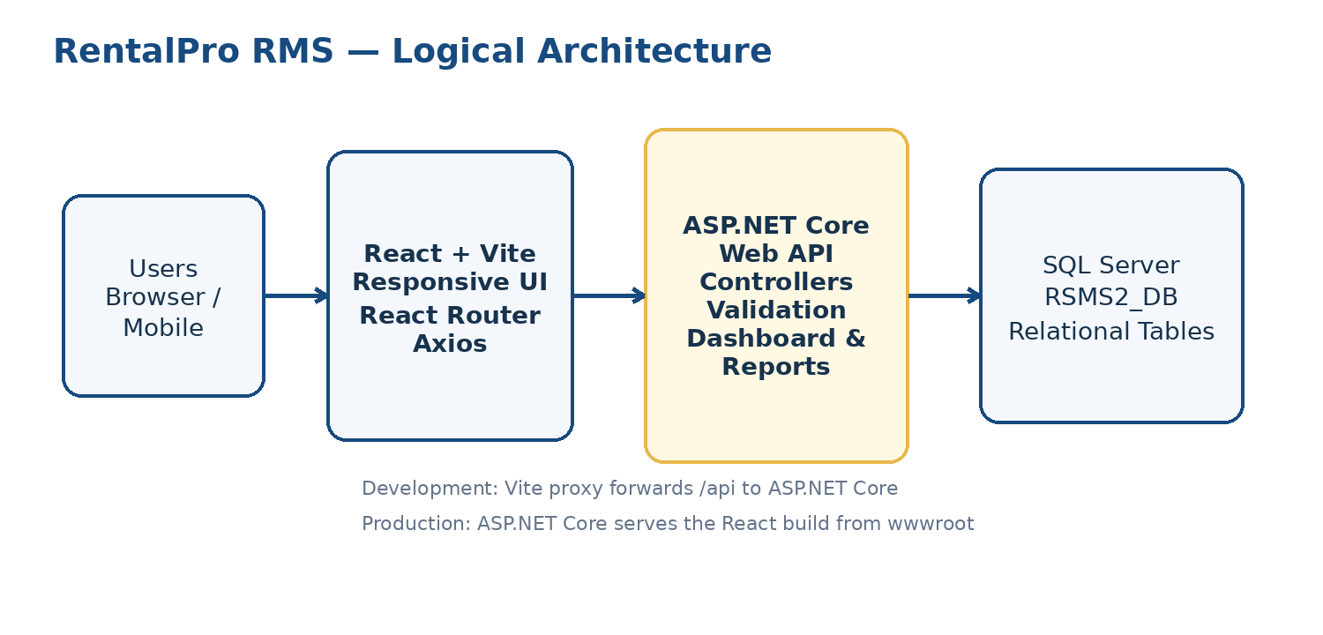
Figure 1. Logical system architecture

3.2 Technology Requirements
Layer | Technology | Requirement
Frontend | React, React DOM, React Router, Axios, Lucide React | Responsive SPA with reusable pages, components, context and hooks.
Frontend build | Vite | Development server, proxy support and optimized production build.
Backend | ASP.NET Core Web API, .NET 8 | Controller-based REST API with dependency injection and Swagger.
Data access | ADO.NET / Microsoft.Data.SqlClient | Parameterized SQL queries and mapping to C# models.
Database | Microsoft SQL Server | Relational storage in RSMS2_DB with primary and foreign keys.
API documentation | Swagger / OpenAPI | Interactive endpoint discovery and testing in Development.

3.3 Operating Environment
- Windows 10 or Windows 11 development workstation.
- Visual Studio 2022 with ASP.NET and web development workload and .NET 8 SDK.
- Node.js and npm for the React/Vite frontend.
- SQL Server and SQL Server Management Studio.
- Modern browser such as Microsoft Edge, Google Chrome or Firefox.
- Local development URLs defined by launch settings and Vite configuration.

4. Functional Requirements
Priority legend: Must = required for baseline acceptance; Should = valuable quality or deployment requirement; Could = planned extension.

4.1 Public Website and Navigation
FR-001 | Public home content — The system shall display brand, hero content, actions and feature highlights using data from GET /api/website/home. | Must
FR-002 | About content — The system shall display mission, vision, values and live property/owner/customer/rental statistics from GET /api/website/about. | Must
FR-003 | Contact information — The system shall display address, phone, email, working hours and expected response time from GET /api/website/contact. | Must
FR-004 | Contact submission — The system shall validate and accept contact messages through POST /api/website/contact. | Must
FR-005 | Primary navigation — The header shall provide Home, Management Works, About and Contact navigation. | Must
FR-006 | Responsive navigation — The navigation shall collapse into a mobile menu on small screens. | Must

4.2 Authentication and Session
FR-010 | Login — The system shall verify username and password against the Users table through POST /api/auth/login. | Must
FR-011 | Session storage — The frontend shall store the authenticated user ID, username and role in localStorage for browser-session continuity. | Must
FR-012 | Protected routes — The frontend shall redirect unauthenticated users to Login and block roles that are not permitted for a route. | Must
FR-013 | Logout — The system shall clear the stored session and return the user to the public website. | Must
FR-014 | Server authentication — A production deployment shall authenticate API requests using JWT or secure cookies and enforce roles on controllers. | Should

4.3 User Management
FR-020 | List users — Admin shall list users without returning password values. | Must
FR-021 | Search users — Admin shall search users by username or role. | Must
FR-022 | Create user — Admin shall create a unique username with role Admin, Manager or User. | Must
FR-023 | Update user — Admin shall update username, password and role. | Must
FR-024 | Delete user — Admin shall delete a selected user when database constraints allow it. | Must

4.4 Owner and Customer Management
FR-030 | Owner CRUD — Admin and Manager shall create, list, search, update and delete owner records. | Must
FR-031 | Owner validation — Owner full name and phone shall be required; email shall use valid email format when provided. | Must
FR-032 | Customer CRUD — Admin and Manager shall create, list, search, update and delete customer records. | Must
FR-033 | Customer types — Customer type shall support Tenant, Buyer or Both. | Must
FR-034 | Relational protection — Owners or customers referenced by operational records shall not be removed without controlled handling of related data. | Must

4.5 Property and Apartment Management
FR-040 | Property CRUD — Admin and Manager shall manage property name, type, location, price, status, owner and description. | Must
FR-041 | Property types — The UI shall support Apartment, House, Shop, Office and Villa property types. | Must
FR-042 | Property status — Property status shall be Available, Rented or Sold. | Must
FR-043 | Owner reference — Each property shall reference an existing owner. | Must
FR-044 | Apartment view — The Apartments module shall operate on Properties records where PropertyType equals Apartment. | Must
FR-045 | Property search and filters — Property lists shall support search and applicable status/type filters. | Must
FR-046 | Apartment details — Users shall open an apartment details page by property ID. | Must

4.6 Rental Management
FR-050 | Rental CRUD — Admin and Manager shall create, list, search, update and delete rental agreements. | Must
FR-051 | Rental references — A rental shall reference an existing property and customer. | Must
FR-052 | Availability rule — A new rental shall use only a property whose status is Available. | Must
FR-053 | Date rule — Rental EndDate shall be later than StartDate. | Must
FR-054 | Rental status update — Creating or updating a rental shall set the selected property status to Rented. | Must
FR-055 | Rental release — Deleting a rental or changing its property shall return the previous property to Available when appropriate. | Must

4.7 Sales Management
FR-060 | Sales CRUD — Admin and Manager shall create, list, search, update and delete property sales. | Must
FR-061 | Sale references — A sale shall reference an existing available property and an existing buyer customer. | Must
FR-062 | Paid amount rule — PaidAmount shall not exceed SalePrice. | Must
FR-063 | Balance calculation — Sale balance shall equal SalePrice minus PaidAmount. | Must
FR-064 | Payment status calculation — Sale status shall be Unpaid, Partial or Paid according to the paid amount. | Must
FR-065 | Sold status — Creating or updating a sale shall set the selected property status to Sold. | Must
FR-066 | Sale deletion release — Deleting a sale shall return its property status to Available. | Must

4.8 Payment Management
FR-070 | Payment CRUD — Authenticated permitted users shall create, list, search, update and delete payments. | Must
FR-071 | Payment references — A payment shall reference an existing customer and property. | Must
FR-072 | Payment type — Payment type shall be Rent or Sale. | Must
FR-073 | Payment amount rule — PaidAmount shall not exceed TotalAmount. | Must
FR-074 | Remaining balance — RemainingBalance shall equal TotalAmount minus PaidAmount. | Must
FR-075 | Payment filter — Payment lists shall support filtering by payment type. | Must

4.9 Dashboard and Reports
FR-080 | Dashboard totals — The dashboard shall show totals for users, owners, customers, properties, apartments, rentals, sales and payments. | Must
FR-081 | Property indicators — The dashboard shall show counts of available and rented properties. | Must
FR-082 | Financial indicators — The dashboard shall show total amount received and total outstanding balance. | Must
FR-083 | Recent operations — The dashboard shall show the five most recent rentals and sales. | Must
FR-084 | Summary report — The system shall expose a summary report for properties, owners, customers, rentals, sales, payments and apartments. | Must
FR-085 | Properties by status — The system shall group and count properties by status using LINQ. | Must
FR-086 | Payments by type — The system shall group payment count, paid total and remaining total by type using LINQ. | Must
FR-087 | Health endpoint — The system shall provide GET /api/health to verify backend/frontend connectivity. | Must

5. Business Rules
Rule ID | Business Rule
BR-001 | Usernames must be unique.
BR-002 | Allowed system roles are Admin, Manager and User.
BR-003 | Each property belongs to one owner; one owner may own many properties.
BR-004 | An apartment is a property with PropertyType = Apartment.
BR-005 | Only Available properties may be newly rented or sold.
BR-006 | A property cannot logically be Rented and Sold at the same time.
BR-007 | Rental EndDate must be later than StartDate.
BR-008 | Rental deposit must be zero or greater.
BR-009 | Sale PaidAmount cannot be greater than SalePrice.
BR-010 | Payment PaidAmount cannot be greater than TotalAmount.
BR-011 | Sale Balance and Payment RemainingBalance are derived values.
BR-012 | Deleting a rental or sale releases the property to Available in the current business workflow.
BR-013 | Passwords must not be returned in list or detail API responses.
BR-014 | Contact submissions are currently acknowledged but not persisted or emailed.

6. Data Requirements

6.1 Core Entities
Entity | Primary Data | Key Relationships
Users | UserID, Username, Password, Role | Independent authentication record.
Owners | OwnerID, FullName, Phone, Email, Address | One Owner to many Properties.
Customers | CustomerID, FullName, Phone, Email, Address, CustomerType | Referenced by Rentals, Sales and Payments.
Properties | PropertyID, PropertyName, PropertyType, Location, Price, Status, OwnerID, Description | References Owners; referenced by Rentals, Sales and Payments.
Rentals | RentalID, PropertyID, CustomerID, RentAmount, Deposit, dates, PaymentStatus | References Properties and Customers.
Sales | SaleID, PropertyID, BuyerID, SalePrice, PaidAmount, Balance, SaleDate, PaymentStatus | References Properties and Customers.
Payments | PaymentID, CustomerID, PropertyID, PaymentType, TotalAmount, PaidAmount, RemainingBalance, PaymentDate, Note | References Customers and Properties.

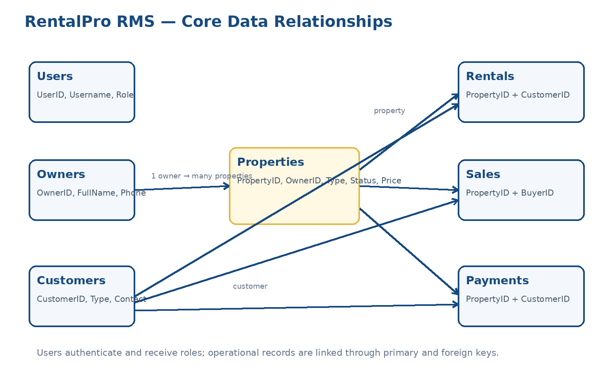
Figure 2. Core entity relationship overview

6.2 Data Integrity Requirements
- Primary keys shall use SQL Server identity values.
- Foreign keys shall prevent orphan Properties, Rentals, Sales and Payments.
- Required fields and string lengths shall be validated by API models and database constraints.
- Money values shall use decimal types and must not be negative unless explicitly permitted.
- Computed balance fields shall be generated from total and paid values.
- Parameterized SQL commands shall be used for all user-provided values.
- Date values shall be transmitted in an unambiguous ISO-compatible format.

7. API and Integration Requirements

7.1 Endpoint Catalogue
Resource | Methods / Paths | Purpose
Authentication | POST /api/auth/login | Validate credentials and return user role information.
Users | GET/POST /api/users; GET/PUT/DELETE /api/users/{id} | System user CRUD and search.
Owners | GET/POST /api/owners; GET/PUT/DELETE /api/owners/{id} | Owner CRUD and search.
Customers | GET/POST /api/customers; GET/PUT/DELETE /api/customers/{id} | Customer CRUD and search.
Properties | GET/POST /api/properties; GET/PUT/DELETE /api/properties/{id} | Property CRUD, search and filters.
Apartments | GET/POST /api/apartments; GET/PUT/DELETE /api/apartments/{id} | Apartment-only property operations.
Rentals | GET/POST /api/rentals; GET/PUT/DELETE /api/rentals/{id} | Rental agreement operations.
Sales | GET/POST /api/sales; GET/PUT/DELETE /api/sales/{id} | Property sales operations.
Payments | GET/POST /api/payments; GET/PUT/DELETE /api/payments/{id} | Payment and balance operations.
Dashboard | GET /api/dashboard | Operational and financial summary.
Reports | GET /api/reports/summary; /properties-by-status; /payments-by-type | Grouped management reports.
Website | GET /api/website/home|about|contact; POST /api/website/contact | Public website content and contact request.
Health | GET /api/health | Application connectivity check.

7.2 API Behavior
- JSON property names shall be serialized in camelCase.
- Successful creation shall return HTTP 201 Created with the created identifier or record.
- Successful read/update/delete shall return HTTP 200 where appropriate.
- Missing records shall return HTTP 404 with a readable message.
- Invalid business input shall return HTTP 400.
- Duplicate unique values shall return HTTP 409 where implemented.
- Unexpected production errors shall be logged and returned without exposing connection strings or stack traces.
- Swagger shall be enabled in the Development environment.

7.3 Frontend Integration
- Axios shall use one shared client with JSON headers and a reasonable timeout.
- The frontend shall obtain the API URL from VITE_API_URL or use the relative /api path for same-origin production.
- During development, Vite may proxy /api requests to the ASP.NET Core host.
- Loading, empty and error states shall be displayed consistently.
- React pages shall use reusable CRUD hooks and components rather than duplicating request logic.

8. User Interface and Experience Requirements
Area | Requirement
Brand | Use the RentalPro RMS building-and-key logo and the blue/gold brand palette.
Navigation | Provide four primary items: Home, Management Works, About and Contact.
Management menu | Show role-appropriate operational modules inside a structured dropdown.
Responsive layout | Support desktop, tablet and mobile widths; tables must scroll or adapt on small screens.
Accessibility | Provide labels, keyboard-accessible controls, sufficient contrast and meaningful button text.
Forms | Display required indicators, validation messages, correct input types and relational dropdowns.
Tables | Support search, clear headings, formatted dates/currency/status badges and row actions.
Feedback | Display loading, success, empty, confirmation and error states.
Consistency | Use reusable Header, Footer, BrandLogo, Modal, DataTable, CrudForm and status components.

9. Non-Functional Requirements
ID | Category | Requirement | Target
NFR-001 | Performance | Common list and dashboard requests should respond quickly under normal local/business load. | ≤ 2 seconds for typical requests.
NFR-002 | Responsiveness | All public and management pages shall be usable on modern phones, tablets and desktops. | 320 px and above.
NFR-003 | Compatibility | The UI shall support current versions of Edge, Chrome and Firefox. | Latest two major versions.
NFR-004 | Availability | The system shall expose a health endpoint and recover cleanly after application restart. | Business-hours availability target ≥ 99% for hosted use.
NFR-005 | Maintainability | Backend concerns shall remain separated into Models, Data and Controllers; frontend into api, hooks, components and pages. | New resource module without broad rewrites.
NFR-006 | Security | Production passwords shall be hashed and API authorization enforced server-side. | No plain-text passwords in production.
NFR-007 | Data integrity | Foreign keys, validation and transaction-safe status updates shall protect relational consistency. | No orphan operational records.
NFR-008 | Usability | Primary tasks shall use clear labels and no unnecessary complexity. | New user completes common CRUD with minimal guidance.
NFR-009 | Logging | Backend shall record startup, errors and significant failures without exposing secrets. | Structured server logs.
NFR-010 | Backup | Database backup and restoration procedures shall exist before production use. | At least daily backup for hosted deployment.

10. Security and Privacy Requirements
Current implementation risk The supplied educational database stores passwords as plain text and the frontend stores a role-based session in localStorage. This is acceptable only for classroom/local demonstration, not for public production.

- Use ASP.NET Core Identity or a proven password hasher; never store plain-text passwords.
- Issue authenticated JWTs or secure HttpOnly cookies after successful login.
- Apply [Authorize] and role policies to API controllers, not only React routes.
- Use HTTPS in deployed environments.
- Restrict CORS to approved frontend origins.
- Validate and parameterize all database inputs.
- Do not return password fields in any API response.
- Store connection strings in backend configuration or secret stores, never in frontend .env files.
- Add audit logs for user, property, rental, sale and payment changes before production use.
- Define data retention and access rules for customer and owner contact information.

11. Configuration and Deployment Requirements

11.1 Development Configuration
- Create and seed RSMS2_DB using the supplied SQL script.
- Update DefaultConnection in appsettings.json for the target SQL Server instance.
- Run the ASP.NET Core API from Visual Studio or dotnet run.
- Run npm install and npm run dev in the frontend directory.
- Ensure the Axios base URL or Vite proxy points to the active API URL.
- Test API operations through Swagger and the React application.

11.2 Production Build
- Set the frontend API base to the relative /api path for same-origin hosting.
- Run npm run build to create the Vite dist directory.
- Copy the contents of dist into the ASP.NET Core web root (wwwroot in the current project).
- Enable UseDefaultFiles, UseStaticFiles and MapFallbackToFile("index.html").
- Publish the ASP.NET Core project and deploy the database separately.
- Configure HTTPS, production logging, authentication, secrets and backups.

11.3 Required Configuration Values
Location | Setting | Purpose
Backend appsettings.json | ConnectionStrings:DefaultConnection | SQL Server connection.
Backend launchSettings.json | applicationUrl | Local HTTP/HTTPS API ports.
Frontend .env | VITE_API_URL | Optional development API base address.
Frontend vite.config.js | server.proxy / target | Development forwarding of /api requests.
Program.cs | CORS origins | Approved development frontend origins.

12. Validation and Error Handling Requirements
Condition | Expected Response / UI Behavior
Record not found | API returns 404 and UI displays a readable message.
Invalid model fields | API returns 400 validation details; form highlights relevant fields.
Duplicate username/property name or configured duplicate value | API returns 409 Conflict where duplicate checks exist.
Missing owner/customer/property relation | API returns 400 and does not insert the record.
Unavailable property selected for new rental or sale | API returns 400 explaining the availability rule.
Paid amount exceeds total/sale amount | API returns 400 and preserves existing data.
Delete blocked by foreign key | API returns a business-readable error rather than an unhandled SQL exception.
Network/API unavailable | Frontend displays a retryable error state.
Unknown React route | NotFound page is shown; production refresh falls back to index.html.

13. Acceptance Criteria and Test Scenarios
Test ID | Scenario | Expected Result
AT-001 | Open /api/health. | HTTP 200 with Running status.
AT-002 | Open Swagger in Development. | All controllers and endpoints are listed.
AT-003 | Login with seeded Admin account. | Admin session created and Admin modules visible.
AT-004 | Login with Manager account. | Manager sees operational modules but not System Users.
AT-005 | Login with User account. | User is restricted to permitted pages.
AT-006 | Create owner and property. | Property appears with selected owner name.
AT-007 | Create rental for Available property. | Rental is created and property becomes Rented.
AT-008 | Attempt rental for Sold/Rented property. | Request rejected with business message.
AT-009 | Delete rental. | Rental is deleted and property becomes Available.
AT-010 | Create sale with partial payment. | Balance calculated, status Partial, property becomes Sold.
AT-011 | Create payment. | Remaining balance calculated correctly.
AT-012 | Search each CRUD page. | Visible records match the search term.
AT-013 | Open dashboard. | Counts and financial totals match database records.
AT-014 | Open reports. | Grouped status/type totals match source data.
AT-015 | Refresh /properties or /about in production host. | React page loads through fallback, not 404.
AT-016 | Test 375 px viewport. | Navigation, forms, cards and tables remain usable.

14. Assumptions, Constraints and Dependencies
- The baseline database is Microsoft SQL Server and uses the schema in RSMS2_DB.
- The current project is intended as a beginner-friendly educational and small-business baseline.
- Database and API are assumed to use compatible network access and credentials.
- Property images shown in the interface may be static assets; image upload is not part of the current schema.
- Contact messages are not stored because no ContactMessages table exists.
- Role restrictions in the current UI do not replace server-side authorization.
- The production React build must remain synchronized with the frontend source after changes.

15. Recommended Future Enhancements
Priority | Enhancement | Reason
High | ASP.NET Core Identity/JWT and server role policies | Protect all API operations and remove plain-text passwords.
High | Database transaction boundaries for multi-step rental/sale status changes | Guarantee atomic updates.
High | Audit log | Track who changed financial and property records.
Medium | ContactMessages table and email notifications | Persist and process website inquiries.
Medium | Property image upload and media storage | Support real listings rather than static assets.
Medium | Lease documents, receipts and PDF exports | Improve operational completeness.
Medium | Pagination and server-side filtering | Support larger datasets efficiently.
Low | Maps, SMS, online payment integration and tenant self-service | Extend customer-facing functionality.

16. Requirements Traceability Summary
Requirement Area | Database / Backend | Frontend
Authentication | Users table, AuthController, UserData | Login, AuthContext, ProtectedRoute
Owners | Owners table, OwnersController, OwnerData | Owners page, reusable CRUD components
Customers | Customers table, CustomersController, CustomerData | Customers page, relational selects
Properties / Apartments | Properties table, PropertiesController, ApartmentsController | Properties, Apartments, ApartmentDetails
Rentals | Rentals table, RentalsController, RentalData | Rentals page and CRUD form
Sales | Sales table, SalesController, SaleData | Sales page and calculated status
Payments | Payments table, PaymentsController, PaymentData | Payments page and balance display
Dashboard | DashboardController and LINQ summaries | ManagementOverview and statistic cards
Reports | ReportsController | Reports page
Public website | WebsiteController | Home, About and Contact pages

Appendix A — Baseline Project Structure
RentalProRMS_Website_Working_Fixed/
├── backend/
│ ├── RentalProRMS.sln
│ └── RentalProRMS.Api/
│ ├── Controllers/
│ ├── Data/
│ ├── Models/
│ ├── Database/
│ ├── Properties/
│ ├── wwwroot/
│ ├── Program.cs
│ ├── appsettings.json
│ └── RentalProRMS.Api.csproj
├── frontend/
│ ├── src/
│ │ ├── api/
│ │ ├── components/
│ │ ├── config/
│ │ ├── context/
│ │ ├── hooks/
│ │ ├── layouts/
│ │ └── pages/
│ ├── package.json
│ └── vite.config.js
└── Build-Frontend-Into-Backend.bat

Appendix B — Baseline Local URLs
Service | Example URL
ASP.NET Core HTTP | http://localhost:5107
ASP.NET Core HTTPS | https://localhost:7107
Swagger | https://localhost:7107/swagger or http://localhost:5107/swagger
API health | /api/health
React development | Defined by Vite server configuration; recommended to use a port different from the API.

Configuration warning The supplied frontend Vite configuration uses port 7107, which is also an ASP.NET Core HTTPS port. For separate development servers, assign Vite a different port such as 5173 and proxy /api to https://localhost:7107 or http://localhost:5107.

Approval
This document represents the requirements baseline for the supplied RentalPro RMS implementation. Changes to scope, database structure, roles or business rules should be documented through a new revision.
Role | Name | Signature | Date
Project Owner
Developer
Supervisor / Reviewer

