求 $x^{2}-3x+1=0$ 的根

方法一：

>> p=[1,-3,1]

p =

1 -3 1

>> x=roots(p)

x =

2.6180

0.3820

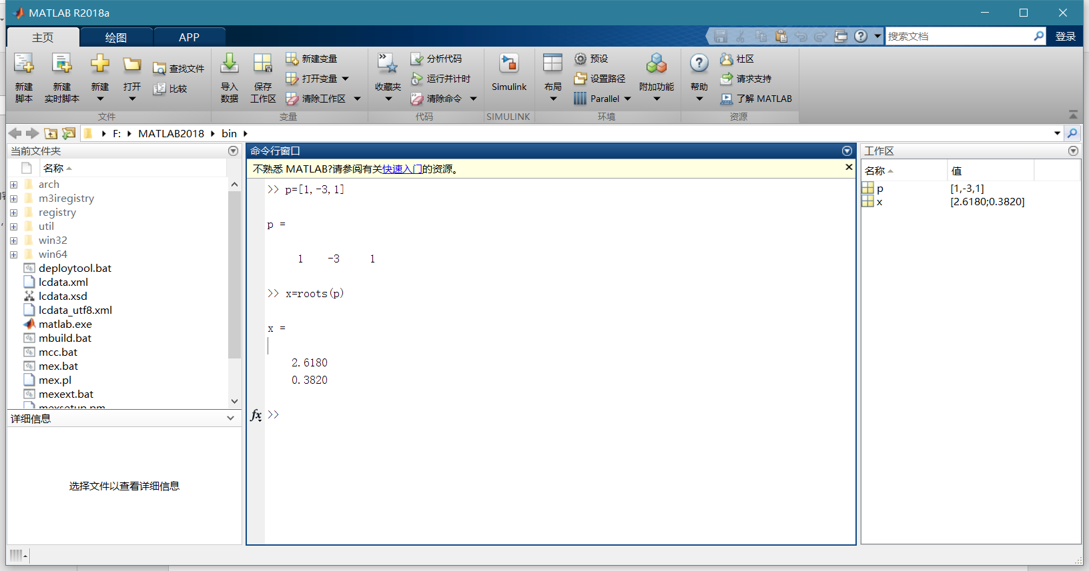

>> x=-5:0.1:5;

>> y1=x.\*x-3\*x+1;

>> y2=zeros(size(x));

>> plot(x,y1,x,y2);

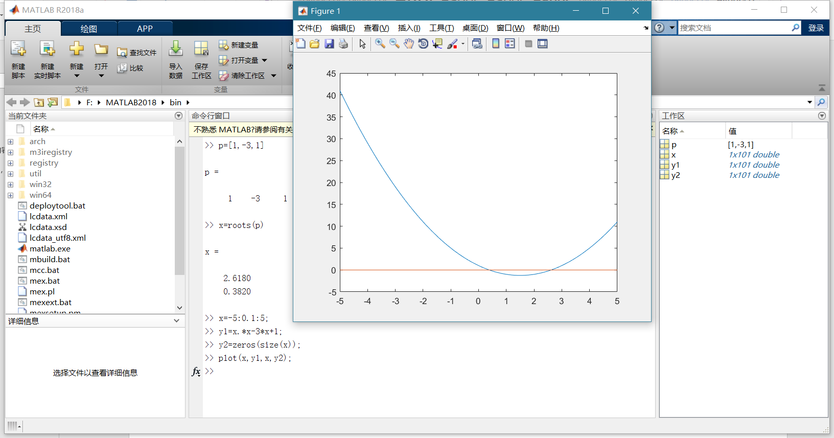

方法二：函数fzero

>> f=@(x)x\*x-3\*x+1;

>> x1=fzero(f,0.5)

x1 =

0.3820

>> x2=fzero(f,2.5)

x2 =

2.6180

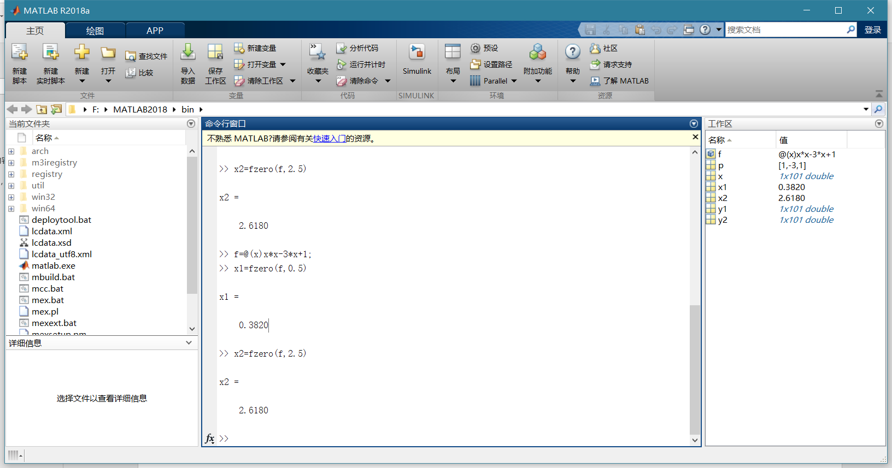

方法三：求根函数fsolve

>> f=@(x)x\*x-3\*x+1;

>> x1=fsolve(f,0.5,optimset('Display','off'))

x1 =

0.3820

>> x2=fsolve(f,2.5,optimset('Display','off'))

x2 =

2.6180

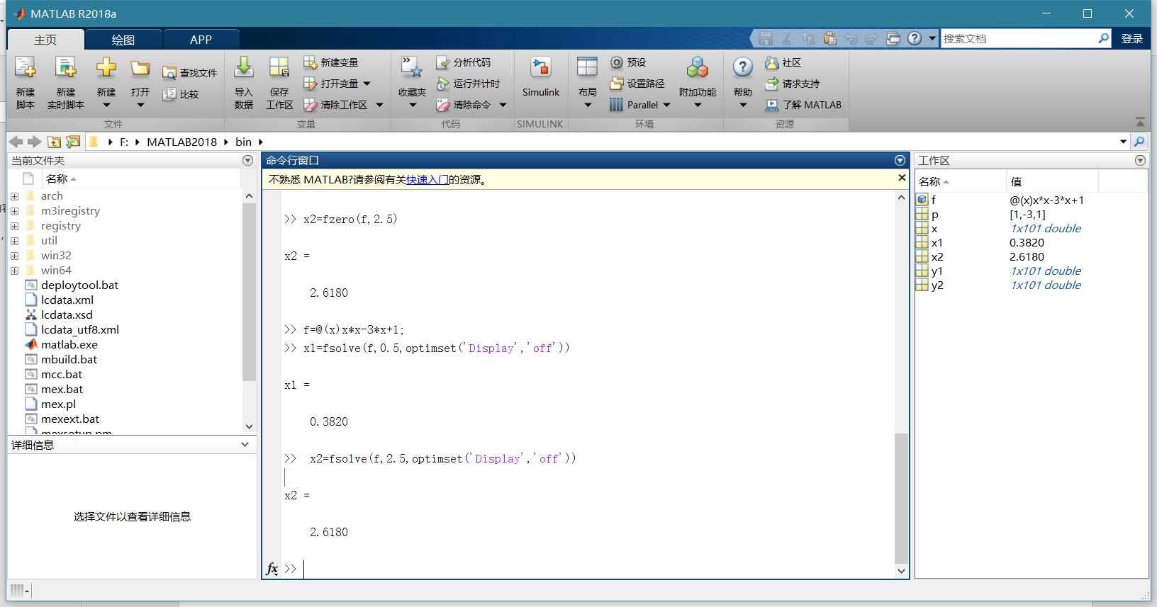

方法四：符号求根函数solve

>> syms x

>> x=solve(x^2-3\*x+1)

x =

3/2 - 5^(1/2)/2

5^(1/2)/2 + 3/2

>> x=eval(x)

x =

0.3820

2.6180

