**FINAL PROJECT:**

**PROPOSAL FOR DATASET**

**Team Members:** Dhairya Dave (NUID: 002110382) Manan Soni (NUID:002982645) Parth Savaliya (NUID: 002982302)

**Proposal of a Dataset**

# CONTEXT

This dataset is about **Product/Fashion recommendation** of H&M. It have 105542 rows and 25 variables about product, sections, description, color, etc. Another dataset related to this is customer like if customer has membership, what is age, etc. This dataset is officially given by H&M and it requires approx. 300 mb storage space. This is for proposal and understanding the research objectives. In nutshell, what we can do to H&M using this data. This is just short proposal for selection of dataset. As a perspective of analyst, this kind of data we will have to sort in future for company. Provided data is of **Sept 2018 to Sept 2020**. To add to this, Dataset can be used for fashion recommendation or to determine the taste of purchases.

# CONTENT

* This dataset has these features for recommendation and understanding the products. This also includes different wears photos for business possibilities. Skewness is good according to number of samples.
* It has another dataset in relation of customer but it won’t be that useful like we can get gender, age and membership to understand shopping taste from that of customers.

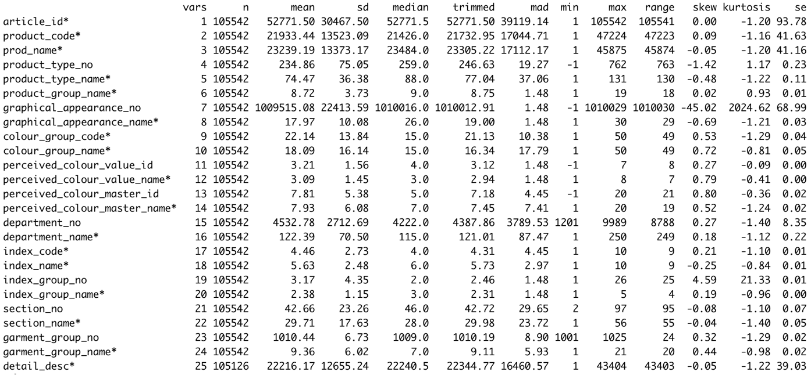

# RESEARCH OBJECTIVES

1. Determination of customer and their status of membership with age.
2. Each items has department plus section with color options we can get which product is most repetitive with respect to other variable like product type?
3. How much men products and women products ration in this data?
4. To be specific, in women how many percentages of different product type? Which product has significant numbers.
5. This is overview so if we get transactions, we can go much deeper for great business solution.
6. We can get the production relative frequencies about colors and type as we have different variables.

# SOURCE

Kaggle: https://www.kaggle.com/competitions/h-and-m-personalized-fashion-recommendations/data