

*Toronto*

**Final Project: Draft Report**

Soni Manan ***NUID****: 002982645*

Savaliya Parth ***NUID****: 002982302*

Dave Dhairya ***NUID****: 002110382*

*College of Professional Studies****,*** *Master of Professional Studies in Analytics.*

***Subject****: ALY6015*

Under the guidance of

**Dr. Prof. Alex Maizlish**

**Introduction**

Data has been released by H&M for their benefits and put as competition on Kaggle. All of the dataset contains data regarding their products and customers like clothing’s, accessories and customers membership status and their activeness. These data can be used for recommendation of their product based on sales. Initially it looked like we need to feature variables and subset them to get proper predictions.

**Descriptive Analysis**

* Articles dataset has 105502 samples and 25 variables.
* Customers dataset has 1371980 samples and 7 variables in which postal and id are hashed so useless as well as many rows has NA which cant be replaced with mean and median so replaced with mode.
* Most of the values are character and others are assigned id.

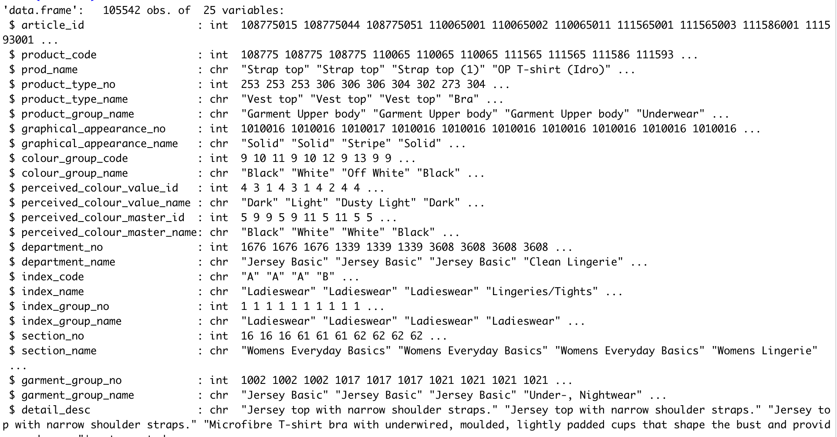

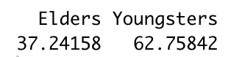 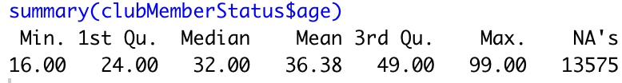

* Mean age is 36.38 and we consider age 15 to 40 are youngsters who are into good fashion where 37% elders of H&M customers.
* Age distribution of H&M is not normal as we can judge like H&M is brand for upcoming fashion and provide clothing’s according to west. So most of are in the range of 0-40 and little increment between 50-70 age group.
* 90% are active who follows news for whatever reason, some have pre-created membership and few left like 7% has left membership.
* Cleaning such as removing hasn’t take place while making this analysis as it can affect.

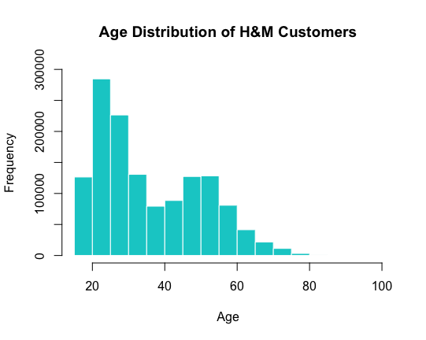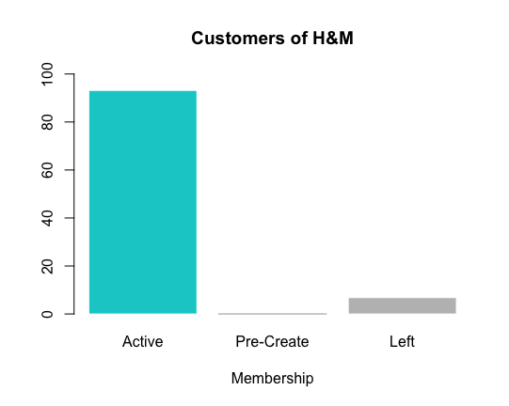

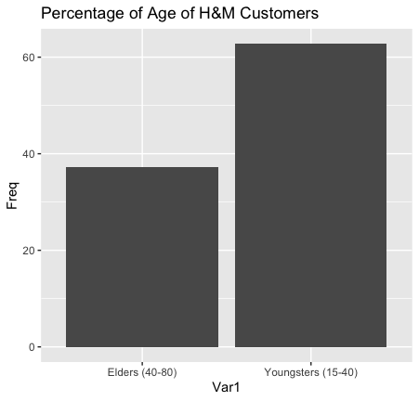

* 90% are active who follows news for whatever reason, some have pre-created membership and few left like 7% has left membership.
* As we can see, Trousers, Dresses, Sweaters, Tees and Top are top 5 whose cumulative relative frequency is almost 45%. Among that Trousers and Dresses tops with 11 and 10% respectively.

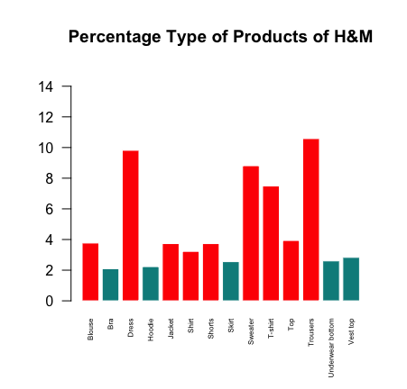

* Index name are just like category of articles.
* Ladieswear, tops with 25% in this where Divided, and Menswear are almost 15%. Following that, Childrenswear are at 10%.

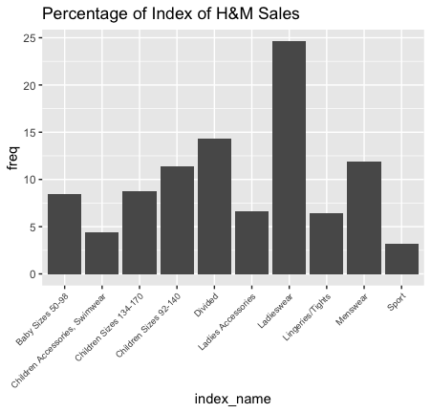

* This is uneven distribution of indexes at H&M. Following upper diagram, this follows same as that but in descriptive way. For ladieswear this has different ladieswear section like Everyday collection, Casual, etc. We can answer questions by subsetting or labelling this.

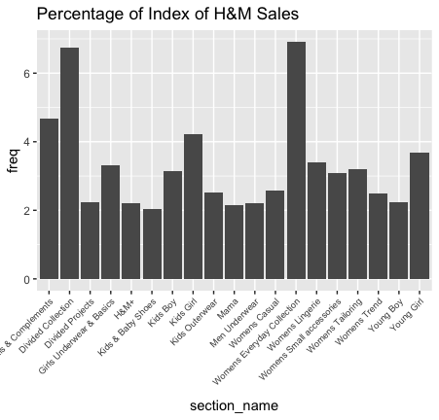

* This is uneven distribution of indexes at H&M. Following upper diagram, this follows same as that but in descriptive way. For ladieswear this has different ladieswear section like Everyday collection, Casual, etc. We can answer questions by subsetting or labelling this.
* This is overall colour preferences of customers. We can see Dark has preferred by 40% people. Dusty light and light has preferred by 20 and 15% customers respectively.

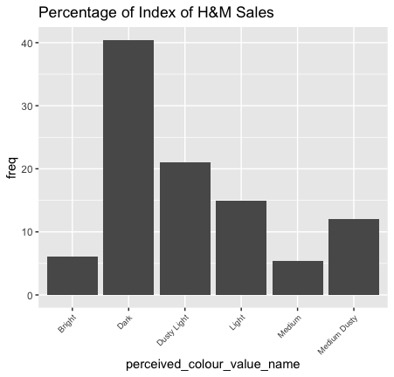 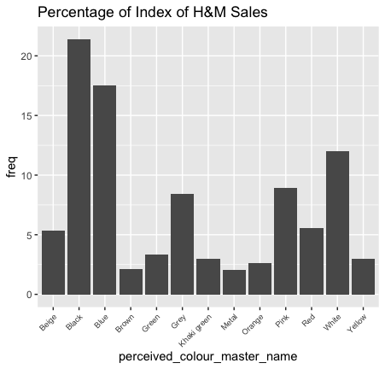

* To be precise, in Dark, Black and Blue are highly preferred by 37%. White and Pink are second highest preference of customers.
* To be precise, in Dark, Black and Blue are highly preferred by 37%. White and Pink are second highest preference of customers.
* So people around 50% people prefers Solid over patterns and etc. So if a research question ask like what are the chances of a customer will buy a t-shirt with solid or with some kind of pattern.

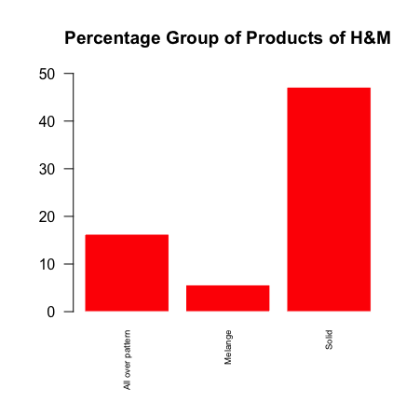

**Hypothesis Testing**

Hypothesis testing is important as we need to be sure and gain some confidence about our variables. There many methods to test and we tried ANOVA and chi-square method due to all of the variables are categorical. Also used ANOVA there is a continuous variable in customers dataset which is age. To be specific, chi-square is where all the variables which are going to test are categorical.

**Customer Hypothesis**

**Statement:** We will test and gain statistical results if membership of H&M has some relationships with Age and Fashion news frequency.

Null Hypothesis (H0): There is no effect on Club Membership of H$M from the other features like Age and Fashion news frequency.

Alternative Hypothesis (H1): There is some impacts on Club membership from other features.

**Summary:** For this test the level of significance is 95% which means value of alpha for the test is 0.05 to test.

We will use 2-factor ANOVA. For that, all of the variables are independent of each other at initial.

From this test we can see that p-value of individual variables are almost 0 and for interaction of age and fashion news frequency is also 0. In nutshell, All of the variables are less than value of alpha which is 0.05 as mention earlier.

From Tukey interpretation, we can say is Youngs whom are less than 30 having no news frequency and Youngs with monthly news frequency’s interaction is greater than significance. As X axis is showing difference in mean.

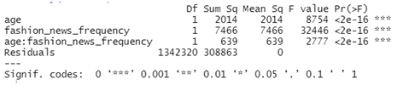

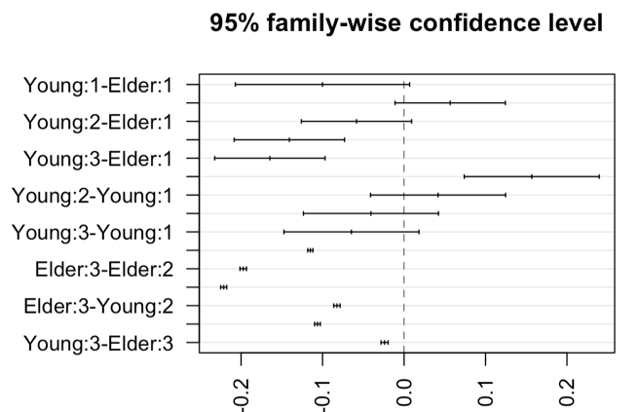

**Impact of Graphic patterns and Product type on Sales of H&M**

**Statement:** In this, testing and gaining statistical confidence if graphics patterns on product and product type do have impact on sales of such product.

Null Hypothesis (H0): Graphic patterns and Type of Articles do not have any impact on purchases.

Alternative Hypothesis (H1): They are not independent of purchases made by customers.

**Summary:** For this test the level of significance is 95% which means value of alpha for the test is 0.05 to test.

We will use Chi-squared. Due to, all of the variables are categorical and having same number of samples. Note that the value of p is almost 0 which is less than the value of significance 0.05 and **χ2** statistics is **109893** which is far greater than **3913.956** which is critical value of test.

From this test we can see that p-value is 0 which is less than 0.05 so that we have enough evidence to reject the null hypothesis and conclude that there is some effect of graphic patterns and type of product on sale.

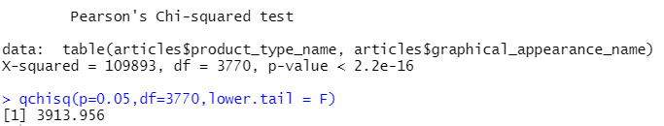

**Impact of Colours and Product type on Sales of H&M**

**Statement:** We will test for, if colours of product and product type do have effects on numbers of sales.

Null Hypothesis (H0): Colours of product such as dark, light and Type of Articles (product) do not have any impact on sales made by clients of H&M.

Alternative Hypothesis (H1): They do not have impact on purchases.

**Summary:** We will use again Chi-squared again for this test. Note that the value of p is almost 0 which is less than the value of significance 0.05 and **χ2** statistics is **80176** which is far greater than **2586.735** which is critical value of test.

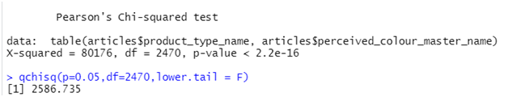

**Model and Prediction**

From the data, all of the variables are almost categorical such as T-shirts, its section, its colour, its pattern. So most of the variables are categorical not discrete and non-continues. So we think of a algorithm taught in this course is Logistic Regression. We will use Binomial and reason will be mention further.

**Logistic Regression (GLM):** In this test, there are multiple samples of different graphic patterns of articles in which we focused on Solid pattern to predict. If a random article whether or not having a solid pattern instead other one.

So made a dummy variable named solid and those samples whom have solid pattern it will denoted as 1 and others as 0. So we will perform binomial Logistic regression for checking between 1 & 0. So in simple, model will test if a article has solid pattern or not. Input variables will be graphical pattern and its colour.

First we split dataset into train and testing sets which had threshold of 0.7.

For the training, we put solid (0,1) variable as independent and other as dependent. From this we can say P value is 0 for all the variables. Accuracy is 94% and false positives are 4617. But this is for training set so we need to test this model with testing set. To add to this, 34644 are true positives and 34516 are true negatives, surprisingly false negatives are 0.

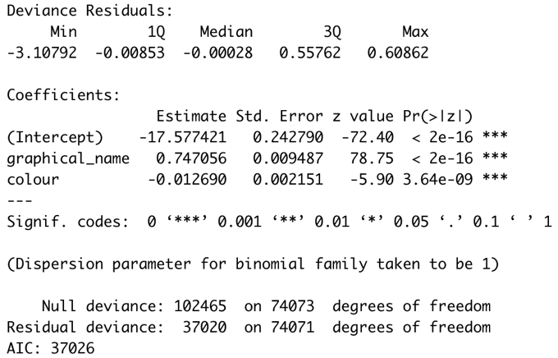 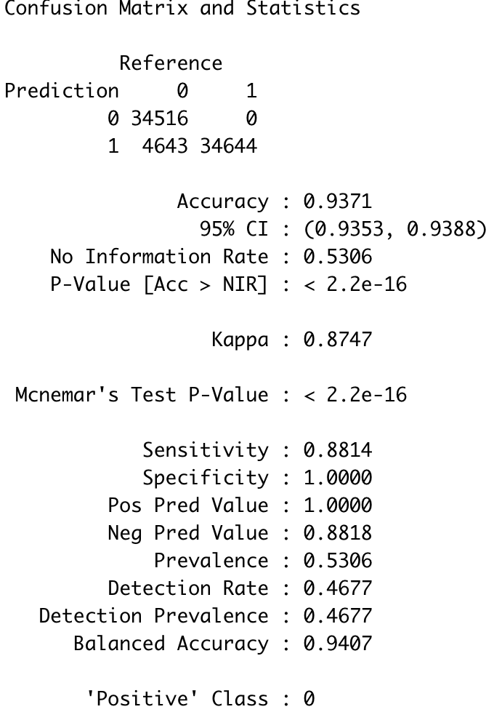

This is for Testing Variables now and accuracy is almost same as training. And looking at testing results we have 2030 are false positives.

Sensitivity is 88% which tells us that how capable our model is to tell for the true positives.

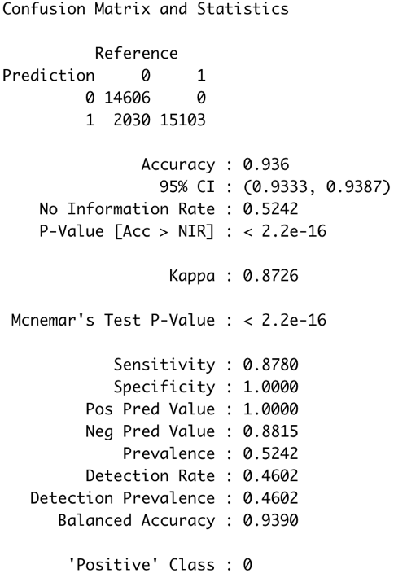

**ROC & AUC**

ROC (Receiver Operating Characteristics) and AUC is Area under curve. Basically, These are the measures to gain the performance of a classification model. And For our model the AUC is 0.8955 which is almost 90%.

AUC tells how much the model is capable of determining between classes. The higher this value, the better model Is to tell if yes and no.

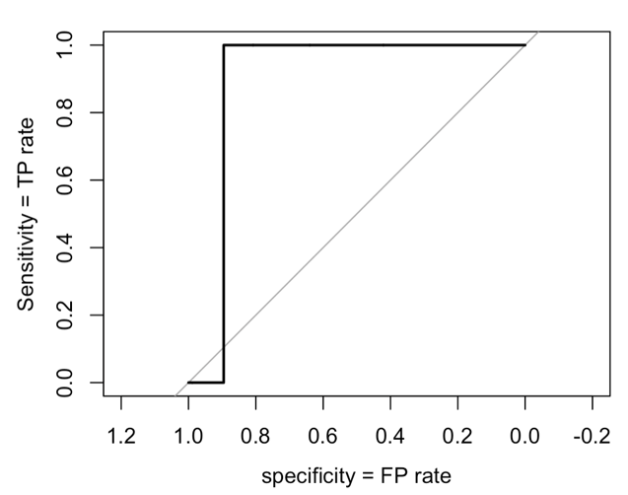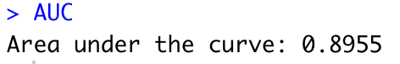

**Conclusion**

The model we developed and later used to predict, helped us to figure out whether the article (product) picked up by any customer is solid or not we can classify and also we have performed logistic regression for that which has accuracy of 94% on training set and to add to that same model was able to achieve 93.67% in our testing set.

The ROC & AUC helped us to check how much specific our model is capable of a given samples(customer picking up a specific category of t-shirt). We were able to get AUC value equal to 0.8955 which is 89%. The closer the value to 1, better the model performance and truthiness

Above mentioned tasks helps us to understand the analysis and interpretation of the dataset as hypothesis testing gives us gain confidence with proper proof.

**References**

H&M Personalized Fashion Recommendations, Provide product recommendations based on previous purchases, H&M Group *Sources*: https://www.kaggle.com/competitions/h-and-m-personalized-fashion- recommendations/data

**Appendix**

setwd(dirname(rstudioapi::getActiveDocumentContext()$path))

articles = read.csv("./articles.csv")

customers = read.csv("./customers.csv")

psych::describe(customers)

summary(customers)

unique(customers$club_member_status)

library(dplyr)

Mode <- function(x) {

ux <- unique(x)

ux[which.max(tabulate(match(x, ux)))]

}

customers[customers$club_member_status == "",] = Mode(customers$club_member_status)

clubMemberStatus = customers %>% filter(club_member_status != "")

clubMemberStatus$club_member_status = as.numeric(as.factor(clubMemberStatus$club_member_status))

clubMemberStatus$fashion_news_frequency = as.numeric(as.factor(clubMemberStatus$fashion_news_frequency))

print(prop.table(table(clubMemberStatus$club_member_status))*100)

barplot(prop.table(table(clubMemberStatus$club_member_status))*100,

names.arg = c("Active","Pre-Create","Left"),

xlab="Membership",

col=ifelse(prop.table(table(clubMemberStatus$club_member_status))*100 > 80,'cyan3','grey'),

border=ifelse(prop.table(table(clubMemberStatus$club_member_status))*100 <5,'gray','white'),

main="Customers of H&M",

ylim=c(0,100))

hist(clubMemberStatus$age,

xlab="Age",

main="Age Distribution of H&M Customers",col='cyan3',border='white',

ylim=c(0,300000))

brackets <- clubMemberStatus %>% mutate(agegroup = case_when(age > 0 & age <= 15 ~ 'Teen',

age > 15 & age <= 40 ~ 'Youngsters (15-40)',

age > 40 & age <= 80 ~ 'Elders (40-80)')) # end function

age_brackets = as.data.frame(prop.table(table(brackets$agegroup)) * 100)

ggplot(age_brackets,aes(x=Var1,y=Freq))+geom_bar(stat='identity') +labs(title='Percentage of Age of H&M Customers')

summary(clubMemberStatus$age)

psych::describe(articles)

str(articles)

# PRODUCT SALES RELATIVE PLOT

salesAsType = articles %>% count(product_type_name) %>% mutate(freq = n / sum(n)*100) %>% filter(freq > 2)

barplot(salesAsType$freq,names.arg=salesAsType$product_type_name,ylim=c(0,15),main='Percentage Type of Products of H&M',cex.names = 0.5,las=2,col=ifelse(sales$freq > 3,'Red','cyan4'),border='white')

salesAsTypeGroup = articles %>% count(product_group_name) %>% mutate(freq = n / sum(n)*100) %>% filter(freq > 1)

barplot(salesAsTypeGroup$freq,names.arg=salesAsTypeGroup$product_group_name,ylim=c(0,50),main='Percentage Group of Products of H&M',cex.names = 0.5,las=2,col='Red',border='white')

salesAsGraphics = articles %>% count(graphical_appearance_name) %>% mutate(freq = n / sum(n)*100) %>% filter(freq > 5)

barplot(salesAsGraphics$freq,names.arg=salesAsGraphics$graphical_appearance_name,ylim=c(0,50),main='Percentage Group of Products of H&M',cex.names = 0.6,las=2,col='Red',border='white')

library('ggplot2')

salesAsIndex = articles %>% count(index_name) %>% mutate(freq = n / sum(n)*100)

ggplot(salesAsIndex,aes(y=freq,x=index_name))+geom_bar(stat='identity')+theme(axis.text.x = element_text(angle = 45,hjust=1,size=7))+labs(title='Percentage of Index of H&M Sales')

salesAsSection = articles %>% count(section_name) %>% mutate(freq = n / sum(n)*100) %>% filter(freq>2)

ggplot(salesAsSection,aes(y=freq,x=section_name))+geom_bar(stat='identity')+theme(axis.text.x = element_text(angle = 45,hjust=1,size=7))+labs(title='Percentage of Index of H&M Sales')

salesAsColor = articles %>% count(perceived_colour_value_name) %>% mutate(freq = n / sum(n)*100) %>% filter(freq>2)

ggplot(salesAsColor,aes(y=freq,x=perceived_colour_value_name))+geom_bar(stat='identity')+theme(axis.text.x = element_text(angle = 45,hjust=1,size=7))+labs(title='Percentage of Index of H&M Sales')

salesAsColorName = articles %>% count(perceived_colour_master_name) %>% mutate(freq = n / sum(n)*100) %>% filter(freq>2)

ggplot(salesAsColorName,aes(y=freq,x=perceived_colour_master_name))+geom_bar(stat='identity')+theme(axis.text.x = element_text(angle = 45,hjust=1,size=7))+labs(title='Percentage of Index of H&M Sales')

featureGraphics = as.data.frame(articles$graphical_appearance_name)

featureGraphics$Solid = ifelse(featureGraphics$`articles$graphical_appearance_name` =='Solid',1,2)

colnames(featureGraphics) = c("graphical_name",'solid')

featureGraphics$graphical_name = as.numeric(as.factor(featureGraphics$graphical_name))

#1

v1 = select(salesAsIndex,-c(freq))

v2 = select(salesAsColor,-c(freq))

colnames(v1) = c('Name','Sales')

colnames(v2) = c('Name','Sales')

mValues = rbind(v1,v2)

mValues$Name<- as.numeric(as.factor(mValues$Name))

s.anova<- aov(Name~Sales, data=mValues)

smmry<-summary(s.anova)

smmry

tCust <- tCust %>% mutate(ageGroup = case_when(age >= 50 & age <= 100 ~ 'Aged',

age >= 30 & age <= 50 ~ 'Elder',

age <= 30 ~ 'Young'))

tukey = TukeyHSD(aov(club_member_status ~ ageGroup * fashion_news_frequency , data=tCust),conf.level = 0.95)

par(mar=c(6,8,3,2))

plot(tukey,las=2)

tukey

#2

result <- chisq.test(table(articles$product_type_name,articles$perceived_colour_master_name))

result

#3

result <- chisq.test(table(articles$product_type_name, articles$graphical_appearance_name))

result

library(misclassGLM)

mIndex = sample(c(1,2), nrow(featureGraphics),

replace = T,

prob = c(0.7,0.3))

train_x = featureGraphics[mIndex == 1,]

test_x = featureGraphics[mIndex == 2,]

head(train_x)

LR_model <- glm(solid ~ graphical_name,

data = train_x,

family = binomial(link = "logit"))

summary(LR_model)

prob.train_x = predict(LR_model,

newdata = train_x,

type = "response")

cm_data = as.factor(ifelse

(prob.train_x >= 0.5,

1, 2))

library(caret)

confusionMatrix(cm_data,

as.factor(ifelse(train_x$solid == 1, 1,2)))

prob.test_x = predict(LR_model,

newdata = test_x,

type = "response")

prob.test_x

cm_data = as.factor(ifelse

(prob.test_x >= 0.5,

1, 2))

cm_data

head(cm_data)

confusionMatrix(cm_data,

as.factor(ifelse(test_x$solid == 1, 1,2)),

)

library(pROC)

ROC = roc (test_x$solid, prob.test_x)

X = plot(ROC,

col = "black",

ylab = "Sensitivity = TP rate",

xlab = 'specificity = FP rate')

#08 Calculate and interpret the AUC.

AUC = auc(ROC)

AUC