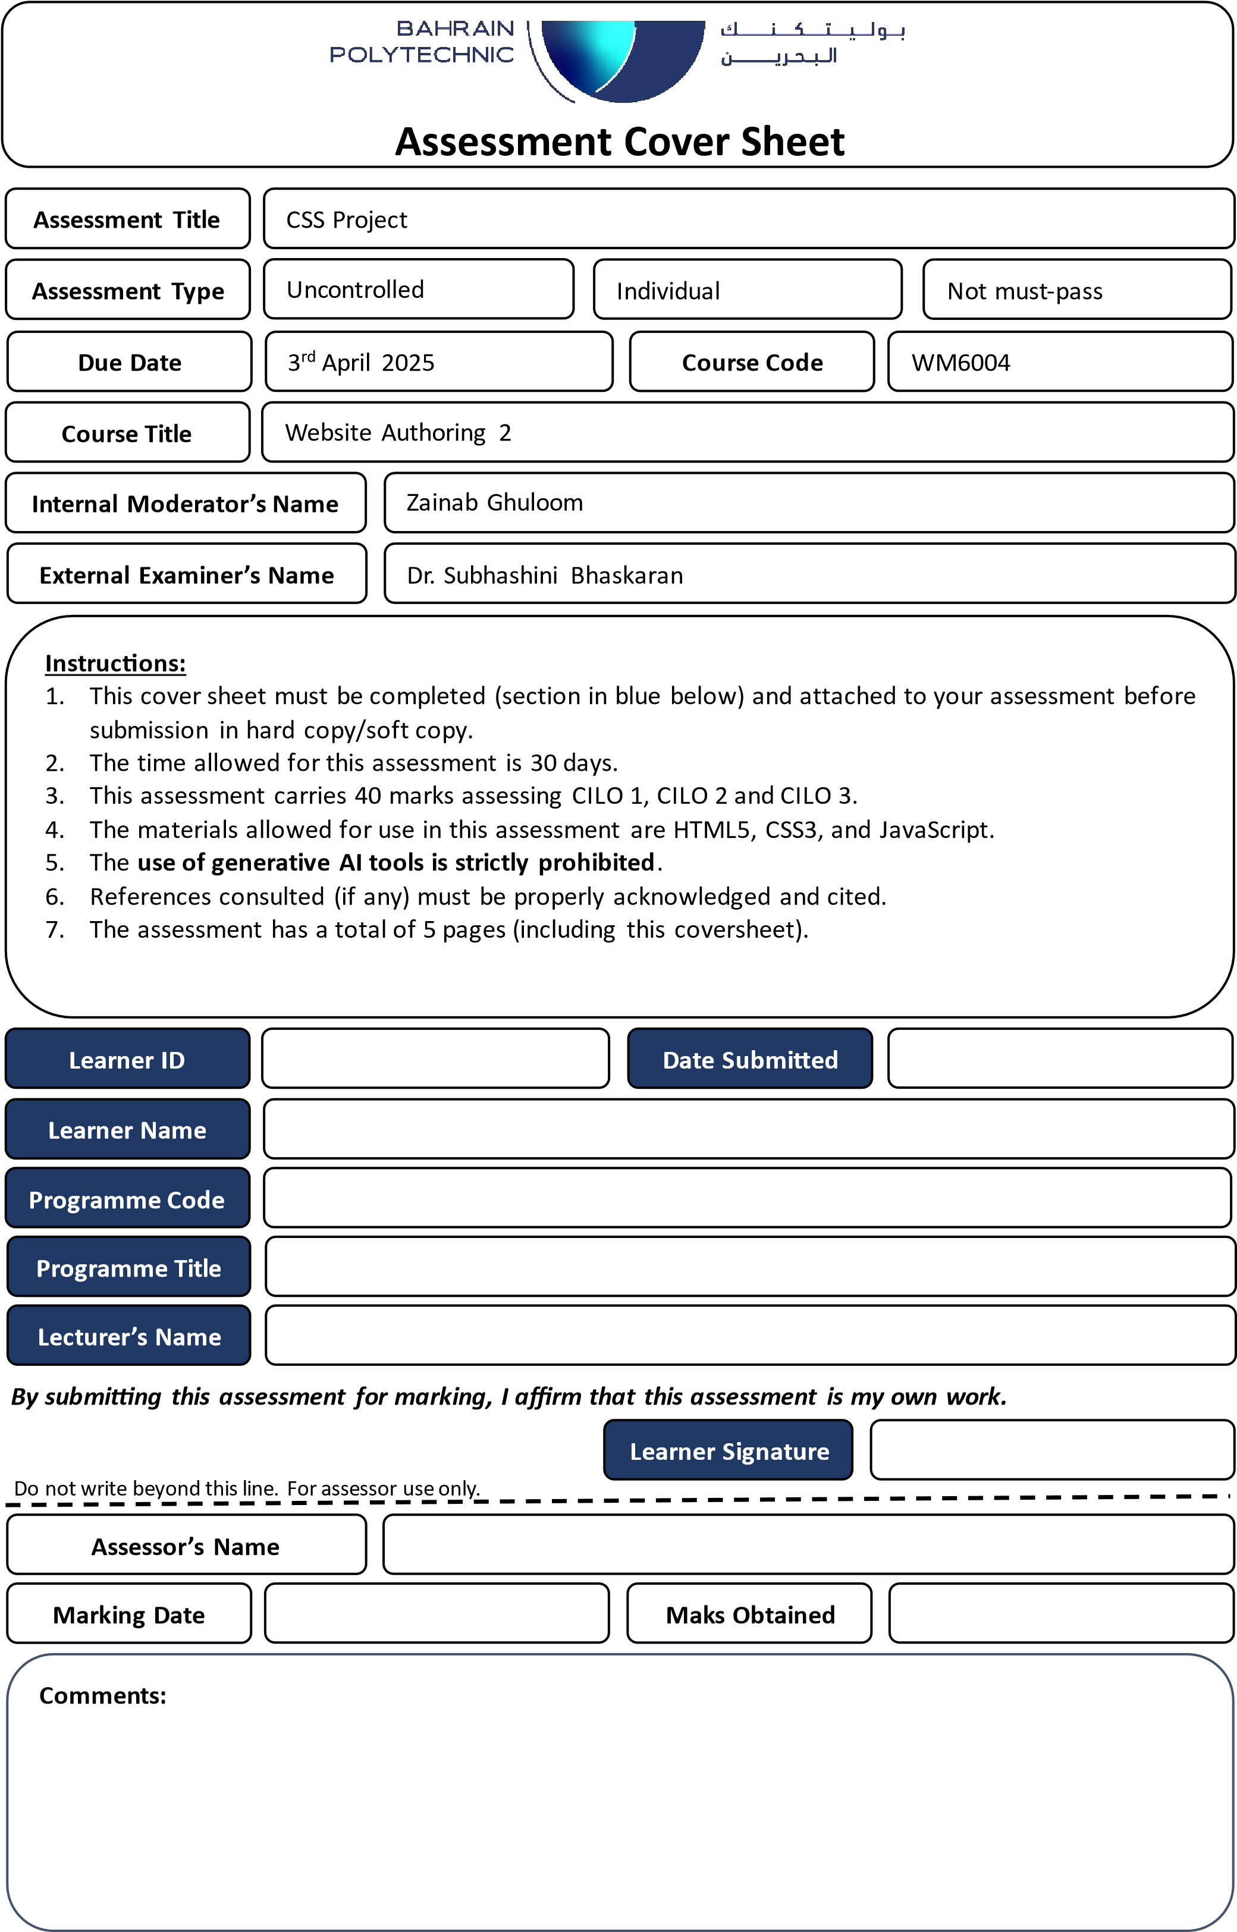

Table of Contents

Introduction explaining project objectives. 4

Target audience 5

Design Decisions 6

UX 6

How have you linked your design decisions to UX standards (at least two). For instance: how have you decided your website colors based on color theory. 6

Website mockups 7

Defining the two SEO practices used on the website supported by evidence (screenshots from the code/website). 8

Defining the two Web Accessibility practices used on the website supported by evidence (screenshots from the code/website). 9

References 10

# Introduction.

## Objective

# Target audience

# Design Decisions

## UX

color theory

### layout

# Website mockups

SEO Practices

Accessibility Practices

# Feature Table

|  |  |  |
| --- | --- | --- |
| **Feature** | **File Name** | **Screen Shot** |
| **JavaScript Self-**  **Correcting Quiz** | index.html script.js | Screen Shot of the code goes here. |
| **Self-Validating**  **Form** | index.html script.js | Screen Shot of the code goes here |
| **Glow Menu Text** | style.css | Screen Shot of the code goes here |

# References