**Machine learning - ICP#1**

**Student Name: Manjunath Reddy Velagacherla**

**Student Id:** **700759509**

**Github Link:**

**QUESTION 1**:

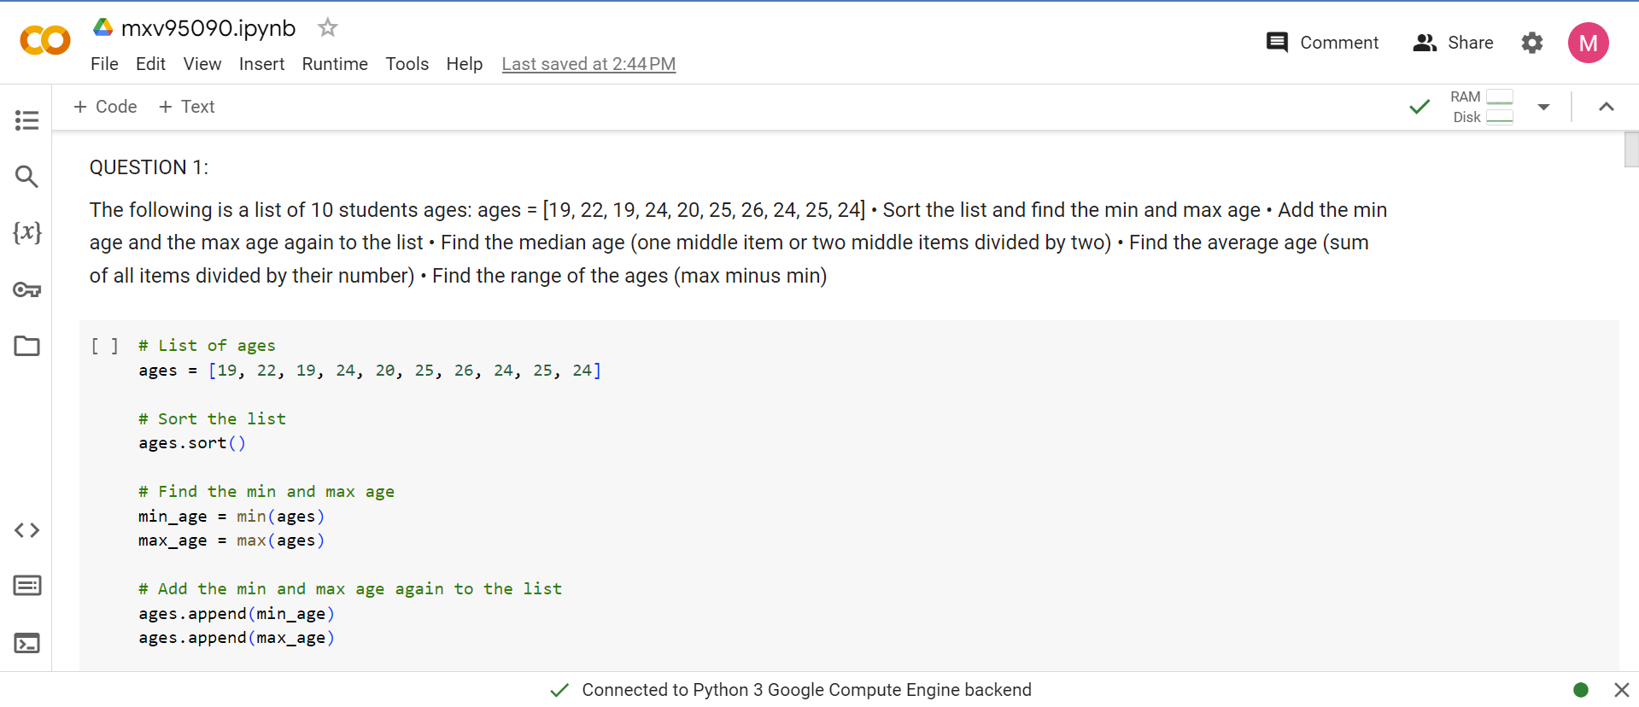

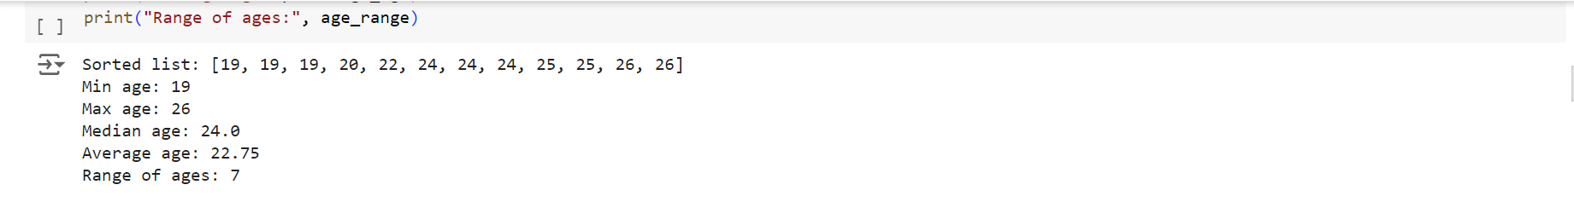

**QUESTION 2:**

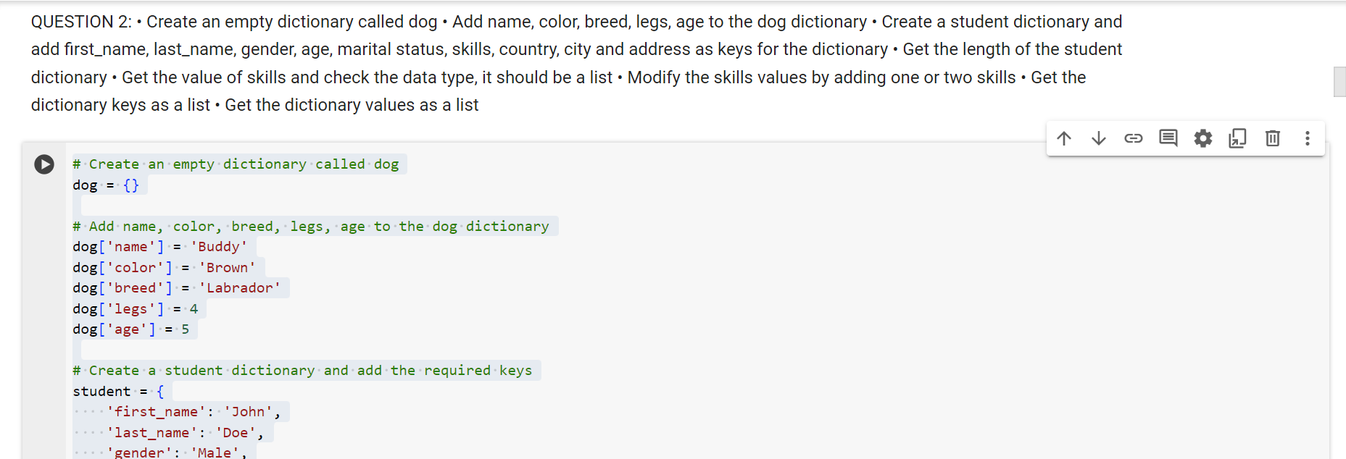

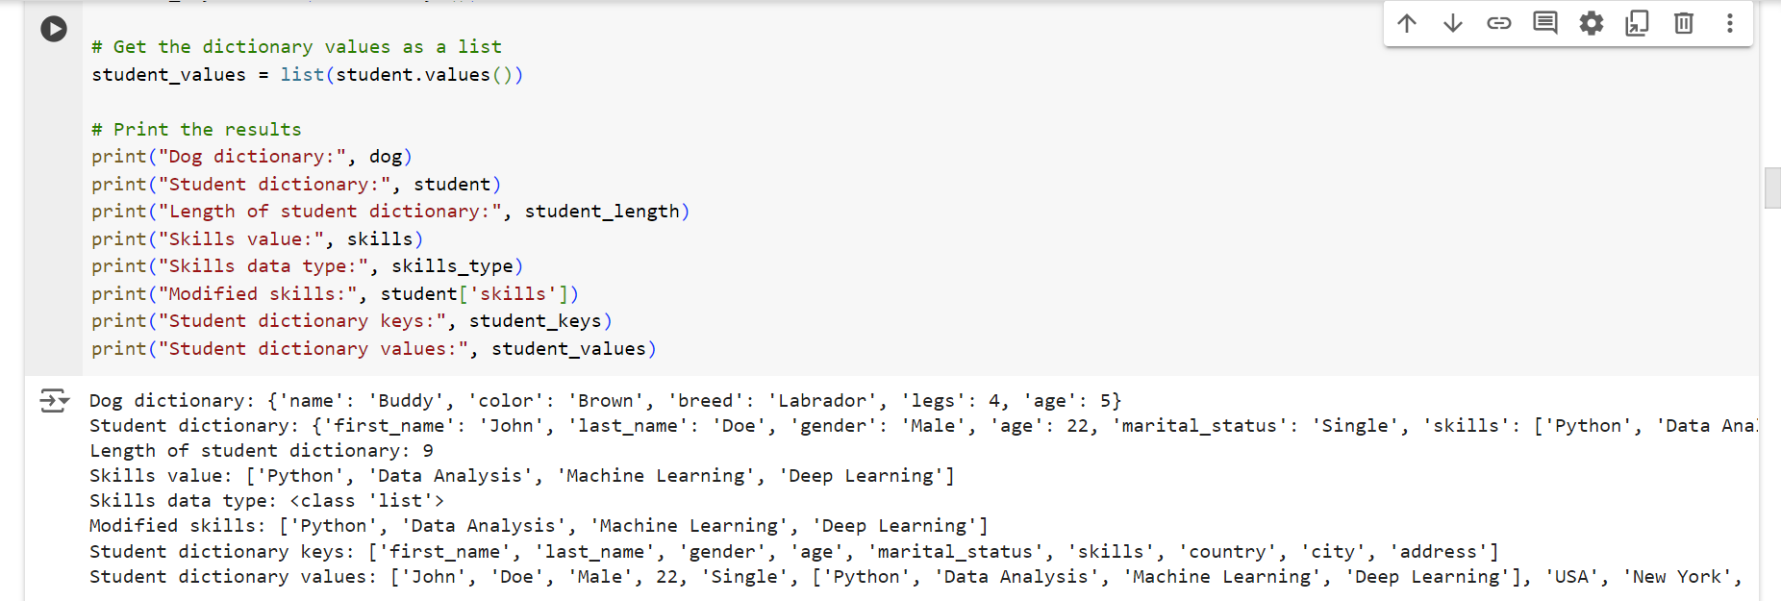

**Question 3:**

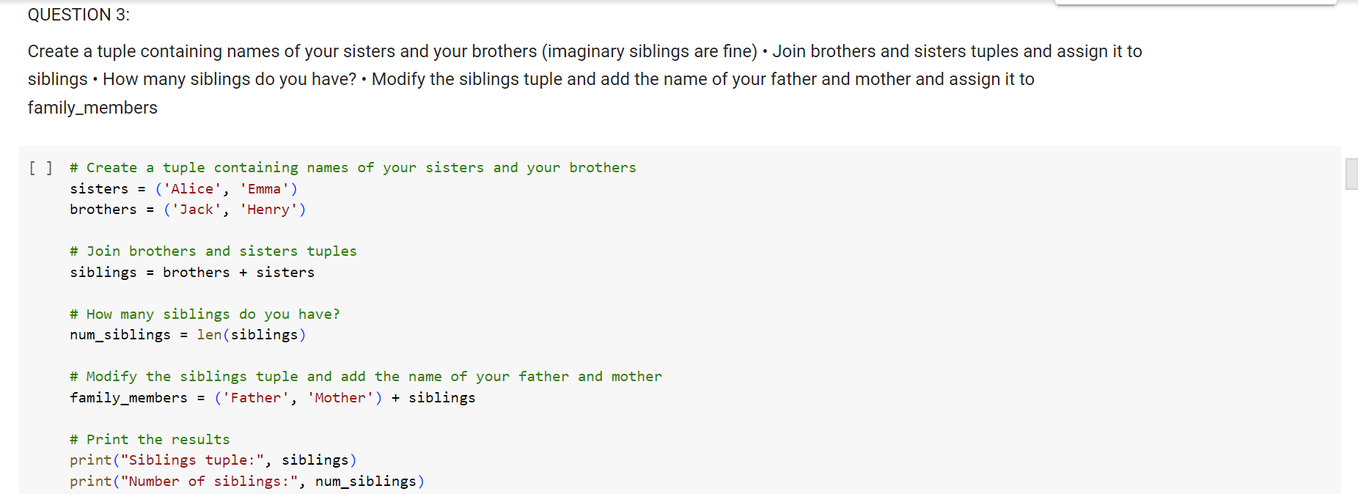



**Question 4:**

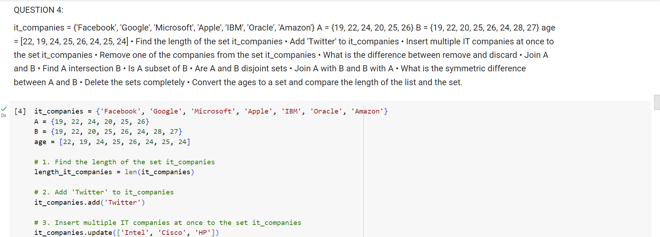

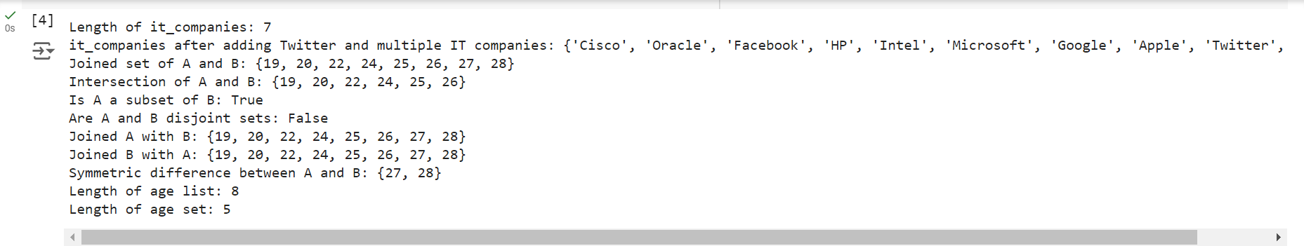

**Question 5:**

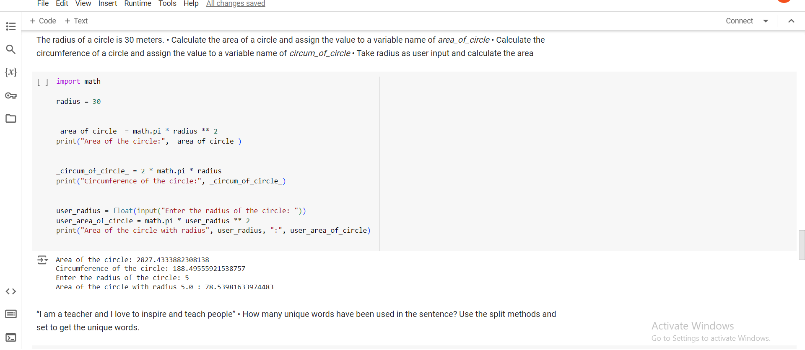

**Question 6:**

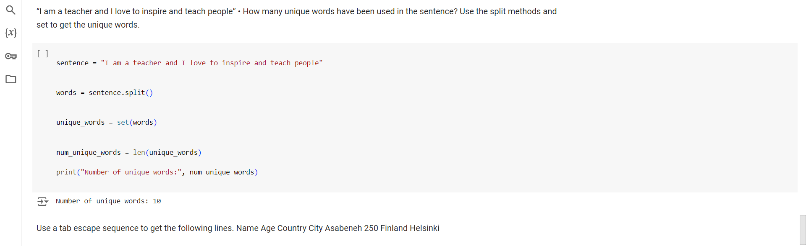

Question 7:

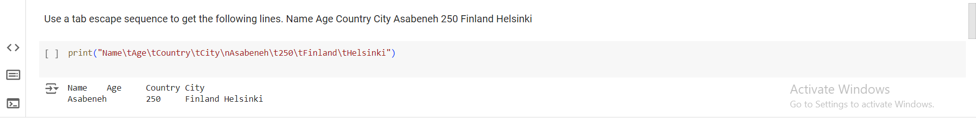

Question 8:



