Battle Ship UWA

GUI Idea
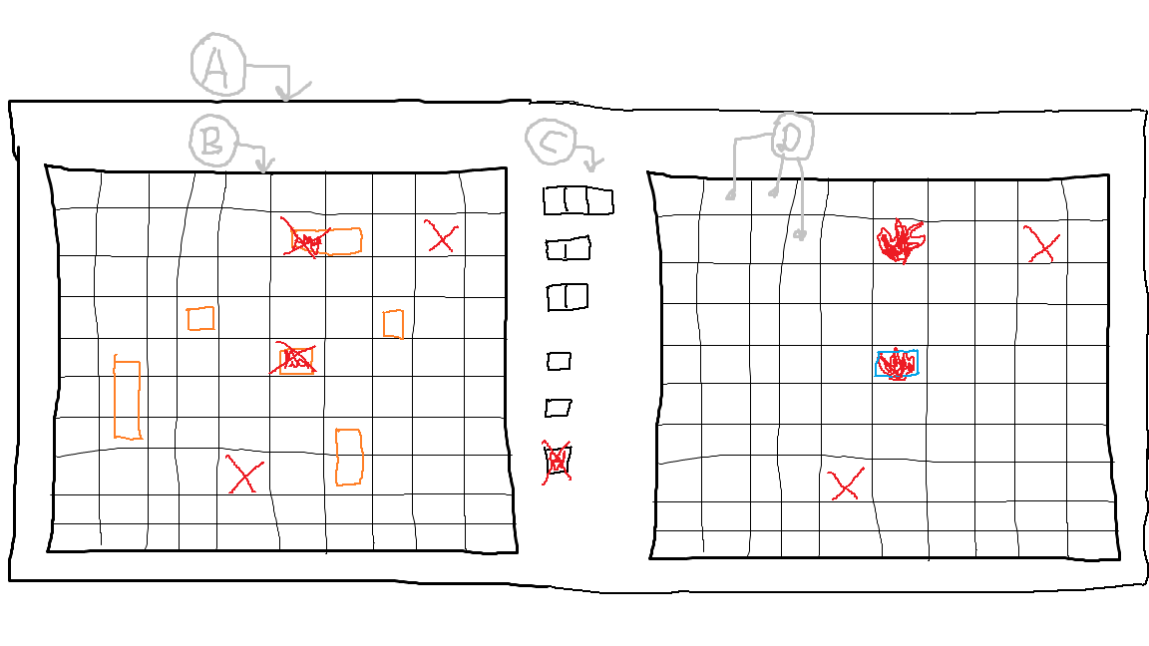
A. Grid (one cell).
B. Hbox (horizontal stack)
B.1 Grid - 1st cell (left one)
B.2 Vbox (vertical stack) 2nd cell (middle one)
B.2.1 Every stack occupies ship (enemy)
B.2. ...
B.3 Grid -3rd cell (right one)

