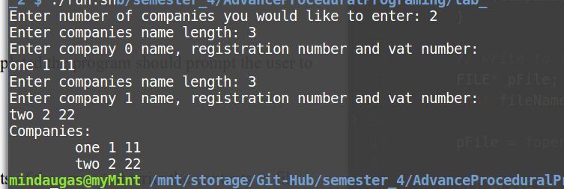

// Mindaugas Sharskus
// 8/2/2018

#include <stdio.h>
#include <stdlib.h>

typedef struct {
char *name;
int regNo;
int vatNo;
}Company;

void main() {
int maxCompanies, nameLength;

printf("Enter number of companies you would like to enter: ");
scanf("%d", &maxCompanies);

// declare dynamick array
Company *companies = (Company*)malloc(maxCompanies * sizeof(Company));

// populate companies array
for( int i = 0; i < maxCompanies; i++){
printf("Enter companies %d name length: ", i);
scanf("%d", &nameLength);

(companies + i)->name = (char*)malloc(nameLength * sizeof(char));

printf("Enter company %d name, registration number and vat number: \n", i);
scanf("%s %d %d", (companies + i)->name, &(companies + i)->regNo, &(companies + i)->vatNo);
}

// Dispaly array data
printf("Companies:\n");
for( int i = 0; i < maxCompanies; i++){
printf("\t%s %d %d\n", (companies + i)->name, (companies + i)->regNo, (companies + i)->vatNo);
}

// write to file
FILE* pFile;
char fileName[] = "companiesOut.txt";

pFile = fopen(fileName, "w"); // open file in "Write" mode

if( pFile == NULL){ printf("File cant be open!!"); }
else{

for(int i = 0; i < maxCompanies; i++){
fprintf(pFile, "Companys %d name: %s, registration number: %d, VAT number: %d\n", i, (companies + i)->name, (companies + i)->regNo, (companies + i)->vatNo);
}
fclose(pFile); // close file
}

// free memory
for(int i = 0; i < maxCompanies; i++){
free((companies + i)->name);
}
free(companies);

}

