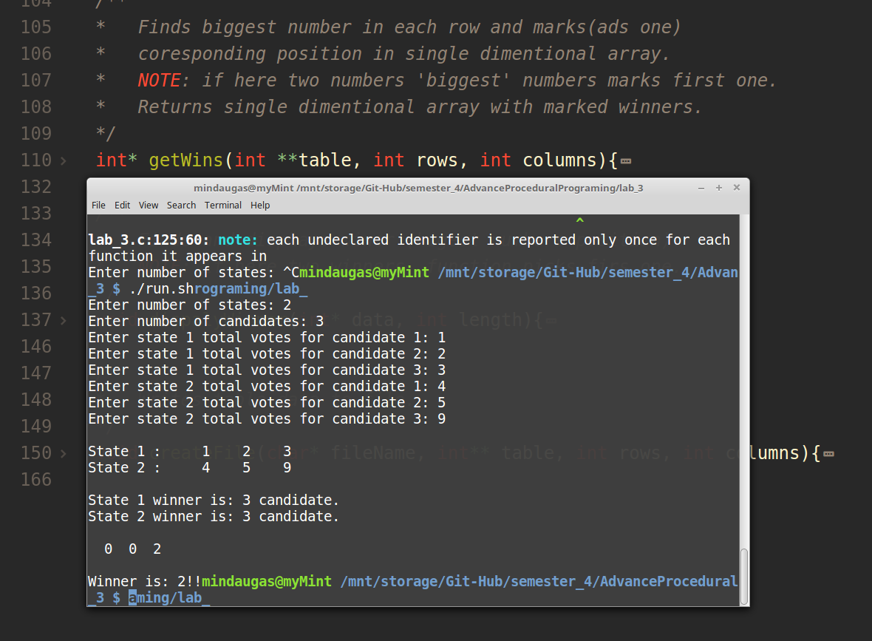
Notes:

- Program sheet didn’t ask to handle even votes. So program in case of even will return first candidate as winner.
- Program sheet ask to write data (not informtion) to file.

CODE:

/*
Mindaugas Sharskus
15/02/2018
*/

#include <stdio.h>
#include <stdlib.h>

int** creteTable(int rows, int columns);
void freeTableMemory(int** table, int rows);
void populateTable(int** table, int rows, int columns);
void displayTable(int **table, int rows, int column);
int* getWins(int **table, int rows, int column);
void displayArrayData(int *table, int length);
void dispalyWinner(int* data, int length);
void createFile(char* fileName, int** data, int rows, int columns);

void main() {
int **datatable, *winsData;
int states, candidates, votes;

// get table sizes
printf("Enter number of states: ");
scanf("%d", &states);
printf("Enter number of candidates: ");
scanf("%d", &candidates);

datatable = creteTable(states, candidates); // create table
populateTable(datatable, states, candidates); // papulate table with data
displayTable(datatable, states, candidates); // show entered data
winsData = getWins(datatable, states, candidates); // get wins for each candidate
printf("Each candidate win data:\n");
displayArrayData(winsData, candidates); // display candidates wins
dispalyWinner(winsData, candidates); // find & and show winner

createFile("votes.txt", datatable, states, candidates);
freeTableMemory(datatable, states); // house keeping
}

/**
* Creates table (2D int array).
* NOTE: do not initialize to 0 (zero) each value.
*/
int** creteTable(int rows, int columns){
// create "rows"
int** table = (int**)malloc(rows * sizeof(int*));
// create "columns"
for(int i = 0; i < rows; i++){
*(table +i) = (int*)malloc(columns * sizeof(int));
}
return table;
}

/**
* Frees memory from given table.
*/
void freeTableMemory(int** table, int rows){
for(int i = 0; i < rows; i++){
free(table[i]);
}
free(table);
}

/**
* Populates given table with the values entered by user.
* NOTE: negative values can't be entered.
*/
void populateTable(int** table, int rows, int columns){
for(int row = 0; row < rows; row++){
for(int col = 0; col < columns; col++){
// validate
do{
printf("Enter state %d total votes for candidate %d: ", row +1, col +1);
scanf("%d", (*(table +row) + col));
}while(*(*(table +row) + col) < 0);
}
}
}

/**
* Displays content of the given table (2d array)
*/
void displayTable(int **table, int rows, int columns){
for(int i = 0; i < rows; i++){
printf("\nState %d : ", i+1);
for(int j = 0; j < columns; j++){
printf("%5d", table[i][j]);
}
}
printf("\n\n");
}

/**
* Displays content of the given single dimentional array
*/
void displayArrayData(int *data, int length){
printf("\n");
for(int i = 0; i < length; i++){
printf("%3d", data[i]);
}
printf("\n\n");
}

/**
* Finds biggest number in each row and marks(ads one)
* coresponding position in single dimentional array.
* NOTE: if here two numbers 'biggest' numbers marks first one.
* Returns single dimentional array with marked winners.
*/
int* getWins(int **table, int rows, int columns){
int winnerPos;
int *winsData = (int*)malloc(columns * sizeof(int));
// reset data to 0 (zero)
for(int i = 0; i < columns; i++){
(*(winsData+i)) = 0;
}

// find winners
for(int i = 0; i < rows; i++){
winnerPos = 0;
for(int j = 1; j < columns; j++){
if( table[i][j] > table[i][winnerPos] ){
winnerPos = j;
}
}
printf("State %d winner is: %d candidate.\n", i+1, winnerPos+1);
(*(winsData + winnerPos))++;
}

return winsData;
}

/**
* Finds and displays winer (higest numbers position).
* NOTE: if here two winners, function picks firs one.
*/
void dispalyWinner(int* data, int length){
int winnerPos = 0;
for(int i = 1; i < length; i++){
if(data[i] > winnerPos){
winnerPos = i;
}
}
printf("Winner is: %d!!", winnerPos);
}

/**
* Writes table data to file.
*/
void createFile(char* fileName, int** table, int rows, int columns){
FILE* pFile;

pFile = fopen(fileName, "w"); // open file in "Write" mode

if( pFile == NULL){ printf("File cant be open!!"); }
else{
for(int i = 0; i < rows; i++){
fprintf(pFile, "\n");
for(int j = 0; j < columns; j++){
fprintf(pFile, "%3d", table[i][j]);
}
}
fclose(pFile); // close file
}
}

