Assignment – 13

Q.1)Create a union of two queries two shows the names, cities, and
ratings of all customers. Those with rating of 200 or greater will also
have the words “High Rating” while the others will have the words
“Low Rating”.

ANS:
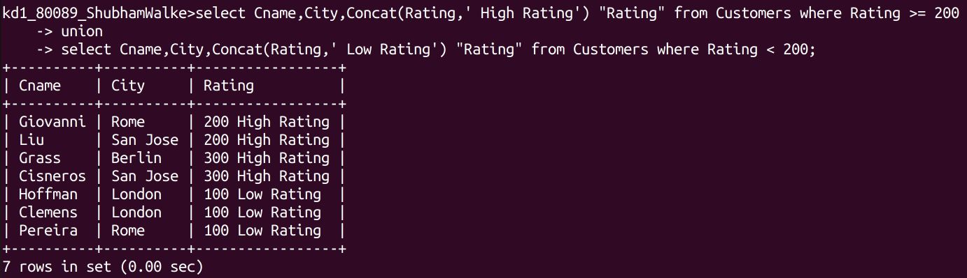

Q.2) Write a command that produces the name and number of each
salesperson and each customer with more than one current order. Put
the results in alphabetical order.
ANS:
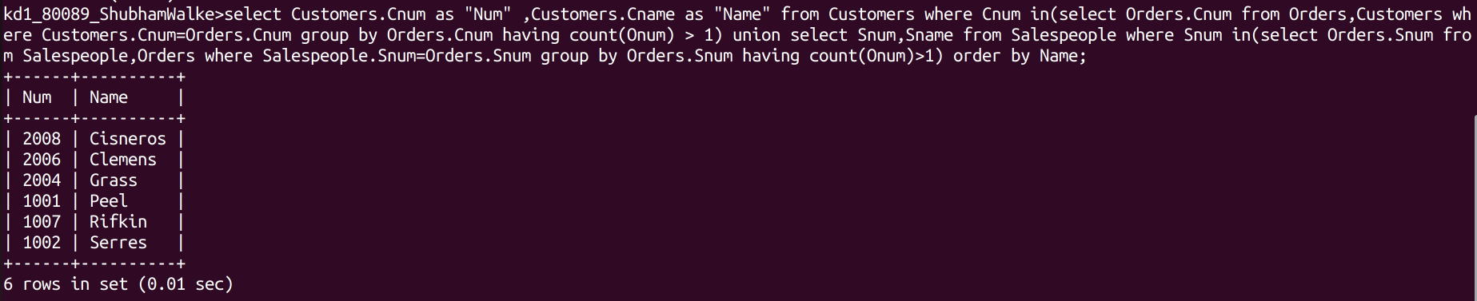
Q.3)Form a union of three queries. Have the first select the snums of all
salespeople in San Jose; the second, the cnums of all customers in San
Jose; and the third the onums of all orders on October 3. Retain
duplicates between the last two queries but eliminate any redundancies
between either of them and first.(Note: in the sample table as given,
there would be no such redundancy. This is besides the point.)

ANS:
