Assignment – 14

Q.1)Write a command that puts the following values, is their given order,
into the salespeople table: city San Jose, name - Blanco, comm- NULL
cnum -1100.
ANS:
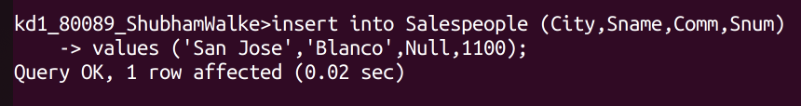
Q.2)Write a command that removes all orders from customer Clemens from the Orders table.
ANS:
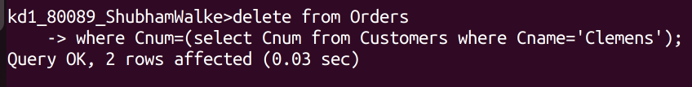
Q.3) Write a command that increases the rating of all customers in Rome
by 100.
ANS:
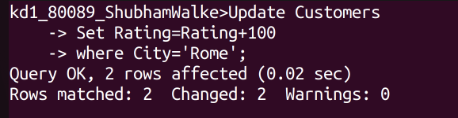
Q.4) Salesperson Serres has left the company. Assign her customers to
Motika.
ANS:

