Assignment No:1

Q1. Creating Sample tables and inserting values.
Create the following tables with given Structures and insert sample
data as Specified.
A)
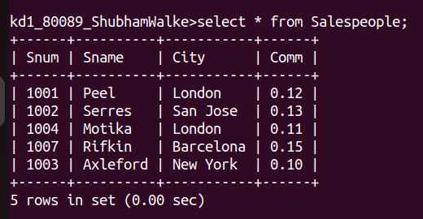
B)
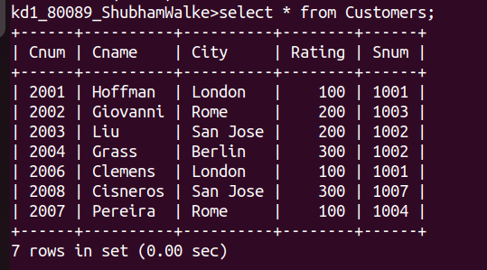
C)

