Assignment 9
Q.1)Write a query that lists each order number
followed by the name of the customer who made
the order.
ANS:
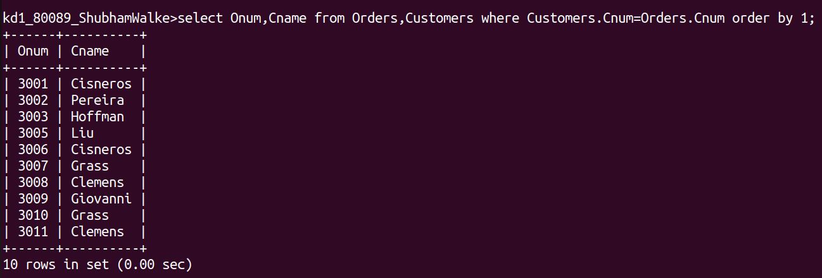
Q.2) Write a query that gives the names of both the
salesperson and the customer for each order
along with the order number.
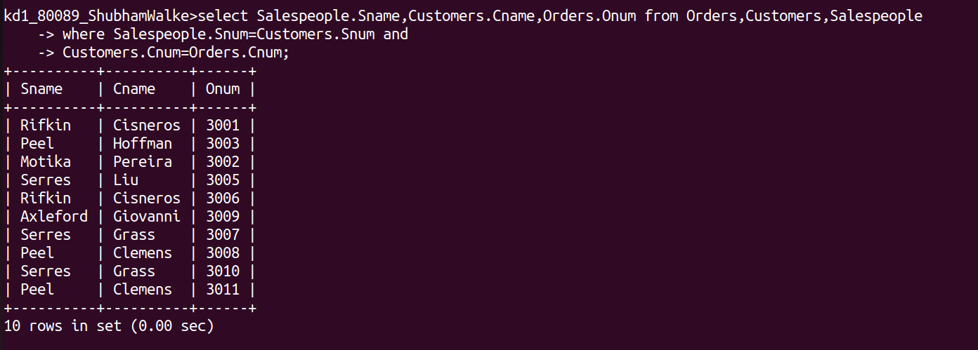
ANS:
Q.3) Write a query that produces all customers
serviced by salespeople with a commision above
12%.Output the customer’s name , the
name, and the salesperson’s rate of
commision.
ANS:
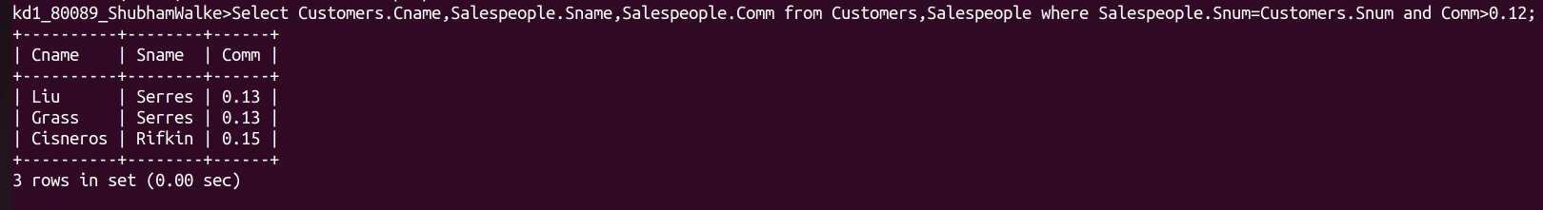
Q.4)Write a query that calculates the amount of the
salesperson’s commision on each order by a customer
with a rating above 100.
ANS:
