ASSIGNMENT 4

Q.1) Write a select command that produces the order
number, amount, and date for all rows in the Order
table.
ANS:
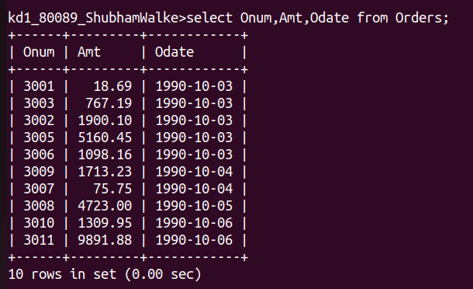
Q.2)Write a query that produces all rows from the
Customers table for which the salesperson's
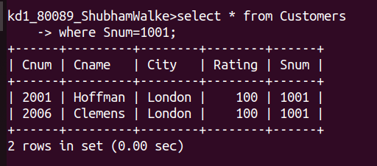
number is 1001.
ANS:

Q.3) Write query that displays the Salespeople a table with the columns in the following order: Select city, sname, snum, comm.

ANS:
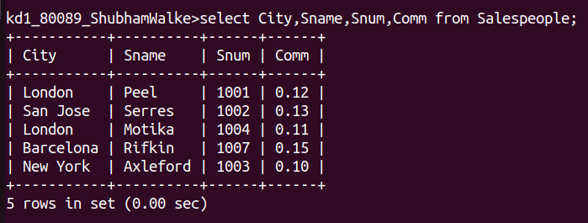
Q.4) Write a select command that produces the rating followed by the name of each customer in San Jose.
ANS:

