ASSIGNMENT 6

Q.1)Write two different queries that would produce all orders taken on October 3rd or 4th, 1990.
ANS:

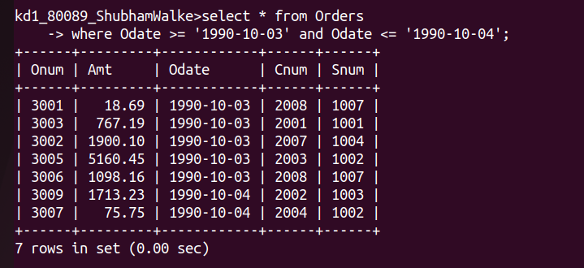
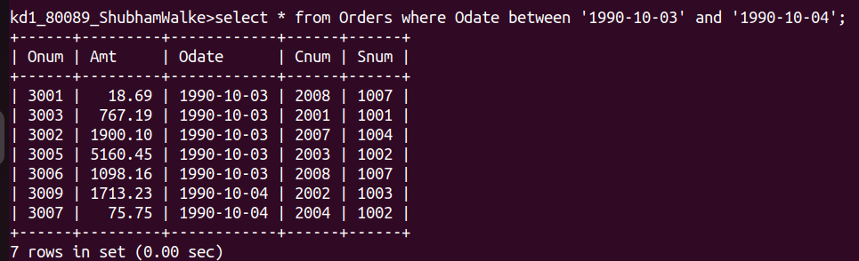

Q.2)Write a query that selects all of the customers serviced by Peel or Motika. (Hint: the snum field relates the two tables to one another).
ANS:
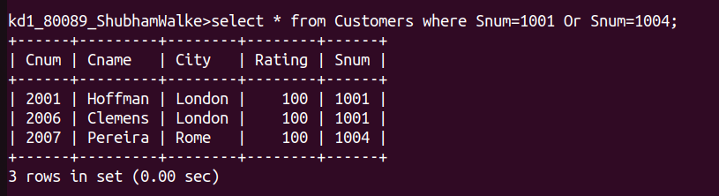
Q.3)Write query that will produce all a customers whose names begin with a letter from ‘A’ to ‘G’.

ANS:

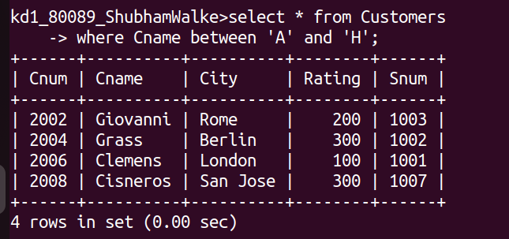
Q.4)Write a query that selects all customers whose form names begin with the letter 'C'.
ANS:
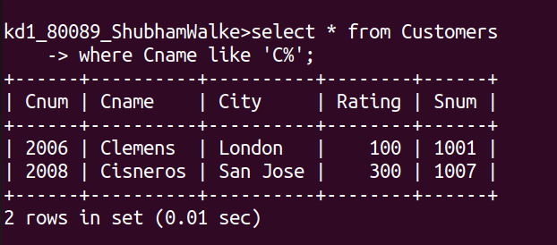
Q.5)Write a query that selects all orders except those with zeroes or NULLS in the amt field.
ANS:
