Assignment 10

Q.1)Write a query that produces all pairs of salespeople who are
living in the same city.Exclude combination of salespeople
with themselves as well as duplicate rows with th order
reversed.
ANS:

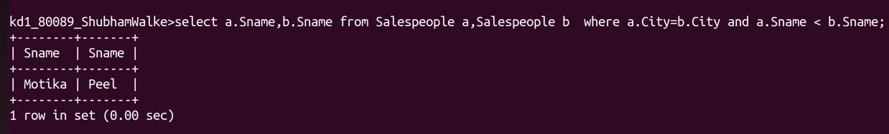
Q.2)Write a query that produces the names and cities of all
customers with same rating as hoffman.
ANS:

