Assignment 12

Q.1)Write a query that selects all customers whose
rating are equal to or greater than any of ‘Serres’.
ANS:

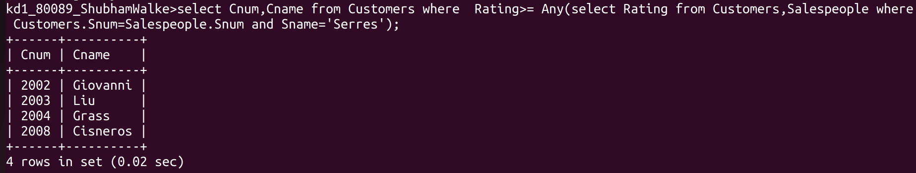
Q.2)Write a query using any or all that will find all
salespeople who have no customers located in
their city.
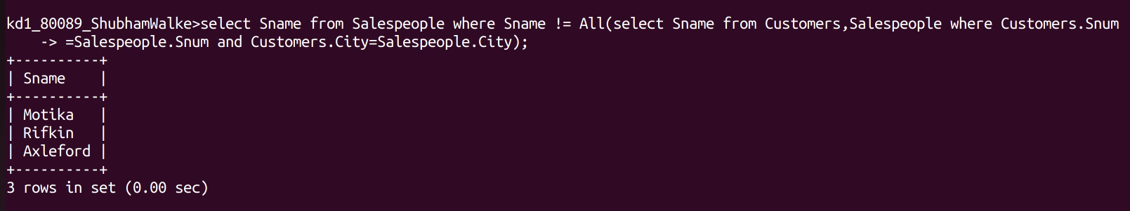
ANS:
Q.3)Write a query that selects all orders for amount
greater than any for the customers in London.
ANS:
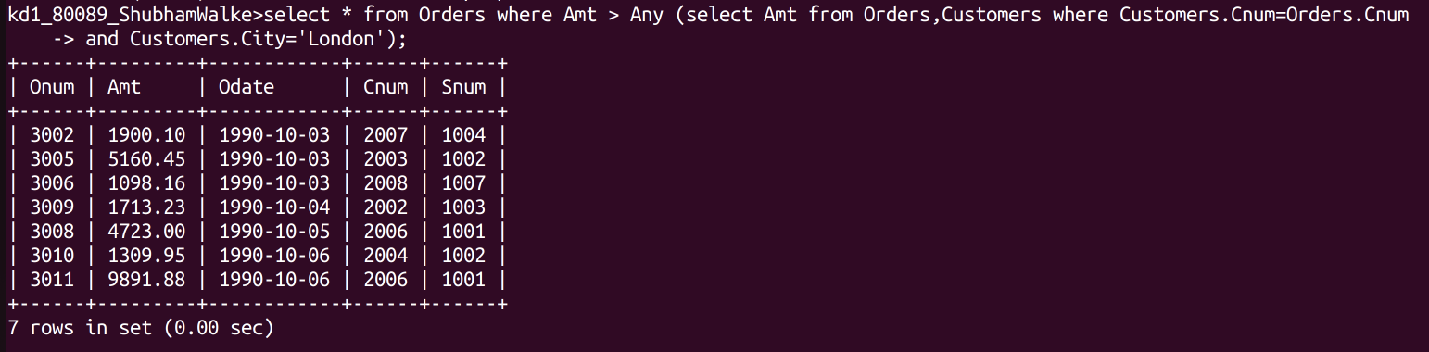
Q.4)Write the above query using min or max.

ANS:
