Assignment 11

Q.1)Write a query that uses a subquery to obtain all orders for the
customer named Cisneros. Assume you do not know his
customer number(cnum).

ANS:

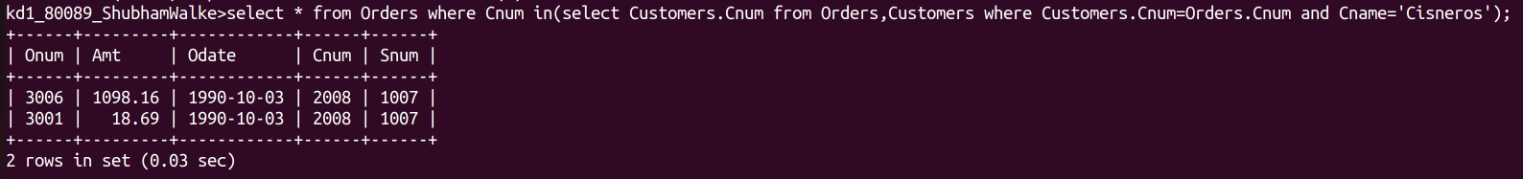
Q.2)Write a query that produces the names and ratings of all
customers who have above – average orders.

ANS:
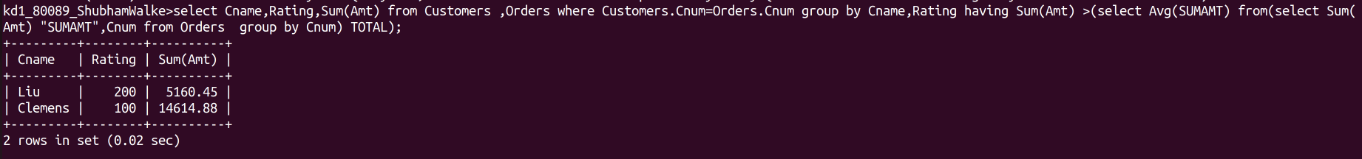

Q.3)Write a query that selects the total amount in orders for
each salesperson for whom this total greater than the amount
of the largest order of the table.

ANS:

