MongoDB Assaignment

Q.7)View list of available collections in CDAC database.
ANS:
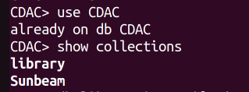

Q.8)View list of available collections in CDAC database.
ANS:

Q.9)Create a new collection by the name of LIBRARY.
ANS:
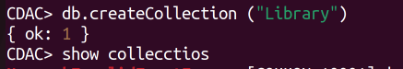

Q.10)Insert the following document in the LIBRARY collection:-
title:'MongoDB programming', author:'Sameer', likes:100

ANS:
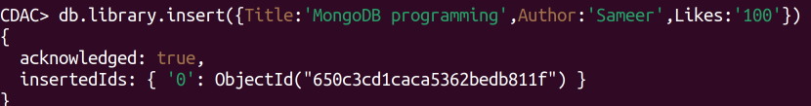
Q.11)View the recently inserted document and note the _id field.
ANS:

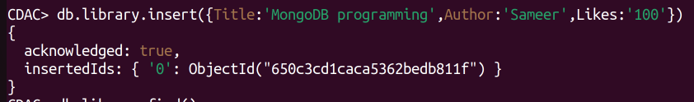

Q.12)Insert another document in the LIBRARY collection as
follows: title:'MySQL programming', authors:['Jack','Jill'],
likes:200.

ANS:

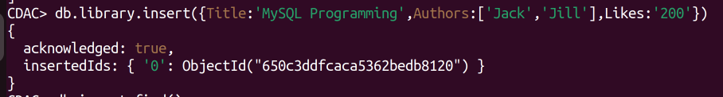
Q.13)View the inserted documents.
ANS:

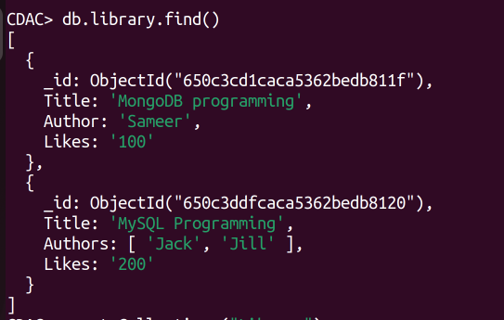

Q.14)View only the first inserted document.
ANS:
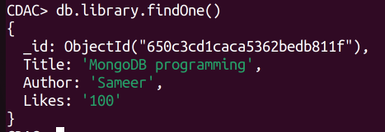

Q.15)View the documents using the pretty() method.
ANS:
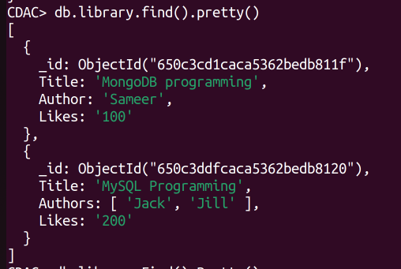

Q.16)Update the document where author name = Sameer and
change it to Sameer Dehadrai.
ANS:
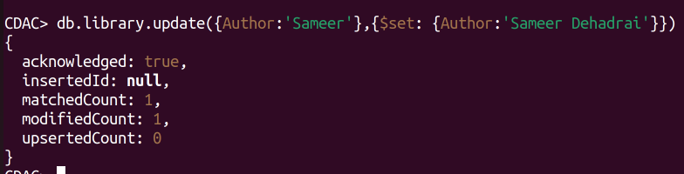
Q.17)Delete all documents that have 100 likes.
ANS:

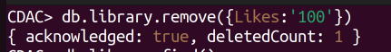

Q.18)Drop the LIBRARY collection.
ANS:

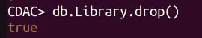

Q.19)Drop the CDAC database.
ANS:

