Assignment 8

Q.1)Assume each salespersonn has 12%
Commision.Write a query on the orders table that
will produce the order number,the salesperson
number,and the amount of the salesperson’s
commisson for that order.
ANS:
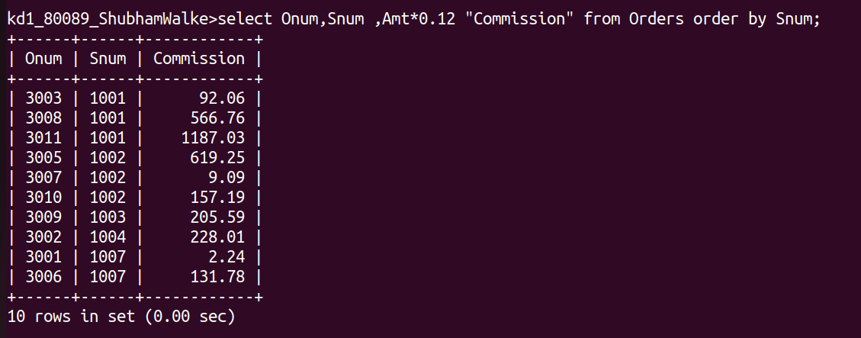
Q.2)Write a query on the customers table that will find
the highest rating in each city.Put the output inthis
form:For the city (city),the highest rating is :
(rating).
ANS:
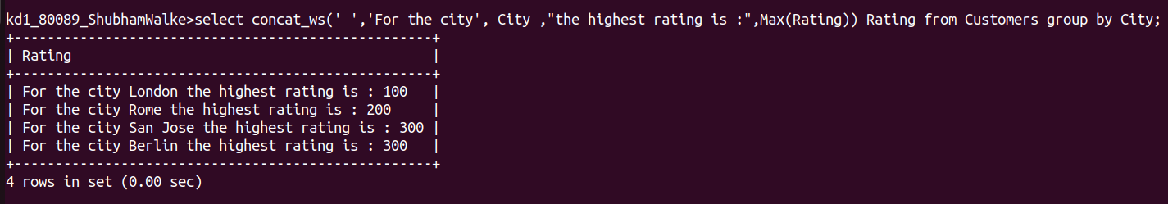

Q.3)Write a query that lists customers in descending
order of rating .Output the rating field first,
followed by the customers’s name and number.
ANS:
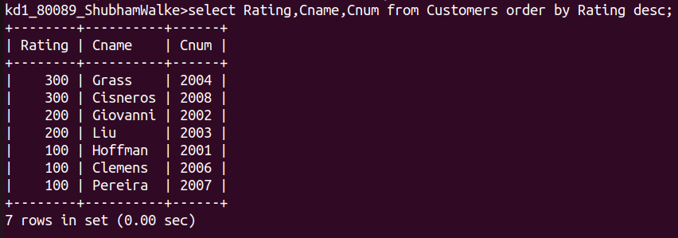

Q.4)Write a query that totals the orders for each day
and places the result in descending order.
ANS:
